
Tell
A study focus tracker that tells you when you stop actually studying
CASE STUDY: IONIC WEB AND ANDROID APPLICATION DEVELOPMENT
BSIT WMA 4A
Submitted by
Mark Joseph Garcia
Developer: concept, design, web application, Android build and documentation
[Group Member 2]
[Group Member 3]
[Group Member 4]
Submitted to
Thomas Chester Pabalan
September 2026
Table of Contents
1. Application Overview 4
1.1 Purpose 4
1.2 Technology 4
2. Features 5
3. Project and File Structure 6
4. Explanation of Important HTML Code 8
4.1 App shell and tab navigation 8
4.2 Opening a document 9
4.3 The study session layout 9
4.4 Settings controls 9
4.5 Session details modal 10
5. Explanation of Important JavaScript Code 11
5.1 Session state and recording events 11
5.2 Rule 1: restless scrolling 11
5.3 Rule 2: going idle (runs every second) 12
5.4 Rule 3: leaving the app 13
5.5 Rendering the document and tracking the page 13
5.6 Ionic events in Settings 14
5.7 Building the History list with the DOM 14
6. Ionic Components Used 16
7. Local Storage Implementation 18
7.1 What is saved 18
7.2 Saving and retrieving safely 18
7.3 How saved data is used 19
8. Responsive Design Implementation 20
8.1 Ionic grid 20
8.2 CSS Grid for the home screen 20
8.3 Orientation media query 21
8.4 Responsive behaviour in JavaScript 21
9. Web-to-Android Build Process 22
9.1 Build steps 22
9.2 Cordova configuration 23
9.3 Same functionality on both platforms 23
10. Website Screenshots 25
10.1 Desktop (1440 × 900) 25
10.2 Tablet (820 × 1180) 29
10.3 Phone (390 × 844) and phone landscape (844 × 390) 30
11. Android Screenshots 31
11.1 Portrait 31
11.2 Landscape 32

If page numbers look out of date, right-click the table and choose Update Field.

1. Application Overview
Tell is a study companion that notices when you stop actually studying. Instead of a plain Pomodoro timer or asking students how focused they felt, Tell watches how you study. It picks up behavioural signals such as frantic back-and-forth scrolling, going idle, and switching away from the app, and tells you when you have drifted.
Students open their own reading material (a PDF or a Word DOCX file) inside the app and read it there while taking notes on the side. Because the document is read inside Tell, the app knows which page was on screen when focus was lost. Every session is saved, so over time Tell becomes a study diagnostic. It shows how much focused time you put in each day and which pages of a reviewer you struggled with most.

1.1 Purpose
- Help students notice distraction as it happens, not after an hour is gone.
- Show which parts of a document were hardest to focus on, so review time goes where it is needed.
- Encourage consistent study habits with a daily focus goal and a day streak.

1.2 Technology
Tell is written in HTML, CSS and JavaScript, and its whole interface is built from Ionic UI components (Ionic 9, using the framework-free web-component build). The same code runs as a website in any browser and is packaged as an Android APK with Apache Cordova. PDF files are rendered with Mozilla's pdf.js and DOCX files are converted to HTML with mammoth.js. All data is stored on the device with the browser's localStorage. There are no accounts and no server.
Part | Technology
User interface | Ionic 9 web components (ion-tabs, ion-card, ion-list, ion-range, ion-modal, ...)
Logic | Vanilla JavaScript (ES modules)
Styling | CSS with Ionic theme variables, CSS Grid, media queries; Poppins font
Documents | pdf.js 3.11 (PDF to canvas), mammoth 1.12 (DOCX to HTML)
Storage | window.localStorage (JSON)
Android | Apache Cordova 13, cordova-android 15 (Android SDK 36)
Website extras | Web App Manifest + Service Worker (installable, works offline)

2. Features
Feature | What it does
Open PDF or DOCX | Pick a file with the Ionic button (or drag and drop it on desktop). Pages render inside the app.
Restless scrolling detection | Flags 4+ quick up/down direction changes within 3 seconds (sensitivity is adjustable).
Idle detection | If there is no scrolling, typing, touching or mouse movement for 12 s (adjustable), Tell asks "Still there?" and beeps until you are back.
Leaving-the-app detection | Switching tabs or apps is detected with the Page Visibility API; on return Tell says how long you were away.
"I'm restless" marker | A floating hand button (or the F8 key) lets you mark the current page as hard to focus on.
Side notes | An auto-saving notes box sits next to the document.
Live session stats | Timer, current page, restless count, marked count and a live focus percentage.
Sound alerts | Three alert tones (Beep, Chime, Buzz) generated with the Web Audio API; can be turned off.
History | Every session is saved. Search by document or notes, filter Today / 7 days / All, swipe to delete (with Undo).
Session details | Where the time went (active / idle / away), which rules fired, and a ranked list of the hardest pages.
Home dashboard | Daily focus goal progress, day streak, a 7-day focused-minutes chart and recent sessions.
Crash recovery | If the app closes mid-session, the next launch offers to save or discard what was recorded.
Settings | Name, daily goal, idle time, scroll sensitivity, away alerts, sound, alert tone, and Light / Dark / System theme.
CSV export | Export a session's timeline and per-page stats (download on web; copied to the clipboard on Android).
Responsive layout | Adapts to phone portrait, phone landscape, tablet and desktop.
Privacy | Documents and data never leave the device.

3. Project and File Structure
The project follows the workflow required by the case study: Ionic web application, then build, then Cordova, then Android APK. There is exactly one application codebase, the web/ folder. The build script copies it to dist/ (the website) and into the Cordova project's android/www/ folder (the Android app).
Folder layout
WMA3/
├── web/ ← the ONE shared Ionic app (source code)
│ ├── index.html all three screens, built from Ionic components
│ ├── css/
│ │ ├── theme.css Tell colours mapped to Ionic variables, dark mode, font
│ │ └── app.css layout and responsive rules
│ ├── js/
│ │ ├── app.js entry point: starts every screen, tab bar, back button
│ │ ├── study.js study session + restlessness detection
│ │ ├── viewer.js PDF / DOCX rendering, current page tracking
│ │ ├── history.js History tab, detail modal, CSV export
│ │ ├── settings.js Settings tab (ionInput / ionChange handlers)
│ │ ├── storage.js every localStorage read and write
│ │ ├── sound.js alert tones (Web Audio API)
│ │ └── ui.js helpers: formatting, toasts, alerts
│ ├── assets/icon.svg app icon
│ ├── manifest.json, sw.js installable website + offline support
│ └── lib/ (generated) Ionic, pdf.js, mammoth, icons, fonts
├── scripts/build.js build step: web/ → dist/ → android/www/
├── dist/ (generated) the built website
├── android/ Cordova project
│ ├── config.xml app id, name, orientation, icons, splash
│ ├── res/icon/ launcher icon + splash images
│ └── www/ (generated) copy of dist/
├── package.json npm scripts: dev, build, serve, build:android
└── README.md
File | Responsibility
web/index.html | Markup for the Study, History and Settings tabs, the session layout and the detail modal.
web/js/study.js | Opening documents, running a session, the three detection rules, saving the session.
web/js/viewer.js | Renders PDF pages to canvases and DOCX to HTML; works out which page is on screen.
web/js/history.js | Builds the history list and summary, search/filter, swipe-to-delete with undo, details, CSV.
web/js/settings.js | Binds every Settings control to the saved settings; applies the theme.
web/js/storage.js | The only file that touches localStorage: settings, history and the in-progress session.
web/js/app.js | Starts the app, moves the tab bar on wide screens, handles the Android back button, registers the service worker.
scripts/build.js | Copies the libraries in, builds the website, and copies it into the Cordova project.
android/config.xml | Cordova configuration: package id com.krezdot.tell, allowed orientations, icons and splash screen.

4. Explanation of Important HTML Code
All screens live in one file, web/index.html. The page loads Ionic's stylesheet and its web-component script, the two document libraries, and finally the app's own JavaScript as an ES module.
web/index.html: loading Ionic and the libraries
<!-- Ionic styles + dark palette (enabled by adding .ion-palette-dark to <html>) -->
<link rel="stylesheet" href="lib/ionic/css/ionic.bundle.css">
<link rel="stylesheet" href="lib/ionic/css/dark.class.css">
<link rel="stylesheet" href="css/theme.css">
<link rel="stylesheet" href="css/app.css">

<!-- Ionic web components (loads each component on demand) -->
<script type="module" src="lib/ionic/ionic.esm.js"></script>

<!-- Document renderers: pdf.js (PDF) and mammoth (DOCX -> HTML) -->
<script src="lib/pdfjs/pdf.min.js"></script>
<script src="lib/mammoth/mammoth.browser.min.js"></script>

<!-- Empty on the web; replaced by Cordova's real cordova.js in the Android build -->
<script src="cordova.js"></script>
cordova.js is an empty placeholder on the website. When the Android app is built, Cordova replaces it with its real runtime. This is what lets one HTML file work on both platforms.

4.1 App shell and tab navigation
The whole app sits inside <ion-app> and <ion-tabs>. Each screen is an <ion-tab> with its own <ion-header>/<ion-toolbar> and scrollable <ion-content>. The <ion-tab-bar> switches between them without reloading the page.
web/index.html: app shell (screens shortened)
<ion-app>
<ion-tabs id="tabs">
<ion-tab tab="study"> ...Study screen... </ion-tab>
<ion-tab tab="history"> ...History screen... </ion-tab>
<ion-tab tab="settings"> ...Settings screen... </ion-tab>

<ion-tab-bar slot="bottom" id="tabBar">
<ion-tab-button tab="study">
<ion-icon src="lib/icons/book.svg"></ion-icon>
<ion-label>Study</ion-label>
</ion-tab-button>
<ion-tab-button tab="history">
<ion-icon src="lib/icons/time.svg"></ion-icon>
<ion-label>History</ion-label>
</ion-tab-button>
<ion-tab-button tab="settings">
<ion-icon src="lib/icons/settings.svg"></ion-icon>
<ion-label>Settings</ion-label>
</ion-tab-button>
</ion-tab-bar>
</ion-tabs>
</ion-app>

4.2 Opening a document
The native <input type="file"> is hidden and an Ionic button opens it instead, so the picker looks the same on every platform. On Android this opens the system file picker. The surrounding drop zone also accepts drag-and-drop on desktop browsers.
web/index.html: drop zone and file button
<div id="dropZone" class="drop-zone">
<ion-icon src="lib/icons/cloud-upload-outline.svg"></ion-icon>
<p class="drop-title">Drop a PDF or DOCX here</p>
<p class="drop-or">or</p>
<input type="file" id="fileInput" hidden
accept=".pdf,.docx,application/pdf,application/vnd.openxmlformats-officedocument.wordprocessingml.document">
<ion-button id="pickFileBtn" size="large" shape="round">
<ion-icon slot="start" src="lib/icons/folder-open.svg"></ion-icon>
Choose a file
</ion-button>
</div>

4.3 The study session layout
During a session the screen is an <ion-grid> with two columns. The size attributes are what make it responsive: size="12" means full width on phones (the columns stack), and size-md="8" / size-md="4" give a two-thirds / one-third split from 768 px up (tablets, landscape phones and desktop).
web/index.html: session grid (side panel shortened)
<ion-grid class="session-grid ion-no-padding">
<ion-row class="session-row">
<!-- Document viewer: full width on phones (portrait), 2/3 width on tablets/desktop/landscape -->
<ion-col size="12" size-md="8" class="doc-col">
<ion-progress-bar id="renderBar" type="indeterminate" hidden></ion-progress-bar>
<div id="doc" class="doc" tabindex="0"></div>
</ion-col>
<ion-col size="12" size-md="4" class="side-col"> ...status, stats, notes, controls... </ion-col>
</ion-row>
</ion-grid>
The floating "I'm restless" button is an <ion-fab> pinned to the bottom-right of the content with slot="fixed":
web/index.html: floating marker button
<ion-fab slot="fixed" vertical="bottom" horizontal="end" id="markerFab" hidden>
<ion-fab-button id="markerBtn" color="secondary" aria-label="Mark that I'm restless">
<ion-icon src="lib/icons/hand-left.svg"></ion-icon>
</ion-fab-button>
</ion-fab>

4.4 Settings controls
Settings are standard Ionic form components. Each has an id so the JavaScript can read and write its value and listen to its events.
web/index.html: idle-time slider
<ion-range id="setAfk" min="5" max="60" step="1" pin="true" snaps="false"
label-placement="stacked">
<div slot="label" class="range-label">Idle alarm after <strong id="setAfkValue">12</strong>s of no activity</div>
</ion-range>

4.5 Session details modal
The details screen is an inline <ion-modal>. It stays hidden until modal.present() is called; its content is filled in by JavaScript for whichever session was tapped.
web/index.html: details modal
<ion-modal id="detailModal">
<div class="ion-page">
<ion-header>
<ion-toolbar color="primary">
<ion-title id="detailTitle">Session</ion-title>
<ion-buttons slot="end">
<ion-button id="detailCloseBtn" aria-label="Close">
<ion-icon slot="icon-only" src="lib/icons/close.svg"></ion-icon>
</ion-button>
</ion-buttons>
</ion-toolbar>
</ion-header>
<ion-content class="ion-padding" id="detailContent"></ion-content>
</div>
</ion-modal>

5. Explanation of Important JavaScript Code
The JavaScript is split into ES modules, one per responsibility. It uses the concepts from the course throughout: variables (let/const session state), functions, DOM manipulation (getElementById, createElement, textContent, classList, replaceChildren) and event handling (addEventListener for DOM events, plus Ionic's ionInput, ionChange, ionSwipe, ionTabsDidChange and ionBackButton).

5.1 Session state and recording events
A study session is one JavaScript object. record() appends an event to the session timeline, updates the counters for the current page and immediately saves the session; persist() writes it to localStorage (at most every 5 seconds unless forced).
web/js/study.js: record()
/** Add an event to the session timeline and update counters. */
function record(type, extra = {}) {
if (!session) return;
session.timeline.push({ t: Date.now(), type, where: where?.key ?? null, ...extra });
if (session.timeline.length > MAX_TIMELINE) session.timeline.shift();

if (type === 'detected') {
session.detections[extra.rule]++;
if (where) pageStats(where.key).restless++;
} else if (type === 'marker') {
session.markers++;
if (where) pageStats(where.key).markers++;
}
renderStats();
persist(true);
}

5.2 Rule 1: restless scrolling
Every scroll of the document calls this function. It keeps only the scroll positions from the last 3 seconds and counts how many times the direction flipped. Normal reading scrolls one way; flipping back and forth is a sign of restlessness. The threshold comes from the Scroll sensitivity setting.
web/js/study.js: checkScrollReversal()
// Rule 1: several up/down direction flips inside a short window = restless scrolling.
function checkScrollReversal(top) {
const now = Date.now();
recentScrolls.push({ t: now, top });
recentScrolls = recentScrolls.filter((s) => now - s.t <= REVERSAL_WINDOW_MS);

let reversals = 0;
let lastDir = 0;
for (let i = 1; i < recentScrolls.length; i++) {
const dir = Math.sign(recentScrolls[i].top - recentScrolls[i - 1].top);
if (dir !== 0) {
if (lastDir !== 0 && dir !== lastDir) reversals++;
lastDir = dir;
}
}

if (reversals >= reversalThreshold() && now - lastDetectedAt > DETECT_COOLDOWN_MS) {
lastDetectedAt = now;
record('detected', { rule: 'scroll_reversal', reversals });
flagRestless('Restless scrolling!');
}
}

5.3 Rule 2: going idle (runs every second)
setInterval(tick, 1000) runs this once a second. It adds the elapsed time to either active or idle time and to the current page, and if nothing has happened for the configured number of seconds it starts nagging with a repeating sound until the user interacts again.
web/js/study.js: tick()
// Runs every second: accumulates time and checks rule 2 (idle).
function tick() {
if (!session) return;
const now = Date.now();
const delta = Math.min(now - lastTickAt, 5000); // timers can pause in the background; away time is measured separately
lastTickAt = now;

if (document.visibilityState === 'visible' && onStudyTab) {
if (afk) {
session.afkMs += delta;
} else {
session.activeMs += delta;
if (where) pageStats(where.key).timeMs += delta;

if (now - lastActivityAt >= settings.afkSeconds * 1000) {
afk = true;
record('detected', { rule: 'afk' });
startNagging('Still there?');
}
}
}
renderTimer();
renderStats();
persist();
}
"Activity" is any of these DOM events. pointerdown and pointermove cover both mouse and touch, so the same code works on desktop and Android:
web/js/study.js: activity listeners
for (const type of ['pointerdown', 'pointermove', 'wheel', 'keydown']) {
document.addEventListener(type, () => { if (session) markActivity(); }, { passive: true });
}

5.4 Rule 3: leaving the app
The browser's Page Visibility API fires visibilitychange when the tab or app goes to the background. On Android this fires when the user presses Home or switches apps. Tell records the time it left, and on return adds the away time and shows a toast.
web/js/study.js: onVisibilityChange()
// Rule 3: leaving the app / tab.
function onVisibilityChange() {
if (!session) return;
if (document.visibilityState === 'hidden') {
hiddenAt = Date.now();
if (settings.awayAlert) {
record('detected', { rule: 'tab_switch' });
startNagging('Come back!');
} else {
record('away');
}
persist(true); // the OS may kill a backgrounded app, so save now
} else {
const awayMs = hiddenAt ? Date.now() - hiddenAt : 0;
hiddenAt = null;
if (settings.awayAlert) session.awayMs += awayMs;
record('back', { awayMs });
lastActivityAt = lastTickAt = Date.now(); // coming back counts as activity
afk = false;
stopNagging();
if (settings.awayAlert && awayMs > 3000) {
toast(`You were away for ${formatDuration(awayMs)}`, { color: 'warning' });
}
}
}

5.5 Rendering the document and tracking the page
PDF pages are drawn one by one onto <canvas> elements with pdf.js. They are rendered at the device's pixel density so text is sharp on phones, while CSS scales the canvas to the screen width. To know which page is being read, Tell checks which canvas covers the upper third of the viewer.
web/js/viewer.js: currentLocation() (PDF part)
export function currentLocation(container, type) {
if (type === 'pdf') {
// The page covering the upper third of the viewer is the one being read
const y = container.scrollTop + container.clientHeight / 3;
let page = 1;
for (const canvas of container.querySelectorAll('canvas')) {
if (canvas.offsetTop <= y) page = Number(canvas.dataset.page); else break;
}
return { key: `Page ${page}`, short: String(page) };
}
// DOCX has no pages: its scroll position is split into 10 sections instead
...
}

5.6 Ionic events in Settings
Settings shows the difference between Ionic's two main events. ionInput fires continuously (every keystroke, or while a slider is dragged), so it is used for live labels. ionChange fires once the value is committed, so it is used to save.
web/js/settings.js: range events
// Ranges: ionInput while dragging (live label), ionChange when released (save)
$('setAfk').addEventListener('ionInput', (e) => { $('setAfkValue').textContent = e.detail.value; });
$('setAfk').addEventListener('ionChange', (e) => updateSetting('afkSeconds', e.detail.value));

$('setSensitivity').addEventListener('ionInput', (e) => {
$('setSensitivityValue').textContent = SENSITIVITY_LABELS[e.detail.value - 1];
});
$('setSensitivity').addEventListener('ionChange', (e) => updateSetting('sensitivity', e.detail.value));
web/js/settings.js: updateSetting() saves and notifies
export function updateSetting(key, value) {
if (settings[key] === value) return;
settings[key] = value;
saveSettings(settings);
listeners.forEach((fn) => fn(key, value));
}

5.7 Building the History list with the DOM
History items are created with document.createElement and filled with textContent (never innerHTML), so a strange file name can never inject HTML. Each item is an ion-item-sliding: swiping reveals a Delete option, and a full swipe fires ionSwipe.
web/js/history.js: swipe to delete
// Swipe left to reveal Delete (a full swipe deletes straight away)
const del = el('ion-item-option', { color: 'danger', expandable: true }, [
el('ion-icon', { slot: 'icon-only', src: 'lib/icons/trash.svg' }),
]);
del.addEventListener('click', () => removeSession(s.id));
const options = el('ion-item-options', { side: 'end' }, [del]);
options.addEventListener('ionSwipe', () => removeSession(s.id));

return el('ion-item-sliding', {}, [item, options]);
Deleting shows an ion-toast with an Undo button that puts the session back at its original position:
web/js/history.js: removeSession()
function removeSession(id) {
const result = deleteSession(id);
if (!result) return;
historyChanged();
toast(`Deleted "${result.removed.docName}"`, {
duration: 4000,
buttons: [{ text: 'Undo', handler: () => { restoreSession(result.removed, result.index); historyChanged(); } }],
});
}

6. Ionic Components Used
Every visible part of Tell is an Ionic component, themed with Ionic CSS variables so the whole app picks up Tell's pink palette and switches cleanly to dark mode. Plain HTML elements are only used for layout wrappers and the PDF canvases.
Component | Where it is used | Purpose
ion-app, ion-tabs, ion-tab, ion-tab-bar, ion-tab-button | Whole app | Three-tab navigation (Study, History, Settings) without page reloads.
ion-header, ion-toolbar, ion-title, ion-buttons | Top of every screen | Screen title, session timer, clear-history button.
ion-content | Every screen | Scrollable content area; scrolling is switched off during a session.
ion-card (+ header, title, subtitle, content) | Home | Welcome card, daily goal, week chart, crash-recovery prompt.
ion-button | Throughout | Choose a file, End session, See all, Save/Discard, Export, Delete.
ion-icon | Throughout | Ionicons (loaded locally so the APK works offline).
ion-grid, ion-row, ion-col | Session screen, History summary, Home | Responsive columns using size / size-sm / size-md / size-lg.
ion-fab, ion-fab-button | Session screen | Floating "I'm restless" marker button.
ion-textarea | Session side panel | Notes; saved on every ionInput.
ion-toggle | Session panel, Settings | Sound alerts, away alerts.
ion-chip | Header, Home | Session timer and day-streak badge.
ion-progress-bar | Home, session, details | Daily goal progress, PDF rendering progress, struggle level per page.
ion-list, ion-item, ion-label, ion-note, ion-list-header | History, Settings, details | Session list, settings rows, time breakdown.
ion-item-sliding, ion-item-options, ion-item-option | History | Swipe left to delete a session.
ion-badge | History, Home | Focus percentage, coloured by how focused the session was.
ion-searchbar | History | Search sessions by document name or notes (ionInput).
ion-segment, ion-segment-button | History, Settings | Today / 7 days / All filter; System / Light / Dark theme.
ion-input | Settings | Name and daily goal (with validation on ionInput / ionBlur).
ion-range | Settings | Idle time (5-60 s) and scroll sensitivity (1-5, with ticks).
ion-select, ion-select-option | Settings | Alert sound picker (popover interface).
ion-modal | History | Session details; a full-screen sheet on phones and a centred dialog on large screens.
ion-alert | Throughout | Confirmations: end session, delete, clear history, reset.
ion-toast | Throughout | "Session saved", "You were away for 5s", Undo delete.

Overlays (ion-toast, ion-alert) are created from JavaScript and presented with Ionic's API:
web/js/ui.js: confirm() built on ion-alert
/** Show an ion-alert with Cancel / confirm buttons. Resolves true if confirmed. */
export async function confirm(header, message, confirmText = 'OK', destructive = false) {
const el = document.createElement('ion-alert');
el.header = header;
el.message = message;
el.buttons = [
{ text: 'Cancel', role: 'cancel' },
{ text: confirmText, role: 'confirm', cssClass: destructive ? 'alert-danger' : '' },
];
document.body.appendChild(el);
await el.present();
const { role } = await el.onDidDismiss();
el.remove();
return role === 'confirm';
}

7. Local Storage Implementation
Tell saves everything with window.localStorage, which stores text key/value pairs in the browser (on the website) or in the app's WebView (on Android). Objects are converted with JSON.stringify when saving and JSON.parse when loading. All storage code lives in one module, web/js/storage.js, so the rest of the app never touches localStorage directly.

7.1 What is saved
Key | Contents | Saved when | Retrieved when
tell.settings | Name, daily goal, idle seconds, sensitivity, away alert, sound on/off, alert tone, theme | Any setting changes (ionInput / ionChange) | App start; applied to every screen
tell.history | Array of finished sessions: document, start/end, active/idle/away time, alerts by rule, markers, per-page stats, timeline, notes | A session is ended, deleted, undone or recovered | History tab, home dashboard (goal, streak, week chart, recent sessions)
tell.activeSession | The session in progress (same shape as a history entry) | Every 5 s, on every alert/marker, and immediately when the app goes to the background | App start: if found, the "Unfinished session found" card is shown

One saved session looks like this (shortened):
Example entry in tell.history
{
"id": "smuf8k2x1a",
"docName": "Networking-Ch4-Subnetting.pdf",
"docType": "pdf", "pageCount": 18,
"startedAt": 1790330700000, "endedAt": 1790333400000,
"activeMs": 2280000, "afkMs": 300000, "awayMs": 120000,
"detections": { "scroll_reversal": 3, "afk": 1, "tab_switch": 1 },
"markers": 2,
"pages": { "Page 7": { "timeMs": 540000, "restless": 3, "markers": 2 } },
"timeline": [ { "t": 1790330712000, "type": "detected", "where": "Page 7", "rule": "scroll_reversal" } ],
"notes": "Subnet mask /26 = 255.255.255.192 ..."
}

7.2 Saving and retrieving safely
Two small wrappers do all reading and writing. Both use try/catch: reading falls back to a default if storage is blocked or the JSON is corrupted, and writing reports failure instead of crashing (for example when storage is full).
web/js/storage.js: read() and write()
function read(key, fallback) {
try {
const raw = localStorage.getItem(key);
return raw ? JSON.parse(raw) : fallback;
} catch (e) {
return fallback; // storage blocked (private mode) or corrupted JSON
}
}

function write(key, value) {
try {
localStorage.setItem(key, JSON.stringify(value));
return true;
} catch (e) {
console.warn(`Could not save ${key}`, e); // usually QuotaExceededError
return false;
}
}
Settings are merged over the defaults when loaded, so a setting added in a newer version of the app still gets a sensible value for existing users:
web/js/storage.js: loadSettings()
export function loadSettings() {
// Merge over the defaults so settings added in a newer version get a sane value.
return { ...DEFAULT_SETTINGS, ...read(KEYS.settings, {}) };
}

7.3 How saved data is used
- Home screen: today's focused minutes (goal bar), the day streak, the 7-day chart and the three most recent sessions are all calculated from tell.history each time the screen is shown.
- History tab: reads tell.history, applies the search text and date filter, and shows totals for the filtered sessions.
- Crash recovery: because tell.activeSession is saved while studying, closing the tab or the Android system killing the app does not lose the session. On the next start the user can save it to history or discard it.
- Storage limit: if localStorage is full when saving history, the oldest sessions' detailed timelines are dropped (their summaries stay) and the save is retried. Settings shows how many KB Tell is using.

8. Responsive Design Implementation
Tell does not depend on a fixed screen size. The layout is driven by the Ionic grid, CSS Grid and media queries, and was tested on desktop (1440×900), tablet (820×1180), phone portrait (390×844), phone landscape (844×390) and an Android 15 emulator in both orientations.
Screen | Layout
Phone portrait (< 768 px) | Home: cards in one column. Session: document on top (58% of the height), side panel below and scrollable. Tab bar at the bottom.
Phone landscape (short screens) | Session: document and side panel forced side by side (62% / 38%), smaller toolbar and tab bar to save height. Home: two columns.
Tablet / small laptop (≥ 768 px) | Home: welcome card beside the goal and week chart. Session: document 2/3, side panel 1/3.
Desktop (≥ 992 px) | Tab bar moves to the top like a normal website navigation bar; Settings shows two columns of cards; details modal is a centred dialog.
Touch screens | Drag-and-drop area hidden (you cannot drag files on a phone); one large "Choose a file" button instead.

8.1 Ionic grid
The session screen uses ion-col sizes (see section 4.3). History summary cards use size="6" size-md="3" (2 per row on phones, 4 on wider screens) and the "How Tell knows" cards use size="12" size-sm="6" size-lg="3" (1, 2 or 4 per row).

8.2 CSS Grid for the home screen
The home screen uses named grid areas. On phones every card is its own row; from 768 px the welcome card and the goal/chart column sit side by side.
web/css/app.css: phone layout
.landing {
display: grid;
grid-template-columns: minmax(0, 1fr);
grid-template-areas: "recover" "hero" "side" "recent" "how" "privacy";
max-width: 1100px;
margin: 0 auto;
padding: 8px 0 24px;
}
#recoverCard { grid-area: recover; }
web/css/app.css: tablet / desktop layout
@media (min-width: 768px) {
.landing {
grid-template-columns: minmax(0, 3fr) minmax(0, 2fr);
grid-template-areas: "recover recover" "hero side" "recent recent" "how how" "privacy privacy";
padding-top: 20px;
}
.hero-card { display: flex; flex-direction: column; }
.hero-card ion-card-content { flex: 1; display: flex; flex-direction: column; }
.hero-card .drop-zone { flex: 1; }
.privacy-note { justify-content: center; }
}

8.3 Orientation media query
A phone in landscape is wide but very short, so the stacked layout would leave almost no room for the document. This query detects landscape screens under 500 px tall and puts the columns side by side even though the width is under 768 px:
web/css/app.css: landscape phones (first rules)
@media (orientation: landscape) and (max-height: 500px) {
.doc-col { flex: 0 0 62% !important; width: 62% !important; max-width: 62% !important; height: 100%; }
.side-col { flex: 0 0 38% !important; width: 38% !important; max-width: 38% !important; height: 100%; border-top: none; }
#markerFab { right: calc(38% + 12px); bottom: 8px; }

8.4 Responsive behaviour in JavaScript
window.matchMedia moves the tab bar to the top on wide screens and back to the bottom on phones, reacting live when the window is resized:
web/js/app.js: placeTabBar()
const wideScreen = window.matchMedia('(min-width: 992px)');
function placeTabBar() {
$('tabBar').slot = wideScreen.matches ? 'top' : 'bottom';
}
PDF pages are rendered once at a sharp resolution and scaled with CSS (width: 100%; height: auto), so rotating the phone or resizing the window never needs a re-render. The page tracker measures the canvases' current positions on every scroll, so it stays correct after a rotation.

9. Web-to-Android Build Process
The Android app is not a separate project. It is the same web application packaged by Cordova. The pipeline is:
web/ (Ionic app) → npm run build → dist/ (website) → android/www/ → cordova build android → APK

9.1 Build steps
- Install dependencies once: npm install downloads Ionic, pdf.js, mammoth, the Poppins font and Cordova into node_modules.
- Copy libraries: scripts/build.js copies only the needed library files into web/lib/ (Ionic components and CSS, 28 Ionicons, pdf.js, mammoth, fonts). Nothing is loaded from a CDN, so the APK works offline.
- Build the website: npm run build copies web/ to dist/. This folder is the finished website and can be served by any web server (npm run serve serves it at http://localhost:8100).
- Create the Cordova project (done once): cordova create android com.krezdot.tell Tell, then cordova platform add android.
- Copy the web build into Cordova: npm run build:android runs the build and copies dist/ into android/www/.
- Build the APK: the same script then runs cordova prepare (which re-adds the Android platform on a fresh copy) and cordova build android, which uses Gradle and the Android SDK to package www/ into app-debug.apk.
- Install and test: drag the APK onto the Android emulator, or run adb install Tell-debug.apk.
package.json: npm scripts
"scripts": {
"libs": "node scripts/build.js libs",
"build": "node scripts/build.js",
"serve": "npm run build && http-server dist -p 8100 -c-1",
"dev": "npm run libs && http-server web -p 8100 -c-1",
"build:android": "node scripts/build.js android && cd android && npx cordova prepare && npx cordova build android",
"run:android": "node scripts/build.js android && cd android && npx cordova prepare && npx cordova run android"
},
scripts/build.js: copying the website into Cordova
function buildAndroid() {
if (!fs.existsSync(path.join(root, 'android', 'config.xml'))) {
console.error('✗ android/ Cordova project not found — see README "Android build"');
process.exit(1);
}
clean(androidWww);
copy(dist, androidWww);
// Service workers don't run inside Cordova's WebView; the app skips registering it there.
console.log('✓ dist/ copied into android/www');
}

9.2 Cordova configuration
android/config.xml sets the app identity and how it behaves on Android. Orientation = default allows both portrait and landscape, and the adaptive icon and splash screen use Tell's pink "T".
android/config.xml
<widget id="com.krezdot.tell" version="2.0.0" xmlns="http://www.w3.org/ns/widgets" xmlns:cdv="http://cordova.apache.org/ns/1.0">
<name>Tell</name>
<description>
Tells you when you stop actually studying, from how you scroll, type and wander off.
</description>
<author href="https://github.com/krez-dot/tell">
Tell team
</author>

<!-- www/ is the built Ionic web app, copied in by `npm run build:android` -->
<content src="index.html" />
<allow-intent href="http://*/*" />
<allow-intent href="https://*/*" />

<!-- Allow both portrait and landscape; the layout adapts to each -->
<preference name="Orientation" value="default" />
<preference name="BackgroundColor" value="0xfffff5f8" />
<preference name="AndroidWindowSplashScreenBackground" value="#fff5f8" />
<preference name="AndroidWindowSplashScreenAnimatedIcon" value="res/icon/splash.png" />

<platform name="android">
<icon background="res/icon/background.png" foreground="res/icon/foreground.png" src="res/icon/icon.png" density="xxxhdpi" />
</platform>
</widget>

9.3 Same functionality on both platforms
Every feature exists on both the website and the Android app. Only a few details are handled differently because of how the Android WebView works, and each one is a single isCordova() check in the shared code:
Detail | Website | Android app
Exporting a session as CSV | Downloads a .csv file | Copies the CSV to the clipboard (Android's WebView cannot download files)
Service worker (offline / installable) | Registered | Not needed; files are already inside the APK
Back navigation | Browser back button | Hardware back button: switches to Study, or offers to end the session (Ionic ionBackButton event)
Opening a file | Browser file dialog or drag-and-drop | Android system file picker

The Android build was tested on an Android 15 emulator (Pixel-class device, 1080×2400): opening a PDF with the system picker, restless-scroll detection, the marker button, leaving and returning to the app, the back button, saving to history, and rotating between portrait and landscape.

10. Website Screenshots
The screenshots below are the website running in Microsoft Edge at different window sizes. The sample sessions show realistic data.

10.1 Desktop (1440 × 900)
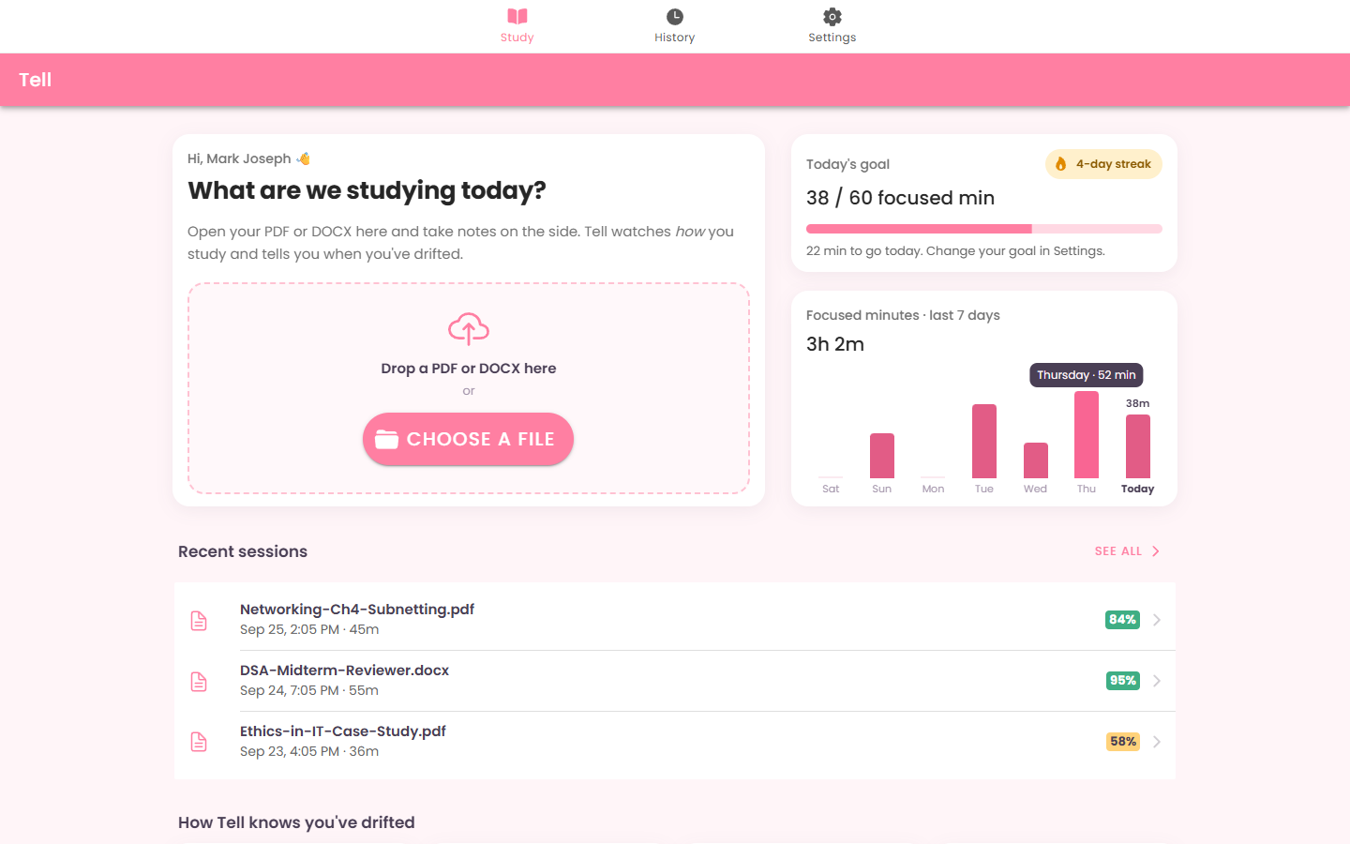
Figure 1. Home: welcome card with drag-and-drop, daily goal with streak, 7-day chart (hovering Thursday), recent sessions
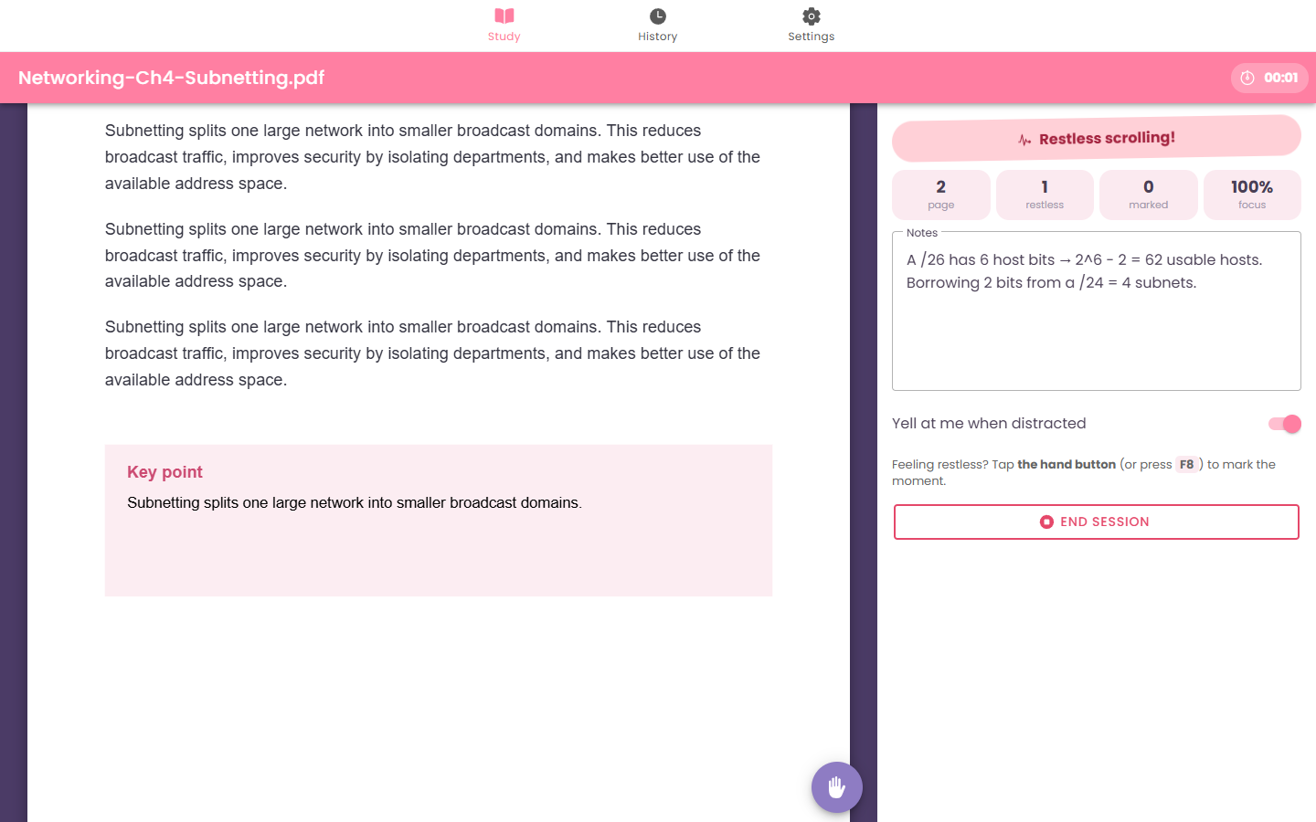
Figure 2. Study session: PDF on the left, live status, stats and notes on the right. Restless scrolling was just detected
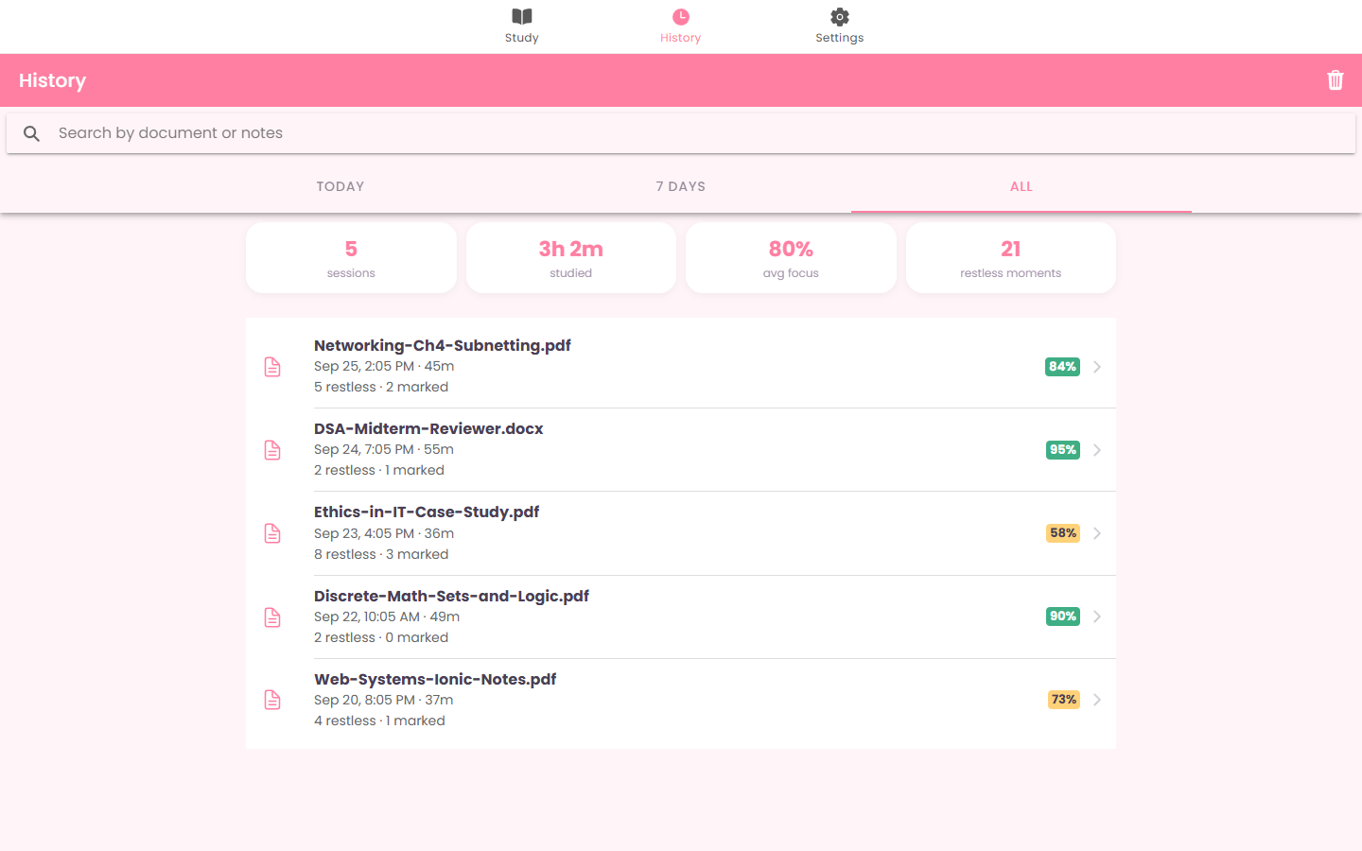
Figure 3. History with search, date filter and totals
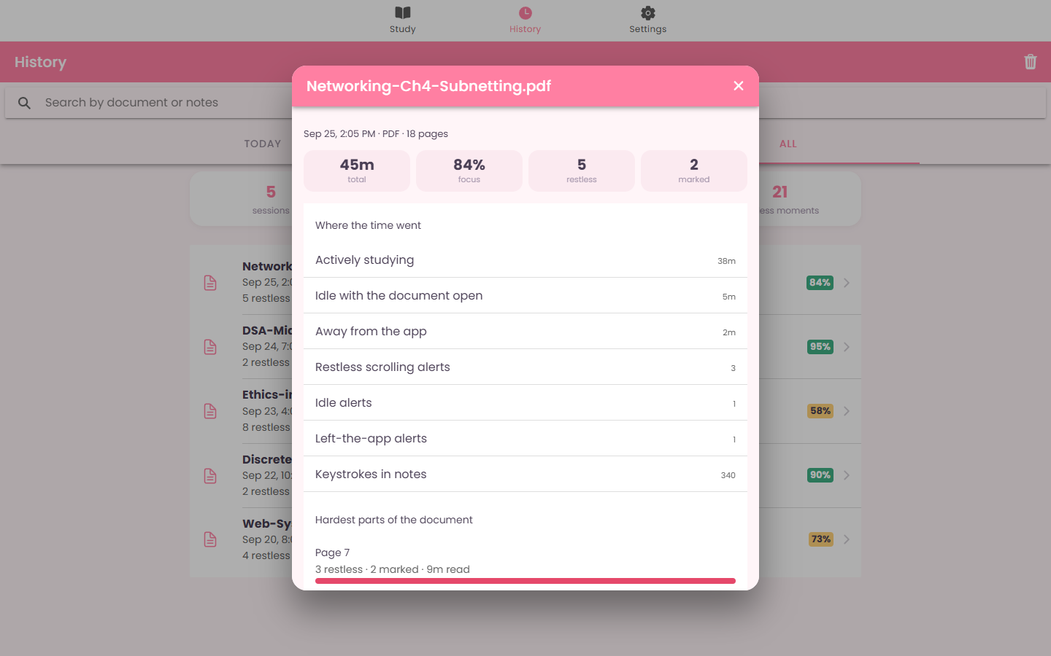
Figure 4. Session details modal: time breakdown and the hardest pages
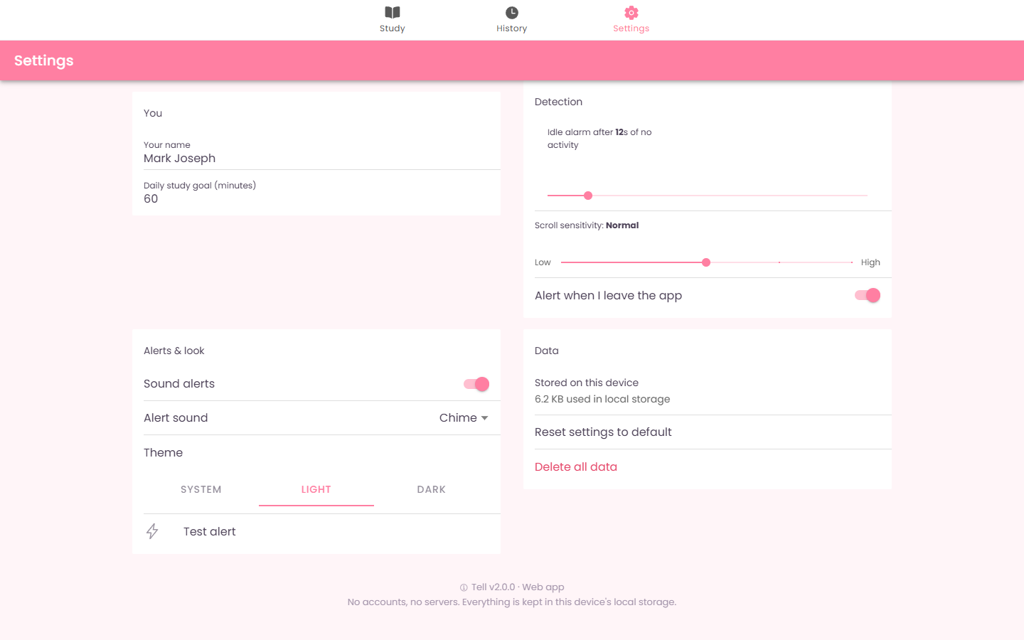
Figure 5. Settings in two columns on a wide screen
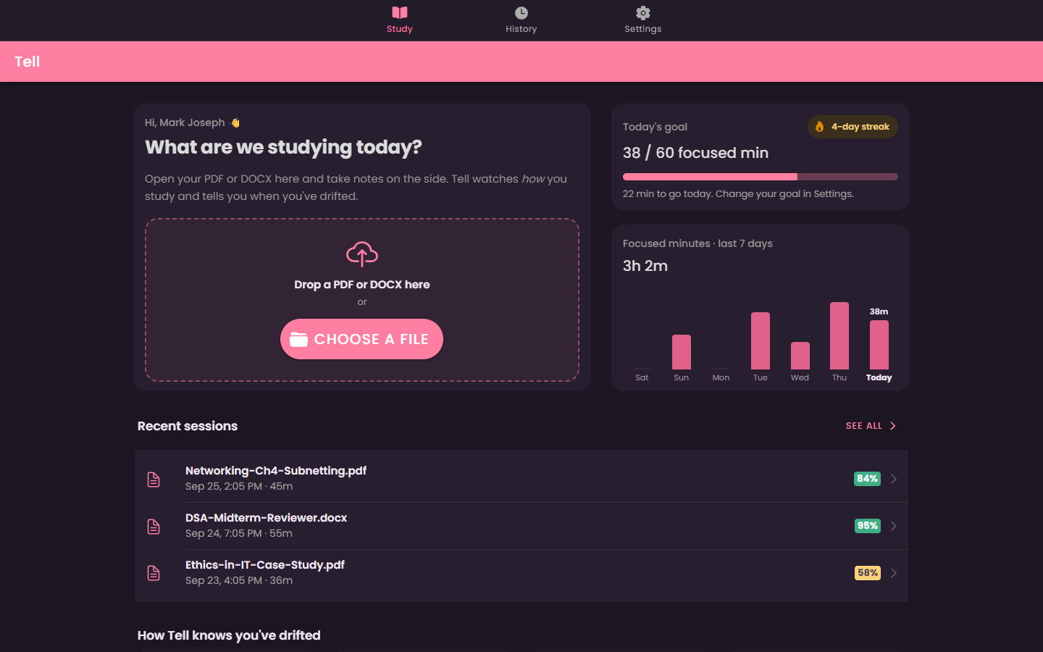
Figure 6. Dark theme

10.2 Tablet (820 × 1180)
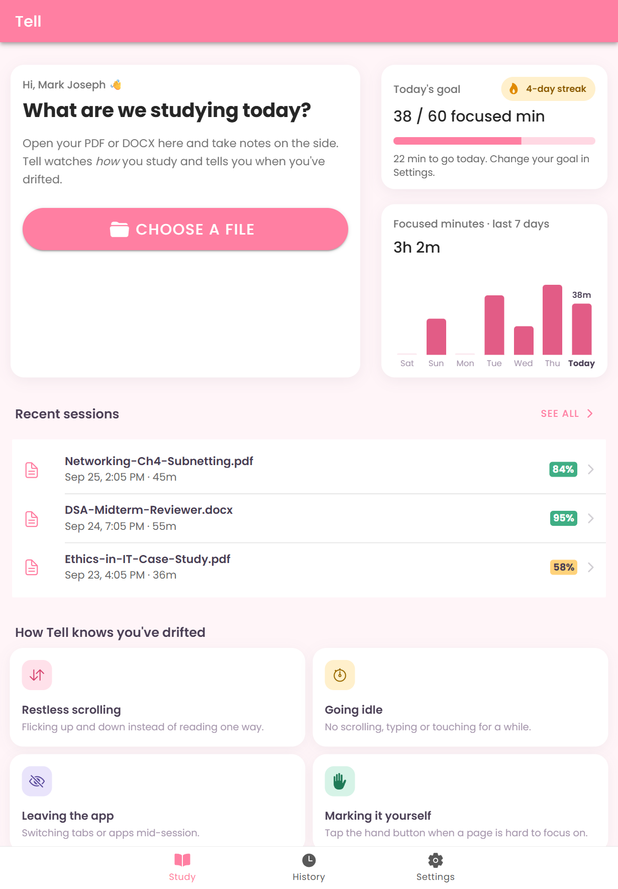  Home | 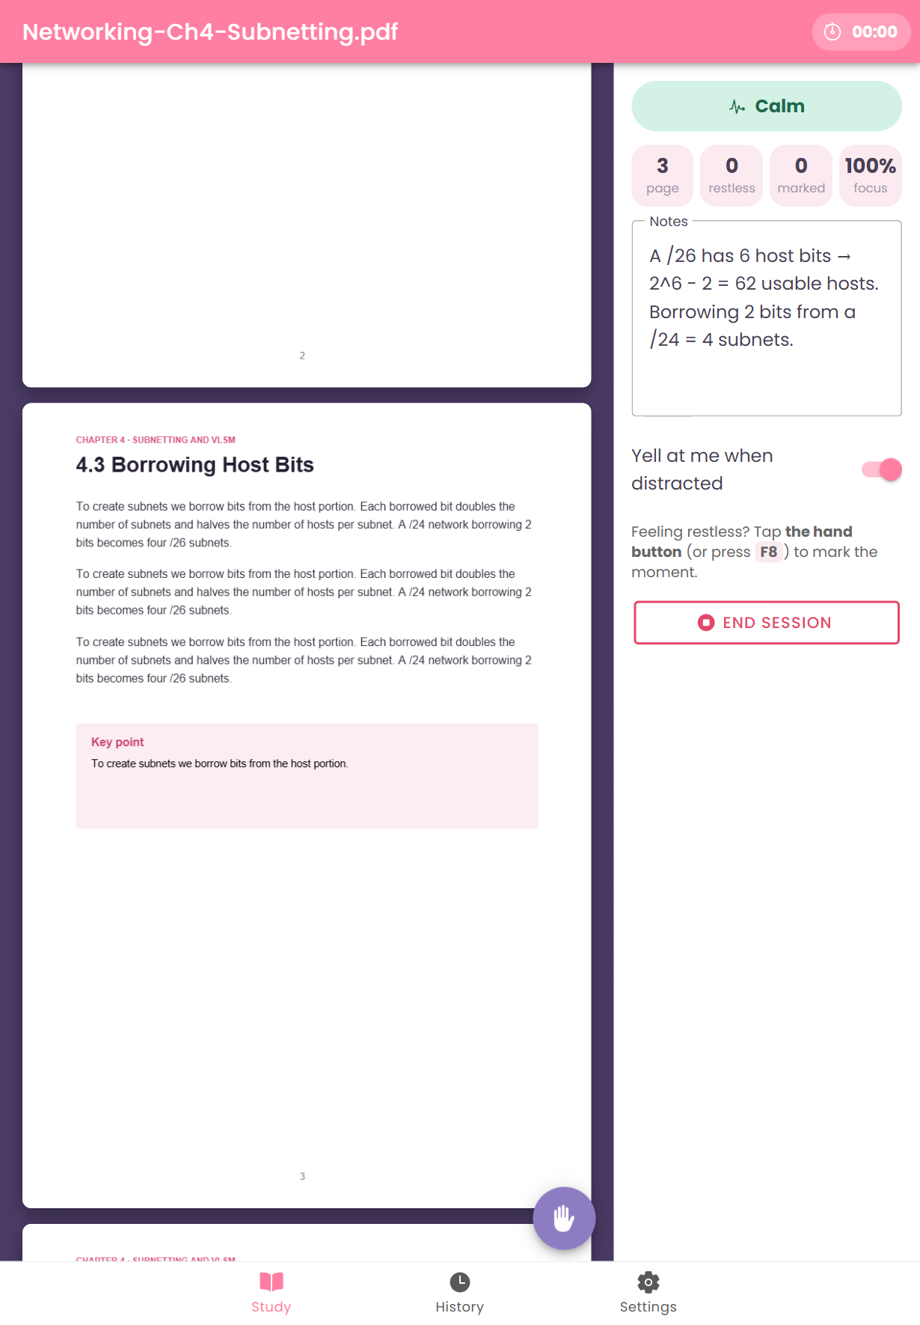  Study session
Figure 7. Tablet: two-column home, document and side panel side by side

10.3 Phone (390 × 844) and phone landscape (844 × 390)
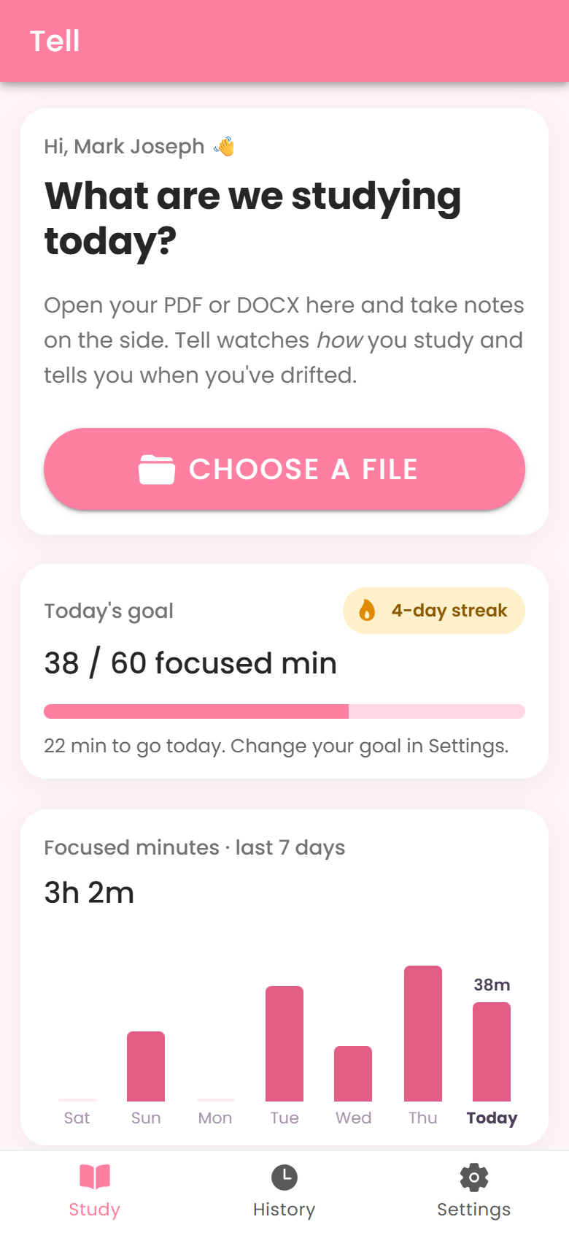  Home | 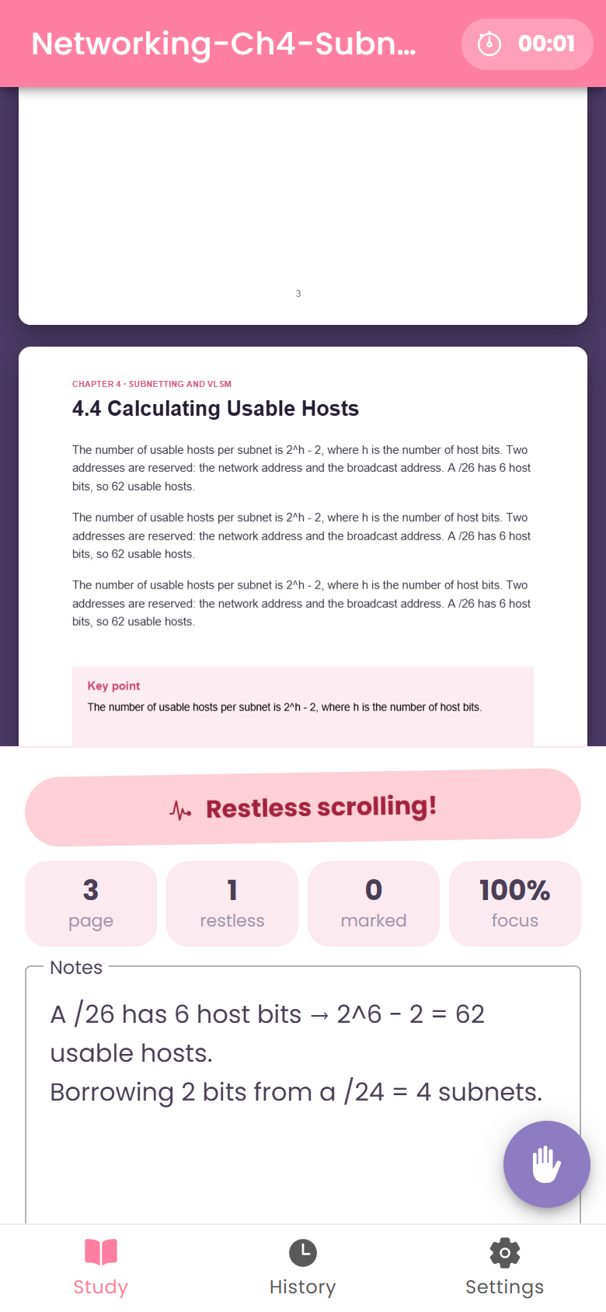  Session (stacked) | 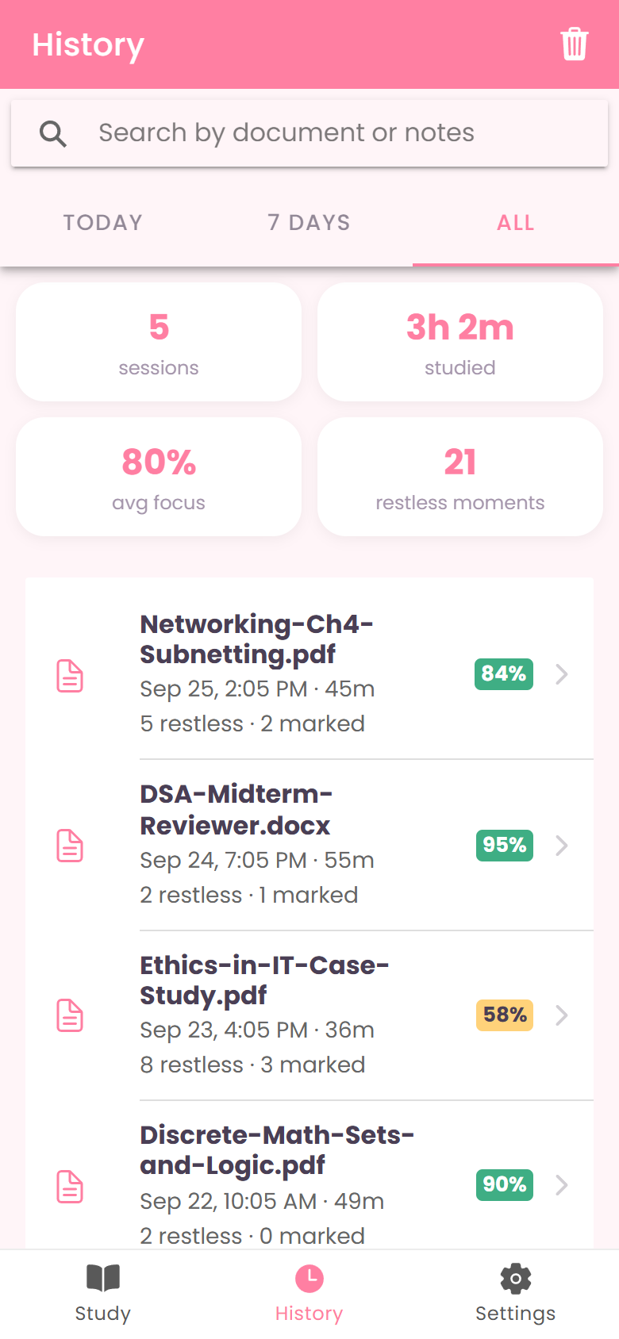  History
Figure 8. Phone portrait: single column, tab bar at the bottom
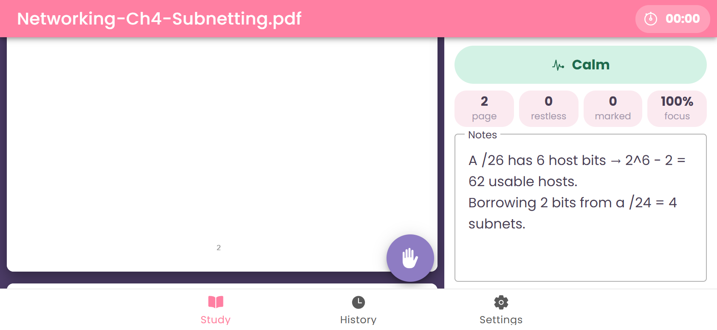
Figure 9. Phone landscape: the session switches to side by side

11. Android Screenshots
Screenshots of the APK built with Cordova, running on the Android Studio emulator (Android 15, 1080 × 2400). Each screen is shown in portrait and landscape.

11.1 Portrait
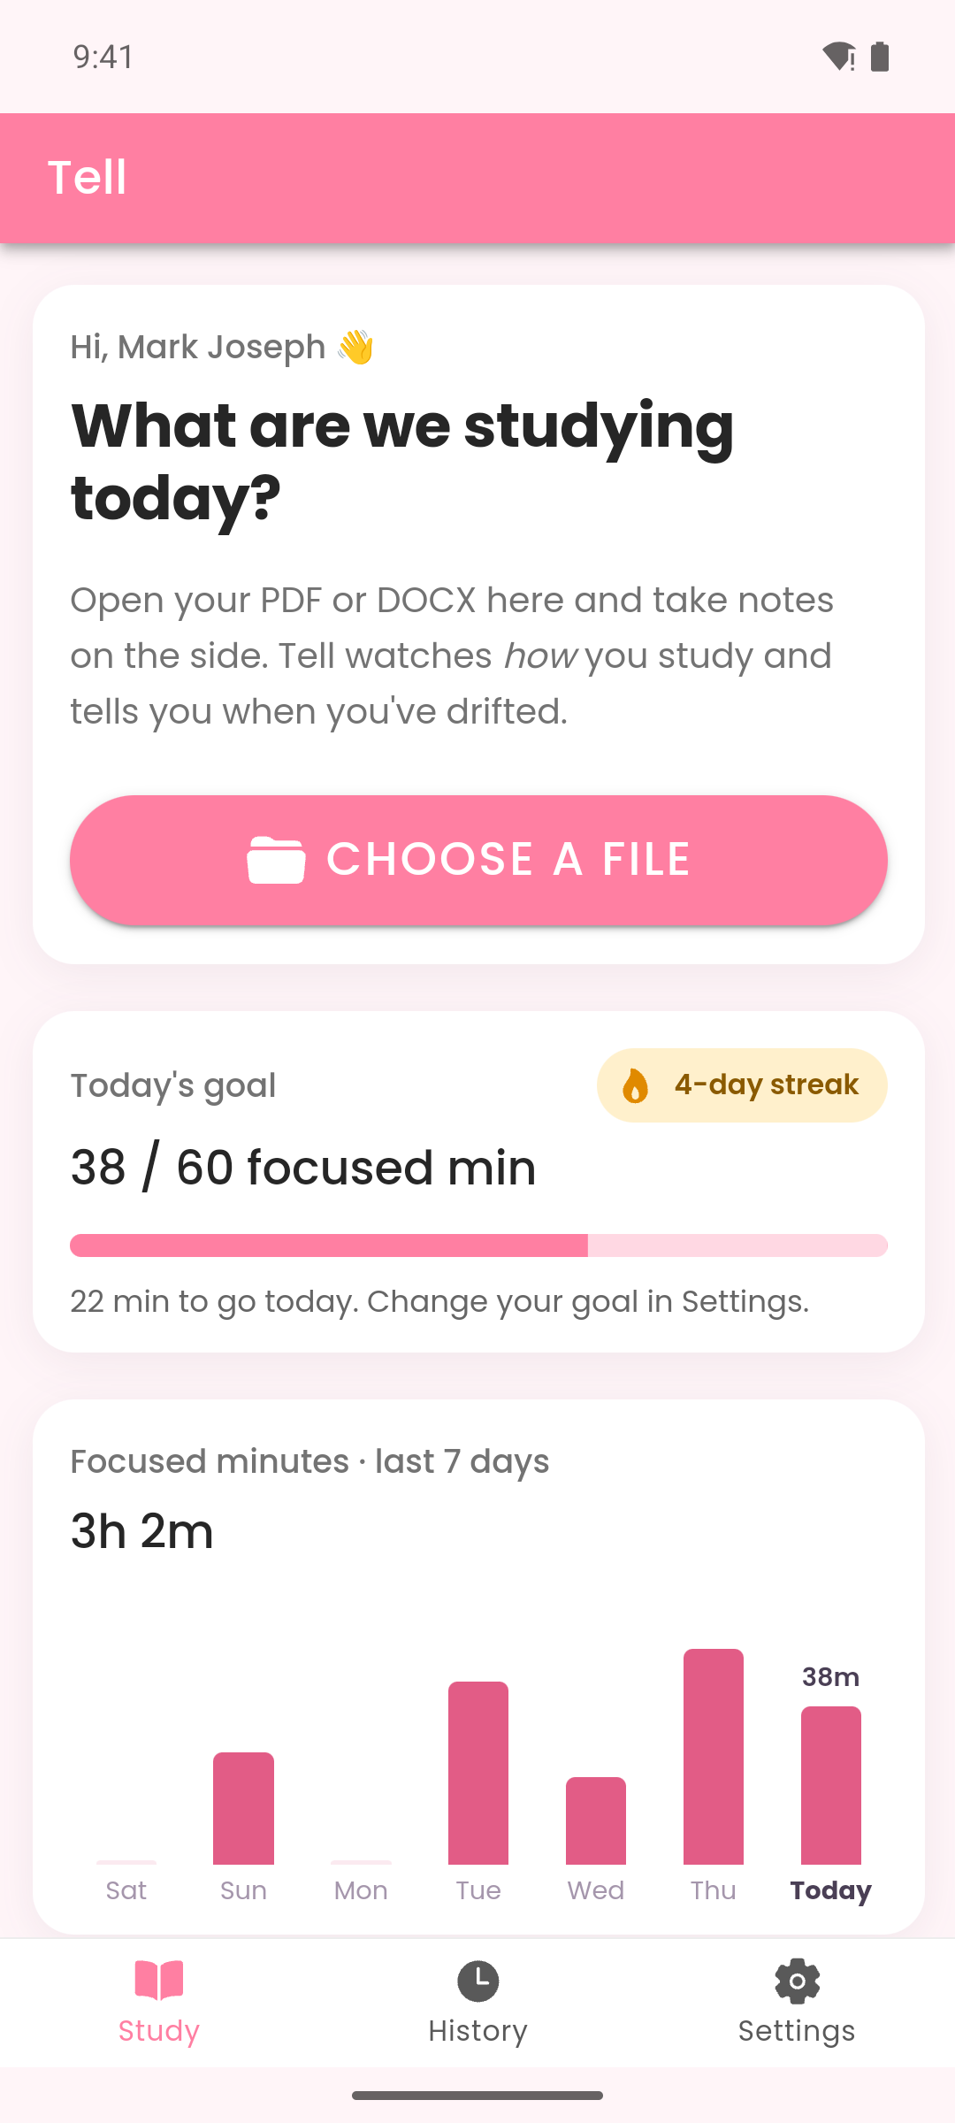  Home | 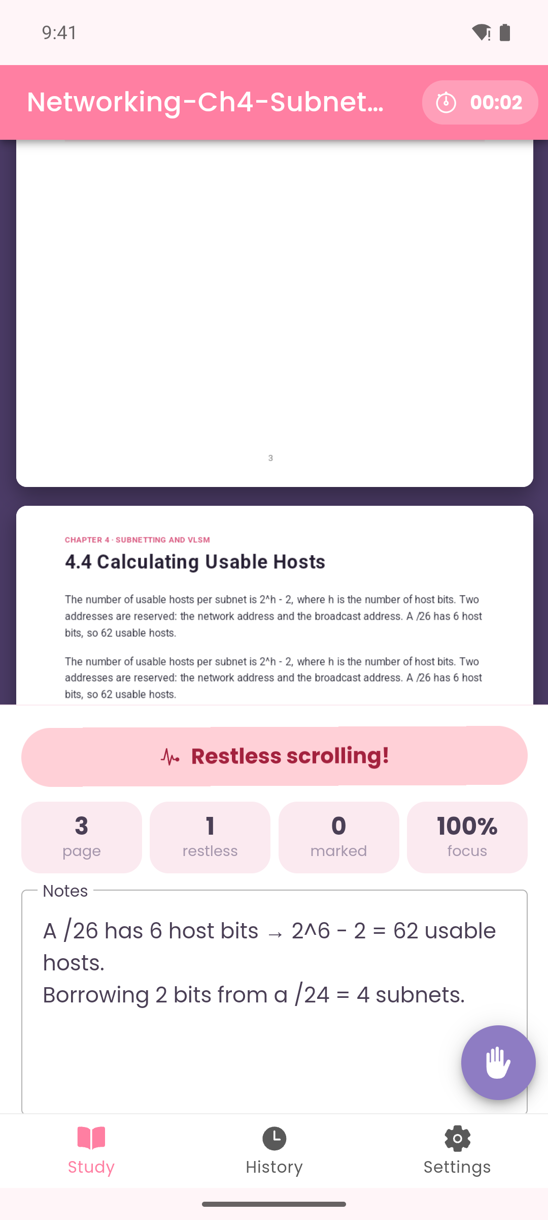  Study session | 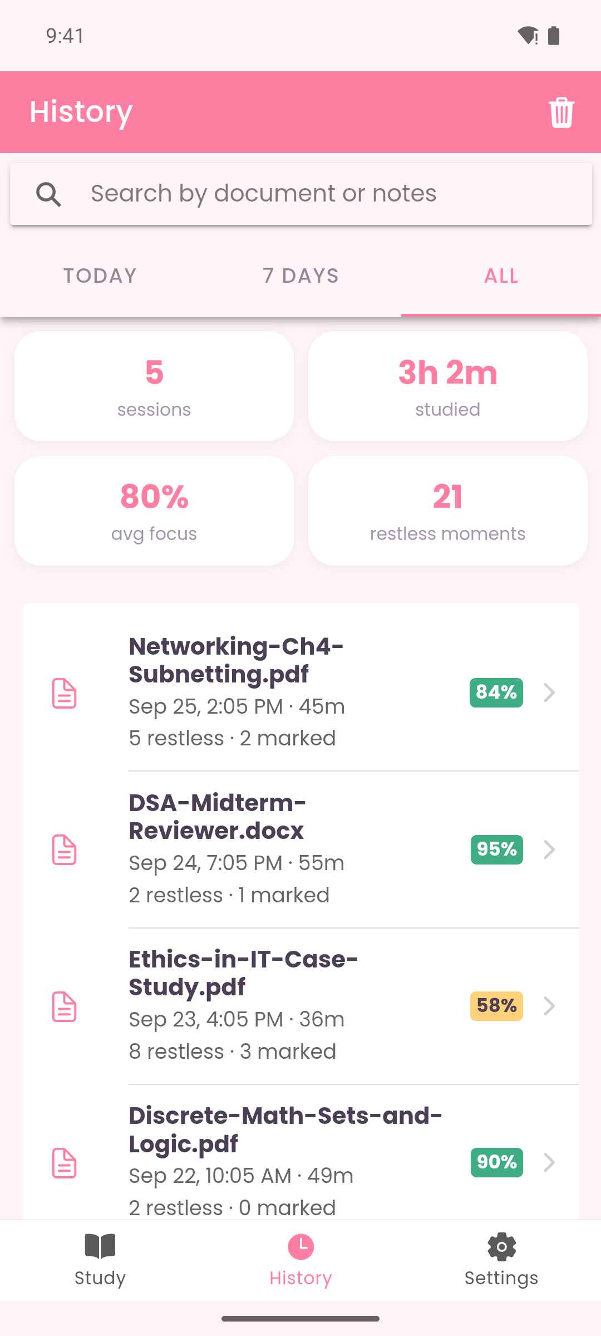  History
Figure 10. Android portrait
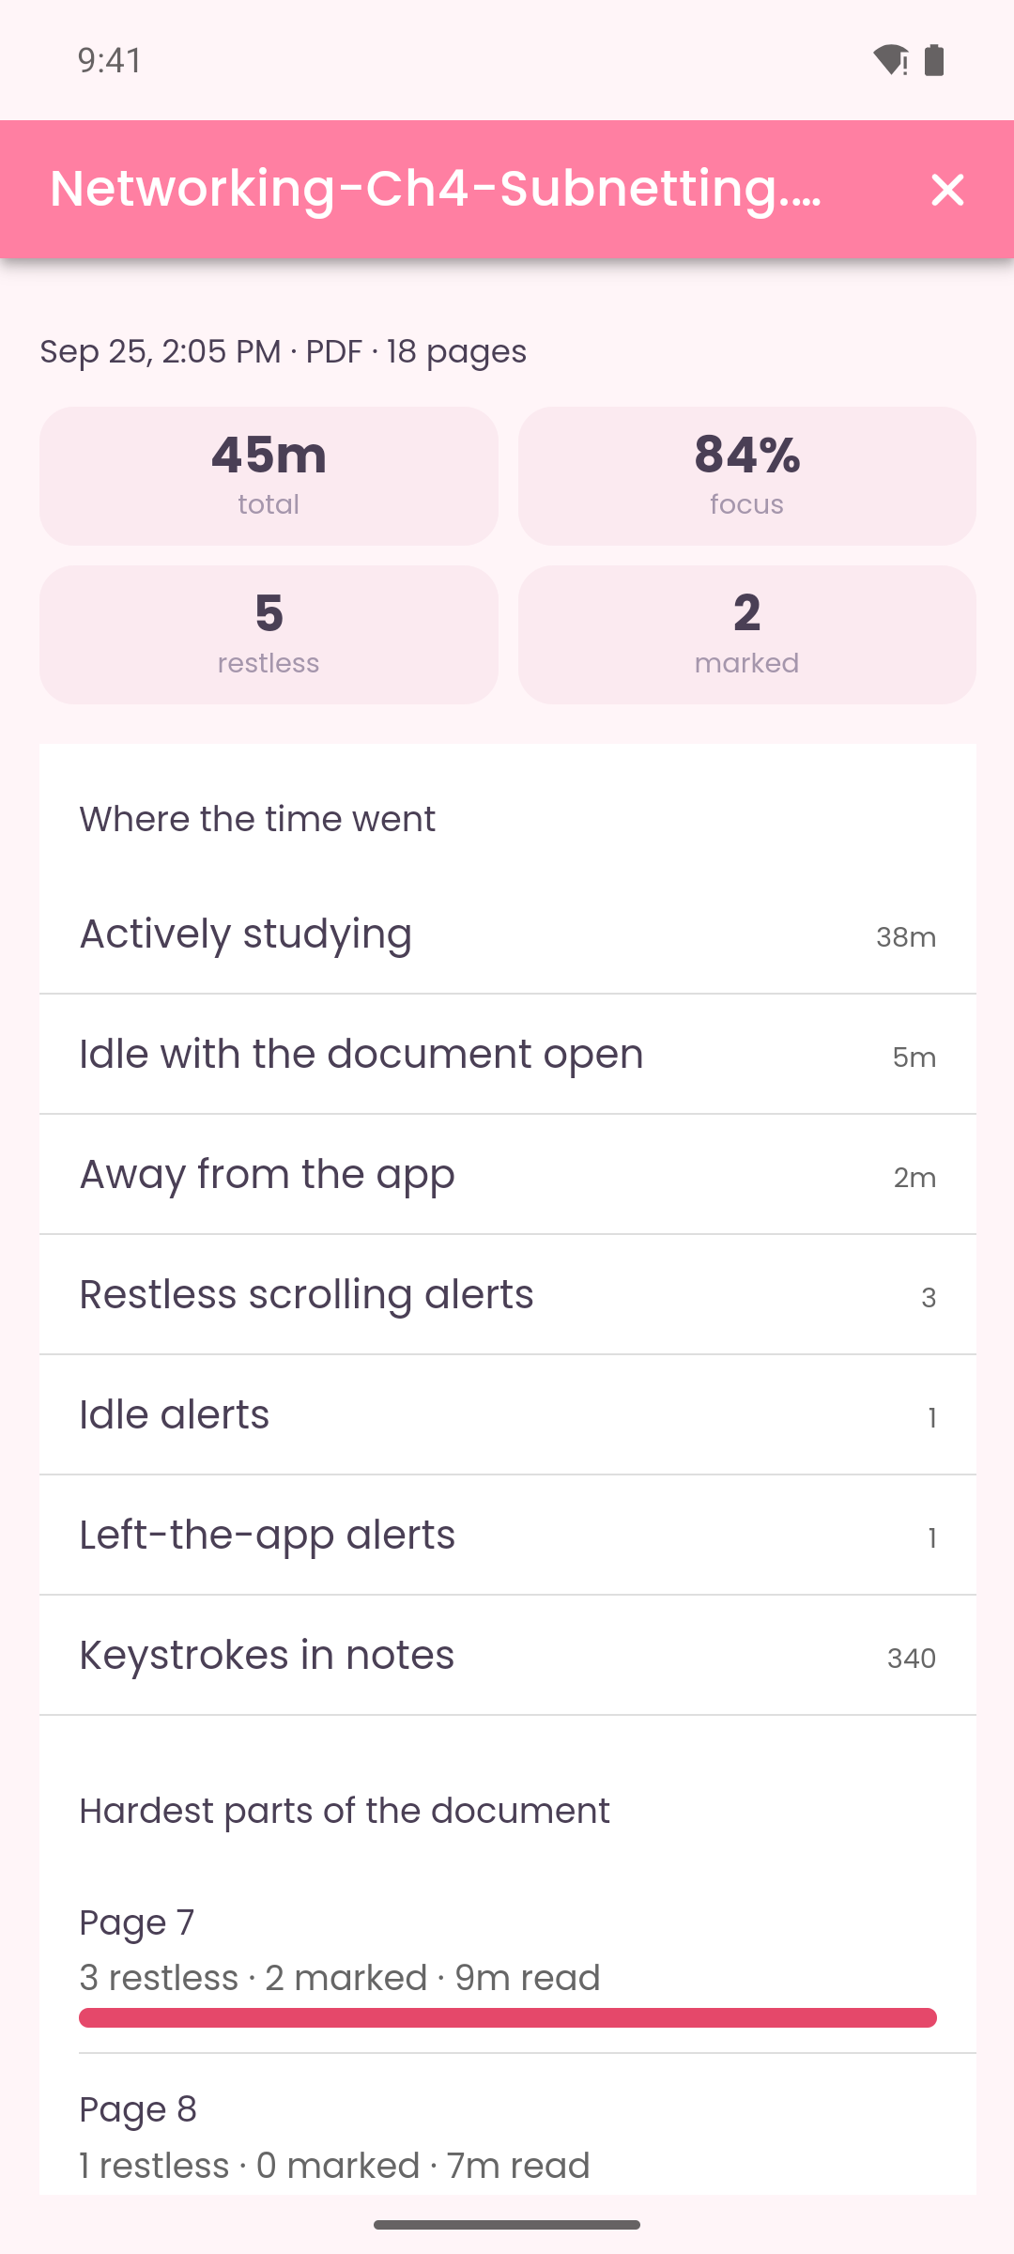  Session details | 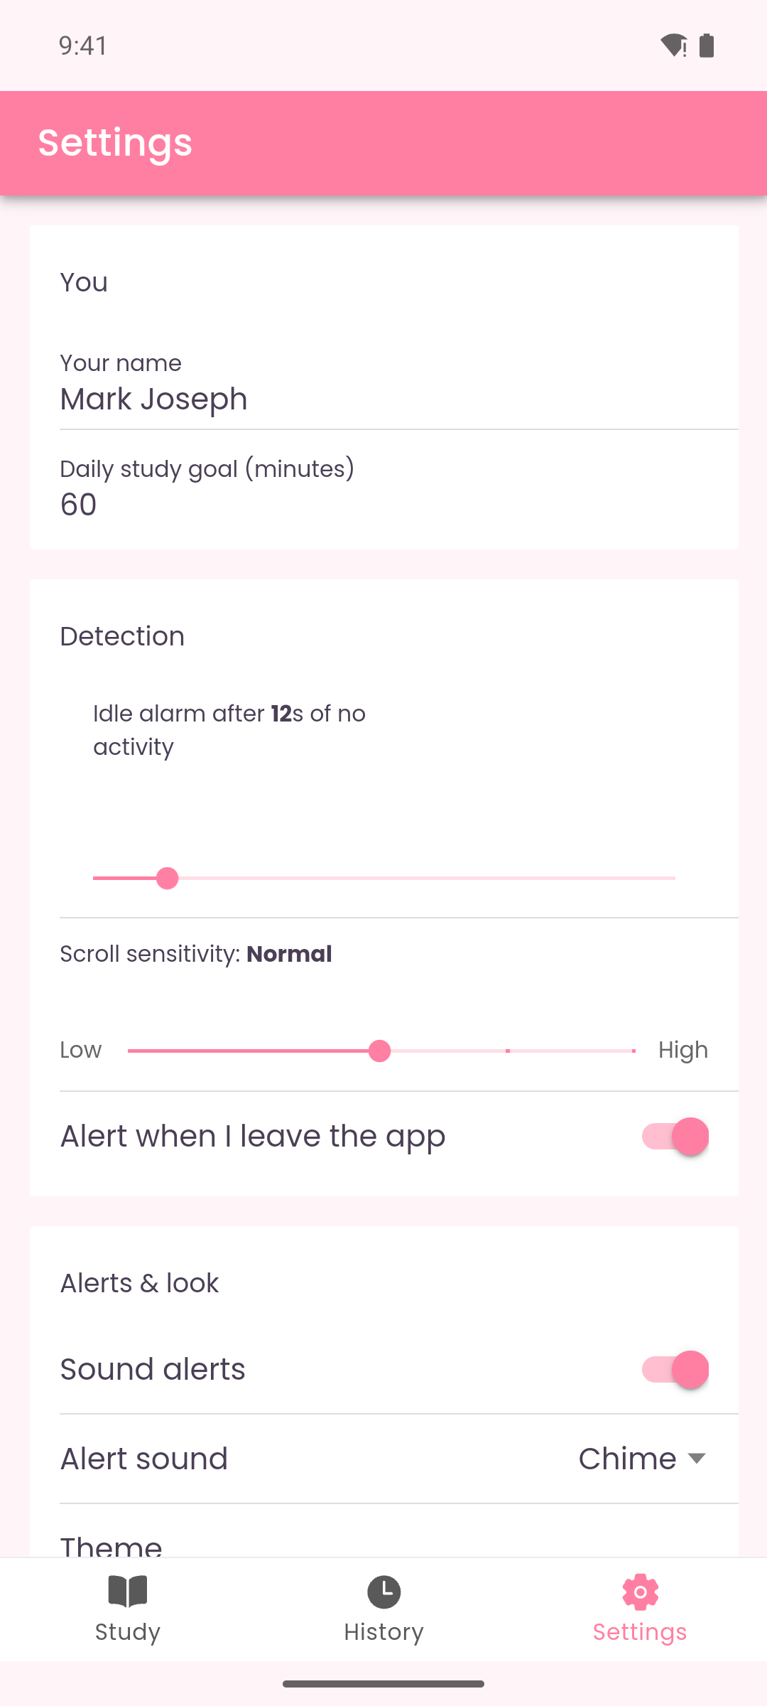  Settings
Figure 11. Android portrait (continued)

11.2 Landscape
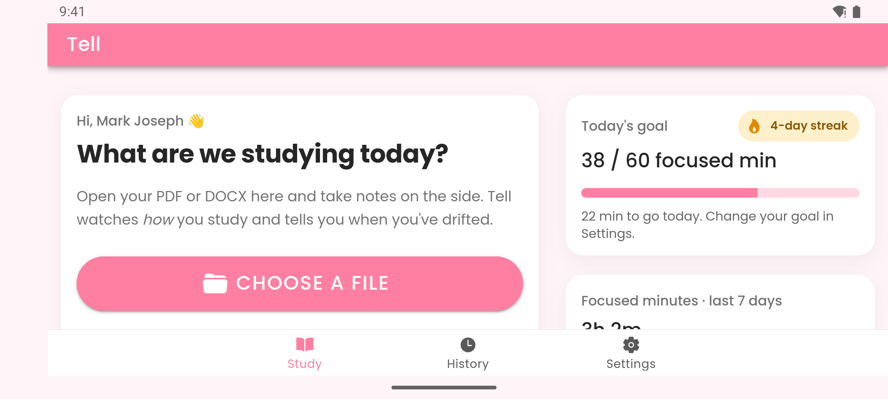
Figure 12. Android landscape: home in two columns
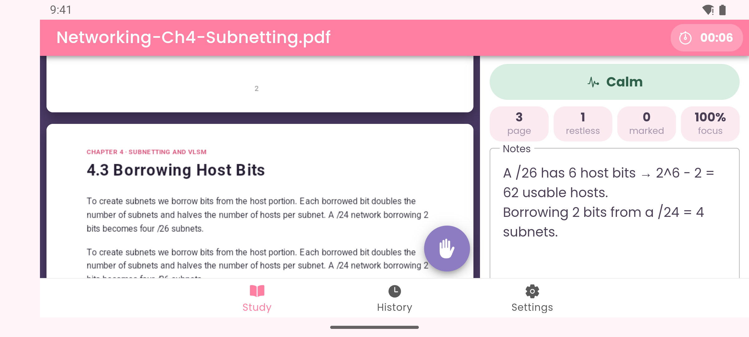
Figure 13. Android landscape: document and side panel side by side
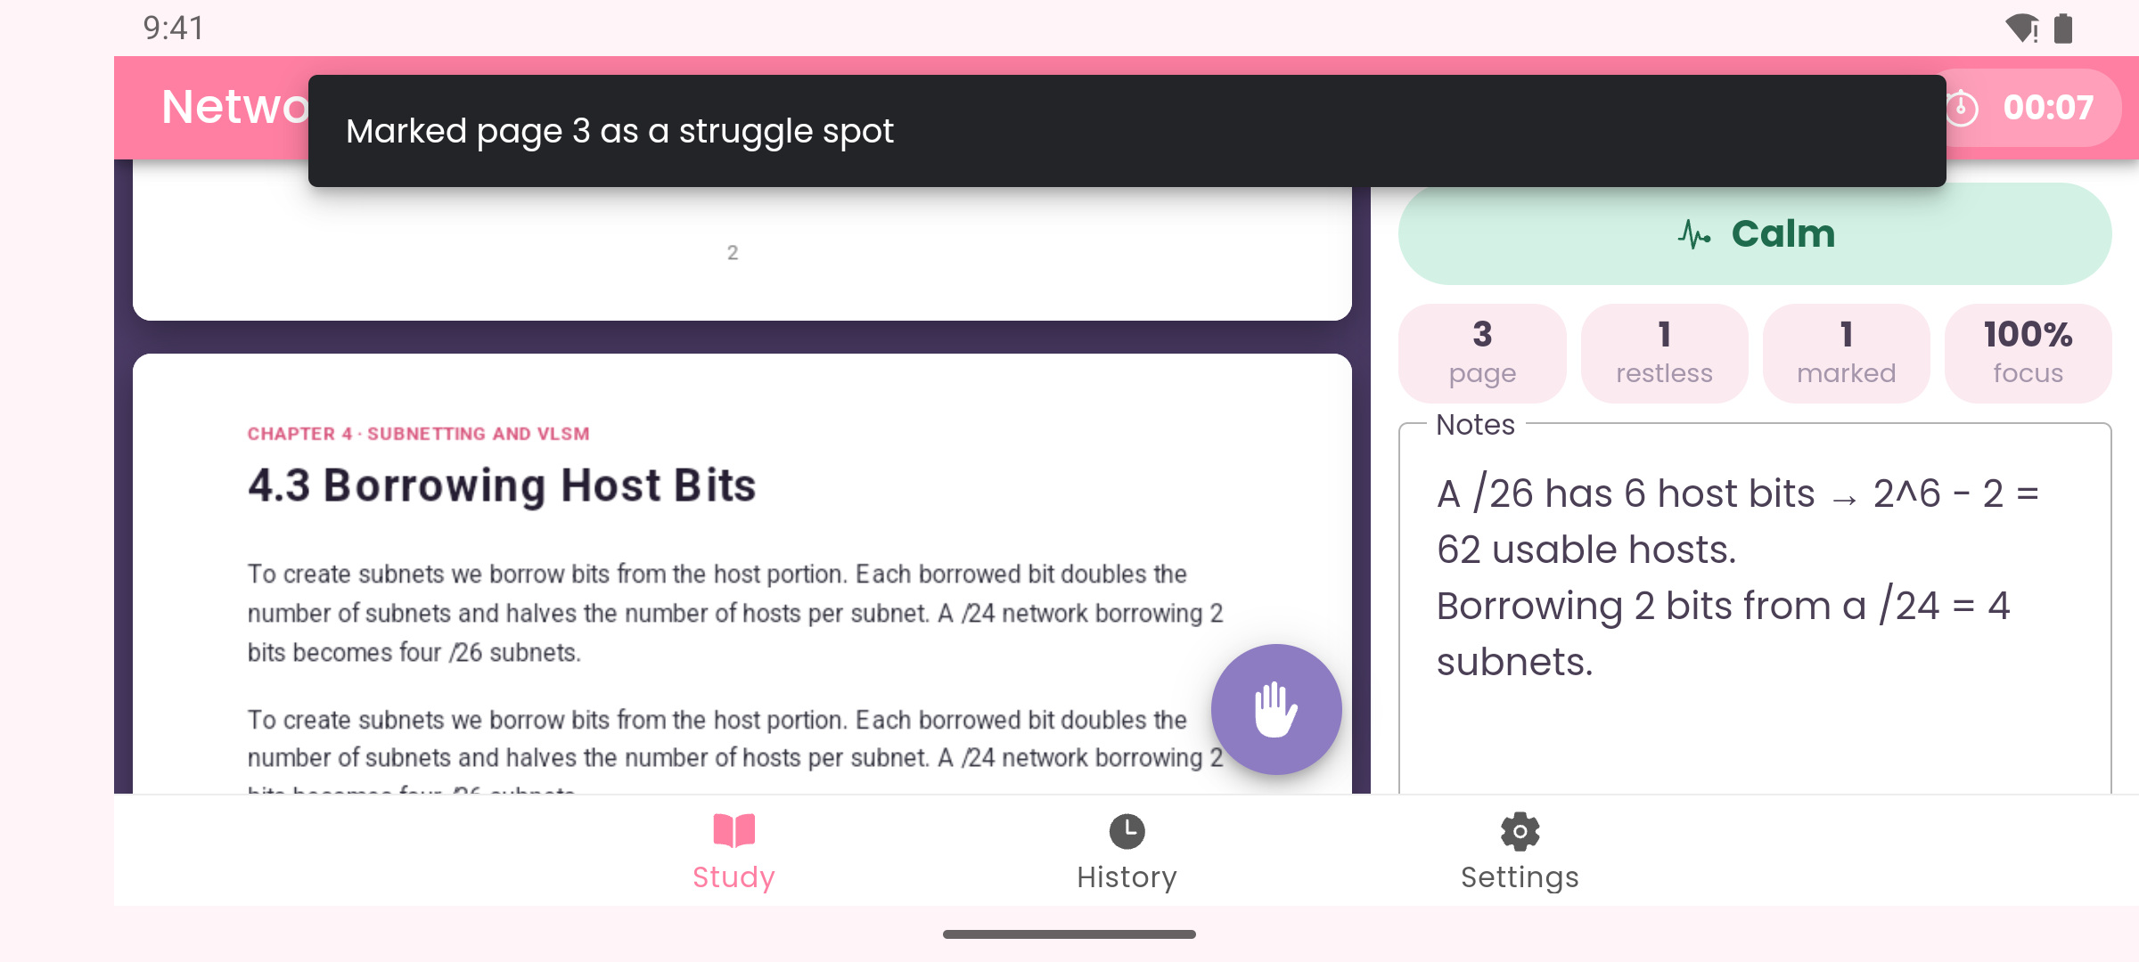
Figure 14. Android landscape: tapping the hand button marks the current page
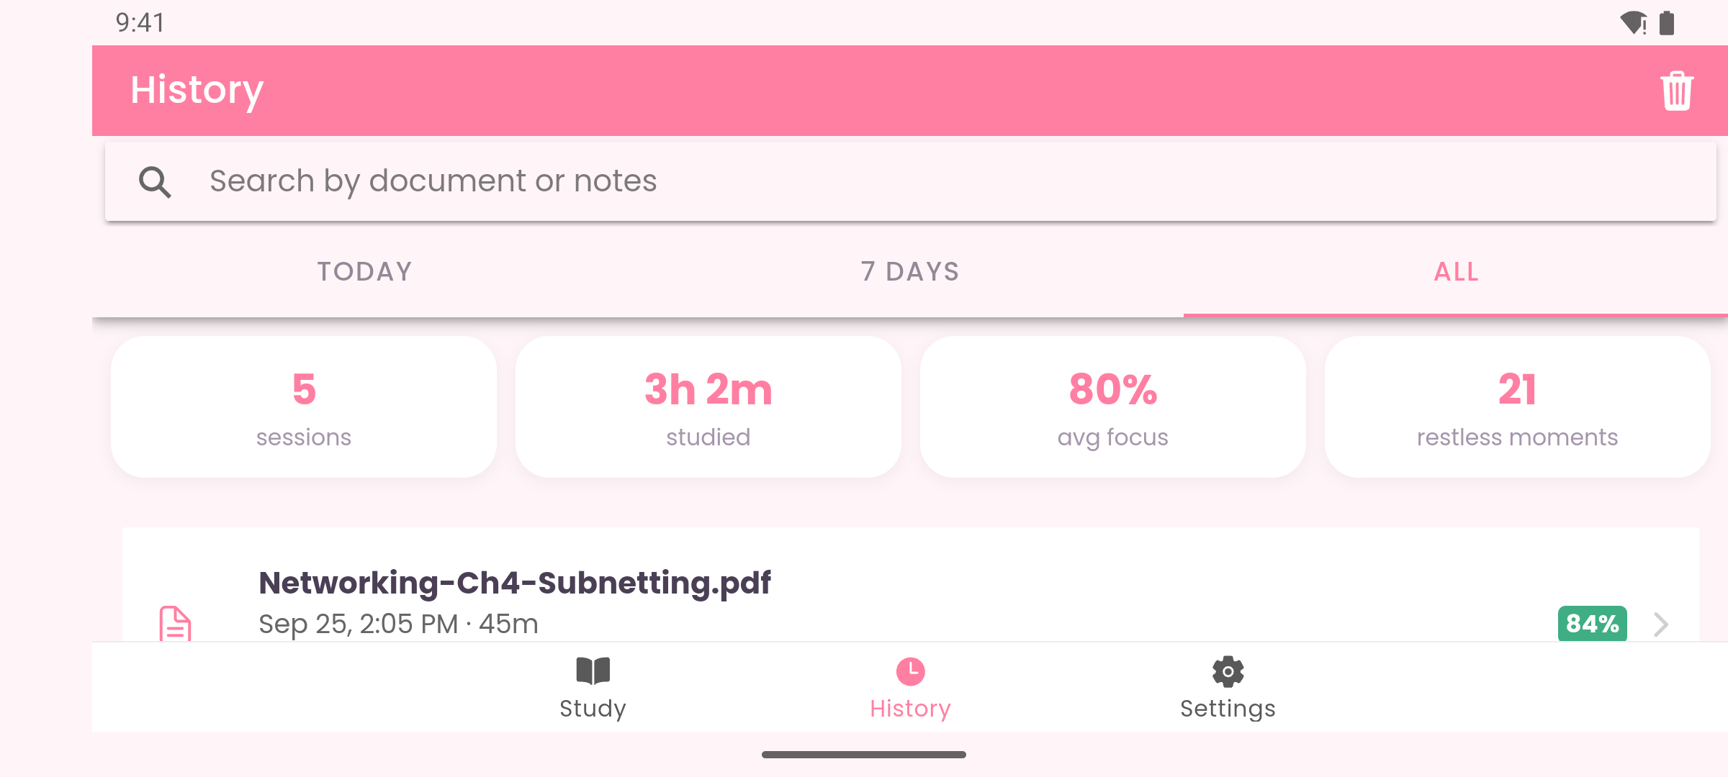
Figure 15. Android landscape: History
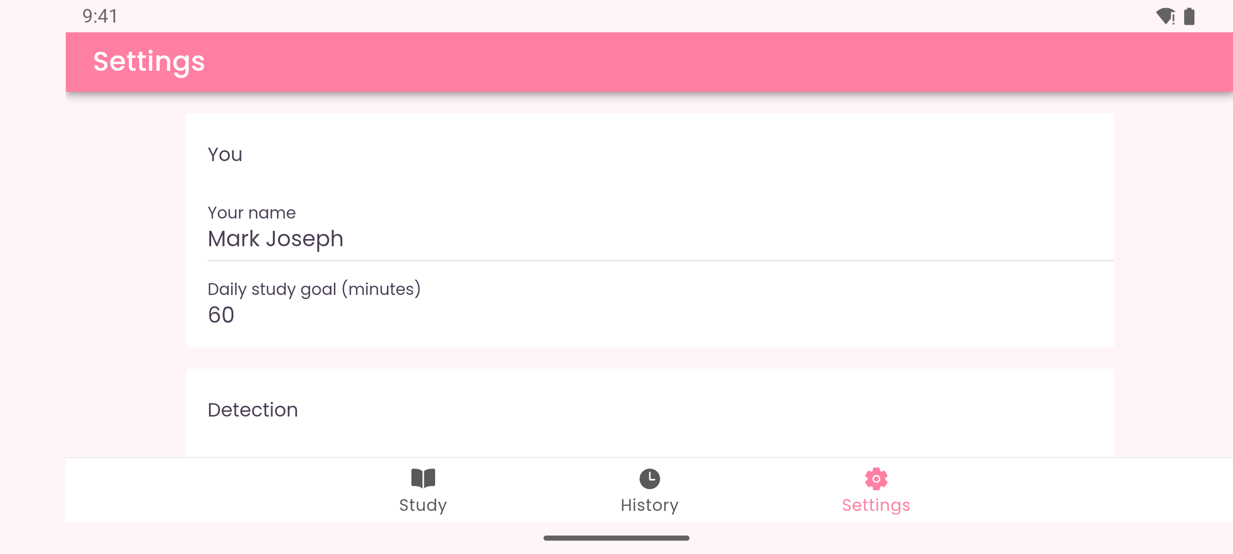
Figure 16. Android landscape: Settings

