**Mathematical model of ‘comparative development of social health in communities’ using Prisoner’s Dilemma**

**KomalGujarathi1**

1 TE COMP, Cummins College Of Engineering, Karve Nagar, Pune -411052, India.

**Abstract:** In this paper we analyze different models of community for their relative development depending upon the interactions among individuals in that community. Few interactions end in mutual benefit of the individuals whereas few end up in disturbance in complete community (or even society). Social health of any community depends upon the cumulative outcomes of these interactions. Paper will study this cumulative value (representing social health) of each society with varying proportions of interacting strategies and provide the quantitative results of the comparative development of social health.

Based on the results obtained from this study, the paper will discuss the results in context of social health of the family, city, state, nation or even a whole world. This paper does not actually deal with ethics or etiquette nor does it aim to compete with philosophers and preachers. Rather it will discuss the results of mathematical modeling of such interactions and study the trend of relative development of social health of communities by applying a Prisoner’s Dilemma.

**Keywords:** Prisoners dilemma, Iterated Prisoners dilemma, Pay off matrix, evolution, society, community, social health.

**Introduction**: Our society contains different groups of individuals called the communities, which varies from family to nation. Individuals from a community interact with the individuals in the same community (intra-community) as well as with the individuals from different communities (inter-community). Social health of any community depends upon the cumulative outcomes of these interactions. Interactions in a society can be thought of like ‘always cooperate with the other individual’, ‘always cheat (Defect) the other individual’, ‘co-operate sometimes and defect sometimes (can be based on complex algorithmic decision making)’etc. This paper creates a virtual society and captures interactions between them. Each individual follows different strategies to arrive at the decision of co-operate (referred as ’C’) v/s defect (referred as ‘D’ in the following text). To study these interactions and their effects over the generations we apply Iterated Prisoners Dilemma (IPD).

**MATERIALS AND METHODS:**

This paper derives its motivation from the competition conducted by a political scientist Robert Axelrod who pioneered research in this field in the late1970’s. Axelrod used the Prisoner's Dilemma to represent his studies. As part of this research Axelrod held a series of computer tournaments in which IPD strategy entries from around the world played games of the IPD against one another in a round robin fashion. This tournament aimed to identify optimal strategies for the Prisoner's Dilemma (there is no *best* strategy; the success of a strategy depends on the other strategies present). The Tit For Tat strategy (TFT) won both computer tournaments conducted by Axelrod indicating that it is an optimal strategy.

We would like to extend the above concept to study the relative development of different community models over multiple generations.

Interactions between the individuals in a community are based upon the classic Prisoner's Dilemma (PD). In a PD two prisoners are questioned separately about a crime they committed. Each may give evidence against the other or may say nothing. If both say nothing, they get a minor reprimand and go free because of lack of evidence. If one gives evidence and the other say nothing, the first goes free and the second is severely punished. If both give evidence, both are severely punished. The overall best strategy is for both to say nothing. However not knowing (or trusting) what the other will do, each prisoner's best strategy is to give evidence, which is the worst possible overall outcome.

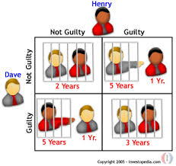

By applying PD to our concept of strategies we use following pay off matrix.

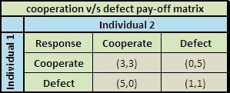

In our simulation of interactions between different strategies, each strategy will have interaction with other strategy and decide to either co-operate or defect. In this interaction both the participant strategies will obtain the points according the above pay off matrix. Each strategy will have its decision making algorithm to arrive at its response. This matrix helps to understand the growth of a particular strategy over the generations.

We restrict our simulation to 3 representative strategies namely ‘Co-operator’ (always co-operates), ‘Defector’ (always defects) and ‘Tit for Tat’ (cooperates first time and further cooperates with cooperator and defects with defector).

We apply the variant of PD known as the Iterated Prisoner's Dilemma (IPD) in which two participating strategies interact iteratively against each other. This removes the obvious advantage for the defectors and represents the real nature of interactions in the society. The length of the IPD (i.e. the number of interactions) must not be known to either player, meaning this information cannot be used by individual strategy to arrive at decision.

To study the relative social development of the modeled communities, each community is provided with some initial points (can be thought as the initial resources). In one generation, each individual in a community interacts with other individual in round robin manner. Each interaction with in the community affects the points of that community as per the model shown below. This model assumes that if both the individuals in an interaction cooperate, then it adds a positive value (say add 3 points from total) to the community where as any defection involved in the interaction adds a negative value to the community (say minus 1 point from total) as complete community has to suffer and pay the cost because of defector in the community.

|  |  |  |
| --- | --- | --- |
| **Points** | **COOPERATE** | **DEFECT** |
| COOPERATE | Points+3 | Points-1 |
| DEFECT | Points-1 | Points-1 |

Considering the above points matrix, we calculate the relative points of each community considering following cases:

**Community consisting of individuals following same strategy**:

We consider the relative points of the communities following a strategy as a whole.

**Note:** X-axis represents the generations and y-axis represents the points earned by the community as a whole.

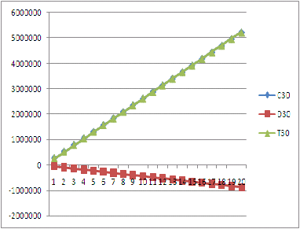

Results clearly depict the different if the community is completely made of cooperators or completely made of the individuals following tit for tat strategy, then the community is really going to prosper (represented by the increase in the points in the above graph) while if the community is made up of defectors only then the collective gain of community go down as a whole.

**Community consisting of individuals following the strategy in a prescribed proportion:**

Consider the relative study of communities consisting of the individuals following the strategies in proportion of 80%-20 % and the community having the individuals in equal proportion.

The graph clearly shows that if the community is made up of the individuals following tit for tat strategy and cooperative strategy, then there is the abrupt increase in the social health of that community from the beginning itself. While if the community is made up of minimum number of individuals following defective nature among the majority of tit for tats, then there is initial declination in the points of the community, but gradually after some time community prospers abruptly. If the community is made up of large mass of cooperators and invasion of defectors into it then it is seen that due to the lenient and altruistic approach shown by the cooperators the defectors in the community get a good chance to rule over the community, thereby affecting the gain of the society as a whole badly. Similarly the invasion of the cooperators in a large group of defectors is not going to be of any benefit to the community at all. Looking at case where the community consists of individuals following the strategies in the equal proportion, the graph shows that initially there is the decrease in the points of the society for few initial generations while after some generations due to the presence of the tit for tats in the society, the gain of the society increases after the critical point.

**CONCLUSIONS:** By studying the above results, we arrived at the following conclusions. There is the good chance for the society to prosper if the community is completely made up of the individuals showing cooperative and faithful attitude towards each other. Community has a good chance to develop even if it has got the prescribed minimum mass of individuals showing the tit for tat kind of nature. Even a critical minimum number of defectors in a community is able to badly affect the social development of the large group of cooperators.

**LIMITATIONS:** In a real society, practically a person in a community may not always follow the same strategy over the time and in every situation. Hence this initial model simulates the idealized communal behavior within the boundaries of isolated three strategies. This simulation can be further made more accurate to represent social behavior.

**STEPS IN SIMULATION:**

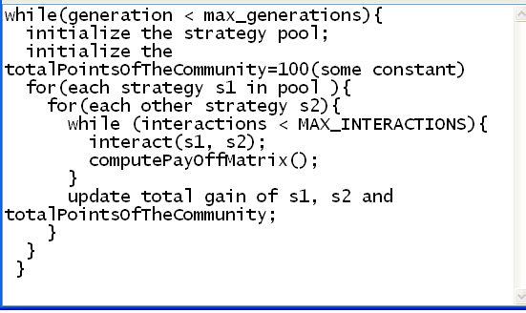

**REFERENCES:**

http://plato.stanford.edu/entries/prisoner-dilemma/

http://en.wikipedia.org/wiki/Prisoner's_dilemma

http://en.wikipedia.org/wiki/Tit_for_tat

Turning point by Fritjof Capra

The evolution of cooperation by Robert Axelrod