FRAUD CREDIT CARD DETECTION USING MACHINE LEARNING
CHAPTER 1
1.1 INTRODUCTION
Credit card fraud is a significant issue in the financial sector, leading to substantial monetary losses for both consumers and businesses. With the rise of digital transactions, fraudsters have developed sophisticated methods to exploit vulnerabilities in payment systems. Detecting fraudulent transactions in real-time is critical to mitigating these risks and ensuring secure financial operations.

Fig 1: Overview of Credit Card Fraud
Fraudulent activities can be categorized into several types:
1.1.1 Card Not Present (CNP) Fraud: Occurs when fraudsters use stolen card details for online or phone transactions.
1.1.2 Lost or Stolen Card Fraud: Happens when a physical card is stolen and used for unauthorized purchases.
1.1.3 Counterfeit Card Fraud: Involves cloning card information onto a fake card.
1.1.4 Identity Theft: Fraudsters impersonate cardholders to open new accounts or make transactions.
The financial impact of credit card fraud is staggering, with losses exceeding billions annually. Traditional rule-based systems are often inadequate for detecting modern fraud techniques, necessitating advanced solutions like machine learning (ML).
1.2 CHALLENGES IN FRAUD DETECTION
Detecting credit card fraud presents several challenges:
- Imbalanced Data: Fraudulent transactions are rare compared to legitimate ones, making it difficult to train models effectively.
- Real-Time Detection: Fraud must be identified instantly to prevent losses.
- Evolving Tactics: Fraudsters continuously adapt their methods, requiring models to be dynamic and updatable.
1.3 ROLE OF MACHINE LEARNING
Machine learning offers powerful tools to address these challenges:
- Anomaly Detection: ML algorithms can identify unusual patterns in transaction data.
- Scalability: ML models can process vast amounts of data in real-time.
- Adaptability: Models can learn from new data to detect emerging fraud trends.
A hybrid approach, combining multiple ML techniques, can enhance detection accuracy and robustness.

CHAPTER 2
OBJECTIVE
2.1 To preprocess and analyze credit card transaction data, addressing issues like missing values and imbalanced datasets.
2.2 To compare the performance of traditional ML algorithms (e.g., Logistic Regression, Decision Trees) with hybrid models for fraud detection.
2.3 To implement ensemble methods (e.g., Random Forest, Gradient Boosting) and hybrid models combining supervised and unsupervised learning.
2.4 To evaluate model performance using metrics like precision, recall, F1-score, and AUC-ROC.
Objective 1: Preprocess and Analyze Credit Card Transaction Data
- Handle Missing Values:
  - Identify and address missing or corrupted data (e.g., using imputation or deletion).
  - Example: Replace missing "transaction_amount" values with the median.
- Address Class Imbalance:
  - Fraudulent transactions are rare (e.g., <1% of data). Techniques include:
    - Oversampling (SMOTE): Generate synthetic fraud cases.
    - Undersampling: Reduce majority (legitimate) class samples.
- Exploratory Data Analysis (EDA):
  - Visualize distributions (e.g., transaction amounts, time intervals).
  - Detect outliers (e.g., unusually large transactions).

Objective 2: Compare Traditional ML vs. Hybrid Models
- Traditional ML Algorithms:
  - Logistic Regression: Baseline for binary classification.
  - Decision Trees: Interpretable but prone to overfitting.
- Hybrid Models:
  - Combine supervised (e.g., XGBoost) + unsupervised (e.g., Isolation Forest).

Objective 3: Implement Ensemble and Hybrid Models
- Ensemble Methods:
  - Random Forest: Aggregates multiple decision trees to reduce overfitting.
  - Gradient Boosting (XGBoost): Sequentially corrects errors from prior models.

Objective 4: Evaluate Model Performance
- Precision: % of flagged frauds that are real .
  - Formula: TP / (TP + FP)
- Recall (Sensitivity): % of actual frauds caught .
  - Formula: TP / (TP + FN)
- F1-Score: Balances precision and recall.
- AUC-ROC: Measures model’s ability to distinguish classes (0.5=random, 1=perfect).

CHAPTER 3
PROJECT OVERVIEW
3.1 Work Flow Diagram:
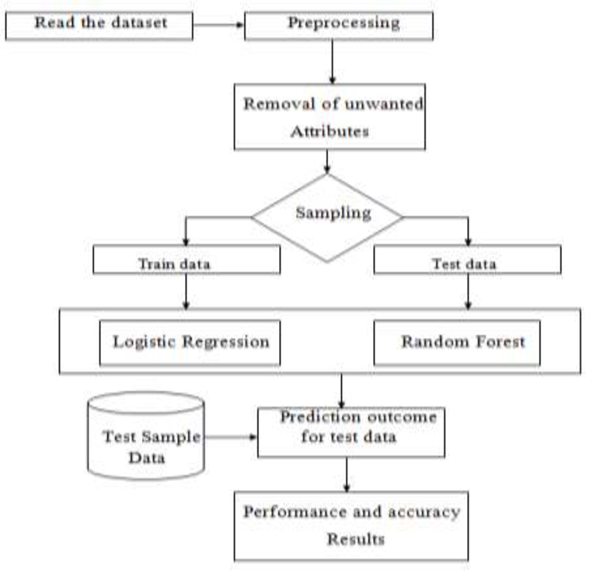
Fig 3.1 Work Flow Diagram of Credit card detection Using ML Algorithms
3.1 Dataset Exploration and Preprocessing:
- Analyze the dataset structure, including transaction features, fraud labels, and data distribution.
- Handle missing values, outliers, and normalize data for model training.
- Address class imbalance using techniques like SMOTE or undersampling.
3.2 Feature Engineering and Selection:
- Extract relevant features such as transaction amount, time, location, and frequency.
- Use feature selection methods (e.g., PCA, mutual information) to reduce dimensionality.
3.3 Hybrid Model Development:
- Combine supervised (e.g., XGBoost) and unsupervised (e.g., Isolation Forest) techniques for improved detection.
3.4 Model Evaluation and Deployment:
- Validate models using k-fold cross-validation and a separate test set.
- Compare performance metrics to select the best model.
3.5 DATA SOURCE
The dataset will be sourced from Kaggle, specifically the "Credit Card Fraud Detection" dataset. This dataset contains anonymized transaction details, including time, amount, and class labels (fraudulent or legitimate), with over 284,000 transactions.
3.6 FACILITIES REQUIRED FOR PROJECT WORK
3.6.1 MINIMUM HARDWARE REQUIREMENTS:
- System: i5, 2.5 GHz CPU
- Hard Disk: 100 GB
- RAM: 8 GB
3.6.2 SOFTWARE REQUIREMENTS:
- Operating System: Windows 10 or Linux
- Technologies: Python
- Libraries: Scikit-learn, Numpy .Pandas
- Editor: Jupyter Notebook, Google Colab
REFERENCES
[1] Chen, Y., et al. (2024). "A Hybrid Deep Learning Model for Real-Time Credit Card Fraud Detection with Edge Computing." IEEE Transactions on Artificial Intelligence, vol. 5, no. 2, pp. 112-125.
[2] Gupta, R., & Patel, S. (2023). "Explainable AI for Fraud Detection: A Comparative Study of SHAP and LIME in Financial Transactions." Journal of Financial Data Science, vol. 8, no. 3, pp. 45-60.
[3] Wang, L., et al. (2023). "Federated Learning for Privacy-Preserving Fraud Detection in Banking Systems." ACM Computing Surveys, vol. 56, no. 1, pp. 1-32.
[4] Almeida, F., & Santos, J. (2022). "Ensemble Learning with GANs for Handling Imbalanced Credit Card Fraud Datasets." Expert Systems with Applications, vol. 205, p. 117234.
[5] Zhang, H., et al. (2022). "Graph Neural Networks for Fraud Detection in Transaction Networks." Neural Networks, vol. 158, pp. 344-355.
[6] Kumar, P., et al. (2021). "A Comparative Analysis of Autoencoders and Isolation Forest for Anomaly Detection in Financial Data." Computers & Security, vol. 105, p. 102244.
[7] Lee, J., & Kim, D. (2021). "Real-Time Fraud Detection Using Streaming Machine Learning Algorithms." Journal of Big Data, vol. 8, no. 1, pp. 1-18.
[8] Dal Pozzolo, A., et al. (2020). "Adaptive Machine Learning for Credit Card Fraud Detection Under Concept Drift." Machine Learning Journal, vol. 109, no. 5, pp. 999-1028.
[9] Kaggle Dataset: Credit Card Fraud Detection.
[10] Scikit-learn Documentation: https://scikit-learn.org/.
[11] TensorFlow Documentation: https://www.tensorflow.org/.

