Name and Surname: Igor Koziński
Index: 203592
Project topic:
Car Dealer
Detailed project description:

The purpose of this project is to design a database for a medium-sized car dealership specializing in new car sales. The system aims to provide a platform to manage the entire sales lifecycle, from arriving in the inventory to final customers order processing.

The database focuses on 3 main areas:
- Product catalog: storing manufacturers, models, specific configurations and available optional features
- Inventory management: storing unique cars identified by their VIN, and their acquisition history
- Sale transactions: registering all orders placed by clients and handled by dealership crew
The database is designed for:
- Client: dealership owner – can use the database to get valuable information about business performance and improve it after analysis
- Users: salespersons – recording orders, tracking their commisons and what order they are assigned to; inventory managers – checking inventory state, tracking sold and newly arrived cars; accountants – tracking transactions
Common scenarios the database might be used in:
- Inventory expansion: An inventory manager records a new batch of unique cars received from a producer, links them to the correct version and options and logs the acquisition date
- Sales orders placement: A salesperson registers a new order placed by a customer. The order links the customer and the salesperson to the specific car being sold with a final price
- Commision tracking: the manager checks in the system the commission rate for each salesperson and pays them based on the commission rate and final price of their orders
Example queries:
- List the name and surname of all salespersons who have sold at least two orders where the final price was higher than the overall average price of all orders
- Identify the name of all options that have been included in orders placed by customers whose budget is greater than $150,000

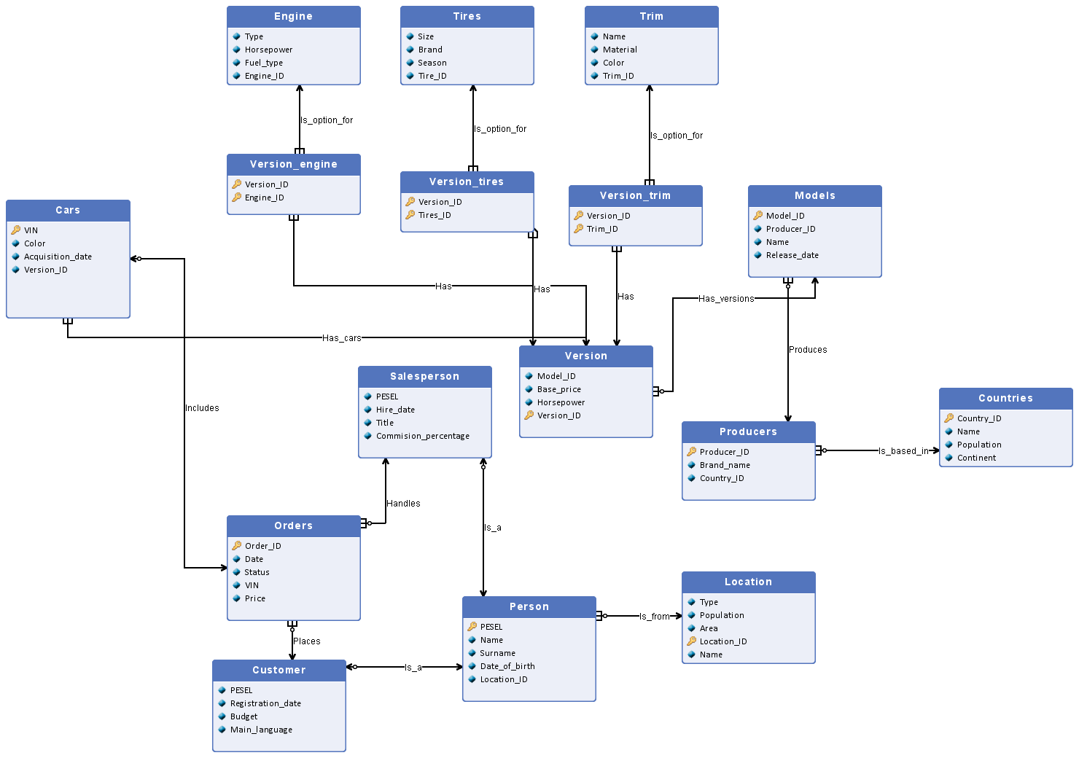
ERD Diagram:
Entity sets descriptions:
1. Entity set: Cars
Category | Details
Description | Represents the set of unique, physical vehicles held in the dealership's inventory. Unlike the abstract "Version," this entity represents the specific metal and rubber object sitting on the lot. It now holds the financial data for the individual vehicle sale.
Primary Key | VIN (Vehicle Identification Number).
Lifecycle | An entry is created when the dealership acquires a physical car from the producer. Records are never deleted to maintain audit history. When sold, the Status changes and it is linked to an Order_ID.
Estimated Size | The dealership will have around 250 cars at a time + historical records.
- VIN
  - Type: Text (Char 17).
  - Domain: Must be exactly 17 alphanumeric characters (standard VIN format).
- Color
  - Type: Text.
  - Domain: Standard color names; max length 30 characters.
- Acquisition_date
  - Type: Date.
  - Domain: Date $\le$ Current Date. Cannot be in the future.
- Status
  - Type: Text.
  - Domain: Value must be one of: {'Available', 'Reserved', 'Sold', 'Maintenance'}.
- Price
  - Type: Float (Currency).
  - Domain: Value $\ge$ 0.00. (Null if not yet sold).
- Order_ID
  - Type: Integer.
  - Domain: Must exist in Orders table or be NULL.
- Version_ID
  - Type: Integer.
  - Domain: Must exist in Version table.

2. Entity set: Version
Category | Details
Description | Represents a specific, fixed configuration of a car model. A Version is a pre-set combination of a Model, Engine, Tire set, and Trim package defined by the manufacturer.
Primary Key | Version_ID (Arbitrary surrogate key).
Lifecycle | Entries are added when a new configuration is introduced by the manufacturer. They are never deleted, even if no cars of this version are currently in stock.
Estimated Size | Approximately 500-600 active versions + historical records.
- Version_ID
  - Type: Integer.
  - Domain: Integer > 0, unique.
- Base_price
  - Type: Float (Currency).
  - Domain: Value > 0.00. (MSRP).
- Horsepower
  - Type: Integer.
  - Domain: Integer > 0 (Cached value from Engine).
- Model_ID
  - Type: Integer.
  - Domain: Must exist in Models table.
- Engine_ID
  - Type: Integer.
  - Domain: Must exist in Engine table.
- Tires_ID
  - Type: Integer.
  - Domain: Must exist in Tires table.
- Trim_ID
  - Type: Integer.
  - Domain: Must exist in Trim table.

3. Entity set: Models
Category | Details
Description | Represents specific lines of cars from a producer (e.g., Focus, Camry, Passat). Defines the marketing identity and production generation of the vehicle.
Primary Key | Model_ID (Arbitrary surrogate key).
Lifecycle | Entries are added when a model line is introduced to the market. Never deleted to maintain sales history.
Estimated Size | Around 100 distinct models.
- Model_ID
  - Type: Integer.
  - Domain: Integer > 0, unique.
- Producer_ID
  - Type: Integer.
  - Domain: Must exist in Producers table.
- Name
  - Type: Text.
  - Domain: Text, max length 50.
- Release_date
  - Type: Integer (Year).
  - Domain: 1900 $\le$ Year $\le$ Current Year + 1.

4. Entity set: Producers
Category | Details
Description | Represents car manufacturers (e.g., Ford, Toyota, Volkswagen). Stores brand information and the country of origin.
Primary Key | Producer_ID (Arbitrary surrogate key).
Lifecycle | Entries are added when the dealership signs a contract with a new manufacturer. Rarely deleted.
Estimated Size | Around 20 entries.
- Producer_ID
  - Type: Integer.
  - Domain: Integer > 0, unique.
- Brand_name
  - Type: Text.
  - Domain: Text, max length 50.
- Origin_country
  - Type: Text.
  - Domain: Standard Country Name (ISO 3166 standards).

5. Entity set: Engine
Category | Details
Description | Represents the catalog of available engine configurations that can be installed in car versions.
Primary Key | Engine_ID (Arbitrary surrogate key).
Lifecycle | Entries are added when a new engine type is introduced by a manufacturer. Never deleted to maintain history.
Estimated Size | Around 50 entries.
- Engine_ID
  - Type: Integer.
  - Domain: Integer > 0, unique.
- Type
  - Type: Text.
  - Domain: Text (e.g., V6, Inline-4), max length 20.
- Horsepower
  - Type: Integer.
  - Domain: Integer > 0.
- Fuel_type
  - Type: Text.
  - Domain: Value must be one of: {'Petrol', 'Diesel', 'Electric', 'Hybrid'}.

6. Entity set: Tires
Category | Details
Description | Represents the catalog of tire specifications available for vehicles.
Primary Key | Tire_ID (Arbitrary surrogate key).
Lifecycle | Entries are added when a new tire model or size becomes available for a version configuration. Never deleted.
Estimated Size | Around 100 entries.
- Tire_ID
  - Type: Integer.
  - Domain: Integer > 0, unique.
- Size
  - Type: Integer.
  - Domain: Integer between 13 and 24 (Inches).
- Brand
  - Type: Text.
  - Domain: Text (e.g., 'Michelin', 'Pirelli').
- Season
  - Type: Text.
  - Domain: Value must be one of: {'Summer', 'Winter', 'All-Season', 'Slick'}.

7. Entity set: Trim
Category | Details
Description | Set of interior and exterior trim packages defining the aesthetic finish and materials of the car.
Primary Key | Trim_ID (Arbitrary surrogate key).
Lifecycle | Entries are added when a new trim package is designed by the manufacturer. Never deleted.
Estimated Size | Around 80 entries.
- Trim_ID
  - Type: Integer.
  - Domain: Integer > 0, unique.
- Name
  - Type: Text.
  - Domain: Text (e.g., 'Luxury', 'Sport').
- Material
  - Type: Text.
  - Domain: Value must be one of: {'Leather', 'Cloth', 'Alcantara', 'Vinyl', 'Mixed'}.
- Color
  - Type: Text.
  - Domain: Standard color names.

8. Entity set: Orders
Category | Details
Description | Represents a transaction log of sales. An order groups the sale of one or more vehicles to a single customer by a single salesperson.
Primary Key | Order_ID (Arbitrary surrogate key).
Lifecycle | An entry is created when a customer initiates a purchase. Status is updated as the paperwork processes (e.g., Pending -> Completed).
Estimated Size | Grows indefinitely with business operations.
- Order_ID
  - Type: Integer.
  - Domain: Integer > 0, unique.
- Date
  - Type: Date.
  - Domain: Date $\le$ Current Date.
- Status
  - Type: Text.
  - Domain: Value must be one of: {'Pending', 'Completed', 'Cancelled', 'Audited'}.
- Budget
  - Type: Float.
  - Domain: Value > 0.00.

9. Entity set: Person
Category | Details
Description | The parent entity for all individuals (Customers and Salespersons). Stores shared demographic data to avoid redundancy and normalize location data.
Primary Key | PESEL. (Polish National Identification Number).
Lifecycle | Added upon the first interaction (hiring or customer inquiry). Never deleted.
Estimated Size | Around 8,000 - 9,000 entries (includes past customers and former staff).
- PESEL
  - Type: Text (Char 11).
  - Domain: String of exactly 11 digits. Must pass standard checksum validation.
- Name
  - Type: Text.
  - Domain: Alphabetic characters only, First letter capitalized.
- Surname
  - Type: Text.
  - Domain: Alphabetic characters only.
- Date_of_birth
  - Type: Date.
  - Domain: Must result in Age $\ge$ 18.
- Location_ID
  - Type: Integer.
  - Domain: Must exist in Location table.

10. Entity set: Salesperson (Inherits Person)
Category | Details
Description | Represents dealership employees responsible for sales transactions. Inherits personal data from the Person entity.
Primary Key | PESEL (Inherited from Person).
Lifecycle | Entry is created when a person is hired. Status/Title may change, but the record remains for historical commission tracking.
Estimated Size | Around 20 active employees.
- PESEL
  - Type: Text (Char 11).
  - Domain: Must exist in Person table.
- Hire_date
  - Type: Date.
  - Domain: Date $\le$ Current Date.
- Title
  - Type: Text.
  - Domain: Value must be one of: {'Junior', 'Senior', 'Manager'}.
- Commision_percentage
  - Type: Float.
  - Domain: Value between 0.00 and 100.00.

11. Entity set: Customer (Inherits Person)
Category | Details
Description | Represents clients who have purchased a car or are interested in buying one. Inherits personal data from the Person entity.
Primary Key | PESEL (Inherited from Person).
Lifecycle | Entry is created when a person places an order or registers an inquiry. Never deleted.
Estimated Size | Around 8,000 entries.
- PESEL
  - Type: Text (Char 11).
  - Domain: Must exist in Person table.
- Registration_date
  - Type: Date.
  - Domain: Date $\le$ Current Date.
- Main_language
  - Type: Text.
  - Domain: ISO 639-1 Code or full name (e.g., 'PL', 'EN').

12. Entity set: Location
Category | Details
Description | Represents specific branches of the dealership network located in different cities. This allows tracking where staff work and where customers are locally served.
Primary Key | Location_ID (Arbitrary surrogate key).
Lifecycle | Entries are added when a new dealership branch is opened. Rarely deleted.
Estimated Size | Small number (e.g., 5-10 branches).
- Location_ID
  - Type: Integer.
  - Domain: Integer > 0, unique.
- Name
  - Type: Text.
  - Domain: Branch Name (e.g., "Warsaw Center").
- Type
  - Type: Text.
  - Domain: Value must be one of: {'Headquarters', 'Showroom', 'Service Center'}.
- City
  - Type: Text.
  - Domain: Existing city names.
- Street
  - Type: Text.
  - Domain: Name of the street.
- Number of positions
  - Type: Integer.
  - Domain: Integer > 0, how many positions are in the dealership branch.
Relationship descriptions:
1. Relationship: Includes
- Entity set 1: Orders
- Entity set 2: Cars
- Relationship type: 1 : 1..N
- Description:
  - The relationship Includes links a sales transaction to the physical vehicles sold.
  - One Order can include Many Cars (e.g., a fleet purchase or a family buying two cars at once).
  - One Car appears in at most One Order.
  - The relationship is optional on the "Cars" side (a car can exist unsold) but mandatory on the "Orders" side (an order must contain at least one car).
  - Implementation: The Cars table holds the Foreign Key Order_ID.
2. Relationship: Handles
- Entity set 1: Salesperson
- Entity set 2: Orders
- Relationship type: 1 : 0..N
- Description:
  - The relationship Handles assigns responsibility for a transaction to a specific employee.
  - One Salesperson can handle Many Orders.
  - One Order is handled by exactly One Salesperson.
  - The relationship is optional on the Salesperson side (new employees may have 0 orders) but mandatory on the Order side.
  - Implementation: The Orders table holds the Foreign Key PESEL (referencing Salesperson).
3. Relationship: Places
- Entity set 1: Customer
- Entity set 2: Orders
- Relationship type: 1 : 0..N
- Description:
  - The relationship Places links a purchase to the client.
  - One Customer can place Many Orders over time.
  - One Order is placed by exactly One Customer.
  - Implementation: The Orders table holds the Foreign Key PESEL (referencing Customer).
4. Relationship: Has_cars
- Entity set 1: Version
- Entity set 2: Cars
- Relationship type: 1 : 0..N
- Description:
  - Links the abstract configuration (Version) to the physical inventory (Cars).
  - One Version definition applies to Many physical Cars.
  - One Car must have exactly One Version specification.
  - Implementation: The Cars table holds the Foreign Key Version_ID.
5. Relationship: Has_versions
- Entity set 1: Models
- Entity set 2: Version
- Relationship type: 1 : 0..N
- Description:
  - Links a general car model to its specific available configurations.
  - One Model can have Many Versions (different engine/trim combos).
  - One Version belongs to exactly One Model.
  - Implementation: The Version table holds the Foreign Key Model_ID.
6. Relationship: Produces
- Entity set 1: Producers
- Entity set 2: Models
- Relationship type: 1 : 0..N
- Description:
  - Links a manufacturer to their product lines.
  - One Producer manufactures Many Models.
  - One Model is produced by exactly One Producer.
  - Implementation: The Models table holds the Foreign Key Producer_ID.
7. Relationship: Has_engine
- Entity set 1: Engine
- Entity set 2: Version
- Relationship type: 1 : 0..N
- Description:
  - Defines which engine is installed in a specific version configuration.
  - One Engine type can be used in Many Versions (e.g., a standard 2.0L engine used in multiple trims).
  - One Version has exactly One Engine (fixed configuration).
  - Implementation: The Version table holds the Foreign Key Engine_ID.
8. Relationship: Has_tires
- Entity set 1: Tires
- Entity set 2: Version
- Relationship type: 1 : 0..N
- Description:
  - Defines the standard tire set for a specific version.
  - One Tire specification can be used on Many Versions.
  - One Version has exactly One Tire set.
  - Implementation: The Version table holds the Foreign Key Tires_ID.
9. Relationship: Has_trim
- Entity set 1: Trim
- Entity set 2: Version
- Relationship type: 1 : 0..N
- Description:
  - Defines the aesthetic package for a version.
  - One Trim package can be applied to Many Versions.
  - One Version has exactly One Trim package.
  - Implementation: The Version table holds the Foreign Key Trim_ID.
10. Relationship: Is_a (Salesperson Inheritance)
- Entity set 1: Person
- Entity set 2: Salesperson
- Relationship type: 1 : 0..1
- Description:
  - Implements the generalization/specialization hierarchy for employees.
  - One Salesperson IS A Person.
  - One Person can be associated with at most one Salesperson record (if they are an employee).
  - This allows the Salesperson entity to inherit common attributes (Name, Surname) from the Person entity.
11. Relationship: Is_a (Customer Inheritance)
- Entity set 1: Person
- Entity set 2: Customer
- Relationship type: 1 : 0..1
- Description:
  - Implements the generalization/specialization hierarchy for clients.
  - One Customer IS A Person.
  - One Person can be associated with at most one Customer record.
  - This allows the Customer entity to inherit common attributes (Name, Surname) from the Person entity.
12. Relationship: Works_in
- Entity set 1: Location
- Entity set 2: Salesperson
- Relationship type: 1 : 1..N
- Description:
  - Links a dealership employee to the specific branch where they are employed.
  - One Location (Branch) employs Many Salespeople.
  - One Salesperson works in exactly One Location.
  - The relationship is mandatory on the Salesperson side (every employee must be assigned to a branch) and mandatory on the Location side (a branch must have staff).
  - Implementation: The Salesperson (or parent Person) table holds the Foreign Key referencing Location_ID.

RDS Schema:

Countries (Country_ID, Name, Population, Continent);
Producers (Producer_ID, Brand_name, Country_ID REF Countries);
Models (Model_ID, Name, Release_date, Producer_ID REF Producers);
Version (Version_ID, Base_price, Model_ID REF Models);
Engine (Engine_ID, Type, Horsepower, Fuel_type);
Tires (Tire_ID, Size, Brand, Season);
Trim (Trim_ID, Name, Material, Color);
Version_engine (Version_ID, Engine_ID ,Version_ID REF Version, Engine_ID REF Engine);
Version_tires (Version_ID, Tire_ID, Version_ID REF Version, Tire_ID REF Tires);
Version_trim (Version_ID, Trim_ID, Version_ID REF Version, Trim_ID REF Trim);
Location (Location_ID, Type, Population, Area, Name);
Person (PESEL, Name, Surname, Date_of_birth, Location_ID REF Location);
Customer (PESEL, Registration_date, Budget, Main_language, PESEL REF Person);
Salesperson (PESEL, Hire_date, Title, Commision_percentage, PESEL REF Person);
Cars (VIN, Color, Acquisition_date, Version_ID REF Version);
Orders (Order_ID, Date, Status, Price, VIN REF Cars, PESEL REF Customer, PESEL REF Salesperson);

