Query 1: Master Inventory View
Business Justification: The raw Cars table is difficult for inventory managers to read because it primarily contains ID numbers (Model_ID, Producer_ID). I made this View to provide a more readable master list that displays the actual brand, model, and version names alongside the VIN. This view is used as a base for other queries for simplification.
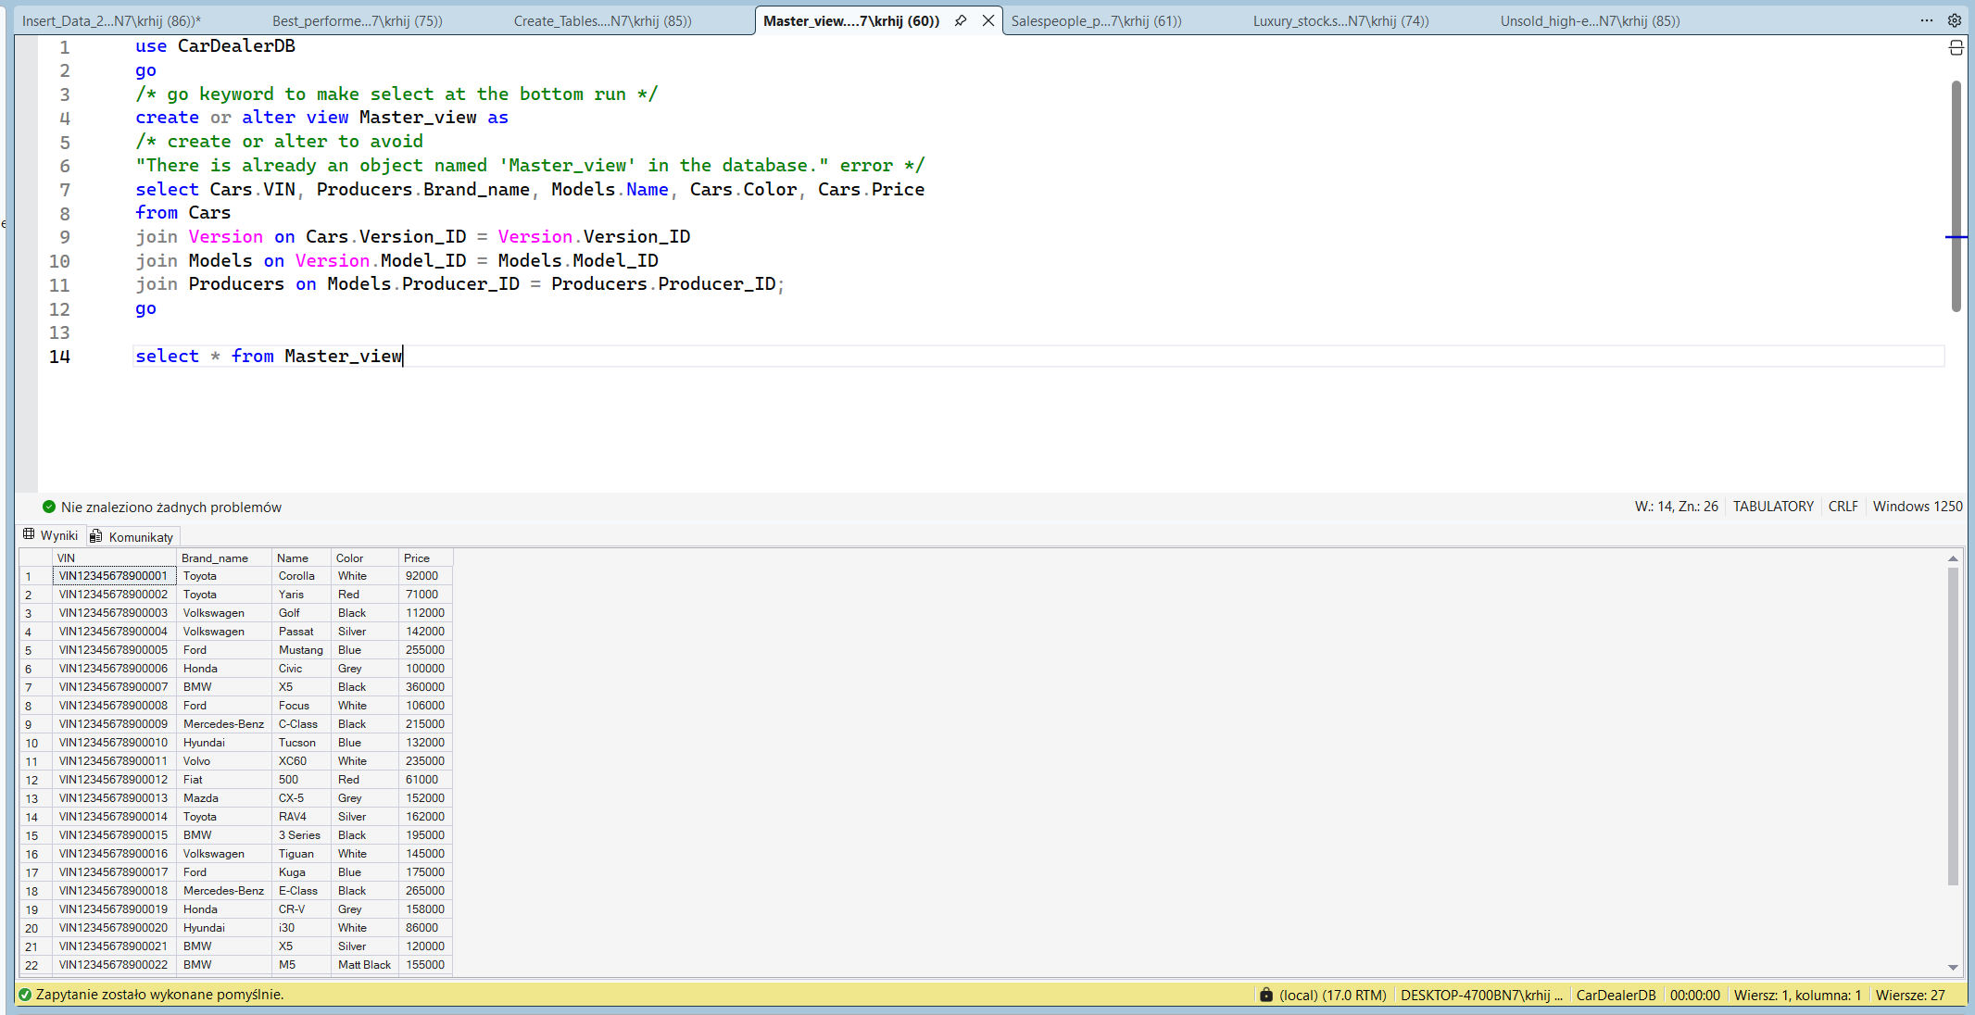
Query 2: Salesperson Performance Leaderboard
Business Justification: The dealership owner needs to monitor employee productivity. This query generates a leaderboard showing how many orders each salesperson has completed and the total revenue they generated. It also includes employees with zero sales (left join) and orders the list by total revenue.
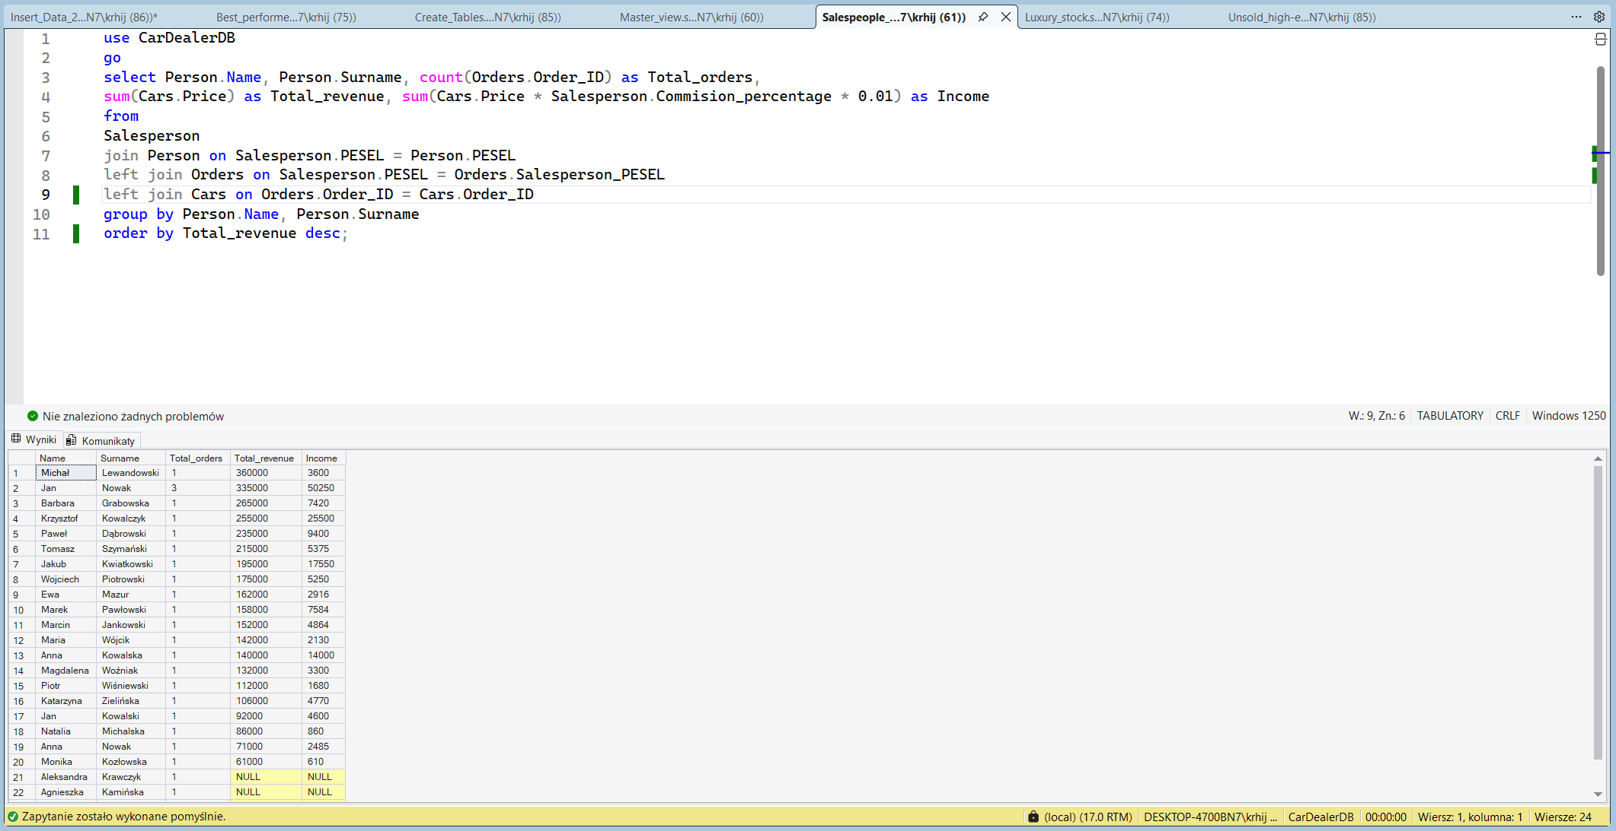

Query 3: Luxury Stock
Business Justification: To manage pricing strategies, the sales team needs to identify premium stock. This query filters the currently available inventory to find cars that are priced higher than the average price of all available cars on the lot.
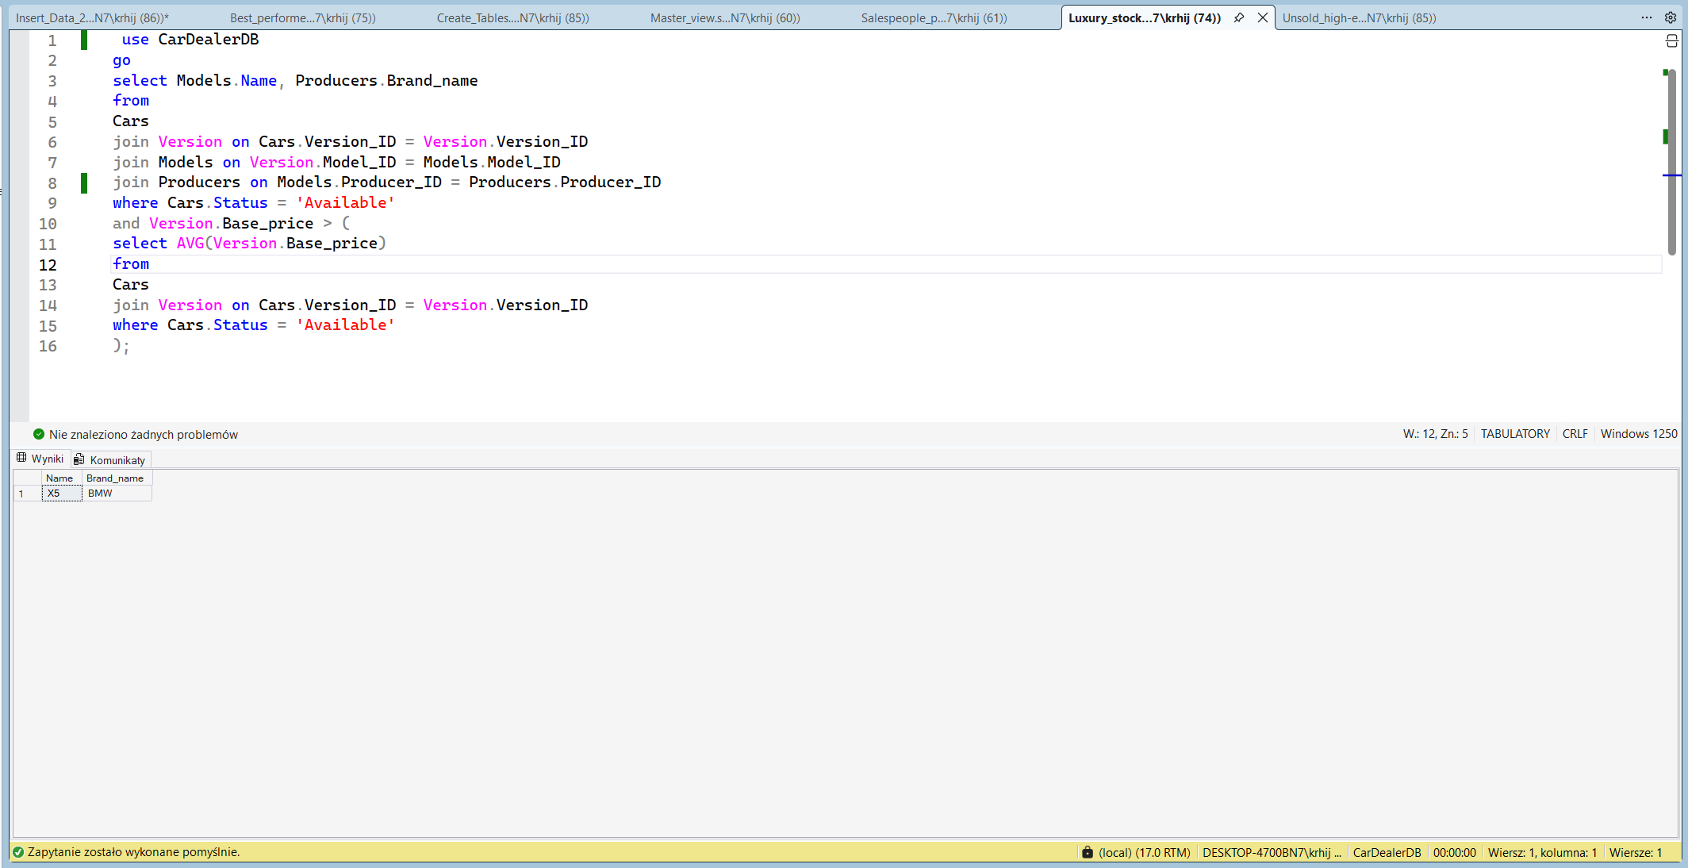
Query 4: Unsold High-End Models
Business Justification: The dealership wants to avoid overstocking expensive cars that are not selling. This query identifies specific high end car configurations (base price > 100,000) that exist in the database but have never been linked to a customer order. This helps managers decide which models to stop ordering from the manufacturer.
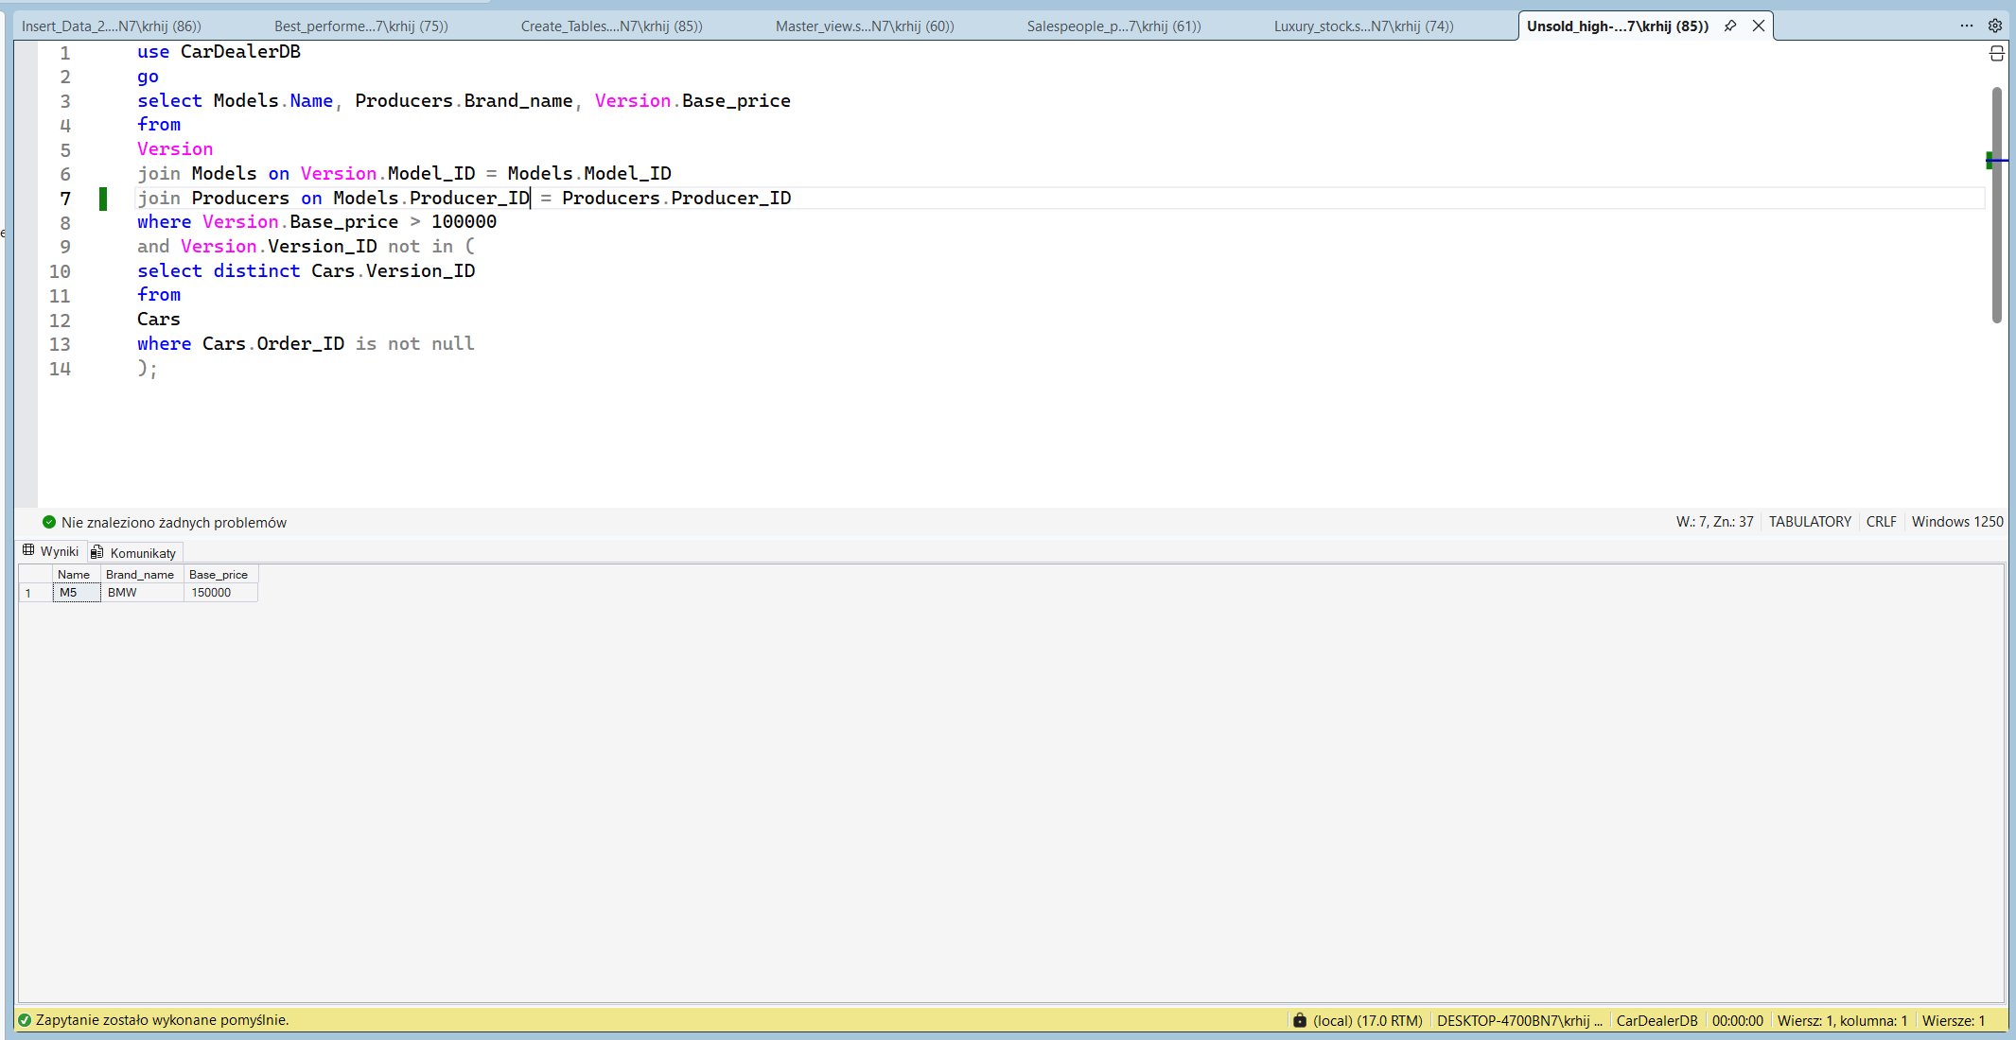
Query 5: Revenue by Brand
Business Justification: This query allows the financial department to analyze which manufacturer brings in the most revenue. It utilizes the Master_view created in Query 1, joins it with the Cars table to get pricing data, and groups the results by Brand Name to show the total sales volume per manufacturer.
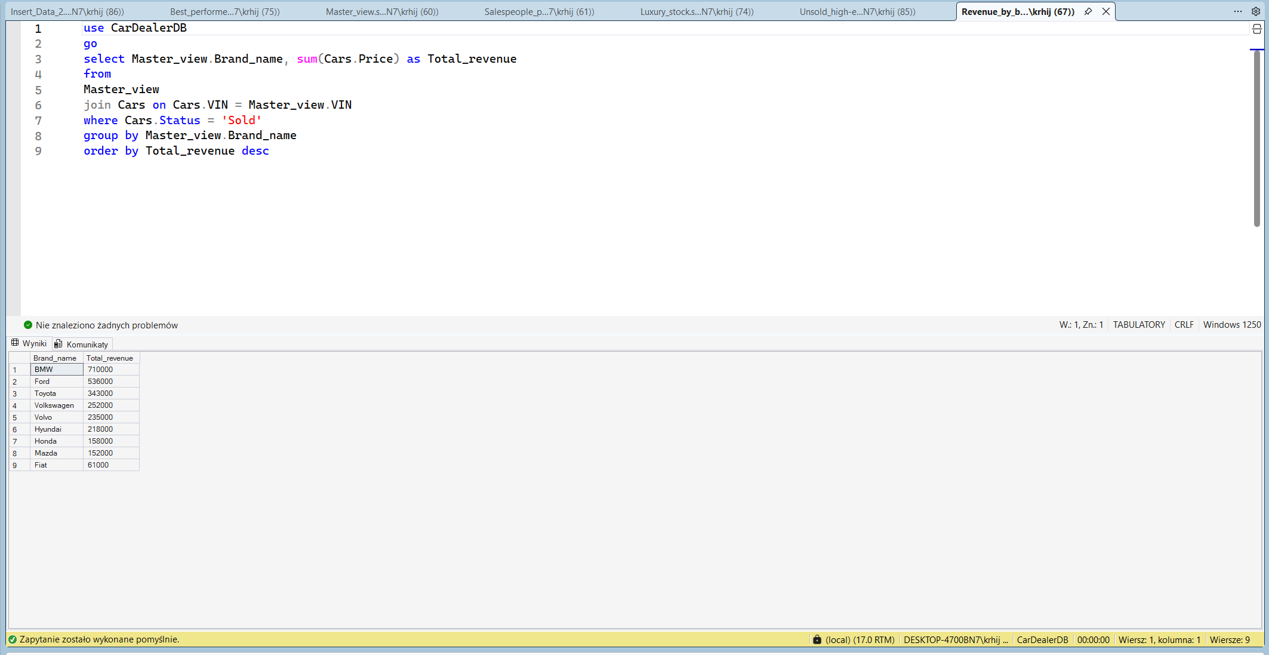
Query 6: Winter Tire Marketing List
Business Justification: The marketing department wants to send a promotional offer for winter tires. To target the right audience, this query retrieves the names and tire details of customers who purchased a car equipped with "Summer" tires. It requires a long join with 5 tables (Customer -> Orders -> Cars -> Version -> Tires).
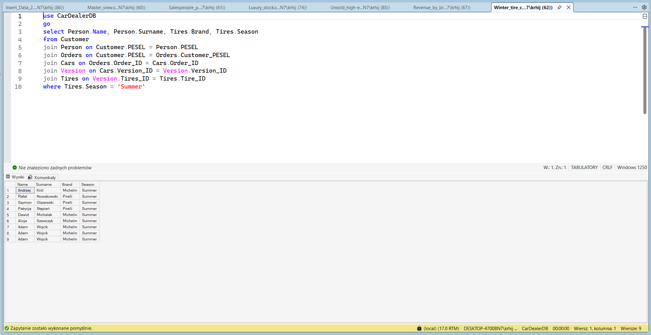
Query 7: Best Performers
Business Justification: This query identifies high earners among salespeople. It lists employees whose commission percentage is strictly higher than the average commission percentage of all employees with the title 'Manager'. This is to prevent anomalies and ensure that such high commissions compared to their superiors are intentional, for example rewarding a top performer.
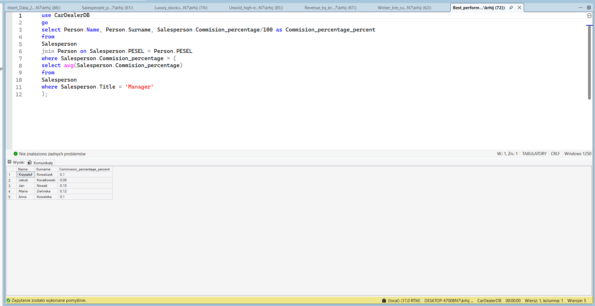
Query 8: Monthly Sales Report
Business Justification: This is a financial report to track business growth. It groups sales data by year and month, calculating the total number of orders and total revenue for each period. This allows the owner to identify seasonal.
