30 September 2026

EPT Tech Note XXX

Comparing Perception workbench setups and tracking version history
Author: Kevin Horne

Question
A customer runs several Genesis HighSpeed test cells, each driven by a Perception virtual workbench (.pVWB). Workbenches are copied between cells and edited over time. When results differ between two cells, or between two test campaigns on the same cell, the first question is always the same: what is different in the setup?
Perception can load a workbench or a settings file (.pSet), but it has no built-in function to compare two of them or to keep a history of changes. How can two workbench setups be compared parameter by parameter, and how can a version history of a workbench be kept?

Answer
A .pVWB file is a structured container that stores the complete Perception setup (hardware settings, RT-FDB formulas, ePower/eDrive configuration, post-process formula database, sheets and displays) as readable XML text. The container can be opened without Perception, the XML flattened into one line per setting, and two files compared. The script vwbhist.py described in this note does this and also keeps a version history of a workbench. A companion window, vwbhist_gui.py, does the same without typing commands: it checks a whole folder of workbenches against a master workbench, keeps the version history and compares any two files. Both only read workbench files and never modify them.

How a workbench is stored
The file begins with the signature Nicolet Structured Storage. Internally it is a small file system: a sector allocation table, a directory of named entries, and data streams chained through fixed-size sectors (512 bytes at the top level, 256 bytes inside the nested System storage). All setup streams are XML encoded as UTF-16 LE with a byte-order mark. The streams found in Perception 8.04 workbenches are:
Stream | Contents
Settings/Settings.xml | Hardware settings: mainframe, network, modules and firmware, groups, recorders, every analog, event and timer/counter channel (range, scaling, coupling, filters, sensor, trigger, alarm), acquisition setup. The RT-FDB formulas are stored here as well.
PowerWizardSetup/PowerWizardSetup.data | ePower / eDrive configuration: measurement methods, channel assignment, spans, cycle detectors, sensors, efficiency blocks, meter lists.
Formulas/Formulas.data | Post-process formula database (user formulas).
WorkbenchV6/Workbench.xml | Sheets, displays, panes and window layout.
InfoSheet, InfoData | Info sheet layout and values.
HardwareConfiguration.xml | Hardware configuration summary.
Restrictions, PreferredDisplayLayout, WorkbenchSettings, WorkbenchRecording, Options | Sheet restrictions, default display layout, workbench and recording-name settings.

Because a stream is split across sectors that are not guaranteed to be contiguous, a plain text search of the .pVWB file finds most settings but can break in the middle of a value. The script reads the allocation table and reassembles each stream before parsing it.

Requirements
- Windows PC with Python 3.8 or newer (python.org). No additional packages are needed.
- The vwbhist files: vwbhist.py (engine and command line), vwbhist_gui.py (window) and vwbhist_gui.bat (starts the window), from https://github.com/krhorne/vwbhist (Code → Download ZIP). Copy them to a folder such as C:\Tools\vwbhist.
- Optional: the sv-ttk package (pip install sv-ttk) gives the window a Windows 11 look that follows the Windows light or dark setting. Without it the window uses the standard look.
- Perception is not needed on the PC that runs the comparison.

Procedure 1: check a folder of workbenches against a master workbench
The quickest way to find setup differences across several test cells is to keep the workbenches of all cells in one folder (or one sub-folder per cell) and compare each of them with a master ("golden") workbench. This is done in the vwbhist window.
- Double-click vwbhist_gui.bat. The window opens on the Folder vs reference tab.
- Next to Folder, click Browse… and select the folder that holds the workbenches. Sub-folders are included; the tree lists every .pVWB and .pSet file.
- Select the master workbench in the tree and click Use selected file (or right-click it and choose Set as reference). A master stored elsewhere can be chosen with the Browse… button next to Reference.
- Every other file is compared with the master and marked in the tree: ★ reference, ✓ same as reference, ≠ N differences, or cannot read (a damaged file, a file still being written, or not a workbench). Each sub-folder shows how many of its files differ, and the totals are shown above the tree.
- Click a file to show its differences from the master in the report pane below the tree. Double-click opens the report in a separate window, so several files can be viewed side by side. Type in Filter (for example Ch A1) to show only matching lines; Save report… writes the report to a text file.
- Leave the window open while working in Perception. Files are re-checked every few seconds, so a workbench saved from Perception shows its new result without any further action.
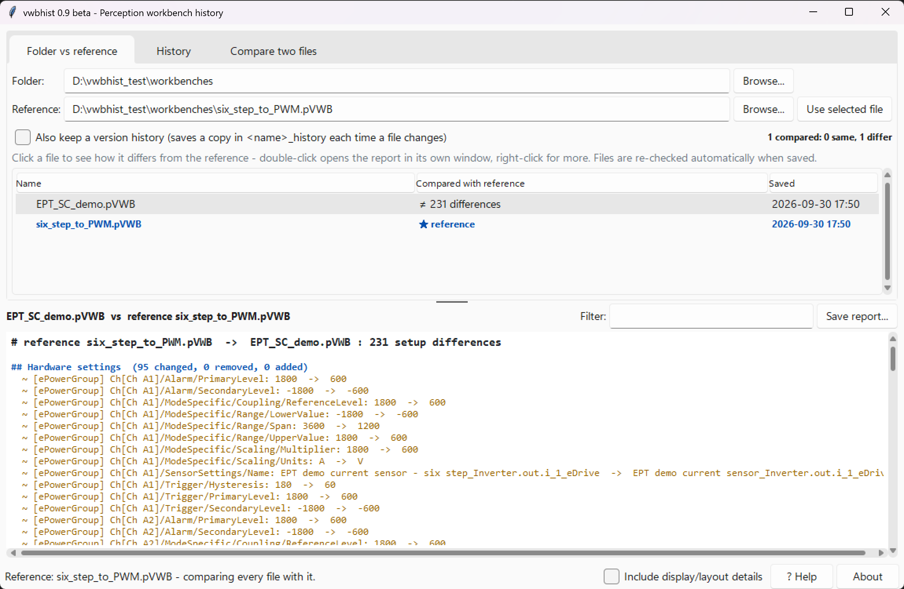
Figure: the Folder vs reference tab. EPT_SC_demo.pVWB differs from the master six_step_to_PWM.pVWB in 231 settings; the report pane lists them by section.
The folder and its master are remembered the next time the window is opened. Right-clicking a file also offers Version history…, Open in Perception and Open containing folder. The window never writes to the folder unless Also keep a version history is ticked (see Procedure 3).

Procedure 2: compare two workbenches
- Save both setups as workbenches in Perception (File → Save virtual workbench as). A .pSet file can be compared the same way, but it contains the hardware settings only.
- In the window, open the Compare two files tab, select workbench A (before) and B (after) with Browse… and click Compare. The report appears in the lower pane. To use the command line instead, continue with the next steps.
- Command line: open a command prompt in the vwbhist folder.
- Run the comparison, writing the report to a text file:
python vwbhist.py compare "C:\WB\Cell3.pVWB" "C:\WB\Cell5.pVWB" > Cell3_vs_Cell5.txt
- Open the report. Differences are grouped by section and by channel; each line shows the setting, the value in the first file and the value in the second file (see Reading the report below).
- To include display and layout differences as well, add -v to the command (in the window: tick Include display/layout details).

Procedure 3: keep a version history of a workbench
The history is stored in a folder next to the workbench, named <workbench name>_history. A new version is recorded only when the setup changes; saves that only move windows or advance the recording number are ignored.
- In the window, open the History tab, click Browse… and select the workbench (or right-click it in the folder tree and choose Version history…). Click Snapshot now to record its current state, optionally with a note such as "min pulse width set to 5 us".
- Select one version and click Show changes (or double-click it) to see what changed in that save. Select two versions (Ctrl+click) to compare them; Selected vs file on disk shows what has changed since a version.
- To record every save automatically, tick Also keep a version history on the Folder vs reference tab and leave the window open: each time Perception saves a workbench in the folder, a new version is recorded if its setup changed. Without the window, run python vwbhist.py watch "C:\Workbenches" in a command prompt and leave it open.
- From the command line, record a version by hand with a note:
python vwbhist.py snapshot "C:\Workbenches\Cell3.pVWB" -m "min pulse width set to 5 us"
- List the history, or show what changed:
rem all versions: time, Windows user, change count, note
python vwbhist.py log "C:\Workbenches\Cell3.pVWB"
rem last saved version vs the one before
python vwbhist.py diff "C:\Workbenches\Cell3.pVWB"
rem version 3 vs version 7
python vwbhist.py diff "C:\Workbenches\Cell3.pVWB" 3 7
rem version 5 vs the file on disk now
python vwbhist.py diff "C:\Workbenches\Cell3.pVWB" 5
- To roll back, open the required vNNNN_….pVWB copy from the history folder in Perception and save it under the working name (in the window: select the version and click Open in Perception).
Each version in the history folder consists of three files:
File | Purpose
v0007_20261002_141500.pVWB | Exact copy of the workbench as saved. Opens directly in Perception.
v0007_20261002_141500.settings.txt | Complete setup as text, one setting = value per line.
v0007_20261002_141500.changes.txt | Differences against the previous version.
history.log | One line per version: file name, time, Windows user, change summary, note.

Help in the window
- Hover the mouse over any button, field or file in the tree for a short explanation.
- Press F1 (or click ? Help) to open the help page at the section for the current tab; type in its Filter box to search it.
- About shows the version, the developer and the support status.
- Include display/layout details (bottom right) also compares display layout and window details, like -v on the command line.

Reading the report
The report is divided into sections: Hardware settings, RT-FDB formulas, ePower / eDrive setup, Formula database, Info sheet, and Sheets. Each section header gives the number of changed, removed and added entries. Hardware settings are keyed by group and physical channel name (for example Ch[Ch A8]) so that a channel is compared with the same channel in the other file, even if its user name changed. RT-FDB formulas are keyed by formula name; for a changed formula every changed field is listed (formula text, units, result type, range, storage and publishing flags).
The excerpt below compares two HBK demo workbenches, a six-step inverter setup and a PWM setup built on the same GEN7tA and Recorder A card:
# six_step_to_PWM.pVWB -> EPT_SC_demo.pVWB : 231 setup differences

## Hardware settings (95 changed, 0 removed, 0 added)
~ [ePowerGroup] Ch[Ch A1]/ModeSpecific/Scaling/Units: A -> V
~ [ePowerGroup] Ch[Ch A8]/Scaling/Multiplier: 0.005 -> 0.6
~ [ePowerGroup] Ch[Ch A8]/TimerCounterPinSettings/DirectionPinInverted: -1 -> 0
~ [ePowerGroup] Ch[Ch A8]/TimerCounterSettings/DebounceFilterTime: 5 -> 6

## RT-FDB formulas (57 changed, 1 removed, 14 added)
~ Inverter.out.u_1
Formula: Recorder_A.Inverter.out.u_1
-> ( RTFormulas.Inverter.out.u_12 - RTFormulas.Inverter.out.u_31 ) / 3
~ Motor.out.M_invert
Formula: 1 -> -1

## ePower / eDrive setup (26 changed, 23 removed, 11 added)
~ .../ElectricalConfigSetup.CurrentFilterFrequency: 50000 -> 200000
~ .../TorqueChannelsDigital.InvertTorque/item: False -> True

## Sheets (0 changed, 2 removed, 2 added)
Read this way, the report shows in a few lines that the voltage measurement changed from phase-to-artificial-star to phase-to-phase (the phase voltages are now derived from line-to-line voltages in the RT-FDB), that the ePower current filter changed from 50 kHz to 200 kHz, and that the torque sign inversion moved from the timer/counter direction pin to the M_invert formula. It also exposes a setup error: the units of current channel Ch A1 (and Ch A3) are set to V, while Ch A2 is still A.

Stored values versus displayed values
Most settings are stored in engineering units, exactly as shown in the Settings sheet. Some are stored as codes. The report always shows the stored value:
Setting | Stored as | Status
Ranges, spans, scaling (Multiplier, Offset, Span, UpperValue, LowerValue) | Engineering units, e.g. Span 3600 for a ±1800 A range | Confirmed against the Settings sheet
On/off settings (Enabled, …Inverted, SamplingEnabled) | -1 = on, 0 = off | Observed
Timer/counter minimum pulse width (TimerCounterSettings/DebounceFilterTime) | Index, not time. Values 4, 5 and 6 observed. The card offers 100 ns, 200 ns, 500 ns, 1 µs, 2 µs and 5 µs (GN310B data sheet); a stored 6 suggests 1 = 100 ns … 6 = 5 µs with 0 = off | Not confirmed. Verify by saving the same workbench with two known settings and comparing
Timer/counter Mode | Code: 3 on a torque frequency input, 11 on a quadrature angle input | Observed only
Input and signal coupling (InputCoupling, SignalCoupling) | Code | Not mapped

What the comparison ignores
Fields that change on every save, or that describe only the screen layout, are excluded by default so that the history is not filled with noise: recording sequence and experiment numbers, window positions and sizes, toolbar and docking state, layout GUIDs, sheet icons and the mainframe connection string. Display layout (Workbench.xml), restrictions and preferred display layout are also excluded. Add -v to any command, or tick Include display/layout details in the window, to include them.

Optional: history in a git repository
If the workbenches are kept in a git repository, git can show readable differences for .pVWB files. Add a .gitattributes file to the repository and register the text conversion once:
.gitattributes:
*.pVWB diff=pvwb
*.pSet diff=pvwb

git config diff.pvwb.textconv "python C:/Tools/vwbhist/vwbhist.py dump"
git diff, git log -p and the diff views of Visual Studio Code or GitHub Desktop then show changed settings instead of "binary files differ". The binary file remains the version that is committed and restored.

Limitations
- vwbhist is a beta project developed by Kevin Horne. It is provided as is, without support or warranty of any kind, and it is not an official or HBK-supported product.
- It was developed and tested with workbenches saved by Perception 8.04. The container format is generic, but setting names can change between Perception versions; check the output once on the customer's own files.
- Enumerated settings are reported as stored codes (see the table above).
- PNRF recordings also carry the setup (Perception can load settings from a PNRF), but reading them has not yet been verified.
- Lists without names (for example the ePower meter list) are compared as sets, so a change of order alone is not reported.

References
- Lab Session Controlling hardware in Perception (2025-09), section Saving hardware and display setups: definition of the virtual workbench (.pVWB) and settings file (.pSet), loading settings from pSet, pVWB or pNRF.
- PNRF Reader SDK User Manual I2697-1.1, appendix C: PreferredDisplayLayout stored as an XML stream.
- GN310B/GN311B data sheet B05492_06, timer/counter section: minimum pulse width filter settings 100 ns to 5 µs.
- Perception eDrive User Manual A05300_02, chapter 11: RT-FDB formula names used in the examples.
- vwbhist source code, updates and README: https://github.com/krhorne/vwbhist

