Lab 01: Exploring Real-World Applications of Computer Vision
Krhystopher Killingsworth
Professor Esmali
Class ITAI 1378 Computer Vision
7 June 2026

Objective:
Explore and analyze real-world applications of computer vision in autonomous vehicles to understand the uses, the technology behind them, and their impact.
Description of Application
Autonomous vehicles are self-driving cars powered by AI (Artificial Intelligence) to navigate and drive without human guidance. The problem this technology aims to solve is that human error is the leading cause of traffic accidents. Autonomous vehicles have the potential to create safer roads by eliminating human error and expanding access to mobility for elderly or disabled individuals who cannot drive.
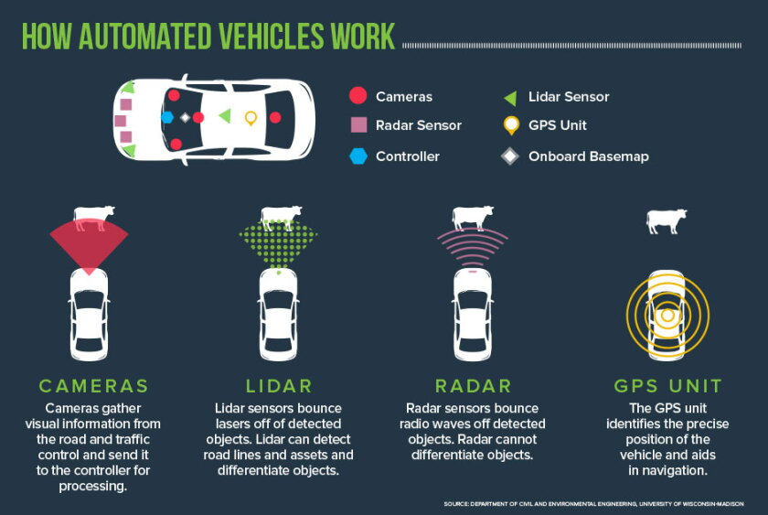
Technology Behind It
A vehicle needs to see and understand its surroundings to drive safely. Cameras and sensors are mounted around the car, providing a live video feed to AI models that detect and classify objects in real time. These models utilize convolutional neural networks, which are specialized deep learning models designed to process data. These models have been trained on millions of images, enabling them to recognize what they see almost instantly.
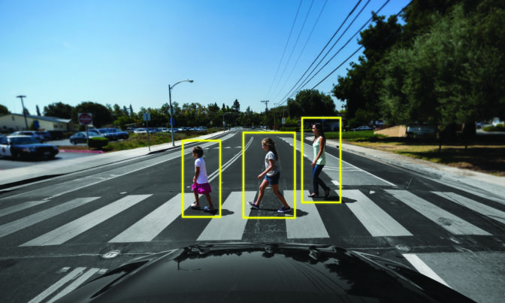
LiDAR is a sensor that emits pulses to build a detailed 3D map of the environment, helping it reliably measure distance. Radar supports the system during bad weather when cameras and LiDAR lose accuracy. The combination of these three inputs is called sensor fusion, and it allows the autonomous vehicle to see a far more complete picture of the surroundings than a single sensor could.
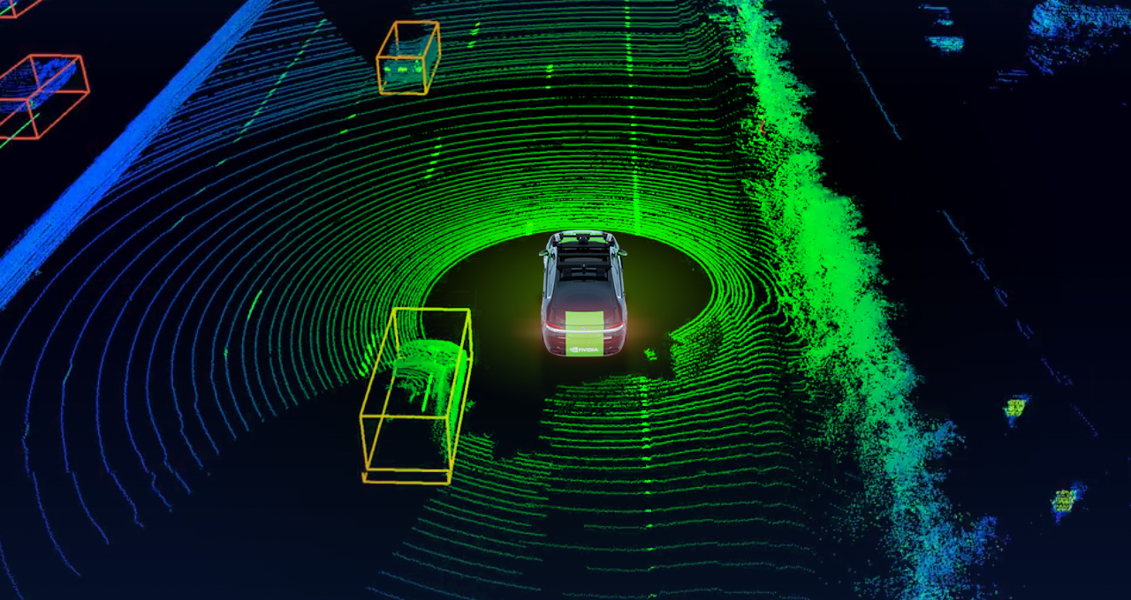
NVIDIA is the current leader in hardware and software providers that power autonomous vehicles. NVIDIA’s DRIVE platform is a full development pipeline that provides everything needed to deploy an autonomous vehicle. DRIVE handles planning, perception, vehicle control, and supports all functions from basic driver assistance to autonomy in real-world situations.
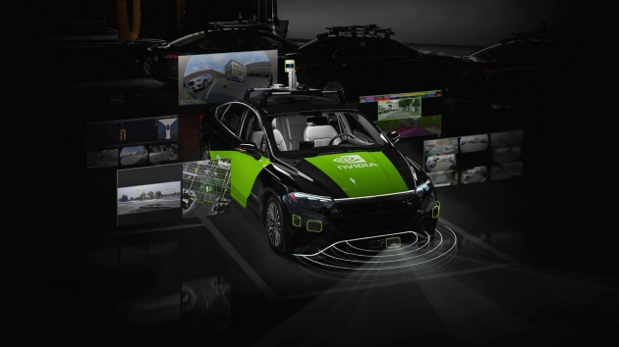

Benefits & Challenges
Benefits include fewer accidents, reduced traffic, lower transportation costs, and expanded mobility for individuals needing transportation assistance. This technology can also lead to smarter city infrastructure that coordinates transportation for greater efficiency.
Challenges faced include autonomous vehicles struggling in inclement weather, construction zones, and unexpected road conditions where the AI may have limited training data. Sensor failures can lead to dangerous outcomes that may put people at risk. Ethical concerns are also raised, as biased data can lead to certain individuals not being properly identified by the AI. Liability concerns arise because, when an autonomous vehicle is involved in an accident, it is currently unclear whether responsibility will fall on the vehicle owner or the system manufacturer.
Reflection
Autonomous vehicles are already operating in multiple cities with production-ready platforms on the road today. The benefits of automated vehicles can help create safer communities, but the challenges must also be addressed to ensure the technology is safe and benefits everyone. Future widespread adoption of this technology could displace professional driver jobs like taxi, and Uber drivers. Safer roads and more transportation access to communities would be the positive trade-off. Future progress of the technology could lead to safer all-weather performance and possibly lower costs as it matures.

Works Cited
“Addressing Disability and Ableist Bias in Autonomous Vehicles: Ensuring Safety, Equity and Accessibility in Detection, Collision Algorithms and Data Collection - DREDF.” DREDF, 7 Nov. 2022, dredf.org/addressing-disability-and-ableist-bias-in-avs/. Accessed 7 June 2026.
Burke, Katie. “How Does a Self-Driving Car See?” NVIDIA Blog, 16 Apr. 2019, blogs.nvidia.com/blog/how-does-a-self-driving-car-see/.
“In-Vehicle Computing for Autonomous Vehicles.” NVIDIA, 2025, www.nvidia.com/en-us/solutions/autonomous-vehicles/in-vehicle-computing/. Accessed 7 June 2026.
Kawamoto, Dawn. “Autonomous Vehicles: Coming to a Road near You (If They’re Not There Already).” Www.govtech.com, Aug. 2018, www.govtech.com/transportation/Autonomous-Vehicles-Coming-to-a-Road-Near-You.html. Accessed 7 June 2026.
NVIDIA. “NVIDIA Autonomous Vehicles Technology.” NVIDIA, 2025, www.nvidia.com/en-us/solutions/autonomous-vehicles/. Accessed 7 June 2026.
“NVIDIA DRIVE AV.” NVIDIA DRIVE AV, 2026, www.nvidia.com/en-us/solutions/autonomous-vehicles/drive-av/. Accessed 7 June 2026.
Roff, Heather. “The Folly of Trolleys: Ethical Challenges and Autonomous Vehicles.” Brookings, 17 Dec. 2018, www.brookings.edu/articles/the-folly-of-trolleys-ethical-challenges-and-autonomous-vehicles/. Accessed 7 June 2026.
Tiwari, Abhinav, and Hany. “Responsible AI Framework for Autonomous Vehicles: Addressing Bias and Fairness Risks.” IEEE Access, Institute of Electrical and Electronics Engineers, Jan. 2025, pp. 1–0, https://doi.org/10.1109/access.2025.3556781. Accessed 23 Apr. 2025.

