SE 3314 – Assignment 1 – Read Me File

By: Krishanth Nagendrasooriyar

#: 250785026

Email: [knagend@uwo.ca](mailto:knagend@uwo.ca)

**Set-Up Instructions**:

1. Open the project folder, and double click the Visual Studio Solution file. (Hint: file with extension .sln)

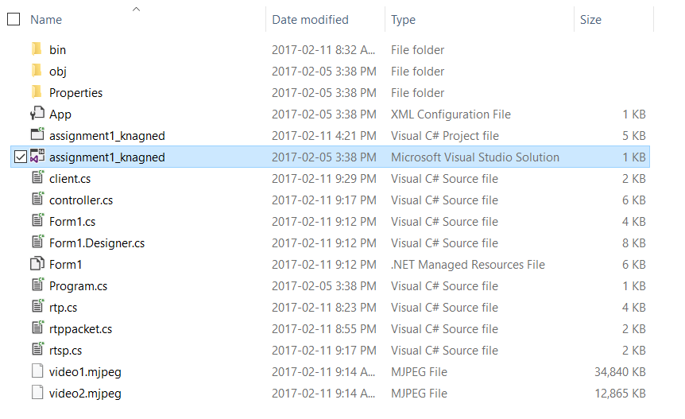

2. Right click Solution Explorer -> Add -> Existing Item; add the 2 video files

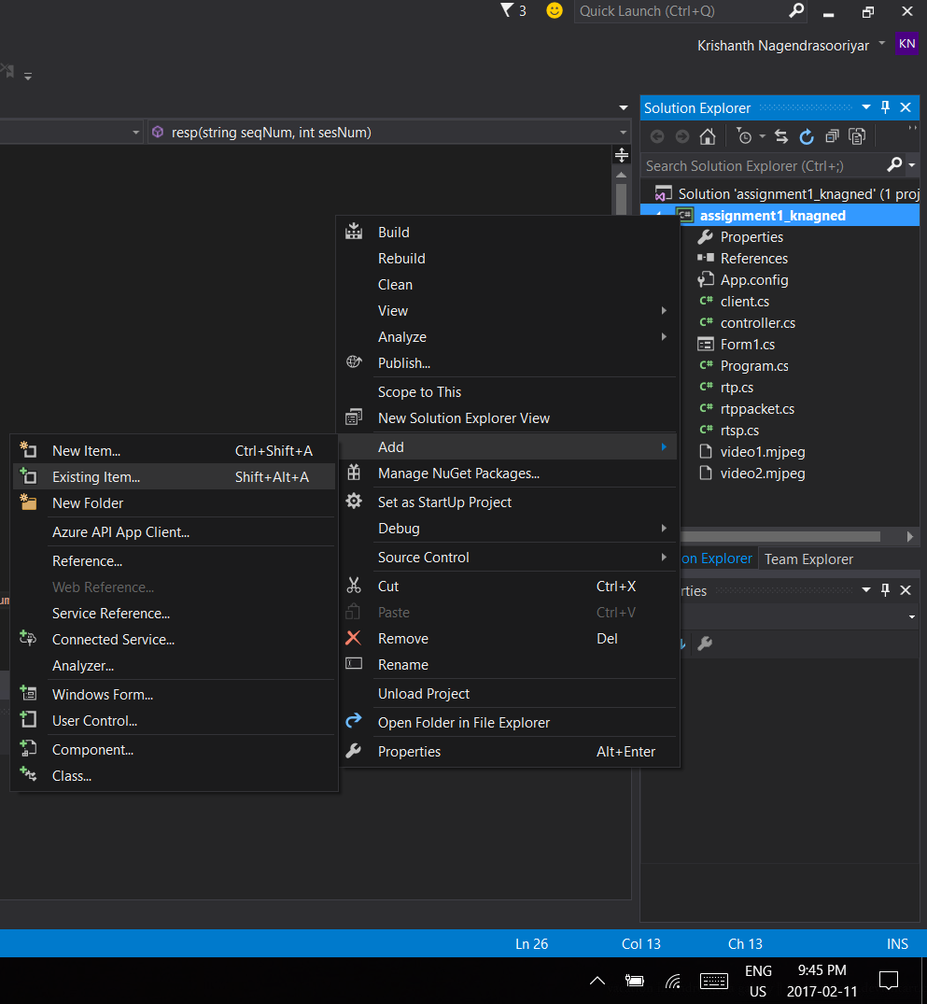

3. Copy the file location of the video, using Visual Studios or File Explorer

4. Open the class name rtp.cs

5. Locate the streamVid function

6. Paste the file location of the video from step 3, onto the first argument for the vid object, without the video file name, and add extra slashes

