**Clickbank Websites Instructions. Getting the Content from our backend.**

We have created an account for you in our content management system:

https://members.creativenichemanager.info/site-backend/

U: daniel.oraca@gmail.com

P: cbank@2015

When logged in you should see a list of articles. As well as drop down menu to filter results by categories.

<https://members.creativenichemanager.info/site-backend/content_clickbank/manage/>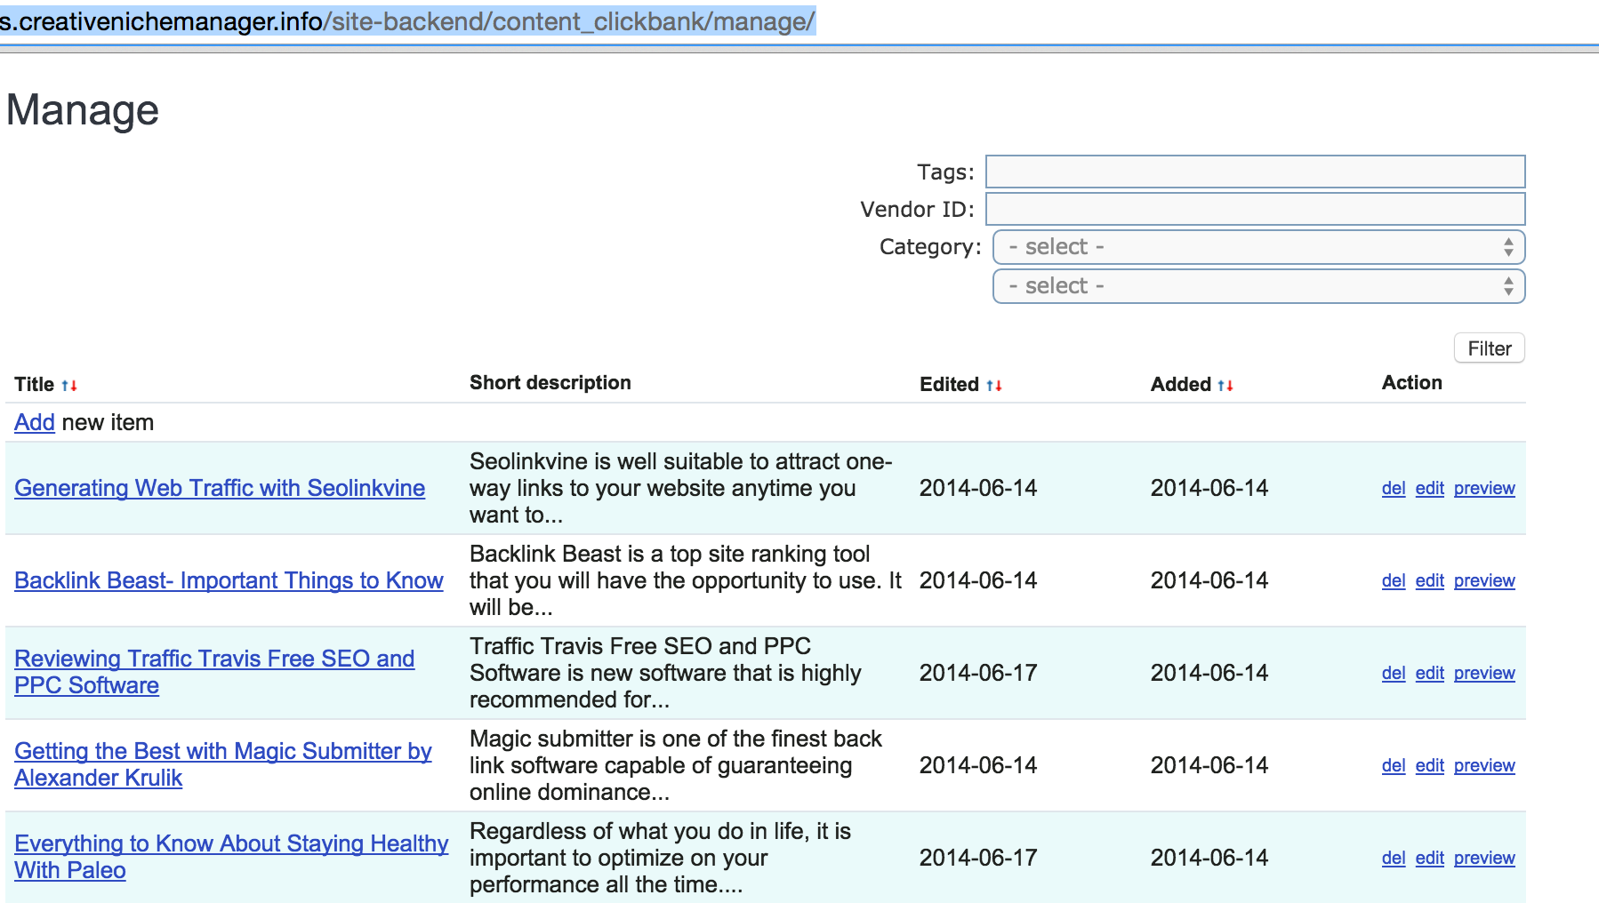

When you click the preview button it will show you the short description and long description as well as images if available. During preview, when you hover the mouse over a link, you will get the Link to hyperlink everything for this article (images, call to action…).

For example, for the first product SEO Linkvine it shows: <http://ethiccash.seolv.hop.clickbank.net/>

This is the link to use.

Then, when you click edit, you get more details (you can use Edit instead of Preview to save time, but don’t edit anything). You also have access to the short description, long description, image URLs, as well as a bunch of tags for all products. You don’t need to use all these tags, 5-6 for each product will be enough.

When you hover an hyperlink in Edit mode, you will see something like this:

#affiliateID#.#vendorID#.[hop.clickbank.net](http://hop.clickbank.net)

This is the generic link: affiliateID will always be: ethiccash

and vendor id is to be found in the vendor field: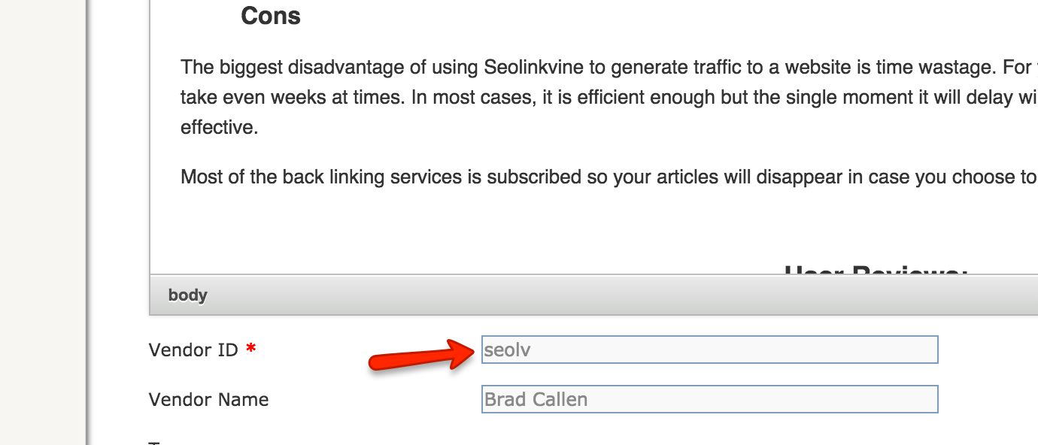

Website [AffiliateMarketingWebGuide.com](http://AffiliateMarketingWebGuide.com)

Logo (same type as for Weight Loss Dieting Plans): Affiliate Marketing 101

Products to pick:

Top one: <https://members.creativenichemanager.info/site-backend/content_clickbank/create/?id=1217>

2nd one: <https://members.creativenichemanager.info/site-backend/content_clickbank/create/?id=1225>

3rd one: <https://members.creativenichemanager.info/site-backend/content_clickbank/create/?id=807>

4th one: <https://members.creativenichemanager.info/site-backend/content_clickbank/create/?id=1221>

5th one:https://members.creativenichemanager.info/site-backend/content_clickbank/create/?id=1223

6th one: <https://members.creativenichemanager.info/site-backend/content_clickbank/create/?id=1219>

Website: [WebTrafficGenerationGuide.com](http://WebTrafficGenerationGuide.com)

Logo: Web Traffic Generation Guide

Products:

Top product: https://members.creativenichemanager.info/site-backend/content_clickbank/create/?id=1405

then <https://members.creativenichemanager.info/site-backend/content_clickbank/create/?id=1399>

<https://members.creativenichemanager.info/site-backend/content_clickbank/create/?id=1397>

<https://members.creativenichemanager.info/site-backend/content_clickbank/create/?id=1117>

<https://members.creativenichemanager.info/site-backend/content_clickbank/create/?id=1403>

<https://members.creativenichemanager.info/site-backend/content_clickbank/create/?id=1401>

https://members.creativenichemanager.info/site-backend/content_clickbank/create/?id=811

Website: Make Money Online [creative.com](http://creative.com)

Logo: Make Money Online Creatively

Top Product: <https://members.creativenichemanager.info/site-backend/content_clickbank/create/?id=1119>

Then:

<https://members.creativenichemanager.info/site-backend/content_clickbank/create/?id=1073>

https://members.creativenichemanager.info/site-backend/content_clickbank/create/?id=1225

<https://members.creativenichemanager.info/site-backend/content_clickbank/create/?id=1099>

<https://members.creativenichemanager.info/site-backend/content_clickbank/create/?id=1105>

<https://members.creativenichemanager.info/site-backend/content_clickbank/create/?id=1103>

https://members.creativenichemanager.info/site-backend/content_clickbank/create/?id=1083

Website: [StressManagementStrategy.com](http://StressManagementStrategy.com)

Logo: Stress Management Strategies

Top product: <https://members.creativenichemanager.info/site-backend/content_clickbank/create/?id=1201>

then:

https://members.creativenichemanager.info/site-backend/content_clickbank/create/?id=1271

<https://members.creativenichemanager.info/site-backend/content_clickbank/create/?id=17>

<https://members.creativenichemanager.info/site-backend/content_clickbank/create/?id=27>

<https://members.creativenichemanager.info/site-backend/content_clickbank/create/?id=29>

<https://members.creativenichemanager.info/site-backend/content_clickbank/create/?id=1269>

<https://members.creativenichemanager.info/site-backend/content_clickbank/create/?id=1199>

thumb: 900 x 372 _1

inner: 900 x 741 (normal) _2

like: 217 x 134 _like

sidebar: 83 x 68 _sidebar