1. **Define banners.**

All banner images should have size of 2800 x 1750 px and be saved as jpg files. They are stored inside website root folder on images/banner folder as follows:

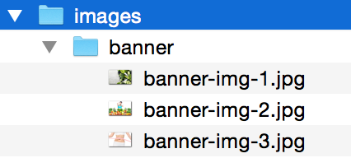

The file names should follow this naming convention:

banner-img-1.jpg

banner-img-2.jpg

banner-img-3.jpg

The code dealing with the banners is located in banner.php file

1. **Define articles.**

Articles are defined inside index-posts.php file as follows:

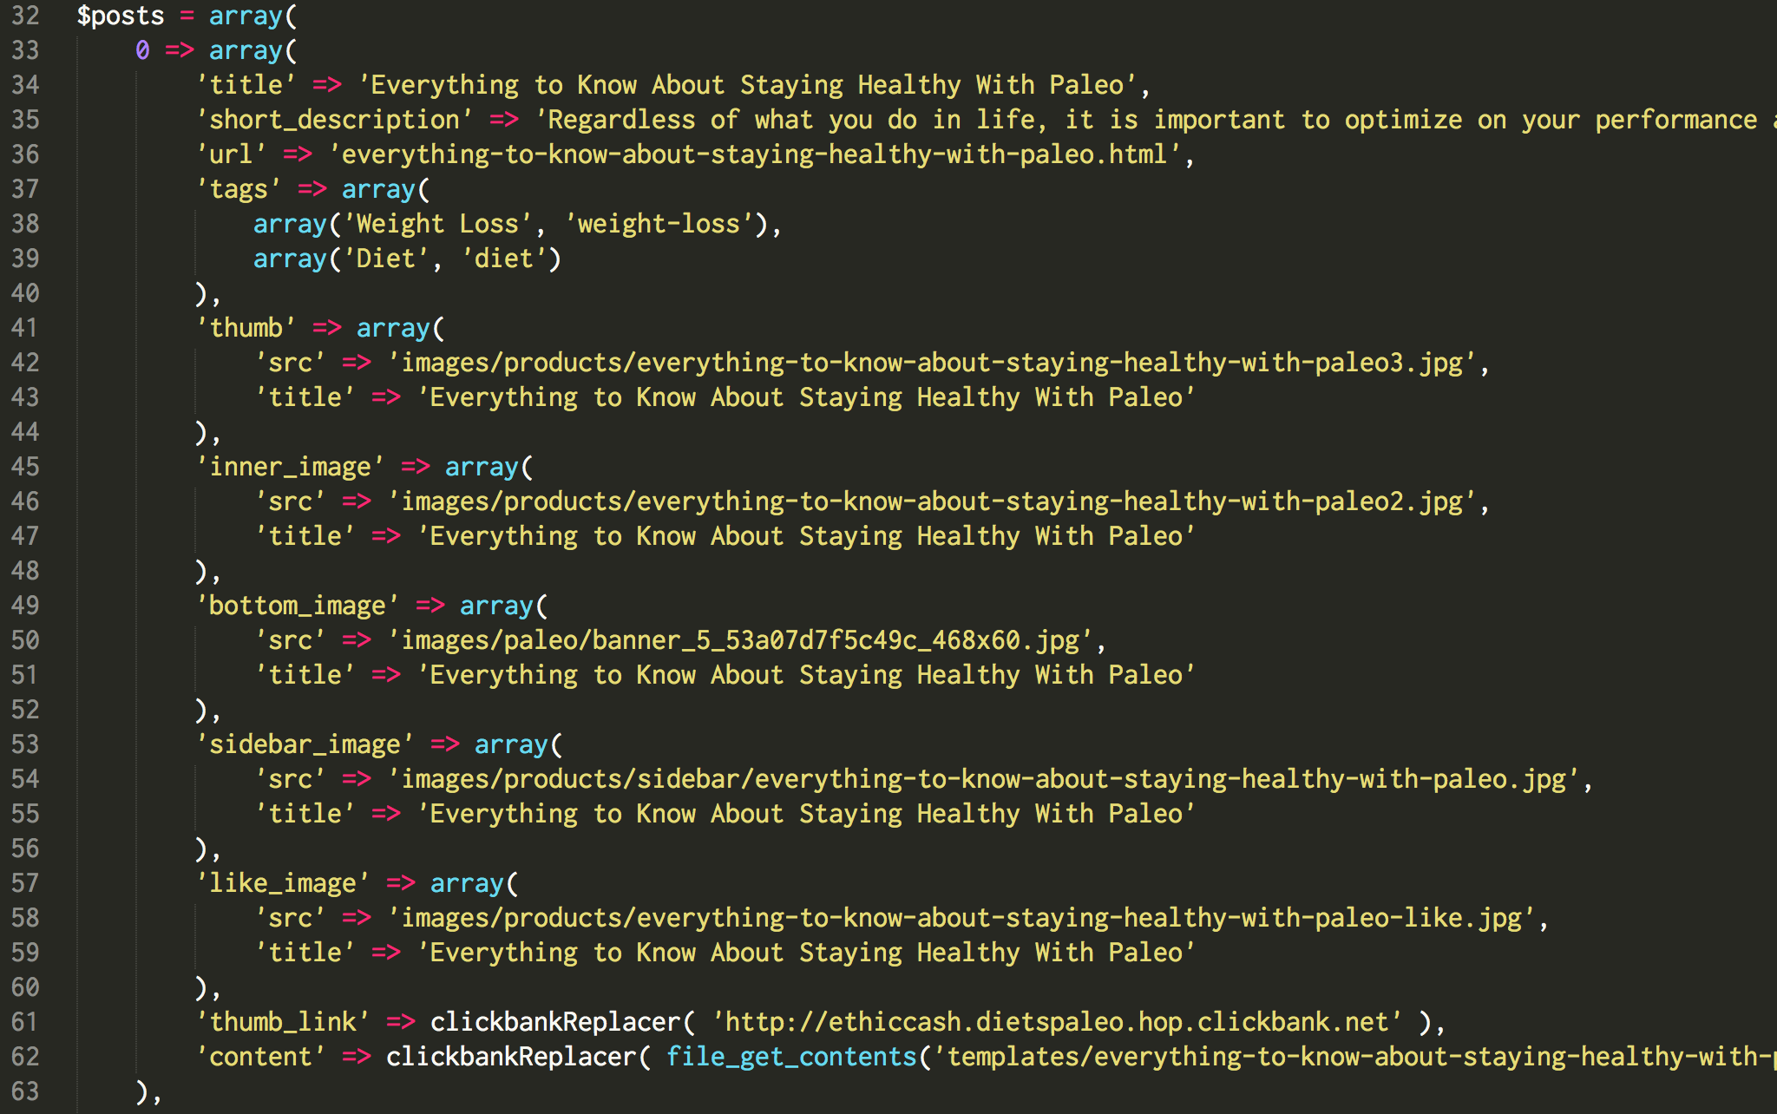

There is a total of 7 articles that have ‘Title’, ‘Short Description’, ‘Url’, ‘Tags’, ‘Thumb’, ‘Inner_image’, ‘Bottom Image’, ‘Sidebar Image’, ‘Like Image’ ‘Thumb Link’, ‘Content’

* **Title** – defines the title used for article
* **Short Description** – is used on front page as the small text bellow article’s image
* **Url** – defines the article’s url; this should be composed using article’s title followed by **.html** extension
* **Tags** – Each tag should be defined as a name and url value as follows:

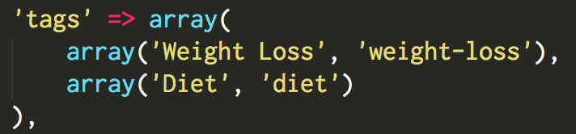

* **Thumb –** images should be saved in website’s root folder in images/products folder. Size of the images should be 900 x 282 pixels. They show up above each article, on front page and article’s pages.
* **Inner Image -** images should be saved in website’s root folder in images/products folder. Size of the images should be 900 x 600 pixels. They show up inside each article, on front page and article’s pages.
* **Bottom Image -** images should be saved in website’s root folder in images/products folder. They show up at the end of article’s pages.
* **Sidebar Image -** images should be saved in website’s root folder in images/products/sidebar folder. Size of the images should be 86 x 57 pixels. They show up above each article, on front page and article’s pages.
* **Like Image -** images should be saved in website’s root folder in images/products folder. Size of the images should be 217 x 134 pixels. They show up on ‘You May Also Like’ box, bellow each article
* **Thumb Link –** this defines the external link
* **Content –** Each article have its content defined as html text saved in templates folder as displayed bellow:  
    
  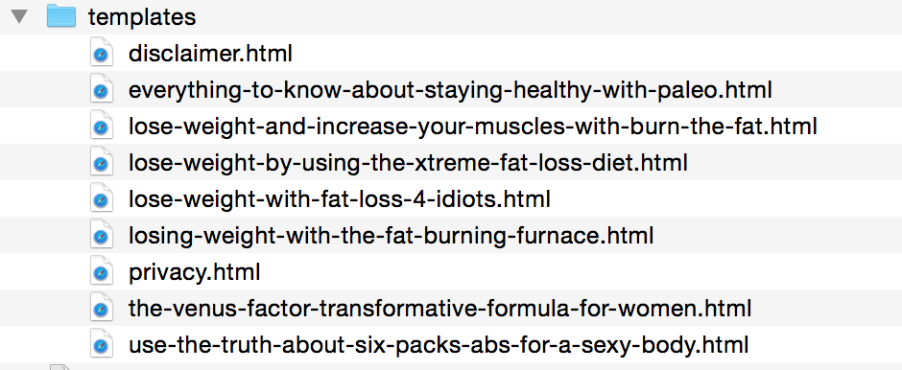

The name of template file is used to link the content of the article.

1. **Define Sidebar.**

* *About the author* block
  + image is stored inside images folder using author.jpg name
  + size of this image is 250 x 375 px
  + text bellow the image can be changed by editing sidebar.php file as illustrated bellow  
      
    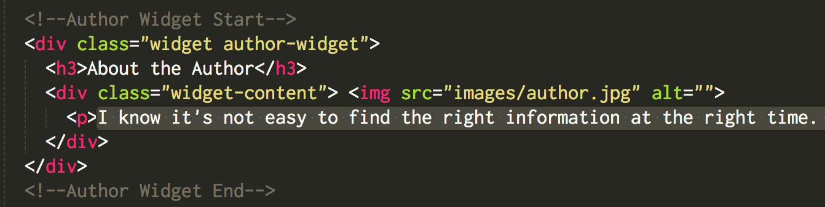
* *Popular image* block
  + images are stored inside images/popular folder using following naming convention popular1.jpg, popular2.jpg, etc.
  + The code currently accepts 7 popular images that are displayed on random order.
* *Tags* block
  + This block is auto generated

1. **Define Footer**

* Images inside *Photostream* block are stored inside images/footer/photostream folder.
* There are 6 images named using this convention photo1.jpg, photo2.jpg, etc. as follows:

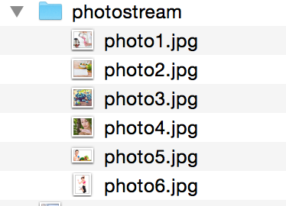

* Size of allo 6 images should be defined as follows:
  + photo1.jpg – 64 x 60 pixels
  + photo2.jpg – 64 x 60 pixels
  + photo3.jpg – 64 x 60 pixels
  + photo4.jpg – 64 x 60 pixels
  + photo5.jpg – 173 x 109 pixels
  + photo6.jpg – 84 x 109 pixels
* Footer also contains 8 images above the copyright information. These images are stored in images/footer folder as follows:  
    
  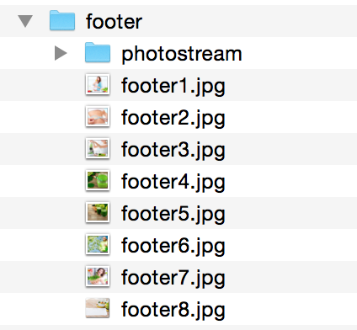
* Size of these images is 225 x 187 pixels

1. **Navigation**After defining all the above elements (Banners, Articles, Sidebar, Footer), the navigation options can be defined by editing the functions.php file as illustrated bellow:

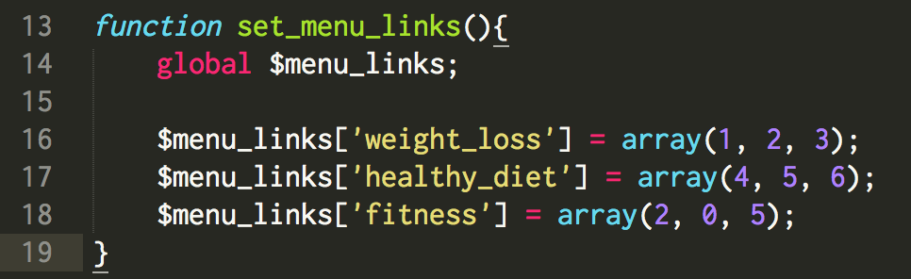

The numbers inside *array(…)* should be replaced by the numbers of articles as defined inside index-posts.php file here:

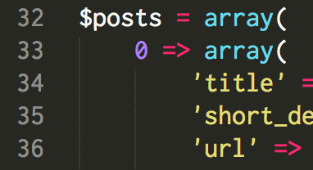

In the above example, “0” represents the article’s index, the one that can be used as refference for navigation.php file.

1. **Configure .htaccess file**

After setting up the article’s urls in index-posts.php file, there is an extra file that needs to be edited - **.htaccess** as illustrated bellow

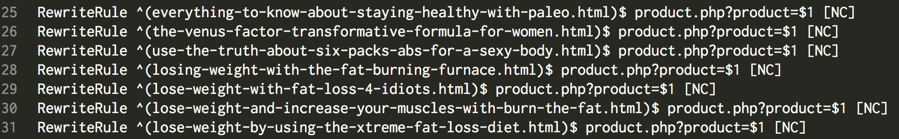

For example, on the first line, this block of text

*everything-to-know-about-staying-healthy-with-paleo.html*

needs to be replaced by the first article’s url as defined in index-posts.php file

Same goes for each article

Also, on .htaccess file, the tag urls must be added as illustrated bellow:

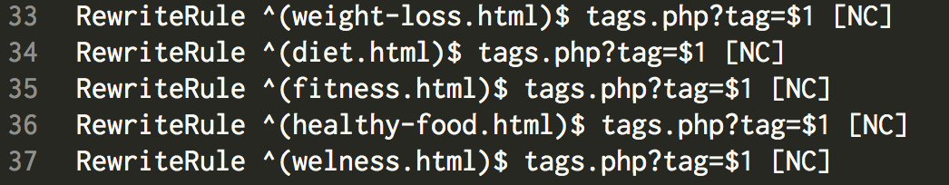

Same rule applies: for example, in first row, this code

*weight-loss.html*

One row must be present for each defined tag in index-posts.php file