Satellite Industry Database
System Documentation Pack
Prepared for stakeholder and developer handover
Date: 8 June 2026

1. Purpose
This document explains the current satellite database system, API, AWS services, and PostgreSQL schema. It uses the implemented repository and AWS handoff as the source basis.

2. System Overview
The current system uses this path:
Vercel frontend -> API Gateway HTTP API -> AWS Lambda -> Amazon RDS PostgreSQL
Item | Value
API base URL | https://60tprkt5qh.execute-api.ap-southeast-1.amazonaws.com
AWS Region | ap-southeast-1, Asia Pacific, Singapore
Frontend env var | NEXT_PUBLIC_API_BASE_URL
Backend runtime | Node.js Lambda
Database | Amazon RDS for PostgreSQL

3. Database Diagram
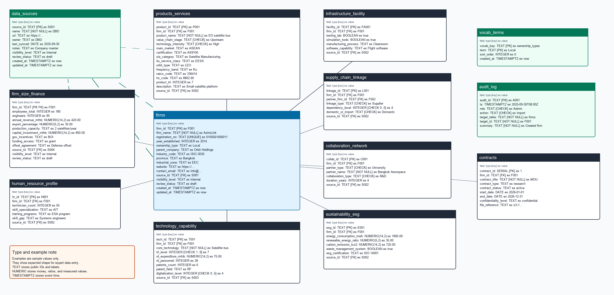
Editable source: docs/system/diagrams/database-v2.drawio

4. AWS Services Used
Service | Role | Reason
Amazon API Gateway HTTP API | Public HTTPS API endpoint | Routes browser and test requests to Lambda. HTTP APIs support Lambda integration and CORS.
AWS Lambda | Node.js API runtime | Runs backend code without a managed server. Reads database settings from environment variables.
Amazon RDS for PostgreSQL | Relational database | Stores firms, products, capability rows, source records, vocab, audit records, and contract metadata.
VPC security groups | Network access control | Allows PostgreSQL traffic to RDS from the Lambda security group. Blocks direct public database access.
Lambda VPC access | Private database access path | Places Lambda network access inside the VPC path required to reach private RDS.
Vercel | Frontend host | Hosts the Next.js frontend. The browser calls API Gateway through HTTPS.

5. API Reference

5.1 Fixed Endpoints
Method | Route | Purpose | Required input
OPTIONS | /* | CORS preflight | None
GET | /health | Check API and database connection | None
GET | /admin/schema-status | Check schema compatibility and row counts | None
POST | /admin/replace-empty-v2 | Replace empty incompatible prototype schema | Existing known tables must have zero rows.
POST | /admin/init | Create database tables | Compatible schema or empty database.
POST | /admin/init-v2 | Create v2 database tables | Compatible schema or empty database.
GET | /dataset | Read full application dataset | None
PUT | /dataset | Replace full application dataset | Full Database object.
POST | /dataset | Replace full application dataset | Full Database object.
GET | /vocab | Read controlled vocab terms | None
PUT | /vocab | Replace controlled vocab terms | Object of vocab keys with string arrays.
GET | /contracts | List contract metadata | None
POST | /contracts | Create contract metadata | firm_id and contract_title.

5.2 CRUD Resources
Route | Table | ID field | Required fields
/firms | firms | firm_id | firm_name
/size-finance | firm_size_finance | firm_id | firm_id
/products | products_services | product_id | firm_id, product_name, value_chain_stage, technology_intensity
/tech | technology_capability | tech_id | firm_id, core_technology, trl_level
/facilities | infrastructure_facility | facility_id | firm_id
/hr | human_resource_profile | hr_id | firm_id
/linkages | supply_chain_linkage | linkage_id | firm_id, partner_firm_id, linkage_type
/collaborations | collaboration_network | collab_id | firm_id, partner_type, partner_name, collaboration_type
/esg | sustainability_esg | esg_id | firm_id
/sources | data_sources | source_id | name
/audit | audit_log | audit_id | role, action, target_table, target_id, summary

5.3 CRUD Method Rules
Method | Pattern | Behavior
GET | /resource | List rows. Returns up to 5000 rows ordered by ID. Audit rows use newest timestamp first.
POST | /resource | Create or upsert a row. If the public ID is missing, the API generates the next ID from the resource prefix.
GET | /resource/{id} | Read one row by public ID. Returns 404 when the row does not exist.
PUT | /resource/{id} | Update or upsert one row. The path ID overrides the body ID.
DELETE | /resource/{id} | Delete one row. Returns the deleted row. Returns 404 when the row does not exist.

5.4 Error Behavior
Status | Meaning
400 | Required field missing for routes with explicit validation, such as contracts.
404 | Route does not exist or record ID was not found.
409 | Schema is not v2-compatible, or replace-empty-v2 found existing data.
500 | Unexpected database or runtime error. Response includes ok false and an error message.

6. Database Schema
Table | Purpose | Primary key | Links
firms | Anchor table for satellite industry organizations. | firm_id | source_id -> data_sources.source_id
firm_size_finance | Current firm size, revenue, capacity, investment, incentives, and funding profile. | firm_id | firm_id -> firms.firm_id, source_id -> data_sources.source_id
products_services | Product and service portfolio with satellite taxonomy fields. | product_id | firm_id -> firms.firm_id, source_id -> data_sources.source_id
technology_capability | Firm technology, TRL, R&D, patent, and digitalization capability rows. | tech_id | firm_id -> firms.firm_id, source_id -> data_sources.source_id
infrastructure_facility | Facilities, testing, simulation, manufacturing, and software capability. | facility_id | firm_id -> firms.firm_id, source_id -> data_sources.source_id
human_resource_profile | Technical workforce profile and skill gap data. | hr_id | firm_id -> firms.firm_id, source_id -> data_sources.source_id
supply_chain_linkage | Directed firm to firm supply chain and ecosystem edges. | linkage_id | firm_id -> firms.firm_id, partner_firm_id -> firms.firm_id, source_id -> data_sources.source_id
collaboration_network | Collaboration rows between firms and institutions. | collab_id | firm_id -> firms.firm_id, source_id -> data_sources.source_id
sustainability_esg | Energy, emissions, waste, and ESG certification profile. | esg_id | firm_id -> firms.firm_id, source_id -> data_sources.source_id
data_sources | Source registry for provenance and evidence. | source_id | Referenced by firm and domain tables.
vocab_terms | Controlled vocabulary terms for frontend dropdowns. | vocab_key, term | No foreign key.
audit_log | Action history for governance and review evidence. | audit_id | Logical link through target_table and target_id.
contracts | Retained prototype contract metadata support. | contract_id | firm_id -> firms.firm_id

7. Setup And Verification
Step | Task | Command or value
1 | Set Lambda env vars | DB_HOST, DB_NAME, DB_PORT, DB_USER, DB_PASSWORD, CORS_ORIGIN.
2 | Check health | GET https://60tprkt5qh.execute-api.ap-southeast-1.amazonaws.com/health.
3 | Check schema | GET https://60tprkt5qh.execute-api.ap-southeast-1.amazonaws.com/admin/schema-status.
4 | Create tables | POST https://60tprkt5qh.execute-api.ap-southeast-1.amazonaws.com/admin/init-v2.
5 | Connect frontend | Set NEXT_PUBLIC_API_BASE_URL in Vercel for Preview and Production.
6 | Verify data flow | Open the app, load firms, create a test firm, and confirm the row appears through GET /firms.

Check | Pass condition
API health | GET /health returns ok true and db_time.
Schema status | GET /admin/schema-status returns ok true.
Dataset load | GET /dataset returns expected arrays.
Frontend sync | The AWS banner shows connected state.
Create firm | POST /firms returns a firm_id and the row appears in GET /firms.
Vercel build | npm.cmd run build completes.

8. Current Prototype Limits
Limit | Current handling
Authentication | Prototype role selection in the frontend.
Secrets | DB_PASSWORD is in Lambda environment variables.
Connection pooling | Lambda connects directly to RDS.
CORS | Prototype uses wildcard origin.
Contract files | Contracts route stores metadata only.

Appendix A. Source References
Source | URL
draw.io export formats | https://www.drawio.com/docs/manual/export/export-diagram/
Amazon API Gateway HTTP APIs | https://docs.aws.amazon.com/apigateway/latest/developerguide/http-api.html
AWS Lambda with Amazon RDS | https://docs.aws.amazon.com/lambda/latest/dg/services-rds.html
AWS Lambda VPC access | https://docs.aws.amazon.com/lambda/latest/dg/configuration-vpc.html
Amazon VPC security groups | https://docs.aws.amazon.com/vpc/latest/userguide/creating-security-groups.html
Amazon RDS for PostgreSQL | https://docs.aws.amazon.com/AmazonRDS/latest/UserGuide/CHAP_PostgreSQL.html
Vercel environment variables | https://vercel.com/docs/environment-variables

