**ЛАБОРАТОРНА РОБОТА № 6**

**СТВОРЕННЯ РЕКОМЕНДАЦІЙНИХ СИСТЕМ**

**Завдання 2.1. Створення навчального конвеєра (конвеєра**

**машинного навчання)**

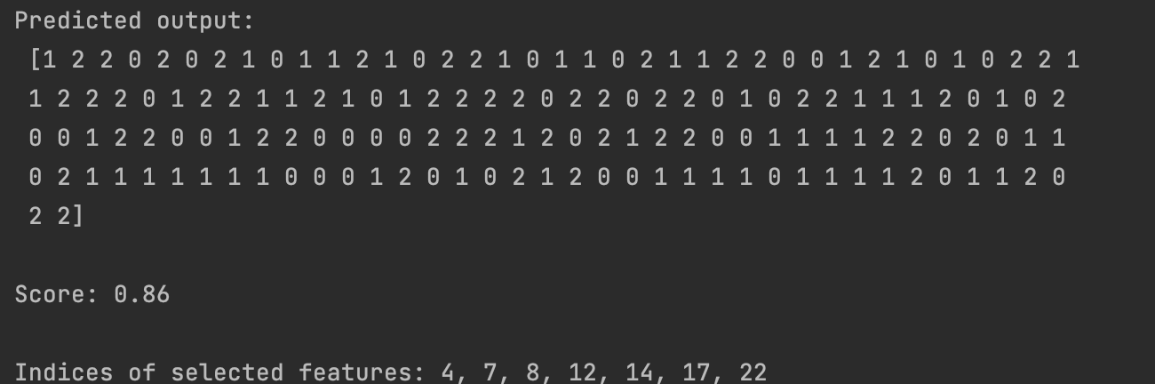

from sklearn.datasets import make_blobs, make_classification  
from sklearn.feature_selection import SelectKBest, f_regression  
from sklearn.pipeline import Pipeline  
from sklearn.ensemble import ExtraTreesClassifier  
  
# Generate data  
X, y = make_classification(n_samples=150,  
 n_features=25, n_classes=3, n_informative=6,  
 n_redundant=0, random_state=7)  
  
  
k_best_selector = SelectKBest(f_regression, k=9)  
  
  
classifier = ExtraTreesClassifier(n_estimators=60, max_depth=4)  
  
  
processor_pipeline = Pipeline([('selector', k_best_selector), ('erf', classifier)])  
  
  
processor_pipeline.set_params(selector__k=7, erf__n_estimators=30)

processor_pipeline.fit(X, y)  
  
  
output = processor_pipeline.predict(X)  
print("\nPredicted output:\n", output)  
  
  
  
print("\nScore:", processor_pipeline.score(X, y))  
  
  
  
status = processor_pipeline.named_steps['selector'].get_support()  
  
  
  
selected = [i for i, x in enumerate(status) if x]  
print("\nIndices of selected features:", ', '.join([str(x) for x in selected]))

**Завдання 2.2. Пошук найближчих сусідів**

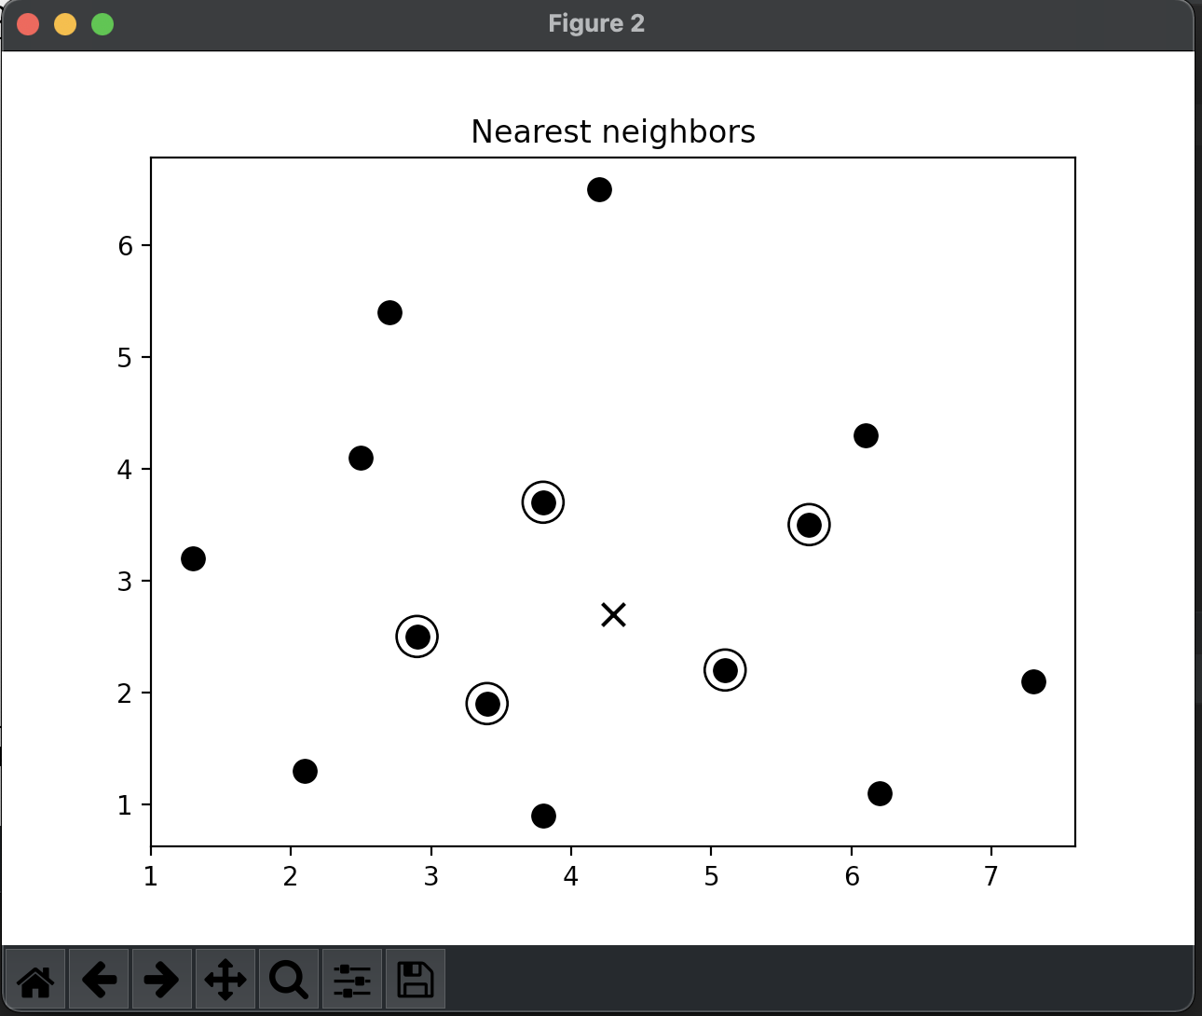

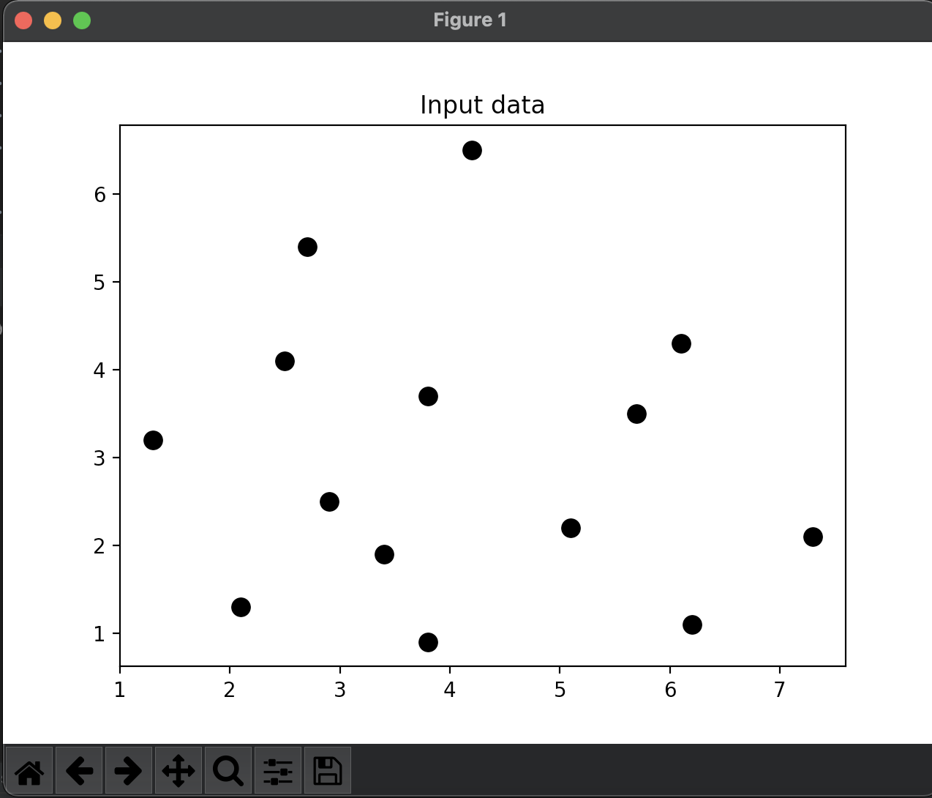

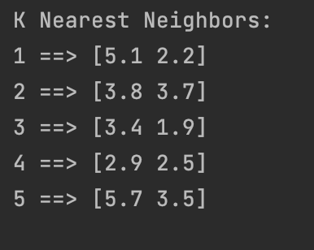

import numpy as np  
import matplotlib.pyplot as plt  
from sklearn.neighbors import NearestNeighbors  
  
  
X = np.array([[2.1, 1.3], [1.3, 3.2], [2.9, 2.5], [2.7, 5.4], [3.8, 0.9],  
 [7.3, 2.1], [4.2, 6.5], [3.8, 3.7], [2.5, 4.1], [3.4, 1.9],  
 [5.7, 3.5], [6.1, 4.3], [5.1, 2.2], [6.2, 1.1]])  
  
  
k = 5  
  
  
test_datapoint = [4.3, 2.7]  
  
  
plt.figure()  
plt.title('Input data')  
plt.scatter(X[:,0], X[:,1], marker='o', s=75, color='black')  
  
  
knn_model = NearestNeighbors(n_neighbors=k, algorithm='ball_tree').fit(X)  
distances, indices = knn_model.kneighbors([test_datapoint])  
  
  
print("\nK Nearest Neighbors:")  
for rank, index in enumerate(indices[0][:k], start=1):  
 print(str(rank) + " ==>", X[index])  
  
  
plt.figure()  
plt.title('Nearest neighbors')  
plt.scatter(X[:, 0], X[:, 1], marker='o', s=75, color='k')  
plt.scatter(X[indices][0][:][:, 0], X[indices][0][:][:, 1],  
 marker='o', s=250, color='k', facecolors='none')  
plt.scatter(test_datapoint[0], test_datapoint[1],  
 marker='x', s=75, color='k')  
  
plt.show()

**Завдання 2.3. Створити класифікатор методом *k* найближчих сусідів**

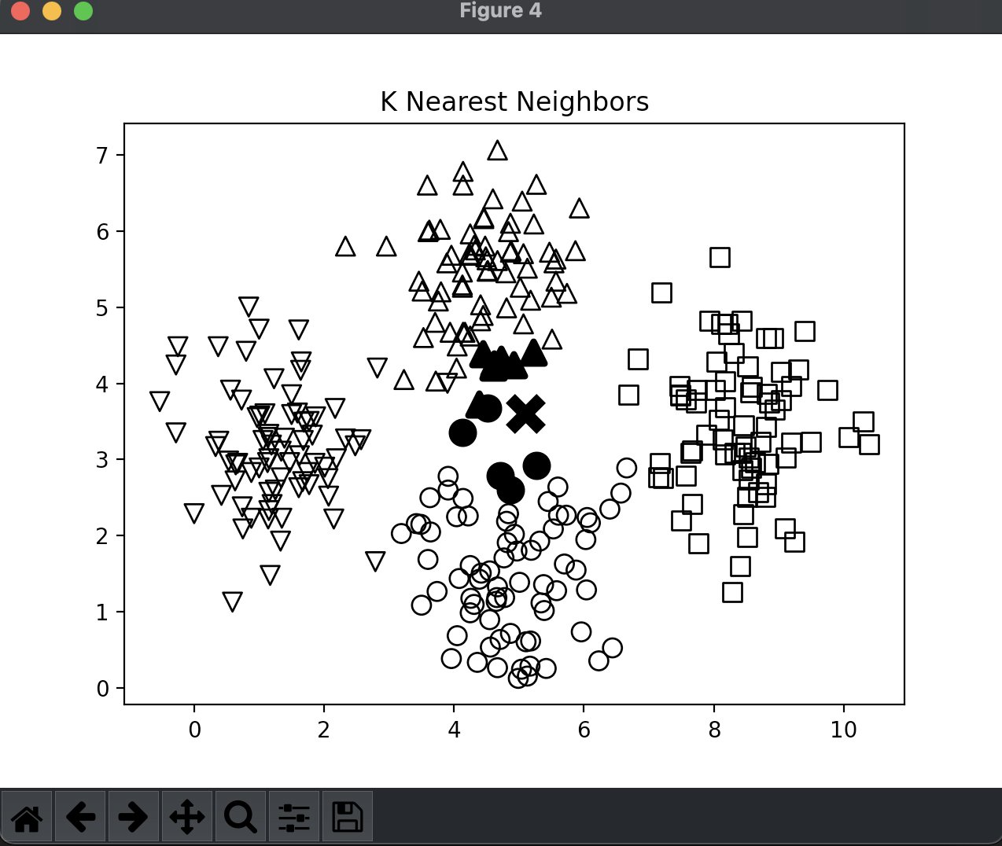

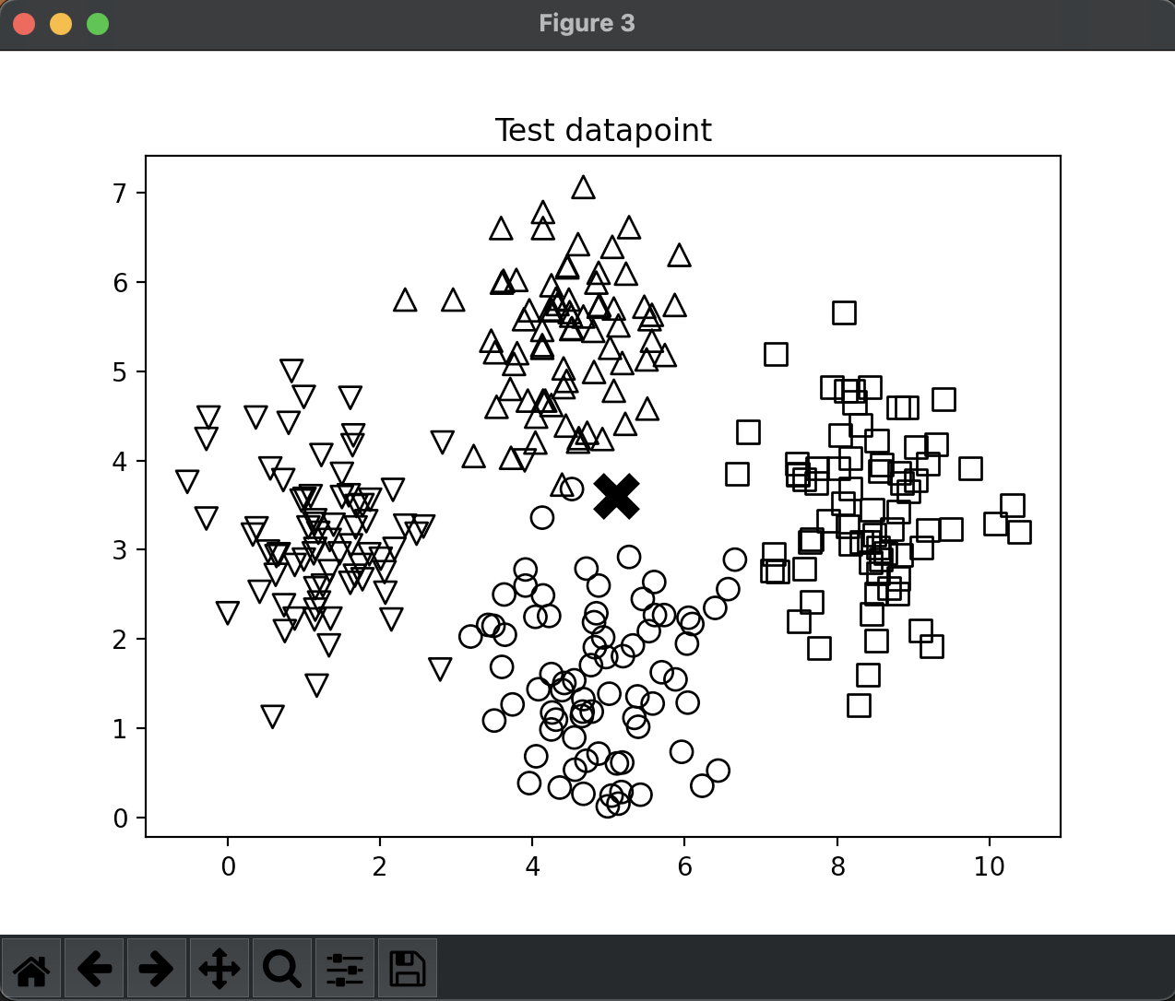

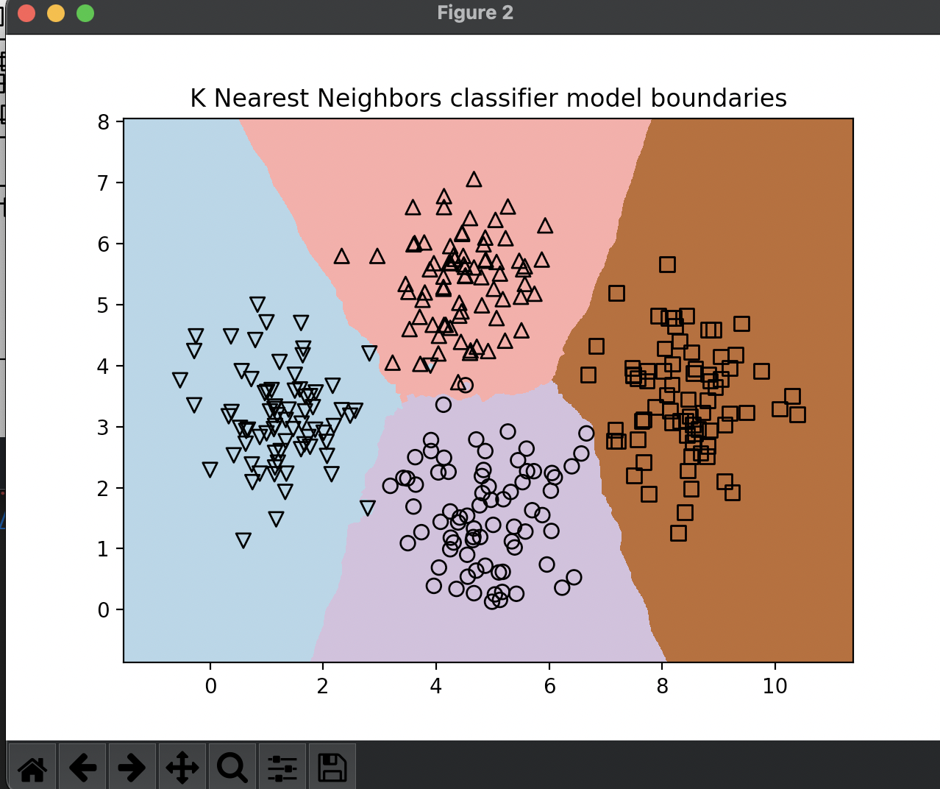

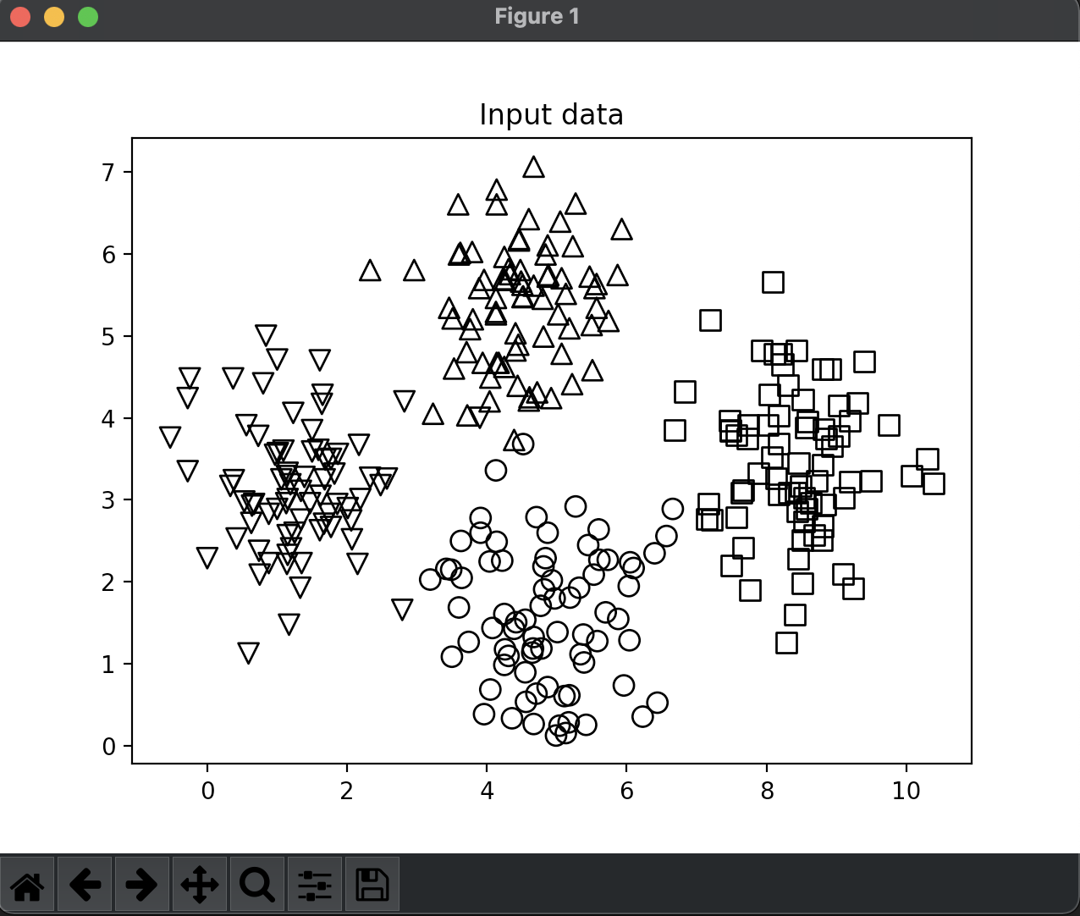

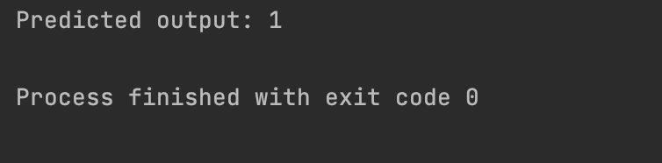

import numpy as np  
import matplotlib.pyplot as plt  
import matplotlib.cm as cm  
from sklearn import neighbors, datasets  
  
input_file = 'data.txt'  
data = np.loadtxt(input_file, delimiter=',')  
X, y = data[:, :-1], data[:, -1].astype(np.int)  
  
plt.figure()  
plt.title('Input data')  
marker_shapes = 'v^os'  
mapper = [marker_shapes[i] for i in y]  
for i in range(X.shape[0]):  
 plt.scatter(X[i, 0], X[i, 1], marker=mapper[i],  
 s=75, edgecolors='black', facecolors='none')  
  
  
num_neighbors = 12  
  
  
step_size = 0.01  
  
  
classifier = neighbors.KNeighborsClassifier(num_neighbors, weights='distance')  
  
  
classifier.fit(X, y)  
  
  
x_min, x_max = X[:, 0].min() - 1, X[:, 0].max() + 1  
y_min, y_max = X[:, 1].min() - 1, X[:, 1].max() + 1  
x_values, y_values = np.meshgrid(np.arange(x_min, x_max, step_size),  
 np.arange(y_min, y_max, step_size))  
  
  
output = classifier.predict(np.c_[x_values.ravel(), y_values.ravel()])  
  
  
output = output.reshape(x_values.shape)  
plt.figure()  
plt.pcolormesh(x_values, y_values, output, cmap=cm.Paired)  
  
  
for i in range(X.shape[0]):  
 plt.scatter(X[i, 0], X[i, 1], marker=mapper[i],  
 s=50, edgecolors='black', facecolors='none')  
  
plt.xlim(x_values.min(), x_values.max())  
plt.ylim(y_values.min(), y_values.max())  
plt.title('K Nearest Neighbors classifier model boundaries')  
  
  
test_datapoint = [5.1, 3.6]  
plt.figure()  
plt.title('Test datapoint')  
for i in range(X.shape[0]):  
 plt.scatter(X[i, 0], X[i, 1], marker=mapper[i],  
 s=75, edgecolors='black', facecolors='none')  
  
plt.scatter(test_datapoint[0], test_datapoint[1], marker='x',  
 linewidth=6, s=200, facecolors='black')  
  
  
_, indices = classifier.kneighbors([test_datapoint])  
indices = indices.astype(np.int)[0]  
  
  
plt.figure()  
plt.title('K Nearest Neighbors')  
  
for i in indices:  
 plt.scatter(X[i, 0], X[i, 1], marker=mapper[y[i]],  
 linewidth=3, s=100, facecolors='black')  
  
plt.scatter(test_datapoint[0], test_datapoint[1], marker='x',  
 linewidth=6, s=200, facecolors='black')  
  
for i in range(X.shape[0]):  
 plt.scatter(X[i, 0], X[i, 1], marker=mapper[i],  
 s=75, edgecolors='black', facecolors='none')  
  
print("Predicted output:", classifier.predict([test_datapoint])[0])  
  
plt.show()

**Завдання 2.4. Обчислення оцінок подібності**

import argparse  
import json  
import numpy as np  
  
  
def pearson_score(dataset, user1, user2):  
 if user1 not in dataset:  
 raise TypeError('Cannot find ' + user1 + ' in the dataset')  
  
 if user2 not in dataset:  
 raise TypeError('Cannot find ' + user2 + ' in the dataset')  
  
 common_movies = {}  
  
 for item in dataset[user1]:  
 if item in dataset[user2]:  
 common_movies[item] = 1  
  
 num_ratings = len(common_movies)  
  
 if num_ratings == 0:  
 return 0  
  
 user1_sum = np.sum([dataset[user1][item] for item in common_movies])  
 user2_sum = np.sum([dataset[user2][item] for item in common_movies])  
  
 user1_squared_sum = np.sum([np.square(dataset[user1][item]) for item in common_movies])  
 user2_squared_sum = np.sum([np.square(dataset[user2][item]) for item in common_movies])  
  
 sum_of_products = np.sum([dataset[user1][item] * dataset[user2][item] for item in common_movies])  
  
 Sxy = sum_of_products - (user1_sum * user2_sum / num_ratings)  
 Sxx = user1_squared_sum - np.square(user1_sum) / num_ratings  
 Syy = user2_squared_sum - np.square(user2_sum) / num_ratings  
  
 if Sxx * Syy == 0:  
 return 0  
  
 return Sxy / np.sqrt(Sxx * Syy)  
  
  
def find_similar_users(dataset, user, num_users):  
 if user not in dataset:  
 raise TypeError('Cannot find ' + user + ' in the dataset')  
  
 scores = np.array([[x, pearson_score(dataset, user,  
 x)] for x in dataset if x != user])  
  
  
 scores_sorted = np.argsort(scores[:, 1])[::-1]  
  
 top_users = scores_sorted[:num_users]  
  
 return scores[top_users]  
  
  
def build_arg_parser():  
 parser = argparse.ArgumentParser(description='Find the movie recommendations for the given user')  
 parser.add_argument('--user', dest='user', required=True,  
 help='Input user')  
 return parser  
  
  
  
def get_recommendations(dataset, input_user):  
 if input_user not in dataset:  
 raise TypeError('Cannot find ' + input_user + ' in the dataset')  
  
 overall_scores = {}  
 similarity_scores = {}  
  
 for user in [x for x in dataset if x != input_user]:  
 similarity_score = pearson_score(dataset, input_user, user)  
  
 if similarity_score <= 0:  
 continue  
  
 filtered_list = [x for x in dataset[user] if x not in \  
 dataset[input_user] or dataset[input_user][x] == 0]  
  
 for item in filtered_list:  
 overall_scores.update({item: dataset[user][item] * similarity_score})  
 similarity_scores.update({item: similarity_score})  
  
 if len(overall_scores) == 0:  
 return ['No recommendations possible']  
  
 movie_scores = np.array([[score / similarity_scores[item], item]  
 for item, score in overall_scores.items()])  
  
 movie_scores = movie_scores[np.argsort(movie_scores[:, 0])[::-1]]  
  
 movie_recommendations = [movie for _, movie in movie_scores]  
  
 return movie_recommendations  
  
  
if __name__ == '__main__':  
 args = build_arg_parser().parse_args()  
 user = args.user  
  
 ratings_file = 'ratings.json'  
  
 with open(ratings_file, 'r') as f:  
 data = json.loads(f.read())  
  
 print("\nMovie recommendations for " + user + ":")  
 movies = get_recommendations(data, user)  
 for i, movie in enumerate(movies):  
 print(str(i + 1) + '. ' + movie)



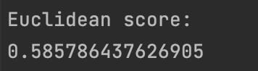



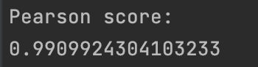



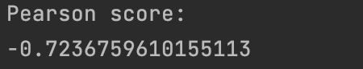



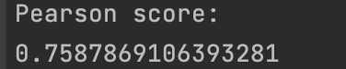



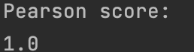

**Завдання 2.5. Пошук користувачів зі схожими уподобаннями**

**методом колаборативної фільтрації**



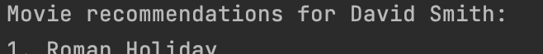



import argparse  
import json  
import numpy as np  
  
  
def pearson_score(dataset, user1, user2):  
 if user1 not in dataset:  
 raise TypeError('Cannot find ' + user1 + ' in the dataset')  
  
 if user2 not in dataset:  
 raise TypeError('Cannot find ' + user2 + ' in the dataset')  
  
 common_movies = {}  
  
 for item in dataset[user1]:  
 if item in dataset[user2]:  
 common_movies[item] = 1  
  
 num_ratings = len(common_movies)  
  
 if num_ratings == 0:  
 return 0  
  
  
 user1_sum = np.sum([dataset[user1][item] for item in common_movies])  
 user2_sum = np.sum([dataset[user2][item] for item in common_movies])  
  
  
 user1_squared_sum = np.sum([np.square(dataset[user1][item]) for item in common_movies])  
 user2_squared_sum = np.sum([np.square(dataset[user2][item]) for item in common_movies])  
  
 sum_of_products = np.sum([dataset[user1][item] * dataset[user2][item] for item in common_movies])  
  
 Sxy = sum_of_products - (user1_sum * user2_sum / num_ratings)  
 Sxx = user1_squared_sum - np.square(user1_sum) / num_ratings  
 Syy = user2_squared_sum - np.square(user2_sum) / num_ratings  
  
 if Sxx * Syy == 0:  
 return 0  
  
 return Sxy / np.sqrt(Sxx * Syy)  
def find_similar_users(dataset, user, num_users):  
 if user not in dataset:  
 raise TypeError('Cannot find ' + user + ' in the dataset')  
  
 scores = np.array([[x, pearson_score(dataset, user,  
 x)] for x in dataset if x != user])  
  
 scores_sorted = np.argsort(scores[:, 1])[::-1]  
  
 top_users = scores_sorted[:num_users]  
  
 return scores[top_users]  
  
  
def build_arg_parser():  
 parser = argparse.ArgumentParser(description='Find the movie recommendations for the given user')  
 parser.add_argument('--user', dest='user', required=True,  
 help='Input user')  
 return parser  
  
  
def get_recommendations(dataset, input_user):  
 if input_user not in dataset:  
 raise TypeError('Cannot find ' + input_user + ' in the dataset')  
  
 overall_scores = {}  
 similarity_scores = {}  
  
 for user in [x for x in dataset if x != input_user]:  
 similarity_score = pearson_score(dataset, input_user, user)  
  
 if similarity_score <= 0:  
 continue  
  
 filtered_list = [x for x in dataset[user] if x not in \  
 dataset[input_user] or dataset[input_user][x] == 0]  
  
 for item in filtered_list:  
 overall_scores.update({item: dataset[user][item] * similarity_score})  
 similarity_scores.update({item: similarity_score})  
  
 if len(overall_scores) == 0:  
 return ['No recommendations possible']  
  
 movie_scores = np.array([[score / similarity_scores[item], item]  
 for item, score in overall_scores.items()])  
  
 movie_scores = movie_scores[np.argsort(movie_scores[:, 0])[::-1]]  
  
 movie_recommendations = [movie for _, movie in movie_scores]  
  
 return movie_recommendations  
  
  
if __name__ == '__main__':  
 args = build_arg_parser().parse_args()  
 user = args.user  
  
 ratings_file = 'ratings.json'  
  
 with open(ratings_file, 'r') as f:  
 data = json.loads(f.read())  
  
 print("\nMovie recommendations for " + user + ":")  
 movies = get_recommendations(data, user)  
 for i, movie in enumerate(movies):  
 print(str(i + 1) + '. ' + movie)

**Завдання 2.6.Створення рекомендаційної системи фільмів**



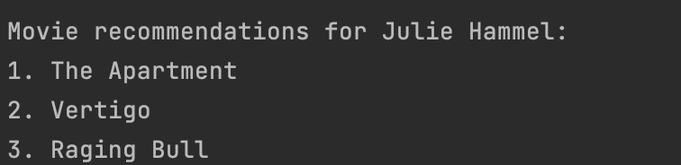



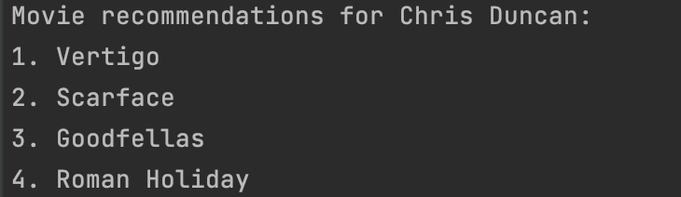

import argparse  
import json  
import numpy as np  
  
  
def pearson_score(dataset, user1, user2):  
 if user1 not in dataset:  
 raise TypeError('Cannot find ' + user1 + ' in the dataset')  
  
 if user2 not in dataset:  
 raise TypeError('Cannot find ' + user2 + ' in the dataset')  
  
 common_movies = {}  
  
 for item in dataset[user1]:  
 if item in dataset[user2]:  
 common_movies[item] = 1  
  
 num_ratings = len(common_movies)  
  
 if num_ratings == 0:  
 return 0  
  
  
 user1_sum = np.sum([dataset[user1][item] for item in common_movies])  
 user2_sum = np.sum([dataset[user2][item] for item in common_movies])  
  
  
 user1_squared_sum = np.sum([np.square(dataset[user1][item]) for item in common_movies])  
 user2_squared_sum = np.sum([np.square(dataset[user2][item]) for item in common_movies])  
  
 sum_of_products = np.sum([dataset[user1][item] * dataset[user2][item] for item in common_movies])  
  
 Sxy = sum_of_products - (user1_sum * user2_sum / num_ratings)  
 Sxx = user1_squared_sum - np.square(user1_sum) / num_ratings  
 Syy = user2_squared_sum - np.square(user2_sum) / num_ratings  
  
 if Sxx * Syy == 0:  
 return 0  
  
 return Sxy / np.sqrt(Sxx * Syy)  
def find_similar_users(dataset, user, num_users):  
 if user not in dataset:  
 raise TypeError('Cannot find ' + user + ' in the dataset')  
  
 scores = np.array([[x, pearson_score(dataset, user,  
 x)] for x in dataset if x != user])  
  
 scores_sorted = np.argsort(scores[:, 1])[::-1]  
  
 top_users = scores_sorted[:num_users]  
  
 return scores[top_users]  
def build_arg_parser():  
 parser = argparse.ArgumentParser(description='Find the movie recommendations for the given user')  
 parser.add_argument('--user', dest='user', required=True,  
 help='Input user')  
 return parser  
  
  
  
def get_recommendations(dataset, input_user):  
 if input_user not in dataset:  
 raise TypeError('Cannot find ' + input_user + ' in the dataset')  
  
 overall_scores = {}  
 similarity_scores = {}  
  
 for user in [x for x in dataset if x != input_user]:  
 similarity_score = pearson_score(dataset, input_user, user)  
  
 if similarity_score <= 0:  
 continue  
  
 filtered_list = [x for x in dataset[user] if x not in \  
 dataset[input_user] or dataset[input_user][x] == 0]  
  
 for item in filtered_list:  
 overall_scores.update({item: dataset[user][item] * similarity_score})  
 similarity_scores.update({item: similarity_score})  
  
 if len(overall_scores) == 0:  
 return ['No recommendations possible']  
  
 movie_scores = np.array([[score / similarity_scores[item], item]  
 for item, score in overall_scores.items()])  
  
 movie_scores = movie_scores[np.argsort(movie_scores[:, 0])[::-1]]  
  
 movie_recommendations = [movie for _, movie in movie_scores]  
  
 return movie_recommendations  
  
  
if __name__ == '__main__':  
 args = build_arg_parser().parse_args()  
 user = args.user  
  
 ratings_file = 'ratings.json'  
  
 with open(ratings_file, 'r') as f:  
 data = json.loads(f.read())  
  
 print("\nMovie recommendations for " + user + ":")  
 movies = get_recommendations(data, user)  
 for i, movie in enumerate(movies):  
 print(str(i + 1) + '. ' + movie)

Висновок: Отже я використовуючи спеціалізовані бібліотеки та мову програмування Python навчитився створювати рекомендаційні системи.