**Multiple Choice System by Qiuer Zhu (Chaozy)**

The system consists 5 features:

1. Create and write questions into a txt.file
2. Edit a specific question
3. Run the multiple choice question examination
4. Display what is inside the file
5. Append a question to the end of the file.

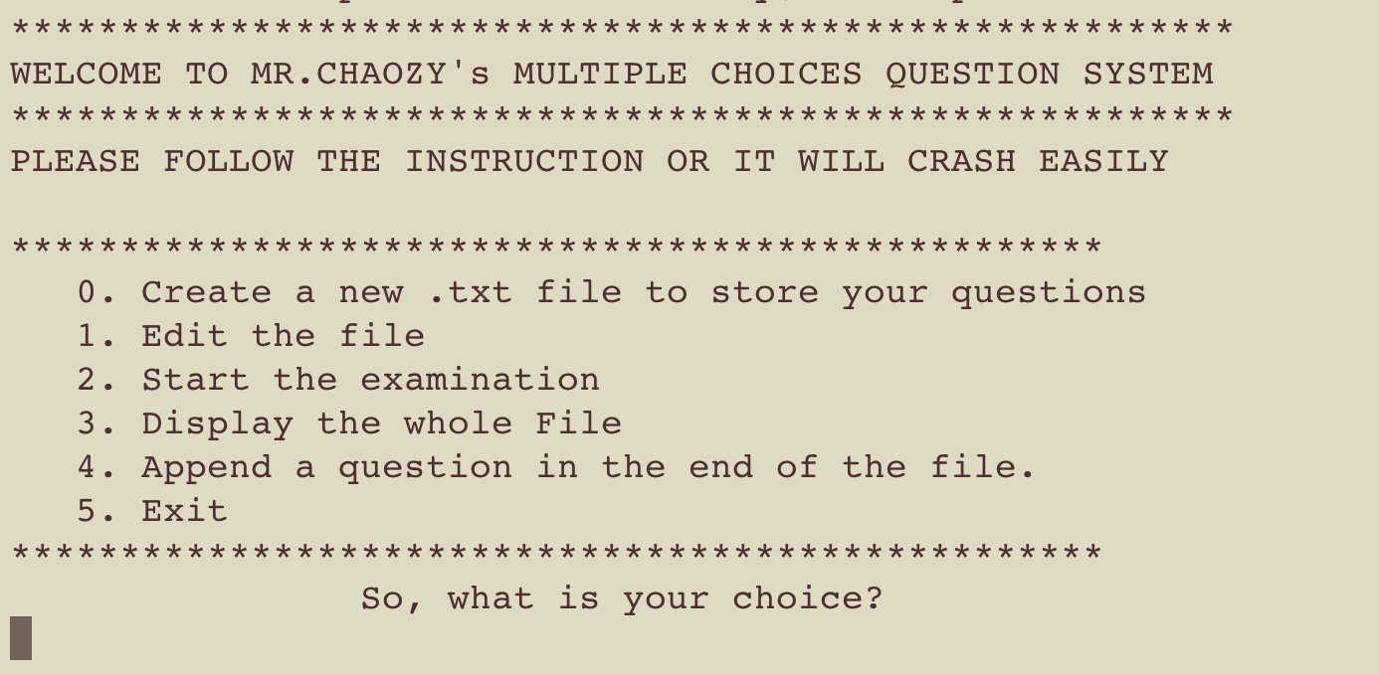

This is the message it shows when user runs the program. It’s a simple FSM to let the user choose the next operation.

In the condition of create and write question into a file, the write() function requires user to enter the numbers of questions, possible answers and valid answers which are about to be entered.

(A txt.file contains 5 questions has been created)

In the condition of editing the file, the index of the question which requires editing needs to be entered, the same writing question process is carried out since basically the same function writeQuestion() is called.

When examination() is called, file is read and questions are displayed. User first enters the number of correct answers and then the **indexes** of the answers one by one. The result will be displayed in the end. In my system, one valid answer scores 1 mark, so if a question has 3 valid answers and only 2 is entered then the mark for this question would be 1 (wrong answer will get -1 mark).

BUGS Report (so far)

1. A global variable arry user_group which contains 1000 structs is used, which will cause problems in reading the file. The solution is writing a function which define the struct and return the array contains the structs. When read file is needed it can call this function so the array is overwritten. (have no time to fix that)
2. When readfile() is called, the last question will be read twice ( can be seen by choosing displayFile). Still have no idea about the cause.