Construction of the WRC-1992 Diagram
Digitization and validation methodology for the interactive teaching app
University West · July 2026 · wrc-1992.vercel.app

1. Background and source material
The WRC-1992 constitution diagram (Kotecki & Siewert, 1992) predicts the Ferrite Number (FN) and the solidification mode (A / AF / FA / F) of stainless steel weld metal from its chemical composition, expressed as a chromium and a nickel equivalent:
Cr_{eq} = %Cr + %Mo + 0.7·%Nb
Ni_{eq} = %Ni + 35·%C + 20·%N + 0.25·%Cu
Unlike the Schaeffler diagram, the WRC-1992 nickel equivalent includes nitrogen and copper. The diagram itself — thirty iso-FN lines from 0 to 100 FN fanning across the axis window Cr_{eq} 17–31, Ni_{eq} 9–18, plus three solidification-mode boundaries — was published as a drawn figure. The positions of these lines were produced by regression on more than 950 measured weld metals, but the underlying line equations were never published. Any faithful software implementation must therefore recover the geometry from the published figure itself.
The source used is the original paper: D. J. Kotecki and T. A. Siewert, "WRC-1992 Constitution Diagram for Stainless Steel Weld Metals: A Modification of the WRC-1988 Diagram", Welding Journal 71(5), May 1992, pp. 171s–178s. The paper is openly available from the American Welding Society and is marked as a contribution of NIST not subject to copyright. Figure 6 — a full-page rendition of the diagram with a 1-unit grid in both axes — served as the digitization source. Crucially, the same paper also contains numeric anchors: two fully worked dilution examples and Table 1 with 36 duplex weld compositions listing Creq, Nieq and calculated FN. These anchors make the digitization self-validating: the geometry is extracted from the figure and then required to reproduce the paper’s own numbers.

2. Digitization pipeline
The geometry was recovered by a reproducible Python pipeline (OpenCV/NumPy, kept in scripts/digitize/ in the repository) in four steps:
- Rendering. The figure page was rasterized from the PDF at 600 dpi and rotated to put Creq on the horizontal axis, giving roughly 345 pixels per equivalent unit.
- Grid calibration. The thin, long grid lines were isolated by morphological opening with long straight kernels. The pixel positions of 14 of 15 vertical and all 10 horizontal grid lines (one vertical line is broken in the print) were then fitted by least squares to the known integer grid, Creq 17–31 and Nieq 9–18. The affine pixel-to-unit transform reproduces the grid with a maximum residual below 0.02 equivalent units — the calibration error is therefore negligible compared with the drawing line width itself.
- Extraction of the 29 solid iso-FN lines. The iso-FN strokes are drawn much thicker than the grid. Erosion removed everything thin (grid, dash-dot curves, text), and the surviving thick strokes were grouped into connected components. Components were filtered by elongation (to discard the FN digit labels) and merged when collinear, since each line is interrupted by its own embedded label. A total-least-squares fit of every merged pixel cluster produced one straight line per FN value. Exactly 29 lines were found, matching the published set FN = 2, 4, …, 30, 35, 40, …, 100.
- Tracing of the dash-dot curves. The FN = 0 line is not one of the solid lines: in the original figure it is drawn dash-dot and slightly curved, and it simultaneously acts as the boundary between the A and AF solidification regions. It and the AF/FA boundary were traced by direction-aware chaining of the dash fragments; the FA/F boundary, which crosses the densest part of the fan and fragments badly, was recovered by a guided pass — dash fragments collected inside a corridor around a manually seeded polyline, followed by a robust quadratic fit (final residual 0.010 units). All three curves are stored as polylines, preserving their curvature.

3. Verification

3.1 Visual check
An overlay script redraws every digitized element on top of the original 600-dpi scan — the 29 straight iso-FN lines with their assigned FN values in red, the three traced dash-dot curves in blue. The digitization was iterated until every redrawn line covered its printed counterpart:
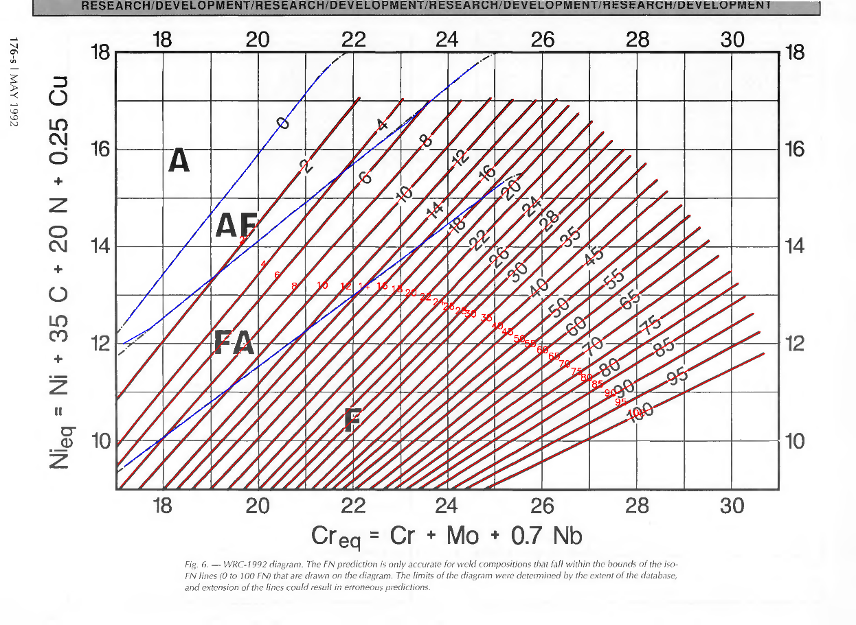
Digitized geometry (red: iso-FN lines, blue: FN 0 and mode boundaries) overlaid on Figure 6 of the original paper.

3.2 Numeric anchor gate
The script that emits the application’s data file first re-implements the app’s FN interpolation in Python and evaluates all numeric anchors from the paper. If any anchor fails its tolerance, no data file is written. The tolerances are ±2 FN where the expected value is at most 30 FN and ±4 FN above (the paper itself notes reduced accuracy at high FN; the Table 1 values were computed from the underlying regression rather than read off the drawn lines). All anchors passed:
Point (Creq, Nieq) | Paper FN | App FN | Tol. | Source in the 1992 paper
(20.30, 13.60) | 4.6 | 4.6 | ±2 | Example 1, point C (E312-16 on AISI 1050, 30 % dilution)
(29.00, 11.90) | 88.2 | 88.7 | ±4 | Example 1, E312-16 all-weld-metal
(24.60, 14.95) | 17.4 | 17.5 | ±2 | Example 2, E309L-16 all-weld-metal
(20.04, 13.39) | 4.3 | 4.3 | ±2 | Example 2, point H (root pass 304 + A36)
(18.83, 12.45) | 3.2 | 3.2 | ±2 | Example 2, AISI 304 plate
(28.10, 15.50) | 36 | 36.1 | ±4 | Table 1, weld 9292-622 (probed just inside the fan)
(28.14, 14.57) | 46 | 46.3 | ±4 | Table 1, weld 9276-057
(23.13, 10.81) | 40 | 36.4 | ±4 | Table 1, weld 9276-854
(25.95, 12.03) | 56 | 56.2 | ±4 | Table 1, weld 9276-904
(23.72, 10.36) | 54 | 54.5 | ±4 | Table 1, weld 9276-853
(24.02, 9.81) | 69 | 70.0 | ±4 | Table 1, weld 9276-817
(28.19, 10.66) | 99 | 99.4 | ±5 | Table 1, weld 9292-202 (FN 100 edge)
Note: Table 1 weld 9292-622 lies at (28.61, 15.81), marginally beyond the drawn tip of the FN 35 line. The app deliberately answers "outside the prediction region" at that exact point — the figure caption warns that extending the lines could give erroneous predictions — so the anchor was probed at the nearest point inside the fan.
The five worked-example anchors agree with the paper to within 0.5 FN, which strongly suggests Kotecki and Siewert read those examples off the same drawn lines that were digitized here.

4. How the app evaluates the diagram
- Ferrite Number. The iso-FN lines fan out and are not parallel, and the FN spacing is nonuniform (steps of 2 up to FN 30, then steps of 5). The app therefore interpolates by signed perpendicular distance: for a query point, the two neighbouring iso-FN lines with opposite-signed distances are found, and FN is interpolated in proportion to the two distances. This is well defined everywhere in the fan and handles the varying line spacing automatically.
- Validity region. A prediction is returned only inside the polygon bounded by the drawn extent of the iso-FN lines (the FN 0 curve, the line end envelope, the FN 100 line and the axis border). In the fully austenitic A region, FN = 0 is returned by definition. Everywhere else the app reports that no prediction is possible, following the figure caption’s explicit warning against extrapolation.
- Solidification mode. The A/AF, AF/FA and FA/F boundaries are stored as digitized polylines and extended linearly (invisibly) to the axis border, so that every point in the axis window classifies to exactly one mode by point-in-polygon test. Only the digitized extents are drawn.
- Dilution and multi-pass welding. Because both equivalents are linear in composition, mixtures of base metals A and B, filler dilution and successive weld passes are straight-line constructions in the diagram — exactly the graphical procedure demonstrated in the paper’s Examples 1 and 2, which the app reproduces end-to-end in its test suite.

5. Locking correctness
The same twelve anchors, the domain-gating behaviour, the mode classification and the complete dilution pipeline of the paper’s two worked examples are asserted in the application’s automated test suite (38 tests). The data file carries a generated-file header, and the project instructions forbid editing it by hand: any change to the geometry must go through the digitization pipeline, pass the anchor gate and be inspected in the visual overlay again.

Appendix: Digitized iso-FN line coefficients
The 29 solid iso-FN lines are straight in the (Cr_{eq}, Ni_{eq}) plane, so each can be written exactly as
Ni_{eq} = a + b·Cr_{eq}
The coefficients below are computed from the digitized endpoints. The slope falls monotonically from about 1.21 at FN 2 to about 0.47 at FN 100 — the fan shape of the diagram expressed numerically.
FN | Slope b | Intercept a | Drawn extent (start → end)
2 | 1.2094 | -9.708 | (17.04, 10.90) → (22.15, 17.08)
4 | 1.1791 | -10.152 | (17.04, 9.94) → (23.07, 17.05)
6 | 1.1348 | -9.818 | (17.04, 9.52) → (23.64, 17.01)
8 | 1.1026 | -9.795 | (17.10, 9.06) → (24.31, 17.01)
10 | 1.0810 | -9.889 | (17.52, 9.05) → (24.93, 17.06)
12 | 1.0872 | -10.574 | (18.05, 9.05) → (25.39, 17.03)
14 | 1.0556 | -10.300 | (18.33, 9.05) → (25.88, 17.02)
16 | 1.0431 | -10.414 | (18.66, 9.05) → (26.32, 17.04)
18 | 1.0438 | -10.824 | (19.04, 9.05) → (26.57, 16.91)
20 | 1.0462 | -11.267 | (19.42, 9.05) → (26.78, 16.75)
22 | 1.0301 | -11.294 | (19.75, 9.05) → (27.07, 16.59)
24 | 1.0124 | -11.270 | (20.07, 9.05) → (27.30, 16.37)
26 | 0.9972 | -11.213 | (20.32, 9.05) → (27.48, 16.19)
28 | 0.9721 | -10.955 | (20.58, 9.05) → (27.74, 16.01)
30 | 0.9729 | -11.236 | (20.85, 9.05) → (27.87, 15.88)
35 | 0.9515 | -11.112 | (21.19, 9.05) → (28.20, 15.72)
40 | 0.9044 | -10.323 | (21.42, 9.05) → (28.43, 15.39)
45 | 0.8689 | -9.745 | (21.63, 9.05) → (28.65, 15.15)
50 | 0.8172 | -8.797 | (21.84, 9.05) → (28.95, 14.86)
55 | 0.7977 | -8.588 | (22.11, 9.05) → (29.13, 14.65)
60 | 0.7731 | -8.283 | (22.42, 9.05) → (29.34, 14.40)
65 | 0.7445 | -7.855 | (22.72, 9.06) → (29.53, 14.13)
70 | 0.6996 | -6.995 | (22.95, 9.06) → (29.74, 13.81)
75 | 0.6529 | -6.088 | (23.20, 9.06) → (30.00, 13.50)
80 | 0.6272 | -5.661 | (23.47, 9.06) → (30.15, 13.25)
85 | 0.6022 | -5.265 | (23.79, 9.06) → (30.30, 12.98)
90 | 0.5674 | -4.657 | (24.16, 9.05) → (30.47, 12.63)
95 | 0.5212 | -3.703 | (24.47, 9.05) → (30.61, 12.25)
100 | 0.4733 | -2.731 | (24.89, 9.05) → (30.70, 11.80)
FN 0 is the exception: in the original figure it is drawn dash-dot and is visibly curved, so it cannot be described by a single a + b·Cr_{eq} equation. It is stored as a ten-point polyline: (17.23, 12.47) (17.60, 12.94) (18.08, 13.54) (18.57, 14.15) (19.23, 14.95) (19.61, 15.41) (20.12, 16.05) (20.52, 16.55) (21.17, 17.36) (21.53, 17.74).
Three caveats apply when using these coefficients:
- They are digitized, not the original regression. The values derive from the drawn figure (accuracy about ±0.05 equivalent units), not from Kotecki & Siewert’s unpublished regression equations. They do, however, reproduce the paper’s own worked examples to within 0.5 FN, so for practical and teaching purposes they are equivalent.
- Validity is limited to the drawn segments. Each equation may only be evaluated within the extent given in the last column — the figure caption explicitly warns that extending the lines could give erroneous predictions.
- The app does not use the a + b form internally. The application works directly with the endpoints and interpolates by signed perpendicular distance between neighbouring lines, which handles the curved FN 0 boundary and the nonuniform FN steps (2-steps up to FN 30, then 5-steps) uniformly.

References
- Kotecki, D. J. & Siewert, T. A. (1992). WRC-1992 Constitution Diagram for Stainless Steel Weld Metals: A Modification of the WRC-1988 Diagram. Welding Journal, 71(5), 171s–178s. https://s3.us-east-1.amazonaws.com/WJ-www.aws.org/supplement/WJ_1992_05_s171.pdf
- Siewert, T. A., McCowan, C. N. & Olson, D. L. (1988). Ferrite Number prediction to 100 FN in stainless steel weld metal. Welding Journal, 67(12), 289s–298s.
- ANSI/AWS A4.2 and ISO 8249: standards defining the Ferrite Number scale and its magnetic measurement.
- Application source code and digitization pipeline: private repository wrc-1992 (scripts/digitize/), deployed at https://wrc-1992.vercel.app.

