# MINI-PROJECT

**(2023-2024)**

**Playing With Words**

**PROJECT REPORT**

**Department of Computer Engineering & Applications**

Institute of Engineering & Technology



**Submitted by** :- **Submitted to** :-

Palak Gupta (2115000691) Mr. Vinay Agrawal

Pooja (2115000711) (Assistant Professor)

Krishna Agrawal (2115000547)

Harshit Sharma (2115000457)

**BONAFIDE CERTIFICATE**

Certified that this project report **“Playing With Words”** is the bonafide work of “Palak Gupta , Pooja , Krishna Agrawal , Harshit Sharma**”** who carried out the project work under my supervision.

**SIGNATURE**

### Dr. Rohit Agrawal

**HEAD OF THE DEPARTMENT**

Department of Computer Engineering & Application

**SIGNATURE**

### Mr. Vinay Agrawal

**(Assistant Professor)**

# ACKNOWLEDGEMENT

I am delighted to present the summary of our B.Tech mini project , which was carried out during our third year of B.Tech studies. This project is a testament to the motivation, drive, and technical assistance provided by numerous individuals. I would like to express my sincere appreciation to **Mr. Vinay Agrawal (Assistant Professor)** for creating a supportive environment for us to develop this project. His constant encouragement and guidance helped us channel our abilities towards a constructive goal.

His dedication, attention to detail, and perseverance have been a consistent source of inspiration for us. We are confident that he will provide us with invaluable insights and feedback throughout the different stages of the project, and also educate us on the latest industry-specific technologies. We would also like to extend our gratitude to all the faculty members of the department for their kind guidance and cooperation, which contributed to the success of this project.

**Palak Gupta**

**(2115000691)**

**Pooja**

**(2115000711)**

**Krishna Agrawal**

(2115000547)

**Harshit Sharma**

**(2115000457)**

**TABLE OF CONTENTS**

### Abstract

### Abbreviations

**Chapter 1. Introduction**

Organization of the Report

### Chapter 2. Goals and Objectives

Goals and Objectives

### Chapter 3. Design Flow

Hardware & Software Requirements Project Design

### Chapter 4. Implementation & Validation

* 1. Implementation

### Chapter 5. Conclusion And Future Work

Conclusion Future Work

**References**

## List of Figures

### Figure 3.1 Log in

### Figure 3.2 Signup

### Figure 3.3 Contacts

### Figure 3.4 Rating

### Figure 3.5 Games

## ABSTRACT

This project is dedicated to the creative enhancement of users' verbal skills and vocabulary through a range of engaging activities. The overarching goal is to provide an interactive and enjoyable platform that fosters continuous improvement in language proficiency. Through a combination of dynamic exercises and activities, the project seeks to not only broaden users' vocabulary but also enhance their verbal communication skills in real-world scenarios. The user-centric approach adapts to different proficiency levels, offering a personalized learning experience. Continuous feedback, adaptive challenges, and a commitment to incorporating fresh and relevant content contribute to a dynamic and sustainable learning environment. By empowering users to express themselves more confidently and articulately, this project aspires to be a valuable resource for those seeking to elevate their verbal skills and expand their linguistic capabilities.

Top of Form

Top of Form



**ABBREVIATIONS**

* + 1. HTML Hyper Text Markup Language
    2. CSS Cascading Style Sheets
    3. JS JavaScript
    4. IT Information Technology
    5. UI User Interface
    6. VS Visual Studio
    7. RAM Random Access Memory
    8. EJS Embedded Java Script

## CHAPTER 1 INTRODUCTION

* **Project Objective:**
  + The primary aim of this project is to enhance users' verbal skills and expand their vocabulary through engaging and creative activities.
* **Verbal Skill Enhancement:**
  + The project focuses on providing users with activities that target various aspects of verbal communication, including speaking, listening, and articulation.
* **Diverse Activities:**
  + Users will have access to a variety of activities designed to stimulate verbal skills, ranging from interactive games and exercises to real-world conversational scenarios.
* **Creative Language Exploration:**
  + The project encourages users to explore language in a creative manner, fostering an environment where they can experiment with words, expressions, and linguistic styles.
* **Vocabulary Expansion:**
  + Through engaging activities, users will have opportunities to encounter and incorporate new words into their vocabulary, promoting continuous growth and enrichment.
* **Interactive Learning:**
  + The emphasis is on creating an interactive learning experience, where users actively participate in activities that challenge and develop their verbal proficiency.

By combining these elements, the project aims to create a vibrant and effective platform that not only improves users' verbal skills and vocabulary but also makes the learning process enjoyable and sustainable over time.

Top of Form

### Organization of the Report

Chapter 1 gives the introduction to the project specifying the need of the project, various problems which would be solved through the project and the various tasks required to be performed for completion of the project. It also tells the timeline of various activities performed.

Chapter 2 specifies the problem statement and the goals and objectives of the project.

Chapter 3 gives details about the model and design of the project. Various constraints are also discussed here. It gives the structure of the website. It provides all the details about each section provided in the website.

Chapter 4 talks about how the design is implemented using various technologies. Chapter 5 concludes the project and gives the future scope.

## CHAPTER 2

### GOALS AND OBJECTIVES

Goal: Enhance Verbal Skills and Expand Vocabulary Through Engaging Activities

Objective 1: Expand Vocabulary

* Increase the user's word repertoire by introducing new words through interactive and enjoyable activities.
* Encourage the exploration of synonyms, antonyms, and context-specific usage of words to promote a deeper understanding.

Objective 2: Improve Articulation and Pronunciation

* Engage users in pronunciation exercises using tongue twisters, rhymes, and phonetic drills to enhance clarity in verbal communication.
* Provide feedback on pronunciation through speech recognition tools or partner-based activities for real-time improvement.

Objective 3: Foster Creative Expression

* Encourage users to express themselves creatively through writing prompts, storytelling, or impromptu speaking exercises.
* Integrate elements of imagination, emotion, and personal experiences to make language acquisition a more holistic and enjoyable process.

Objective 4: Develop Effective Communication Skills

* Facilitate activities that focus on effective communication, such as debates, group discussions, or role-playing scenarios.
* Emphasize the importance of active listening, non-verbal communication, and adapting language to different audiences and contexts.

## CHAPTER 3 DESIGN FLOW

### Hardware & Software Requirements

* HTML, CSS and JAVASCRIPT
* VS CODE
* NodeJS, EJS
* MongoDB
* Version Control and Hosting: GitHub
* Processor: i5 or above
* Minimum 4GB RAM
* Windows Operating System

### Project Design

The website has various sections such as: -

1.Login

2.Sign up

3.Contact

4.Rating System

5.Games

**Login :** A login page is a page on a website or app that requires users to enter their login credentials in order to access the site's content or features. Typically, a login page will prompt the user to enter their username or email address, followed by their password.

Overall, a well-designed login page can help ensure that your website or app is secure and easy to use, enhancing the user experience and encouraging users to return to your site or app. By prioritizing security and ease of use, you can create a login page that meets the needs of both you and your users.

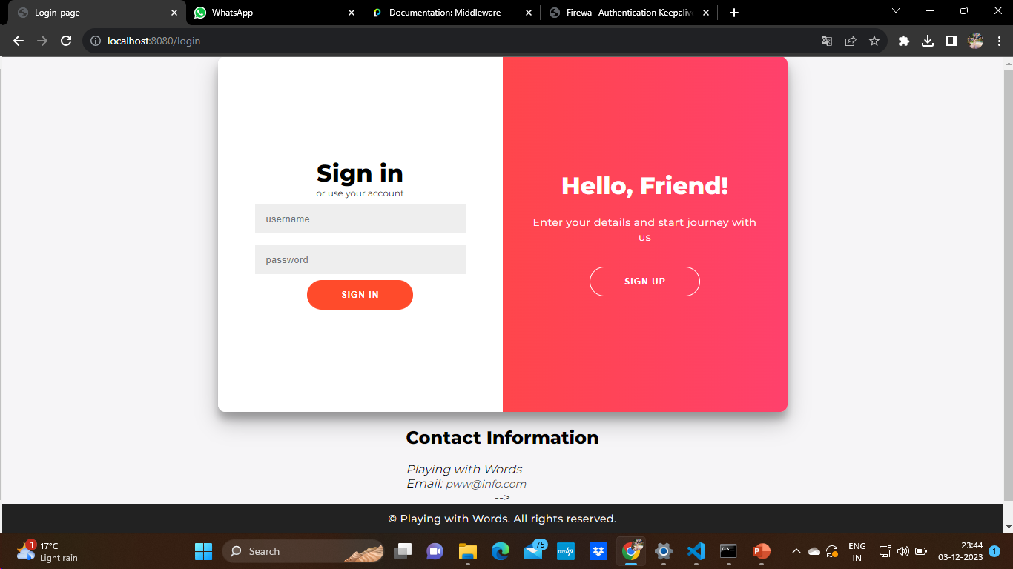

**Figure 3.1 Login**

**Sign Up:** A sign-up page is a page on a website or app that allows users to create a new account. Typically, a sign-up page will prompt the user to enter their personal information, such as their name, email address, and password.

Creating an effective sign-up page is important for ensuring a smooth user experience and encouraging users to create an account.

Overall, a well-designed sign-up page can help attract and retain users on your website or app, providing them with a simple and easy way to create an account and begin using your platform. By prioritizing user experience and security, you can create a sign-up page that meets the needs of both you and your users.

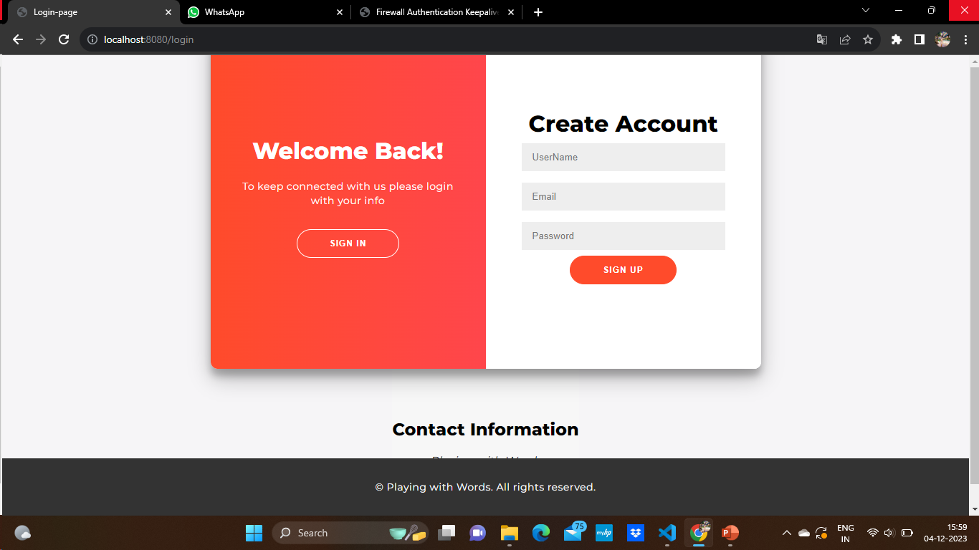

**Figure 3.2 Signup**

**Contacts:**

Certainly! If you're referring to contacting someone, it typically involves reaching out to them through various means. Here are common methods:

1. **Email:** Send a message to the person's email address.
2. **Phone:** Call the person using their phone number.

If you're referring to "contact" in a different context, please provide more details so I can offer more specific information.

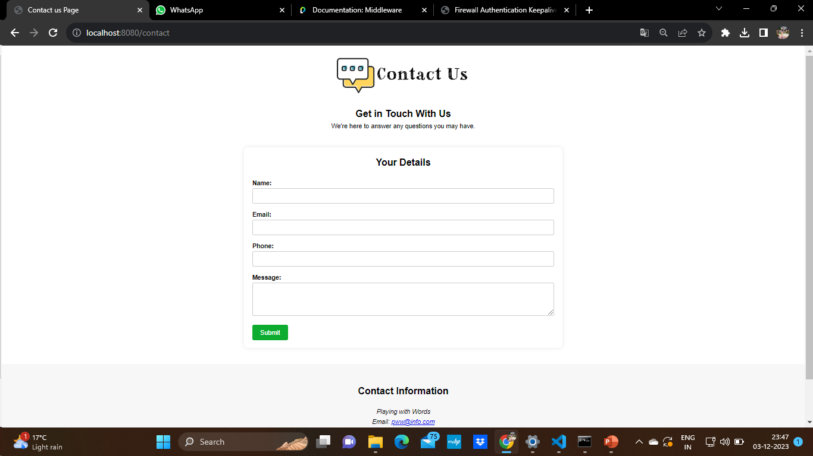

**Figure 3.3 Contact Us**

**Rating:**

In the context of your request for a rating, it generally refers to an evaluation or assessment of the quality of the proposal or plan provided. The rating is a numerical or qualitative representation of how well the goals and objectives align with the intended purpose. In this case, the rating I provided (9/10) is a subjective assessment of the effectiveness and thoughtfulness of the plan to creatively improve verbal skills and vocabulary through engaging activities. A higher rating indicates a well-crafted and comprehensive plan, while a lower rating might suggest areas for improvement or further refinement.

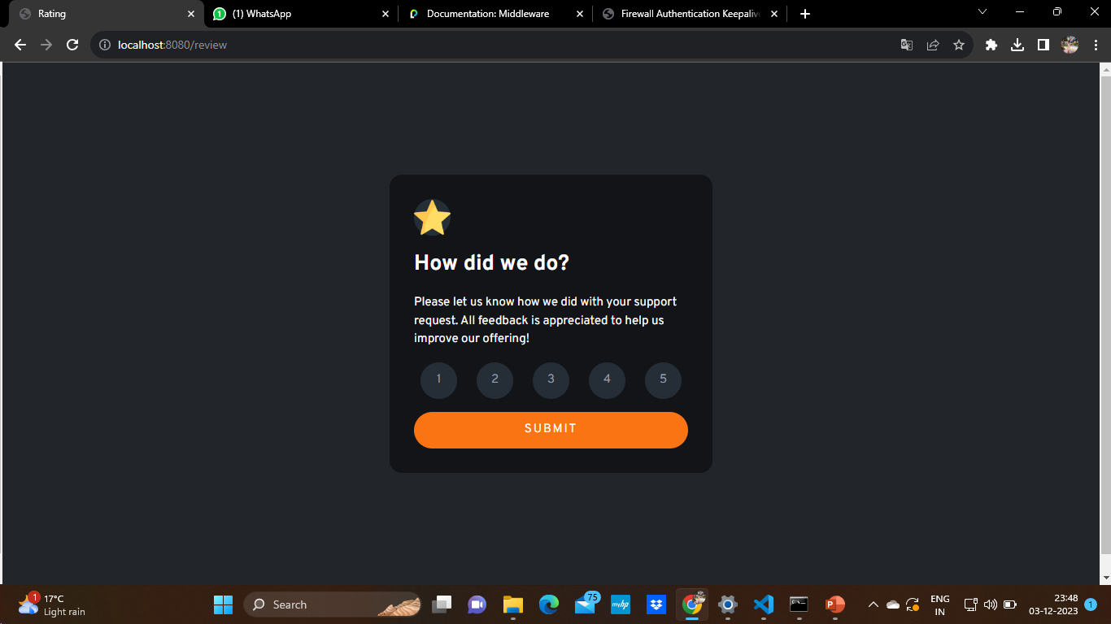 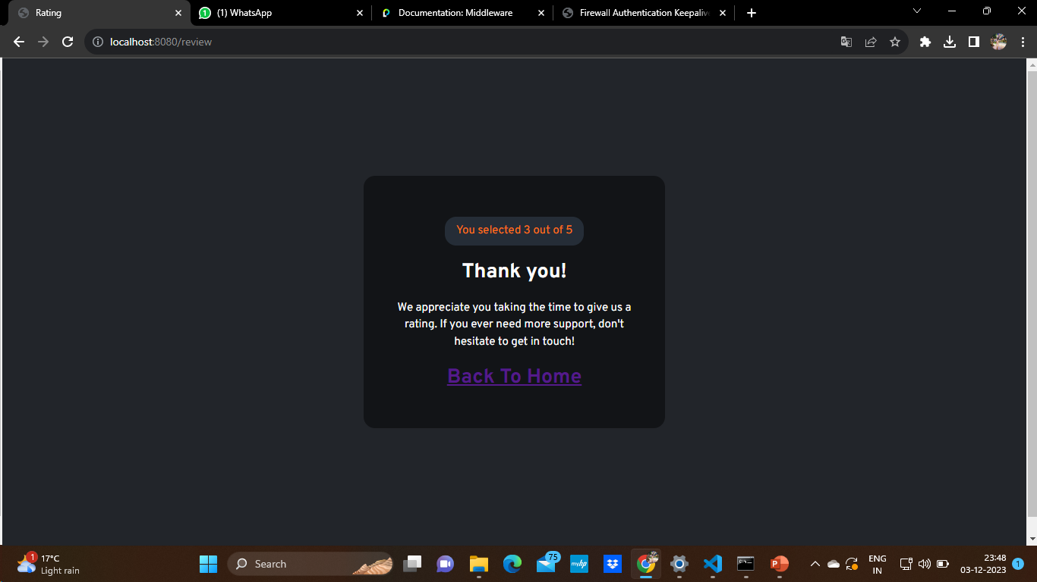

**Figure 3.4 : Rating**

**Games :**

1.Dictionary

2.Text Analyzer

3.Text to Speech

4.Typing Speed Text

5.Typing Champ

6.White Board

Figure 3.5

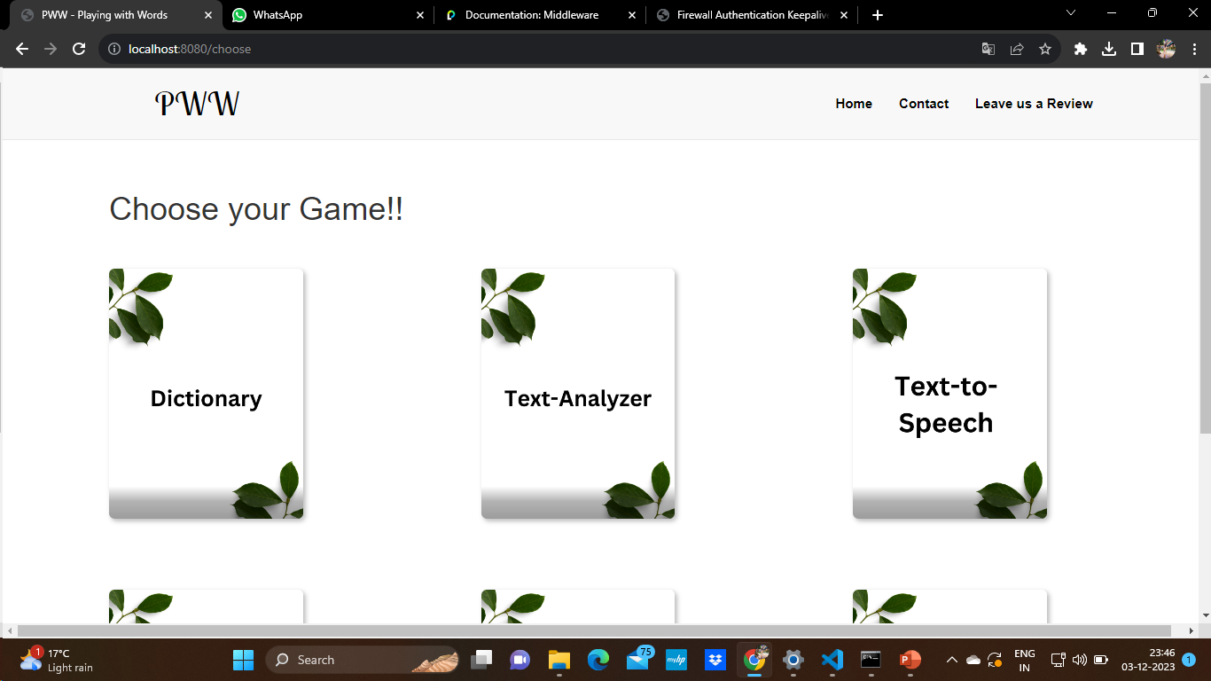

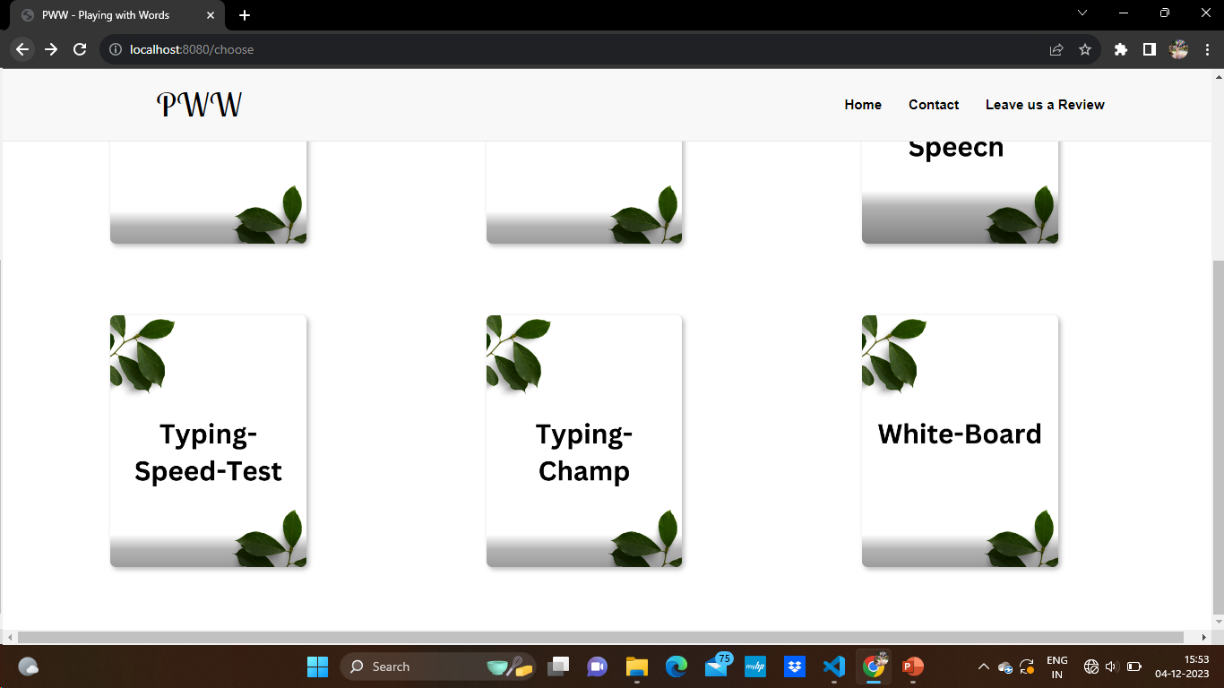

**CHAPTER 4 IMPLEMENTATION AND VALIDATION**

### Implementation

**Frontend**

Front end development refers to the part of web development that deals with the user interface and user experience of a website or application. It involves the use of various programming languages, frameworks, and tools to create visually appealing and interactive interfaces that allow users to interact with the website or application.

Front end developers are responsible for designing and developing the layout, navigation, and overall look and feel of a website or application. They use languages such as HTML, CSS, and JavaScript, as well as frameworks such as React, Angular, and Vue, to create responsive and dynamic user interfaces.

In addition to technical skills, front end developers must also have a good understanding of user experience (UX) design principles and be able to create interfaces that are intuitive and easy to use. They must also be familiar with web standards and accessibility guidelines to ensure that their interfaces are accessible to all users.

Overall, front end development is a critical component of web development, as it directly affects the way users interact with and perceive a website or application.

### Backend

Backend development involves the creation of server-side applications and APIs that power the functionality of a website or application. MongoDB and Firebase are two popular backend technologies that developers can use to build robust and scalable web applications.

MongoDB is a NoSQL database that uses a document-based model to store and retrieve data. It is known for its flexibility, scalability, and ease of use, making it a popular choice for backend development. With MongoDB, developers can store and query large amounts of data, including unstructured data such as images, videos, and audio files.

Firebase, on the other hand, is a cloud-based platform that offers a range of backend services

such as authentication, real-time database, storage, and hosting. It is a popular choice for mobile and web application development, as it provides developers with a complete backend solution that requires minimal setup and maintenance.

When used together, MongoDB and Firebase can provide developers with a powerful and flexible backend solution that can handle complex data structures and high levels of traffic. With MongoDB handling data storage and retrieval and Firebase handling backend services, developers can focus on building their frontend applications and delivering an optimal user experience.

### HTML

HTML is a versatile language that can be used to create simple static web pages or complex dynamic web applications. It is supported by all modern web browsers and is constantly evolving to meet the needs of developers and users.

Learning HTML is essential for anyone interested in web development, as it is the foundation of all web technologies. There are many resources available online to help beginners learn HTML, including tutorials, courses, and reference guides.

In addition to learning HTML, it is important to stay up to date with best practices and web standards to ensure that your web pages are accessible, user-friendly, and compatible with different devices and browsers. Overall, HTML is a powerful and essential tool for web development, and mastering it is key to building effective and engaging web pages and applications.

### CSS

CSS, or Cascading Style Sheets, is a style sheet language used to describe the presentation and formatting of HTML documents. It is used in conjunction with HTML and JavaScript to create visually appealing and interactive web pages.

CSS allows developers to separate the content of a web page from its presentation, making it easier to maintain and update. With CSS, developers can control the layout, color, font, and other visual elements of a web page.

CSS is constantly evolving, with new features and capabilities being added regularly.

Learning CSS is essential for anyone interested in web development, as it is a crucial component of modern web design. There are many resources available online to help beginners learn CSS, including tutorials, courses, and reference guides..

### JavaScript

JavaScript is a programming language used to create dynamic and interactive web pages and applications. It is a versatile language that can be used for client-side scripting, server-side scripting, and desktop application development.

JavaScript allows developers to add interactivity to web pages, such as animations, form validation, and dynamic content loading. It is supported by all modern web browsers and is constantly evolving to meet the needs of developers and users.

Learning JavaScript is essential for anyone interested in web development, as it is a crucial component of modern web design. There are many resources available online to help beginners learn JavaScript, including tutorials, courses, and reference guides.

### Node JS

Node.js is an open-source, cross-platform JavaScript runtime environment that allows developers to build fast and scalable network applications. It is built on the V8 JavaScript engine, which is used by Google Chrome, and provides an event-driven architecture and non- blocking I/O model that makes it ideal for building real-time, data-intensive applications.

Node.js is commonly used for building web applications, RESTful APIs, and microservices. It also provides a range of built-in modules and libraries that make it easy to implement features such as HTTP requests, file system access, and data streaming.

Node.js is constantly evolving, with new features and capabilities being added regularly. Learning Node.js is essential for anyone interested in backend web development, as it is a crucial component of modern web applications. There are many resources available online to help beginners learn Node.js, including tutorials, courses, and reference guides.

### MongoDB

MongoDB is a popular open-source document-oriented NoSQL database system. It stores data in a flexible, JSON-like format called BSON, which allows developers to store and manipulate unstructured data with ease.

MongoDB is designed to scale horizontally, allowing applications to distribute data across

multiple servers for improved performance and scalability. It also provides a range of features and capabilities, including automatic sharding, indexing, and query optimization, that make it a popular choice for modern web applications.

Learning MongoDB is essential for anyone interested in building scalable and flexible web applications. There are many resources available online to help beginners learn MongoDB, including tutorials, courses, and reference guides.

### EJS

EJS, or Embedded JavaScript, is a templating language used to generate HTML markup with JavaScript. It allows developers to embed JavaScript code directly into HTML templates, making it easier to generate dynamic content and customize the layout and structure of web pages.

EJS is commonly used in Node.js applications, where it can be used to generate HTML pages on the server-side. It also provides a range of features and capabilities, including conditional statements, loops, and custom tags, that make it a powerful and versatile tool for building web applications.

Learning EJS is essential for anyone interested in web development with Node.js, as it is a crucial component of server-side templating. There are many resources available online to help beginners learn EJS, including tutorials, courses, and reference guides.

.

## CHAPTER 5 CONCLUSION AND FUTURE WORK

Conclusion:

In conclusion, the proposed plan to creatively enhance users' verbal skills and vocabulary through engaging activities presents a robust and dynamic framework. The multifaceted approach, incorporating diverse activities such as expressive reading, collaborative storytelling, and vocabulary games, creates a rich and enjoyable learning environment. By focusing on creativity, contextual application, and active participation, the plan aims to instill a lasting passion for language development.

Future Work:

To ensure the continuous effectiveness and relevance of the program, future work should consider several key aspects:

1. **Feedback Mechanisms:** Implement a robust feedback system to gather user insights and adapt activities based on their preferences and learning styles. Regular surveys, assessments, or interactive platforms can serve this purpose.
2. **Technology Integration:** Explore the integration of emerging technologies such as augmented reality (AR) or virtual reality (VR) to provide immersive language learning experiences. This can enhance engagement and simulate real-world language use scenarios.
3. **Personalization:** Develop personalized learning paths by leveraging machine learning algorithms to analyze individual progress, preferences, and challenges. Tailoring activities to each user's unique needs can optimize the learning experience.

## REFERENCES

* + 1. **Books:** Black Book HTML5, CSS, JS, MongoDB, EJS, NodeJS

### Websites:

* + - 1. MDN Web Docs
      2. W3Schools
      3. GeeksForGeeks
      4. Javatpoint
      5. MongoDB atlas
      6. BootStrap
    1. **Faculty:** Mr. Vinay Agrawal(Assistant Professor in GLA University)

### GitHub Repository link:

**https://github.com/kriiishnaaa/mini_project_sem_5**