

**Subject Activity Report**

**2023-24**

**SUBJECT: Database Management Systems – BCS403**

**SEM: IV**

**NAME: Krishna R Kulkarni , Krishnendra Samarth , Lekhana G, Maulik D J**

**BRANCH: CSE**

**SECTION: B**

**USN: 1RN22CS069 , 1RN22CS070 , 1RN22CS077 , 1RN2CS087**

**VISION AND MISSION OF INSTITUTION**

## Vision

**Building RNSIT into a World Class Institution**

## Mission

#### To impart high quality education in Engineering, Technology and Management with a Difference, Enabling Students to Excel in their Career by

1. Attracting quality Students and preparing them with a strong foundation in fundamentals so as to achieve distinctions in various walks of life leading to outstanding contributions.
2. Imparting value based, need based, choice based and skill based professional education to the aspiring youth and carving them into disciplined, World class Professionals with social responsibility.
3. Promoting excellence in Teaching, Research and Consultancy that galvanizes academic consciousness among Faculty and Students.
4. Exposing Students to emerging frontiers of knowledge in various domains and make them suitable for Industry, Entrepreneurship, Higher studies, and Research & Development.
5. ProvidingfreedomofactionandchoiceforalltheStakeholderswithbettervisibility.

# VISION AND MISSION OF CSE DEPARTMENT

## Vision

**Preparing better computer professionals for a real world**

## Mission

**The Department of Computer Science and Engineering will make every effort to promote an intellectual and an ethical environment in which the strengths and skills of Computer Professionals will flourish by**

1. Imparting Solid foundation sand Applied aspects in both Computer Science Theory and Programming practices.
2. Providing Training and encouraging R&D and Consultancy Services in frontier areas of Computer Science with a Global outlook.
3. Fostering the highest ideals of Ethics, Values and creating Awareness on the role of Computing in Global Environment.
4. Educating and preparing the graduates, highly Sought-after, Productive, and Well-respected for their work culture.
5. Supporting and inducing Life long Learning practice

**Table of Contents**

|  |  |  |  |
| --- | --- | --- | --- |
| ***Sl. No.*** | ***Contents*** | ***Page No.*** | **Sign** |
| 1 | **INTRODUCTION** | 4 |  |
| 2 | **PURPOSE** | 5 |  |
| 3 | **ATTRIBUTES AND ENTITIES** | 6 |  |
| 4 | **RELATIONSHIP** | 6 |  |
| 5 | **SCREENSHOTS** | 7 |  |
| 6 | **CONCLUSION** | 9 |  |
| 7 |  |  |  |
| 8 |  |  |  |
| 9 |  |  |  |
| 10 |  |  |  |

.

## Introduction

**The F1 Database is designed to manage and analyse data related to the famous motorsport. This system aims to store and process information about drivers, constructors, circuits, and race results effectively.**

**The F1 2021 season was taken into consideration as the dataset.**

**To begin with F1 stands for Formula 1 which is a worldwide motor-sporting event held through the year.**

**The basic idea behind our project is to create a miniature f1.tv website.**

## Purpose

**The primary purpose of this database system is to :**

* **Maintain comprehensive records of drivers, constructors, circuits, and race results.**
* **Facilitate efficient data retrieval and analysis for better decision-making.**
* **Support the management of racing events and historical data analysis.**

## Entities and Attributes

**The database consists of several key entities, each with specific attributes:**

1. **Driver_List**
   * **Attributes:**
     + **Driver_Id (Primary Key)**
     + **FName**
     + **LName**
     + **DOB**
     + **Nationality**
     + **Team**
2. **Constructor_List**
   * **Attributes:**
     + **Const_Id (Primary Key)**
     + **Team_Name**
     + **Base_Location**
     + **Engine_Used**
3. **Circuits**
   * **Attributes:**
     + **Circuit_ID (Primary Key)**
     + **Circuit_Name**
     + **Circuit_Location**
     + **Circuit_Length**
4. **Driver_Champs**
   * **Attributes:**
     + **Driver_Id (Primary Key, Foreign Key)**
     + **Position**
     + **Points**
5. **Const_Champs**
   * **Attributes:**
     + **Const_Id (Primary Key, Foreign Key)**
     + **Position**
     + **Points**
6. **Fastest_Lap**
   * **Attributes:**
     + **Driver_Id (Primary Key, Foreign Key)**
     + **Circuit_ID (Primary Key, Foreign Key)**
     + **Lap_No (Primary Key)**
     + **Time**
7. **Pole_Position**
   * **Attributes:**
     + **Driver_Id (Primary Key, Foreign Key)**
     + **Circuit_ID (Primary Key, Foreign Key)**
     + **Q3_Time**

**8.Fastest_Pitstop**

* + **Attributes:**
    - **Const_Id (Primary Key, Foreign Key)**
    - **Driver_Id (Primary Key, Foreign Key)**
    - **Circuit_ID (Primary Key, Foreign Key)**
    - **Time**

## Relationships

**The entities in the Racing Championship Database are interrelated as follows:**

1. **Driver_List - Driver_Champs:**
   * **Relationship: One to Partial Total (M Total)**
2. **Constructor_List - Const_Champs:**
   * **Relationship: One to Partial Total (M Total)**
3. **Driver_List - Fastest_Lap:**
   * **Relationship: Many to Partial Total (M Total)**
4. **Circuits - Fastest_Lap:**
   * **Relationship: Many to Partial Total (M Total)**
5. **Driver_List - Pole_Position:**
   * **Relationship: Many to Partial Total (M Total)**
6. **Circuits - Pole_Position:**
   * **Relationship: Many to Partial Total (M Total)**
7. **Constructor_List - Fastest_Pitstop:**
   * **Relationship: Many to Partial Total (M Total)**
8. **Driver_List - Fastest_Pitstop:**

**SCREENSHOTS**

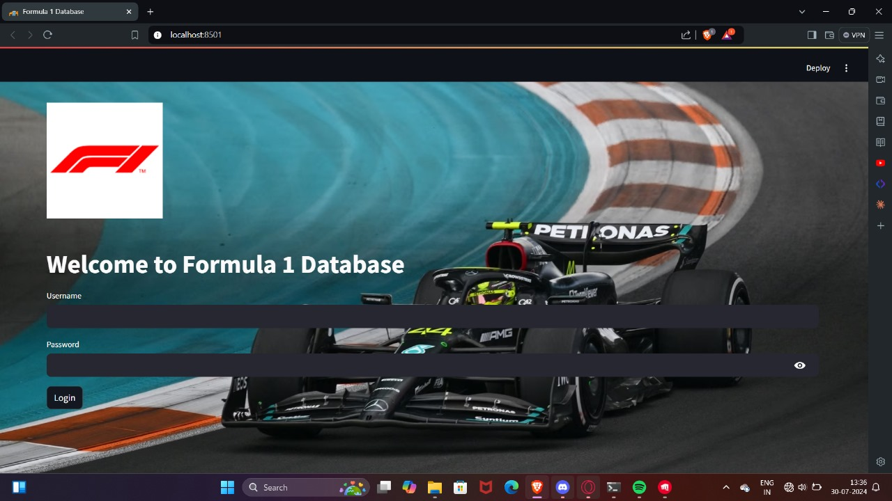

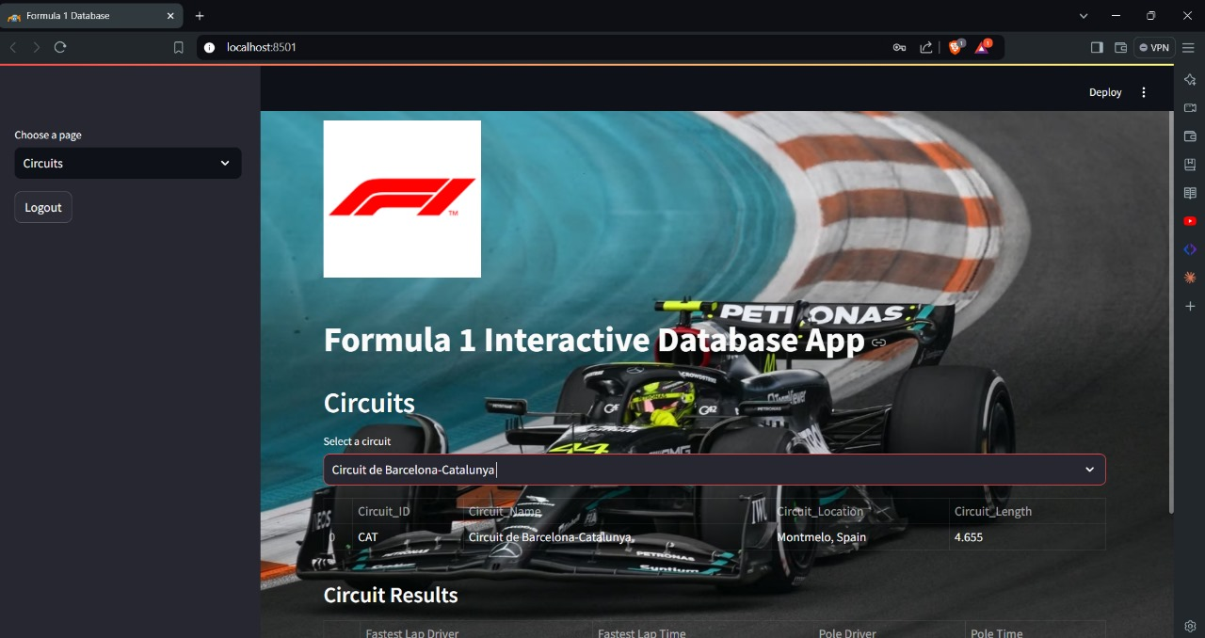

**LOGIN AS ADMIN**

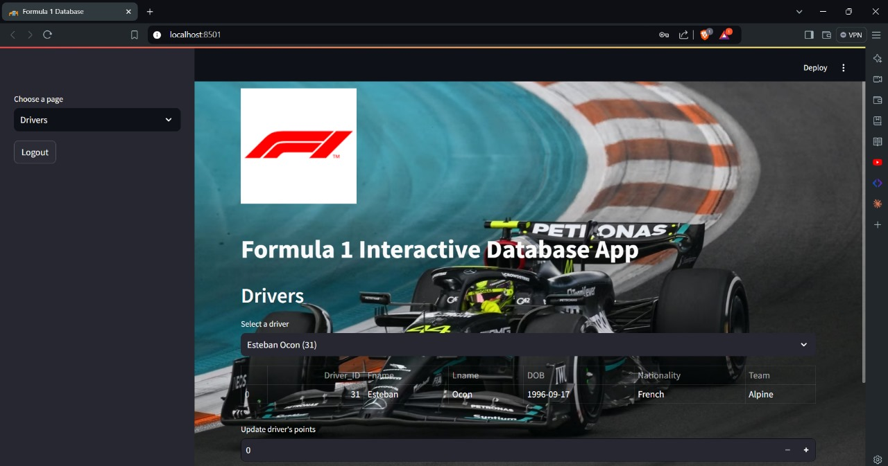

**LOGIN AS USER**

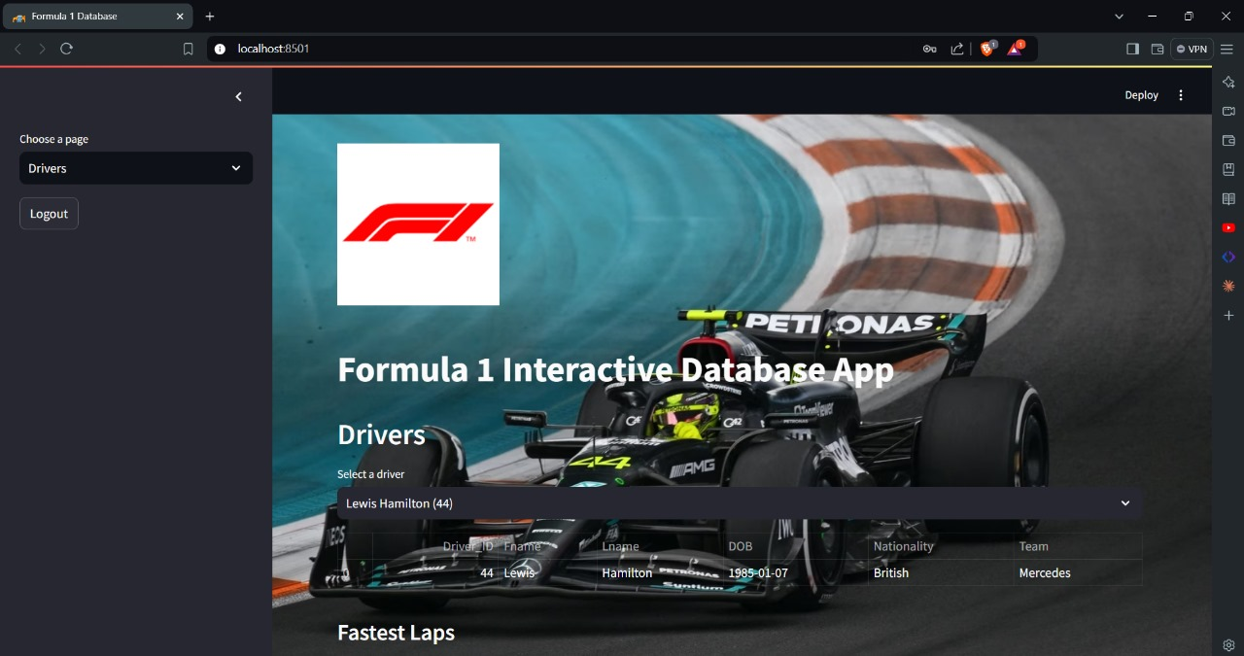

**Conclusion**

**The Racing Championship Database is a robust system designed to handle the complexities of managing data related to racing events. By efficiently organizing and interrelating various entities, the database facilitates comprehensive data analysis and management, thereby supporting the operational and strategic needs of racing championships.**