**IHCI Week-7 Tutorial Activity**

**Rules :**

– Submit a Google Doc, NOT a PDF or a Google slide.

– Use the default fonts, line spacing, and font size unless specifically required in the assignment.

– After submission, the Google Doc will get automatically locked, so you won't be able to make any changes.

– Standard plagiarism rules apply

– Your submission will not be considered for grading and feedback if you do not follow these guidelines.

**Name : Krishna Shukla**

**Roll No. : 2022254**

**HCI Group No. : 13**

**Start your activity here :**

Q1) Using the MIRO board, sketch the user’s flow while interacting with the app that you developed in week 3 (tutorial 3 assignment).

A 1)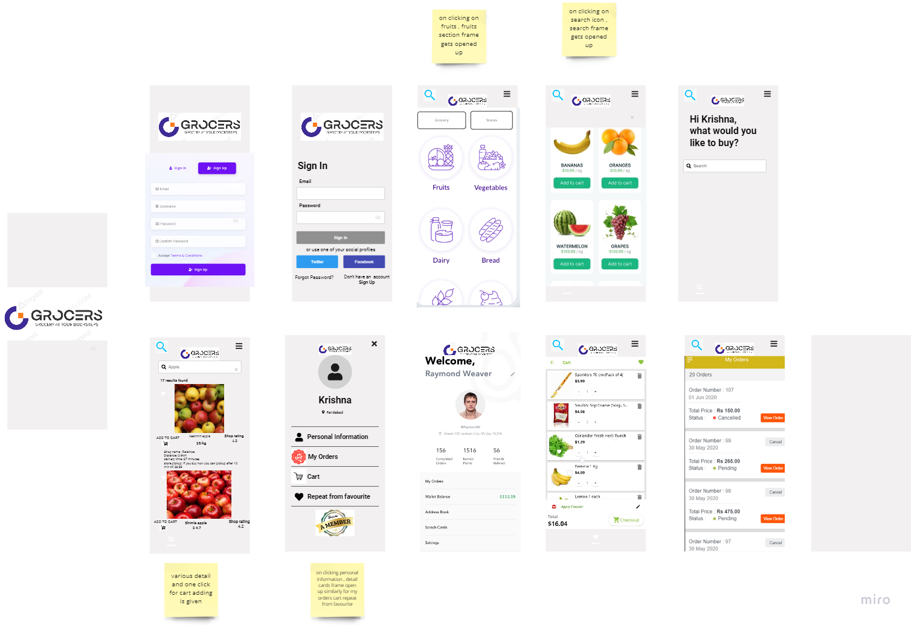

Miro link:

<https://miro.com/app/board/uXjVP2QahzY=/?share_link_id=948465519128>

Q 2) Does your app use any conceptual model? If yes then mention them and explain briefly its relevance. (Please paste the images/sketches of your app that you submitted in week 3.)

A 2) Yes, my app uses one conceptual model on clicking on this icon

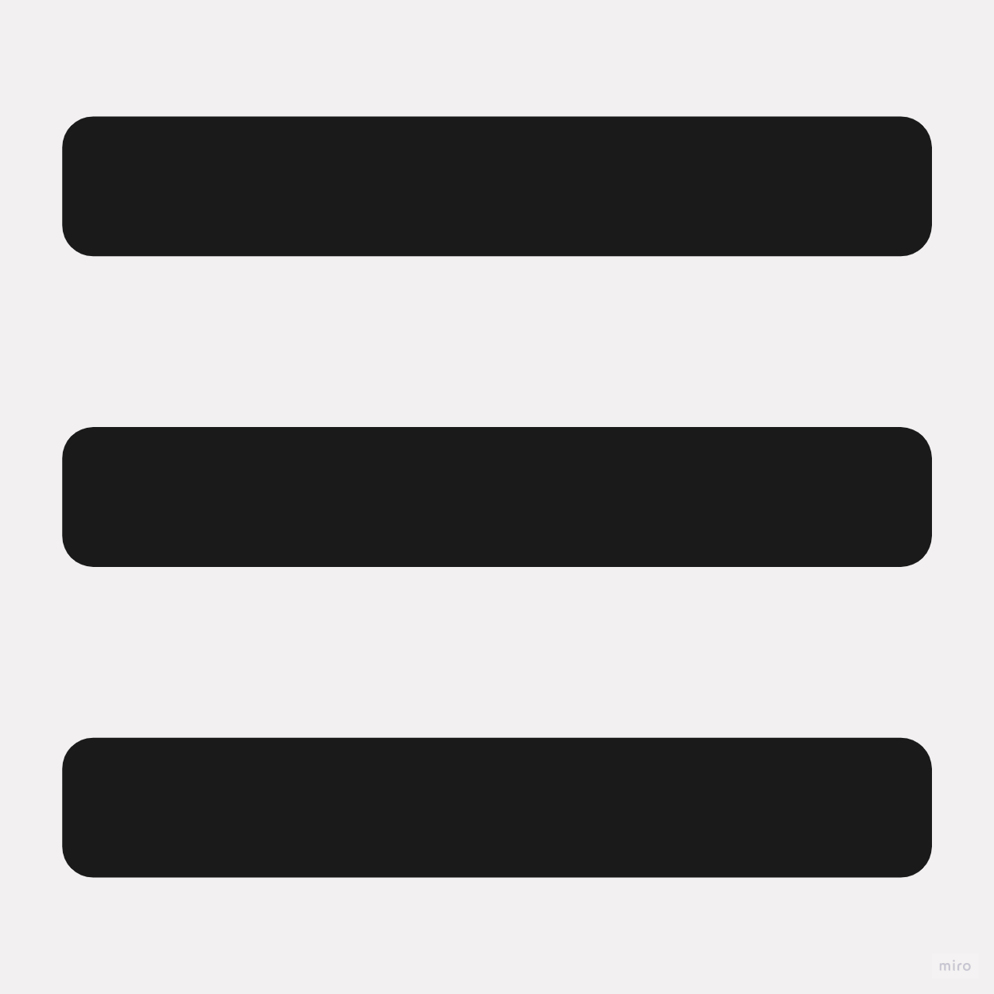 profile frame that gets opened up. It's a break in regular consistency pattern and a unique UI from my perspective

Sketch from tutorial 3

