This is the way software installation via Group Policy works. When you install an application via Group Policy an entry for that application is written to the Registry at:

HKLM\Software\Microsoft\Windows\Current Version\Group Policy\AppMgmt

Uninstalling the application from Control Panel doesn't remove this Registry entry, therefore the Group Policy will not be reapplied and the software will not be reinstalled.

If you want to "manage" the application via Group Policy and you install it via Group Policy, then you should uninstall it via Group Policy, which can be accomplished with this option:

[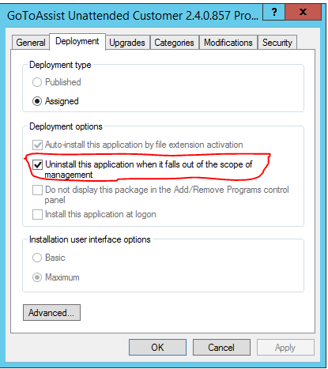](https://i.stack.imgur.com/htAck.png)

If you want to redeploy the application (reinstall it on all targets where it has already been installed - and uninstalled in your case), you can do so like this:

[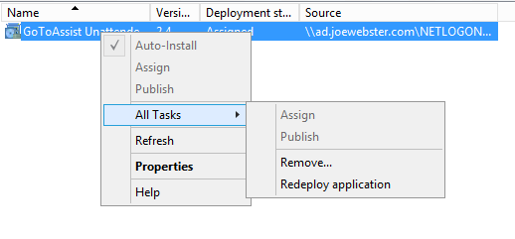](https://i.stack.imgur.com/QD1nV.png)

Once a GPO software installation has run once, it will not run again without intervention.

You need to remove the registry entry that indicated the install has already run. To do this, go to **HKLM\SOFTWARE\Microsoft\Windows\CurrentVersion\Group Policy\AppMgmt**

Delete the whole key (tree) of the software you need to reinstall. There’s one key per package. Use the GPO Name to identify which one you’re after.

N.B. Also make note of the Product ID, because you will need to delete this corresponding value in the AppMgmt key.

[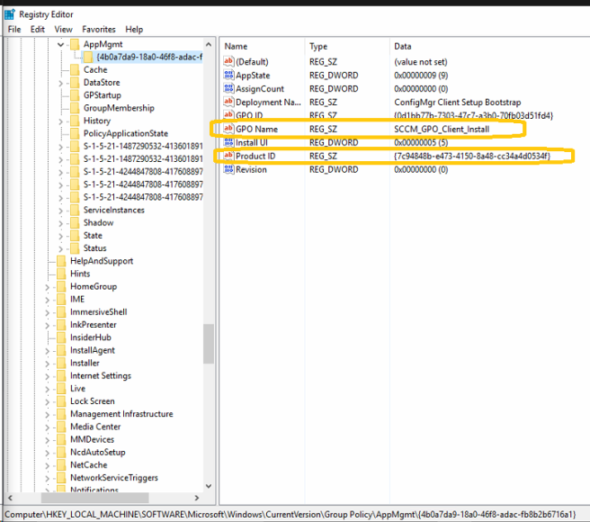](https://itscratchpad.files.wordpress.com/2017/09/gpo_sw_reinstall.png)

[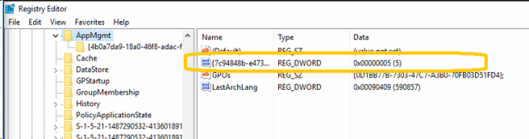](https://itscratchpad.files.wordpress.com/2017/09/gpo_sw_reinstall21.png)

1. Delete Key (tree)
2. Delete associated REG_DWORD in AppMgmt

**Share this:**