EverDrive N8 PRO
User Manual

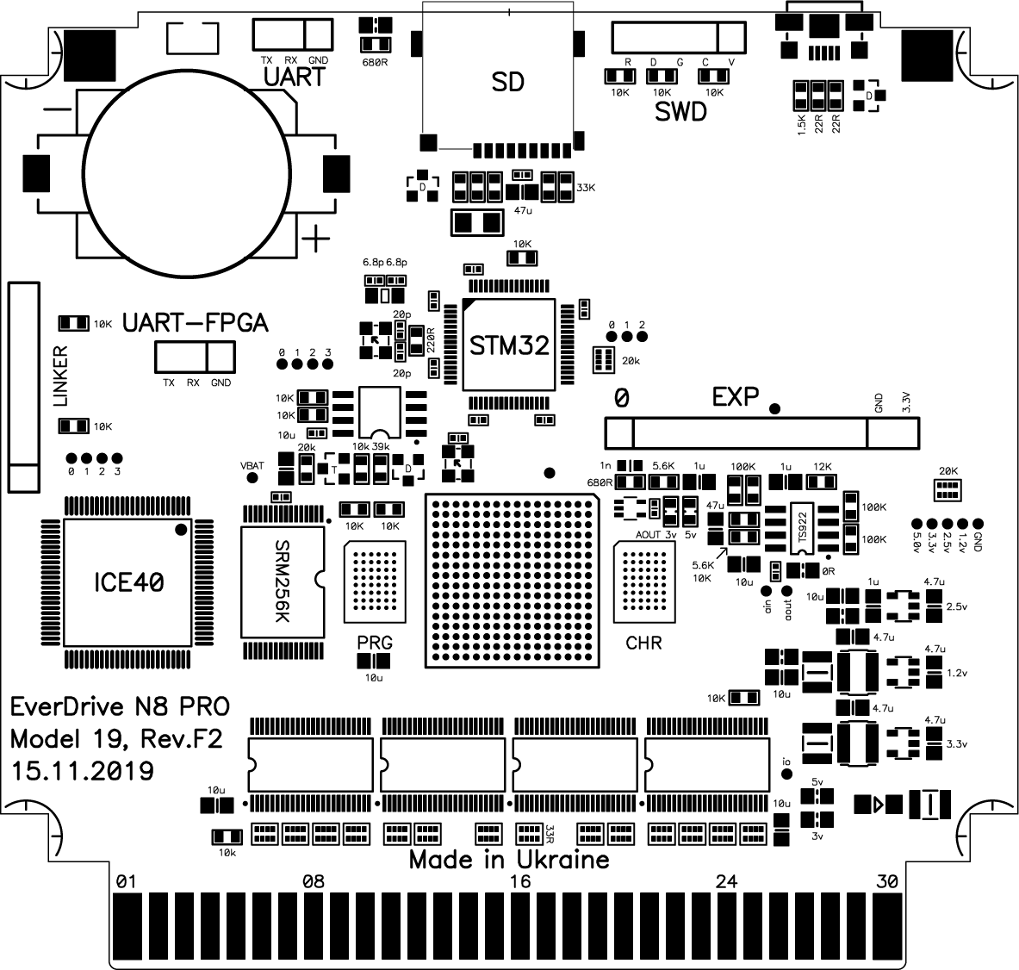


WWW.krikzz.com

30.11.2019

Features

- Cyclone IV FPGA
- 16MB of ROM memory. 8MB for PRG and 8MB for CHR
- 256K of battery ram (save-ram) for game saves
- Real time clock for logging date and time of saves
- High quality 6-layers PCB
- ARM based 32bit I/O co-processor for SD and USB operations acceleration
- Up to 1024 files per folder or unlimited if file sorting disabled
- Wide support of file systems: FAT16/FAT32/EXFAT
- In-game menu. You can save game or return to system menu without physical reset
- Multi slot save states. 99 independent slots for save states
- Instant ROM loading
- USB port for development and system update without removing SD card
- Improved audio mixing circuit with Op Amp
- Battery voltage monitoring. Battery can be replaced in time if it runs dry
- Ultra low battery ram consumption. Estimated battery life is 25 years
- Wide range of supported mappers
- NES2.0 partial support
- Game Genie cheats support
- Dedicated button which is used to swap FDS disk side or as alternative Save State menu call method
- Built-in NSF player with expansion chips support (VRC6, VRC7, Sunsoft-5b, Namco-163)

Initial setup

- Format SD card in FAT32 or exFAT
- Download N8OS-2.xx.zip from http://krikzz.com
- Unzip OS files to SD card
- Copy ROM files to SD. ROM files should be located outside of system folder (EDN8)
- Configure CIC chip. Hit reset 7 times if red indicator on your system is blinking (NES only)

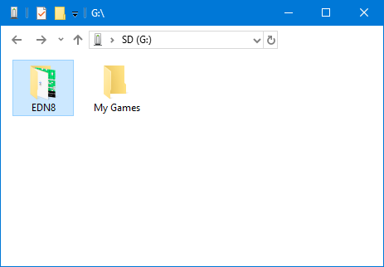
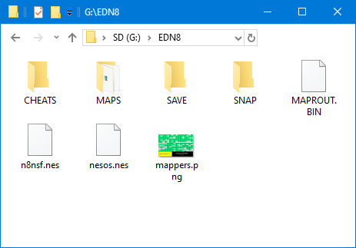

File Manager

- A - Back or Close
- B - Open directory or file menu
- Select – Open main menu
- Start – Run last selected game
- Left/Right – Switch page during file navigation

Upper bar shows current page and total number of pages in current folder.
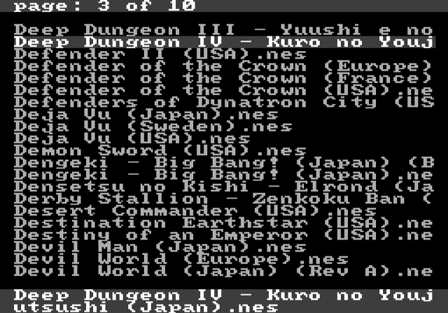
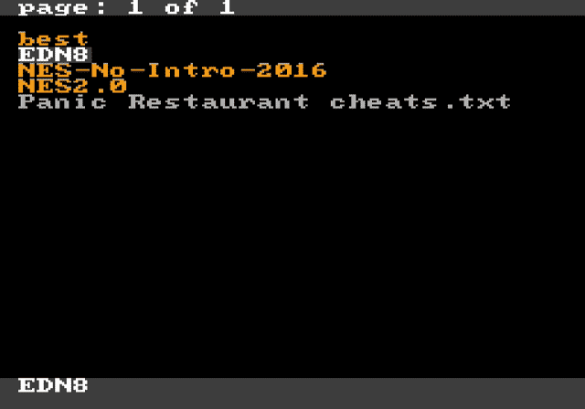
Bottom bar shows full name of selected file.

File Menu

File menu is used for files manipulating on SD card. Menu content is different depending on file type.

Rom file menu

This menu applied to *.nes and *.fds file extensions.
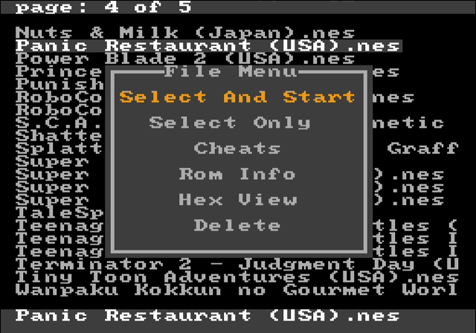
Select and start:
Cartridge will be configured to play selected game right after configuration game will be executed. Cartridge performs next steps during configuration:
- Copy save-ram content to SD card if save-ram was modified by the last played game. File will be created in EDN8/SAVE folder. File name will match the name of last played game.
- Configure hardware according to selected game.
- Check if EDN8/SAVE folder contains file related to selected game and load this file to save-ram if exists.
- Execute selected game.

After reset or power cycle the last selected game can be launched with START button.

Select Only: Same as above but without game execution.

Cheats:
Edit GameGenie cheats for selected file.

Rom Info:
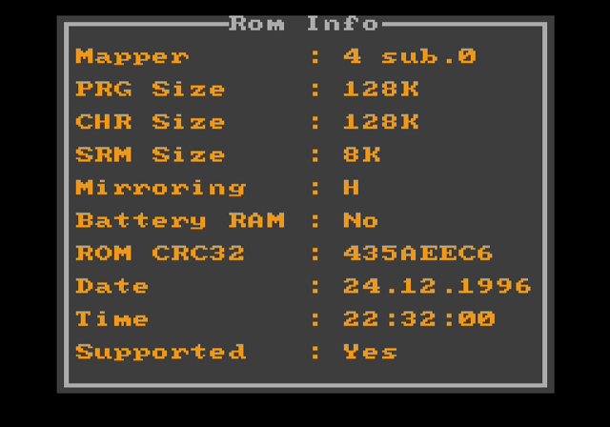
Show ROM configuration: Mapper number, checksum, memory configuration, etc.
Hex View:
Open selected file in hex viewer.

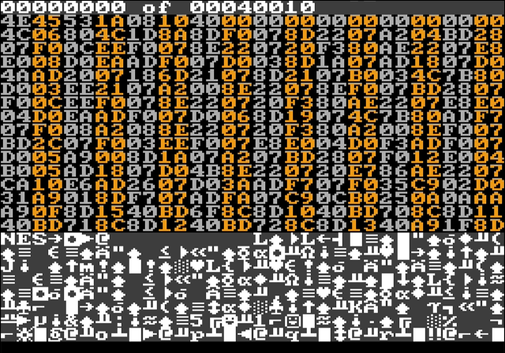

Delete:
Delete file from disk.

Text file menu

This menu is applied to *.txt file extension.
It is used for loading GameGenie cheats from text file. Loaded cheats will be applied to last selected game.
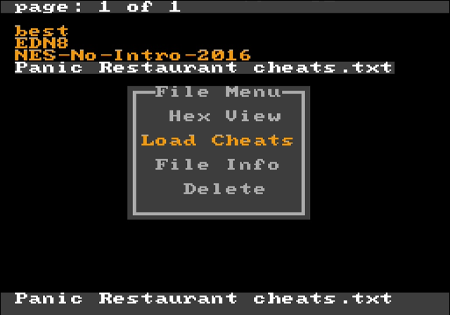

Save-ram file menu

Allow to copy current content of save-ram to file, copy file to save-ram, check file date and size, delete file.

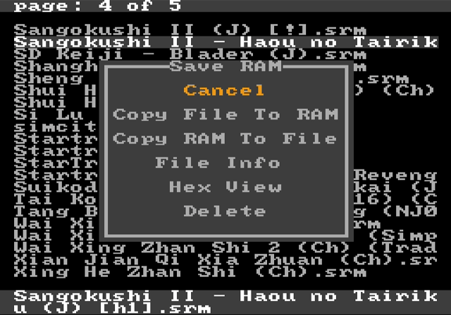

Main Menu

Push SELECT to open Main Menu.

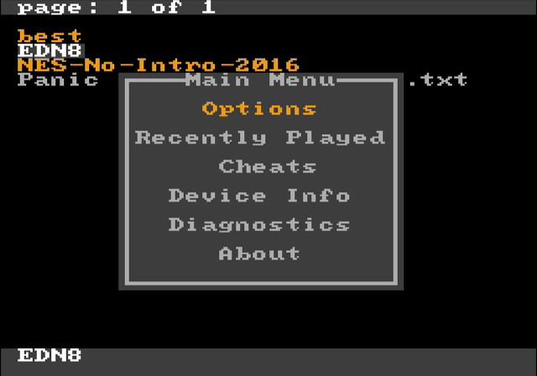
Options

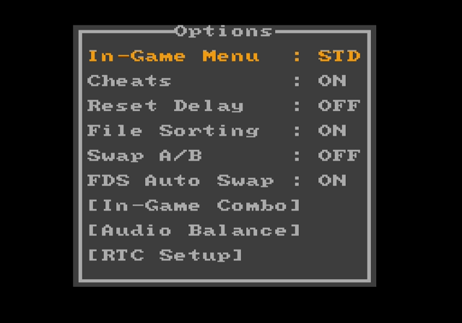
Options->In-Game Menu:
One of 3 modes can be selected for In-Game menu.
- STD: During game play Save State combo on controller will open In-Game menu
- QSS: During game play Save State combo and Load State combo will save and load game without opening In-Game menu
- OFF: Save State function and In-Game menu turned off

Options->Cheats:
Switch on/off cheat functions.

Options->Reset Delay:
OFF: System will back to menu after reset
ON: After short reset hit game will be rebooted, hold reset for 1.3 sec to return in menu.

Options->File Sorting:
Control file list sorting. Max amount of files per folder is 1024 if sorting enabled or unlimited if disabled. Sorting may slow down entering to folders with large amount of files inside.

Options->Swap A/B:
Swap functions of A and B buttons in cartridge menu.

Options->FDS Auto Swap:
This function is for FDS games. It changes disk side automatically when game requires it. Auto swap may not work properly for some games: the button located on the cartridge edge should be used for disk swap.

Options->In-Game Combo:
Controller hot-keys for In-Game menu and save state can be changed here. QSS mode can not be used if save and load combo matches: In-Game menu will be switched to STD mode.

Options->Audio balance:
This menu is for tuning audio volume balance between console audio synthesizer and expansion audio channels on cartridge.
There were few various mappers with expansion sound and they all sound differently with various console revisions. Balancing menu gives possibility to setup proper volume levels depending on used console model. Values can be changed manually one by one or use one of predefined presets which already have tuned values for various systems.
Push SELECT to choose preset or use d-pad for manual control.

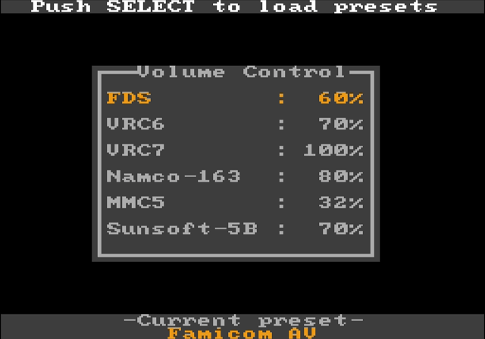

Options->RTC Setup:
Setup system date and time. RTC is used for dating of created and modified files.

Recently Played
List of recently played games for fast access.

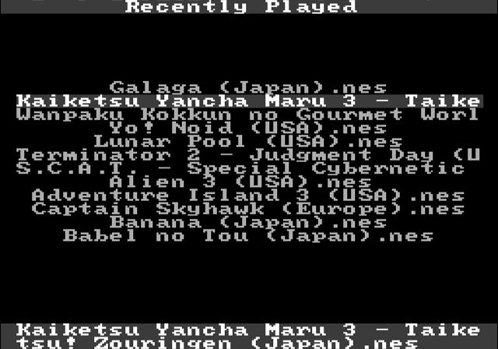

Cheats
Edit cheat codes for last selected game. Bottom bar shows the name of game codes will be applied to. Each game may have own set of codes, they are saved in EDN8/CHEATS folder as text file. The file name matches ROM name to which the codes are related. Up to 8 codes can be applied at same time. Alternative way to edit the codes for certain game is file menu, just hit the game in file manager. Cheats also can be loaded from text file selected in file manager.

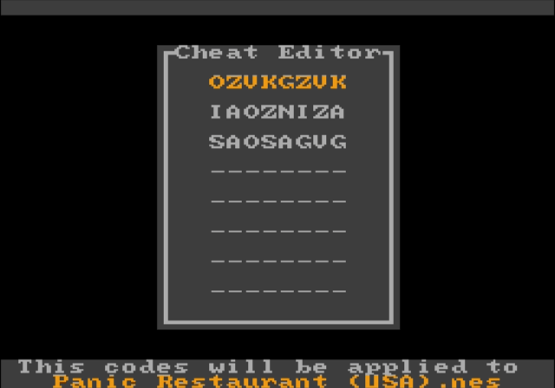

Device Info
Information about the system.

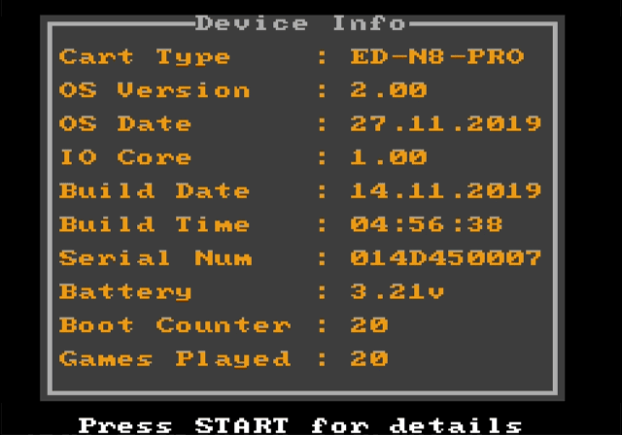

- OS Date: OS compiling date
- IO Core: Co-processor firmware version
- Build Date: Manufacturing cartridge date
- Build Time: Manufacturing cartridge time
- Serial Num: Unique serial number
- Battery: On-board battery voltage monitoring
- Boot counter: System starts counter. Only cold starts after power cycle are counted
- Games Played: New game selection counter

Diagnostics

Diagnostics menu checks cartridge health. All tests should be passed successfully if everything is fine. The only exception can be in "PPU Vram bug" test. This test depends on console, it may faults only at poorly made clones not allowing switching off PPU vram. In such case menu will be switched to another color scheme and will refresh slower. This problem may affect some games as well.

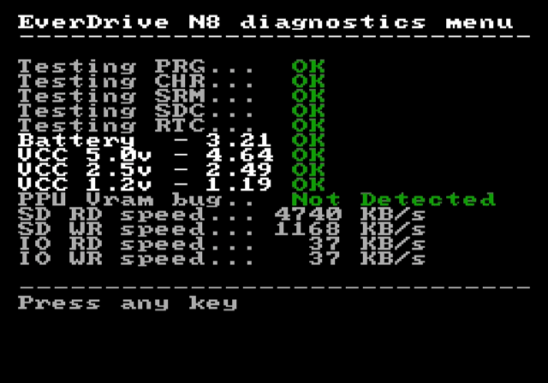

In-Game menu
Allow to return to menu or save the game at any point. During game play hit Save-State combo on controller to open In-Game menu.

- Save State: Save game state. System snapshot will be immediately saved on SD card in EDN8/SNAP folder
- Load State: Load game state
- Slot: Current slot. System supports up to 100 slots. Slot can be change without selecting “Slot” item in menu, just hit LEFT/RIGHT no matter what menu item is selected
- Exit Game: Return to menu
