Cloud Computing Project

-Kritika Murugan

Please refer screenshots folder for more detailed screenshots

# Manual Instance and DB creation on EC2

Steps used to deploy the app:

1. Connect to sys from EC2 Instance connect button, ssh tab
2. Install Java in EC2 Instance
   1. sudo yum install java-1.8.0-openjdk java-1.8.0-openjdk-devel -y
3. Install git
   1. sudo yum install git -y
4. Install Maven
   1. sudo wget http://repos.fedorapeople.org/repos/dchen/apache-maven/epel-apache-maven.repo -O /etc/yum.repos.d/epel-apache-maven.repo
   2. sudo sed -i s/\$releasever/6/g /etc/yum.repos.d/epel-apache-maven.repo
   3. sudo yum install -y apache-maven
5. Install sql
   1. sudo amazon-linux-extras | grep mariadb
   2. sudo tee /etc/yum.repos.d/mariadb.repo<<EOF

[mariadb]

name = MariaDB

baseurl = http://yum.mariadb.org/10.5/centos7-amd64

gpgkey=https://yum.mariadb.org/RPM-GPG-KEY-MariaDB

gpgcheck=1

EOF

* 1. sudo yum makecache
  2. sudo yum repolist
  3. sudo yum install MariaDB-server MariaDB-client
  4. sudo systemctl enable --now mariadb
  5. systemctl status mariadb
  6. sudo mysql_secure_installation
  7. Say yes to everything

1. Run mariaDB
   1. mysql -u root -p
2. Create DB and tables:
   1. create database restaurantDB;
   2. use restaurantDB;
   3. create table item(item_id INT(6) PRIMARY KEY AUTO_INCREMENT, item VARCHAR(1000), item_description VARCHAR(10000), category_id INT(6), price double(4,2) );
   4. INSERT INTO item VALUES (1, 'Eis', 'Lecker!',1,12.36);
   5. INSERT INTO item VALUES (2, 'Pommes', 'Lecker!',2,12.36);
   6. INSERT INTO item VALUES (3, 'Bier', 'Lecker!',3,12.36);
3. git clone <https://github.com/krimuru9336/roegner-hutte.git>
4. cd into newly created folder. Use ls command to see the list of folders
5. Run the app
   1. mvn spring-boot:run
6. Open the newly deployed app on the browser:
   1. http://publicdomain.com:8080
   2. Please find below screenshots incase the above URL does not work
   3. 
   4. 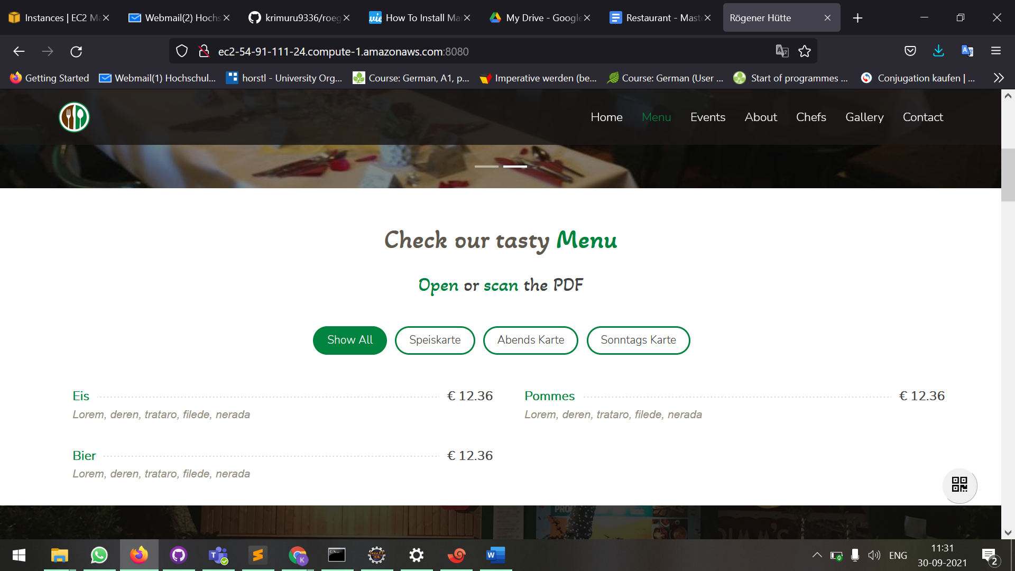There are the values from the DB
   5. Running EC2 Instance: 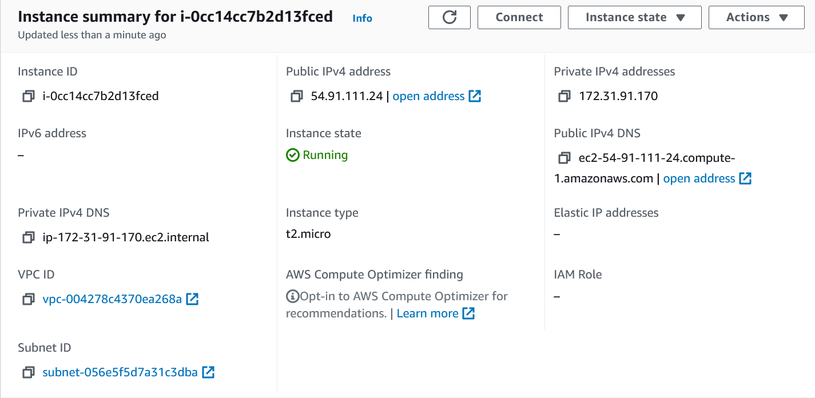 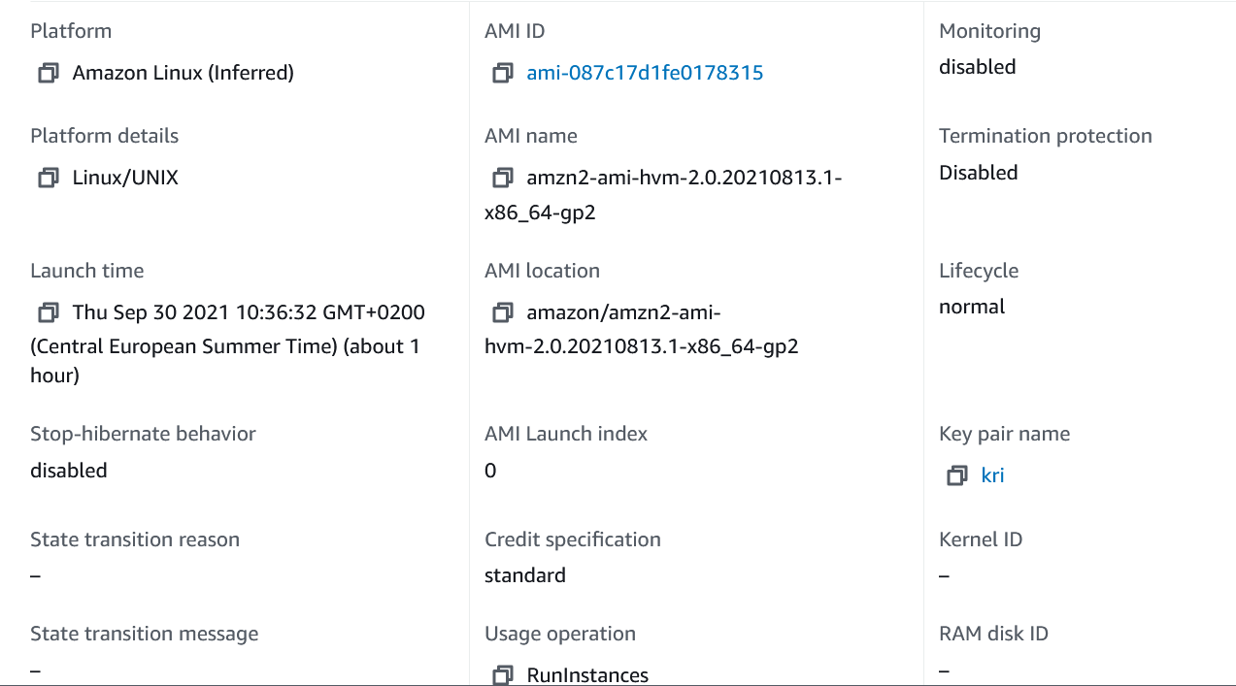
   6. 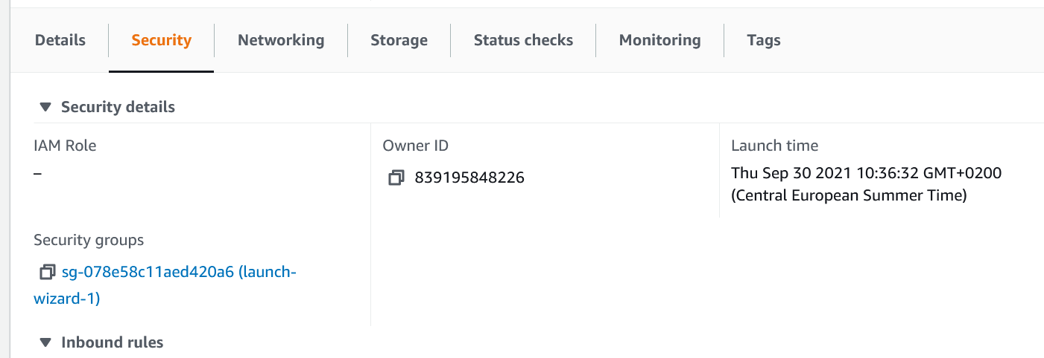 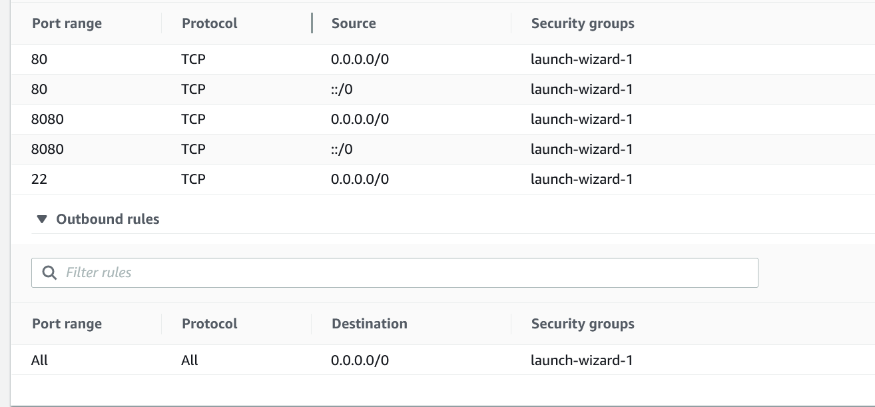

# AUTOMATION

## URL: <http://kri-asg-loadbalancer-454611865.us-east-1.elb.amazonaws.com:8080/>

1. Clone project from Professor’s git via eclipse:
2. Open Git: <https://gogs.informatik.hs-fulda.de/srieger/cloud-computing-msc-ai-examples>
3. Import the project:
   1. Import -> Git -> Project from Git
   2. Copy HTTPS url from git
   3. Click on Clone URI -> Next -> URI will be prepopulated if you have copied to clip board
   4. Next -> master version should be checked
   5. Next -> Import as general project
   6. Finish
4. If no pydev:
   1. Install from Market place under help
5. Finishing Setup
   1. Right click on project -> Pydev -> Set as pydev project
   2. Config first in PATH
6. Modify the code according to the app
7. Go to connect in server -> EC2 Instance Connect -> Connect
8. Sudo less /var/log/messages
   1. Shift+F
   2. Ctrl + C
9. Use loadbalancer: DNS:8080 for it to work
10. 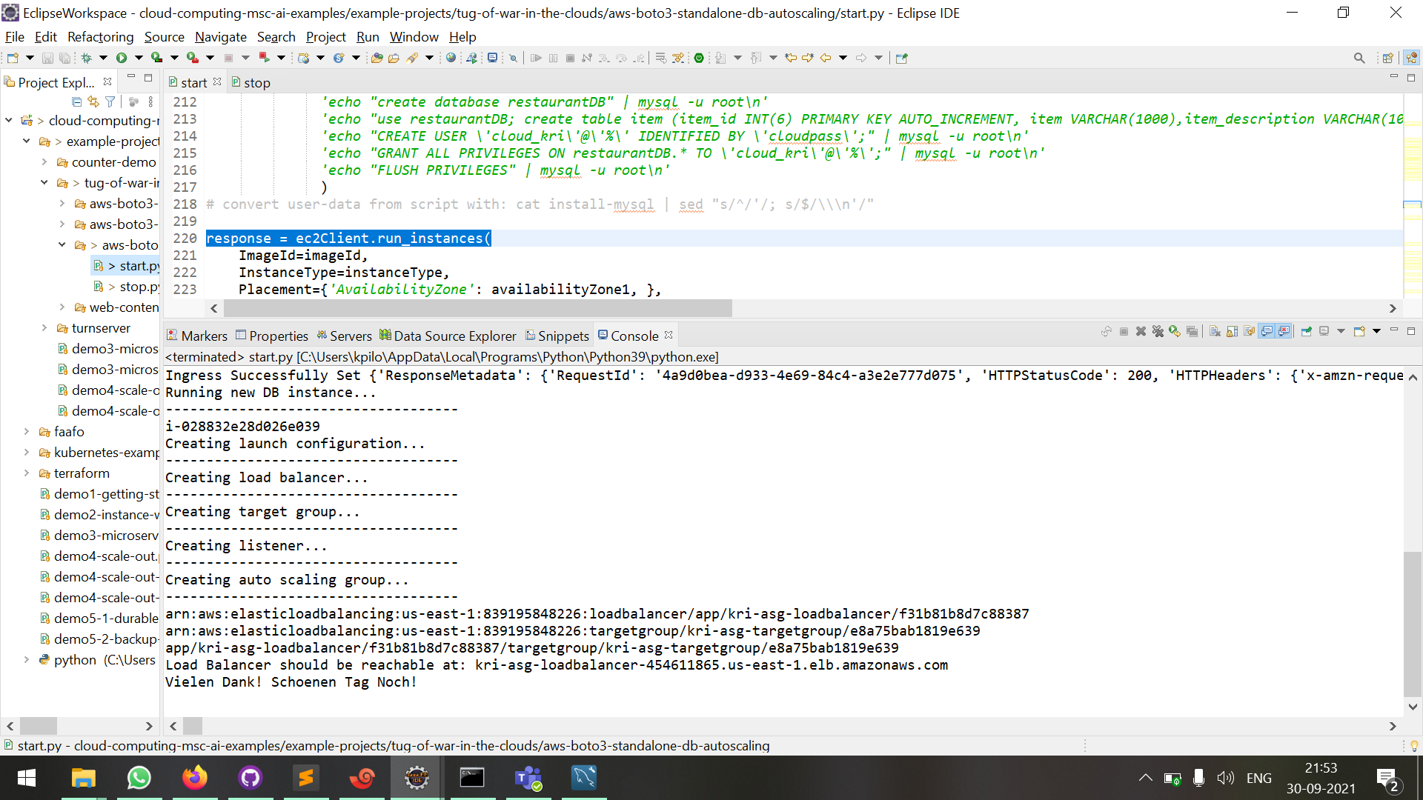
11. 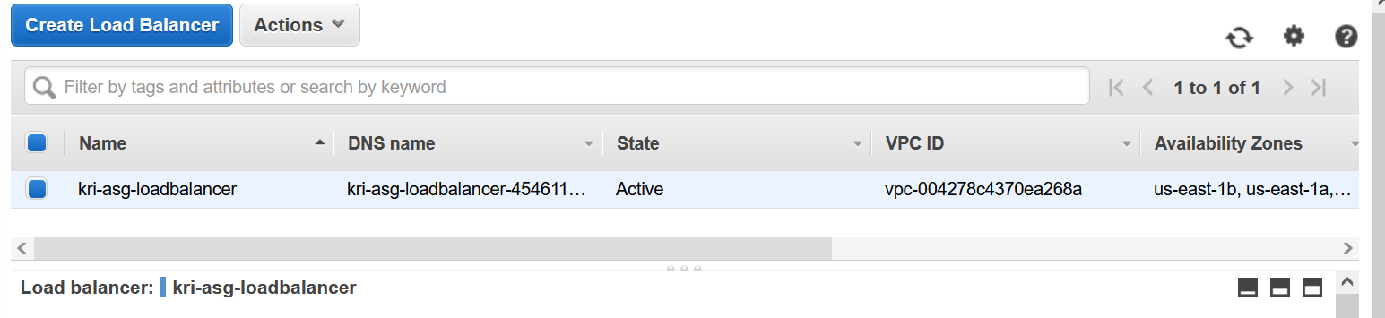
12. 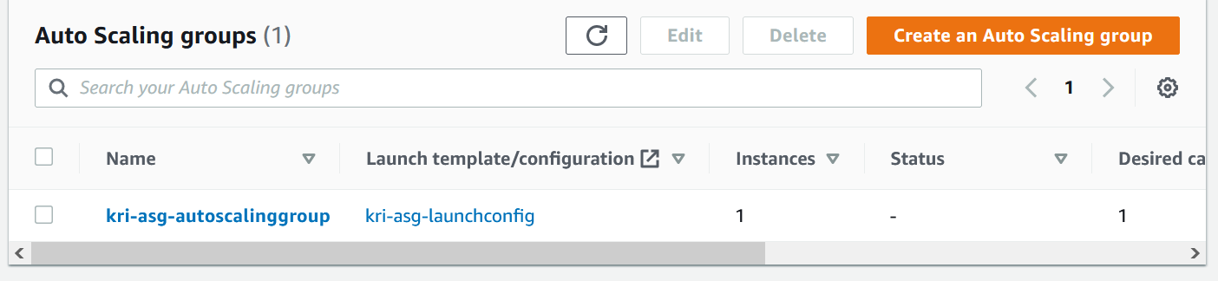
13. 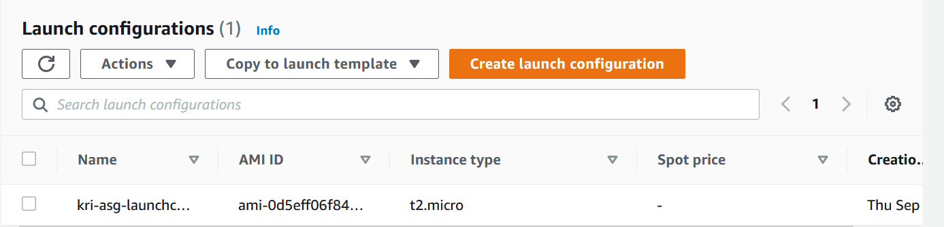
14. 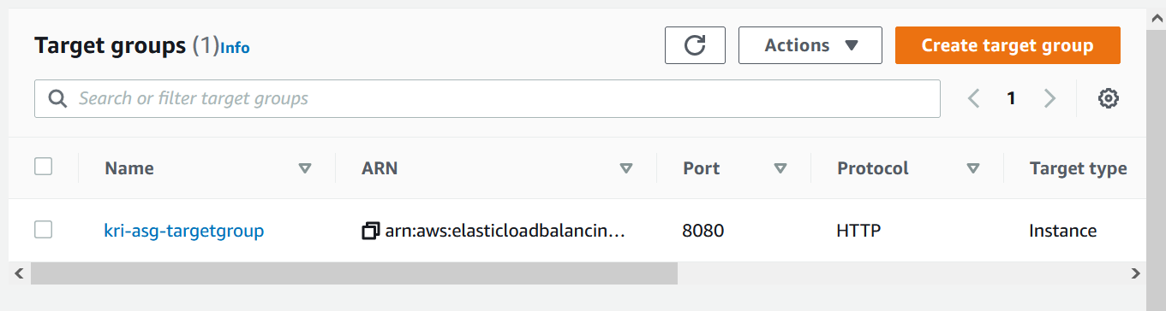
15. 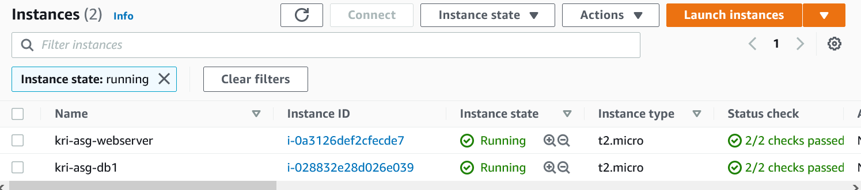
16. Here, the values Eis and Pommes come from the Database