**AJT PROJECT SUBMISSION-1 FORMAT**

**TIFFIN WIFFIN**

1. **TEAM DETAILS**

|  |  |  |  |
| --- | --- | --- | --- |
| **RollNo** | **Name**  **(Firstname Lastname)** | **EmailId** | **Mobile** |
| **50** | **Fenali Shah** | [**Fenali.s.imca16@ahduni.edu.in**](mailto:Fenali.s.imca16@ahduni.edu.in) | **9099094533** |
| **54** | **Krina Shah** | [**Krina.s.imca16@ahduni.edu.in**](mailto:Krina.s.imca16@ahduni.edu.in) | **9426651806** |
| **58** | **Shivam Shah** | [**Shivam.s.imca16@ahduni.edu.in**](mailto:Shivam.s.imca16@ahduni.edu.in) | **9033455118** |
| **60** | **Vishw Shah** | [**Vishw.s.imca16@ahduni.edu.in**](mailto:Vishw.s.imca16@ahduni.edu.in) | **8238270060** |

1. **PROBLEM DEFINITION**

|  |  |
| --- | --- |
| **Title of Project/Software Application** | **Tiffin Service** |
| **Objective/vision/main goal** of developing the software application | **To provide quality food at an affordable price at user’s preferred location.** |
| **What Problem will be solved by the proposed software application** (or real-life need/use of the software application) | **Provide food that is hygienic, tasty and home made.** |
| **End-Users of the software:** different types of users/roles who are going to use the software like admin, customers, manager, employee, etc. | **Admin.**  **Clients.** |
| **Listing of functionality/features/main modules** to be provided in the software to different end-users | 1. **Login via google.** 2. **Home page with multiple options.** 3. **Feedback for food.** 4. **Locate us.** 5. **About us.** |
| **Reports or System-outputs to be generated from the software** | **Invoice** |

1. **DATABASE DESIGN (DATA DICTIONARY)**

1. cust_details

Table description: stores the information about registered customers

|  |  |  |  |  |
| --- | --- | --- | --- | --- |
| **Sr. No** | **Field Name** | **Data Type** | **Constraint** | **Description** |
| **1** | cust_id | Number | #P.K. | Uniquely identify a user |
| **2** | Email_id | Varchar(50) | Not null |  |
| **3** | Password | Varchar(50) | Not null |  |
| **4** | Name | Varchar(50) | Not null |  |
| **5** | Contact_no | Number | Not null |  |
| **6** | Address | Varchar(50) | Not null |  |

2. plans

|  |  |  |  |  |
| --- | --- | --- | --- | --- |
| **Sr. No** | **Field Name** | **Data Type** | **Constraint** | **Description** |
| **1** | Plan_id | Number | #P.K. | Uniquely identify package |
| **2** | Plan_name | Varchar(50) | Not null |  |
| **3** | plan_duration | Number | Not null | In days |
| **4** | Plan_price | Number | Not null |  |

3. orders

|  |  |  |  |  |
| --- | --- | --- | --- | --- |
| **Sr. No** | **Field Name** | **Data Type** | **Constraint** | **Description** |
| **1** | Order_id | Number | #P.K. |  |
| **2** | cust_id | Number | #F.K. |  |
| **3** | Plan_id | Number | #F.K + Not null |  |
| **4** | Start_date | date | Not null |  |
| **5** | End_date | date | Not null |  |
| **6** | quantity | Number | N |  |
| **7** | Order_total | Number | Not null |  |

4. feedback:

|  |  |  |  |  |
| --- | --- | --- | --- | --- |
| **Sr. No** | **Field Name** | **Data Type** | **Constraint** | **Description** |
| **1** | Name | Varchar(50) |  |  |
| **2** | email | Varchar(50) |  |  |
| **3** | Message | Varchar(150) |  |  |

5. adminlogin:

|  |  |  |  |  |
| --- | --- | --- | --- | --- |
| **Sr. No** | **Field Name** | **Data Type** | **Constraint** | **Description** |
| **1** | email | Varchar(50) | #P.K |  |
| **2** | password | Varchar(150) |  |  |

Designs:

Home (Customer) :

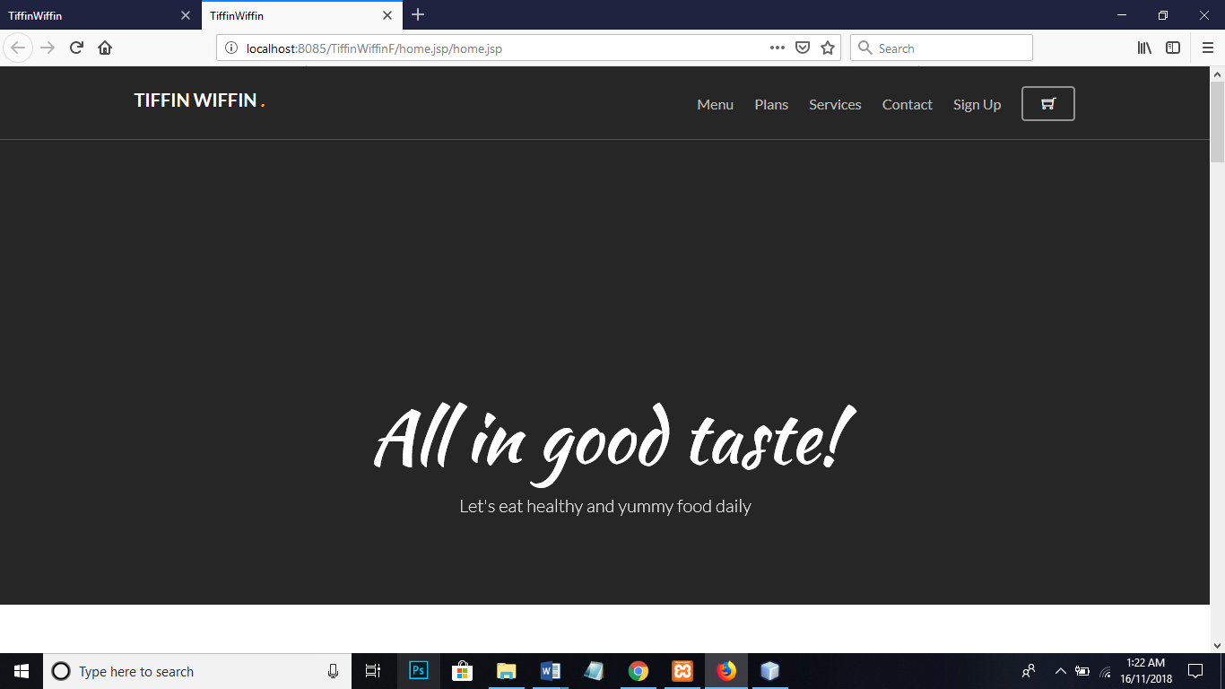

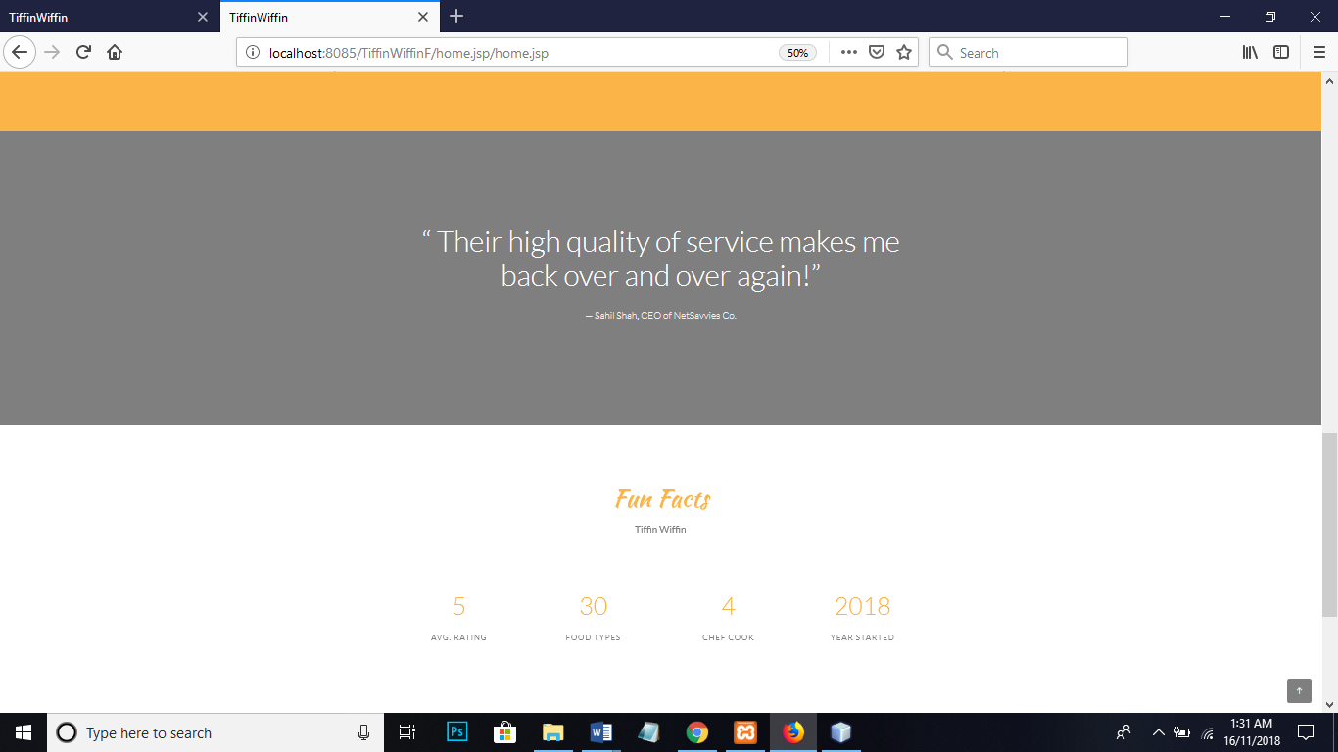

Sign In:

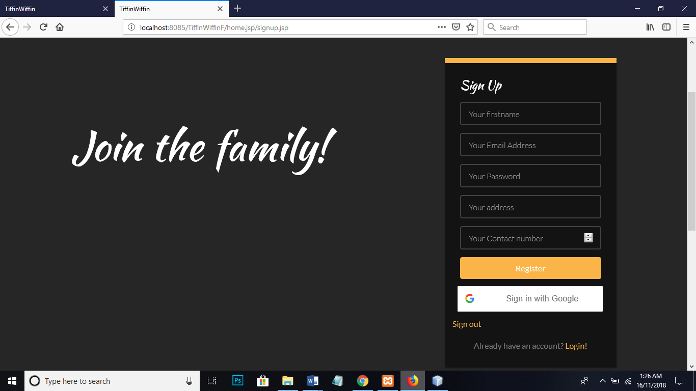

Login (Customer):

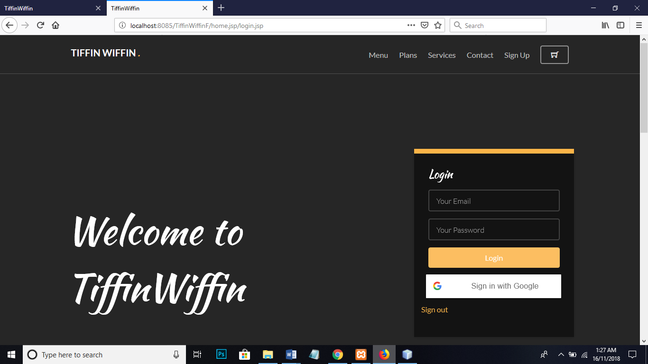

Plans:

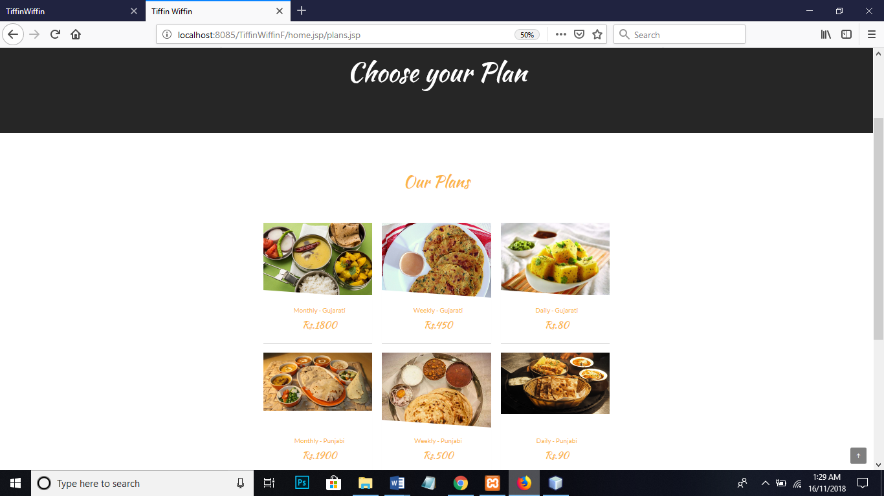

Menu:

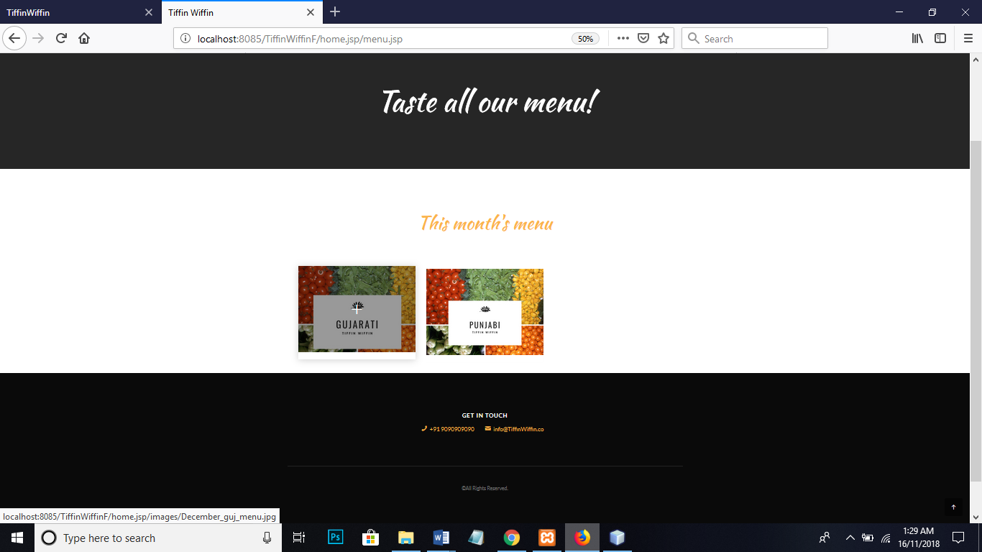

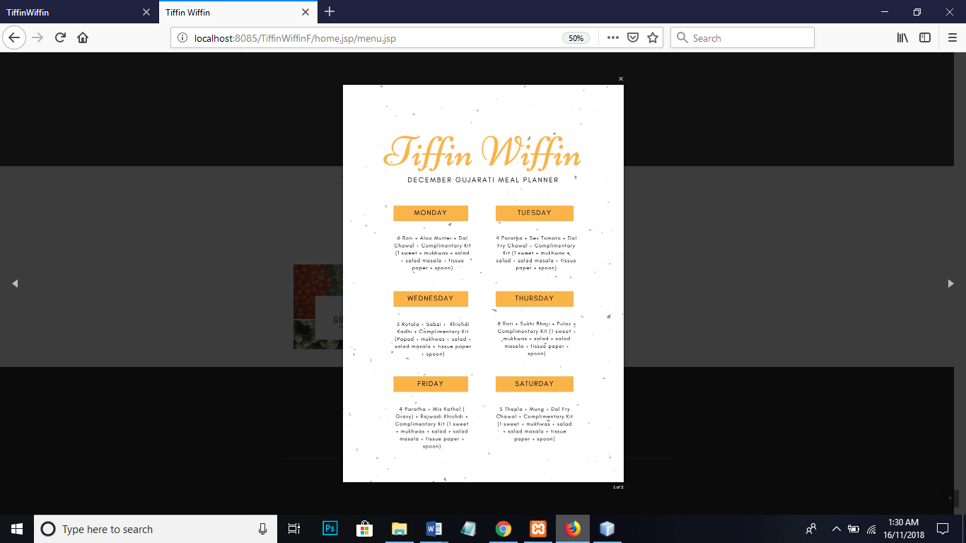

Service:

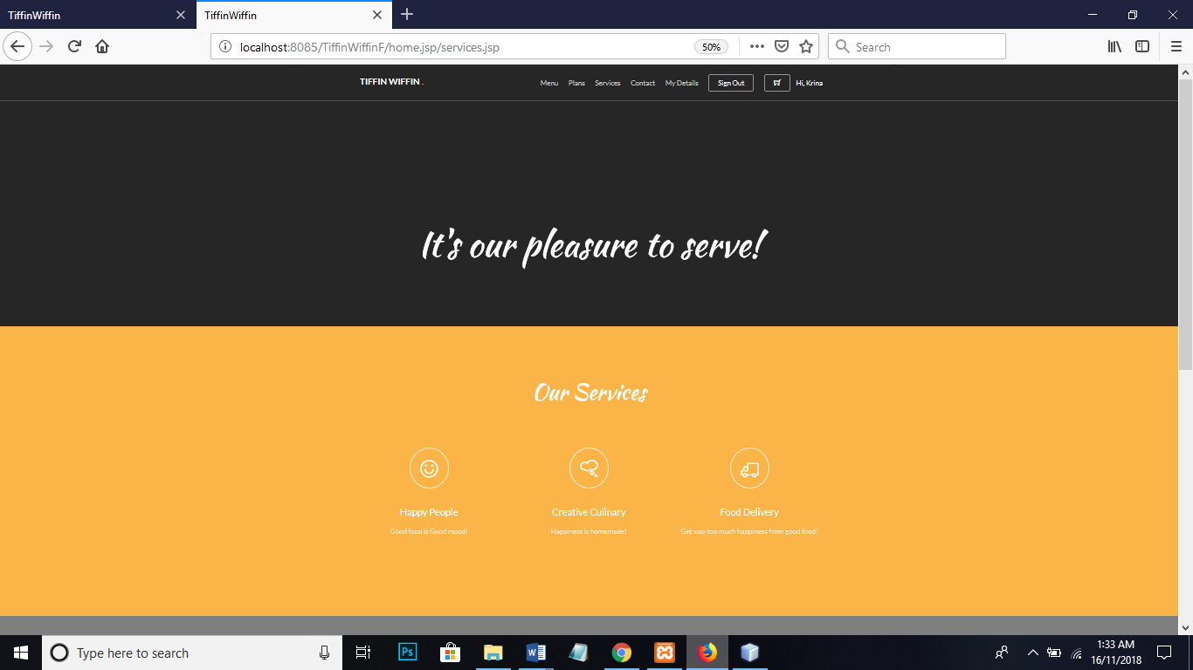

Contact:

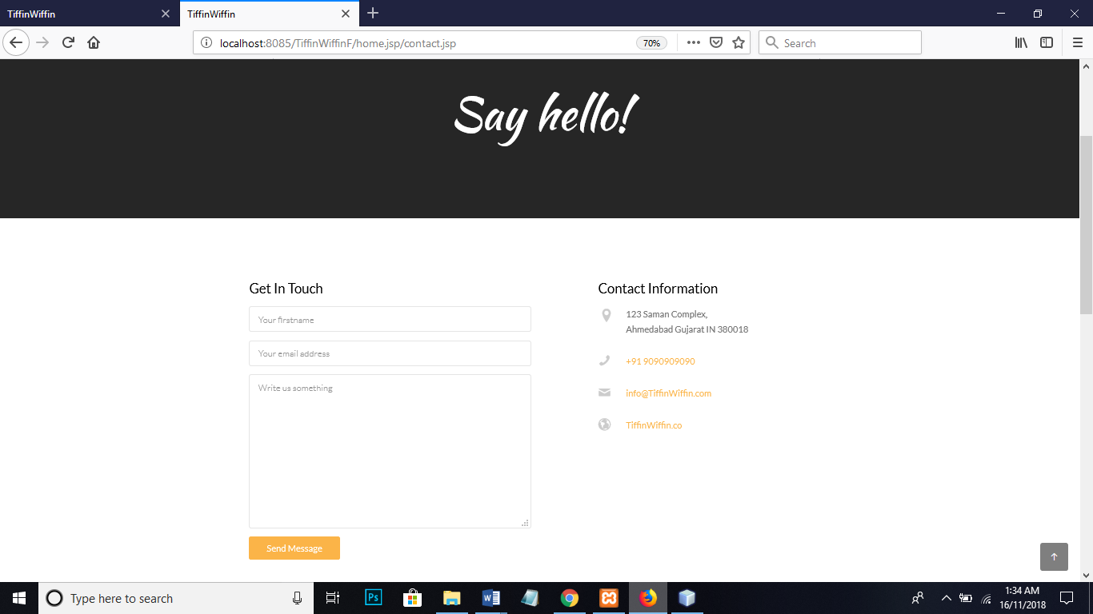

Location:

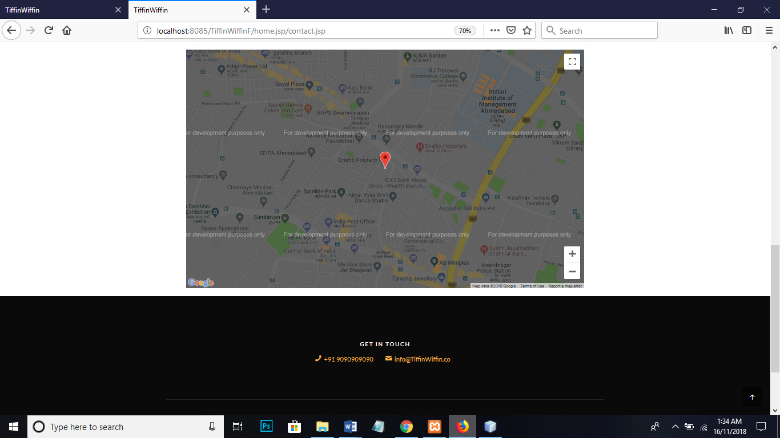

Customer Profile:

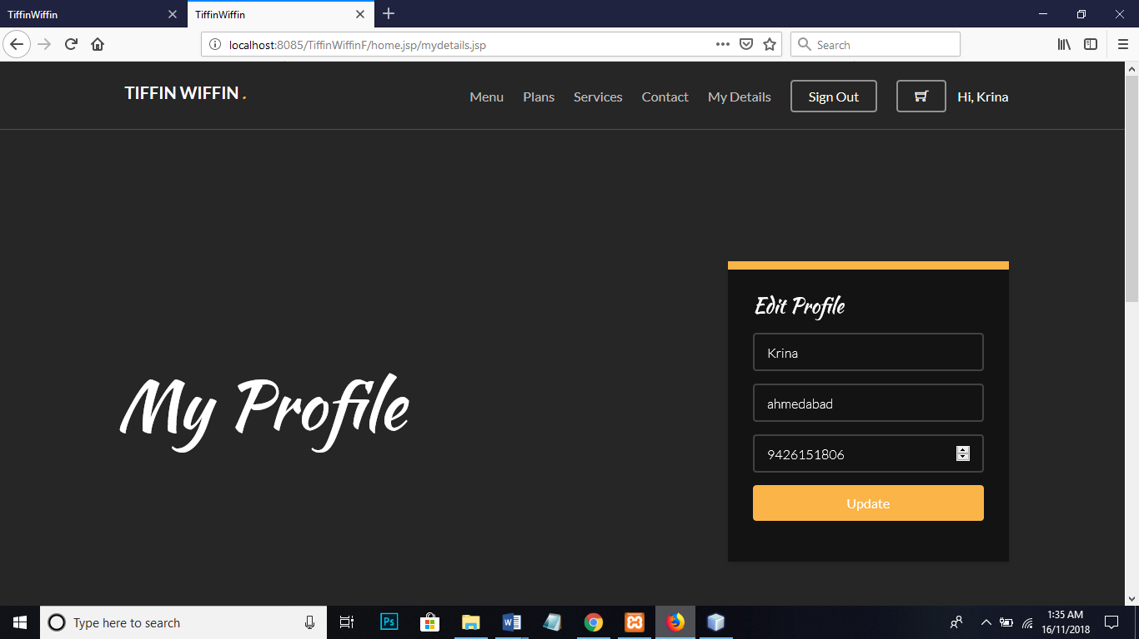

Order:

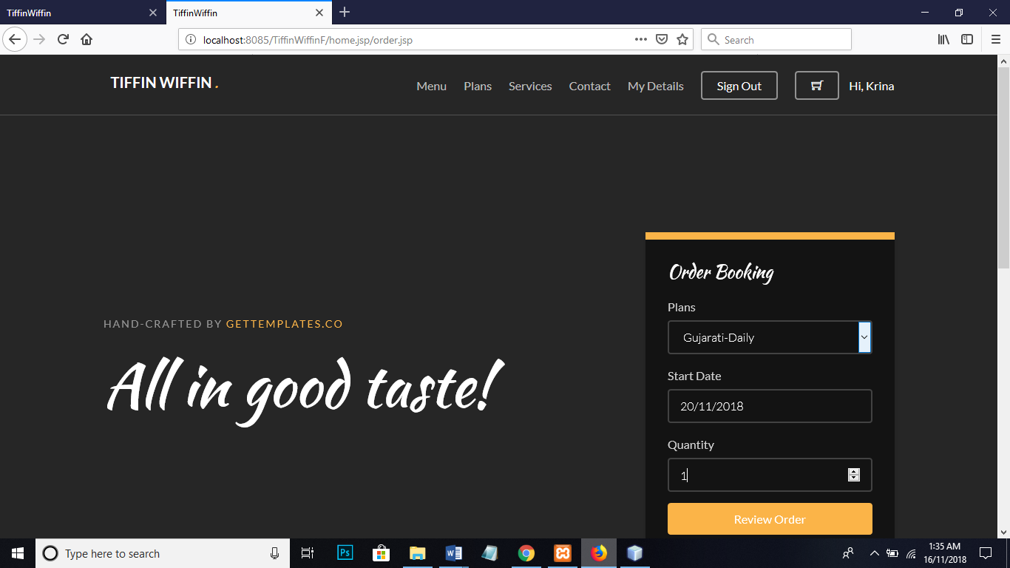

Confirm Order:

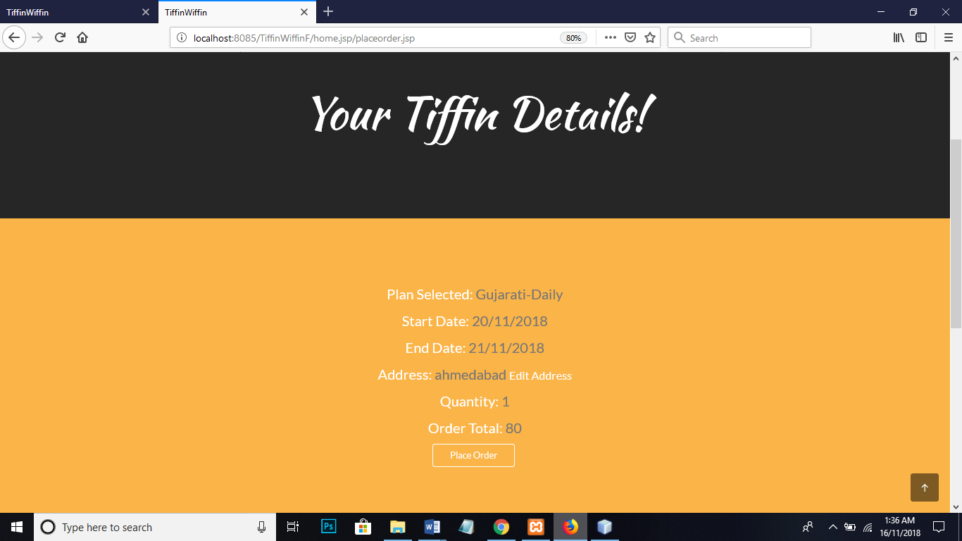

Login (Admin):

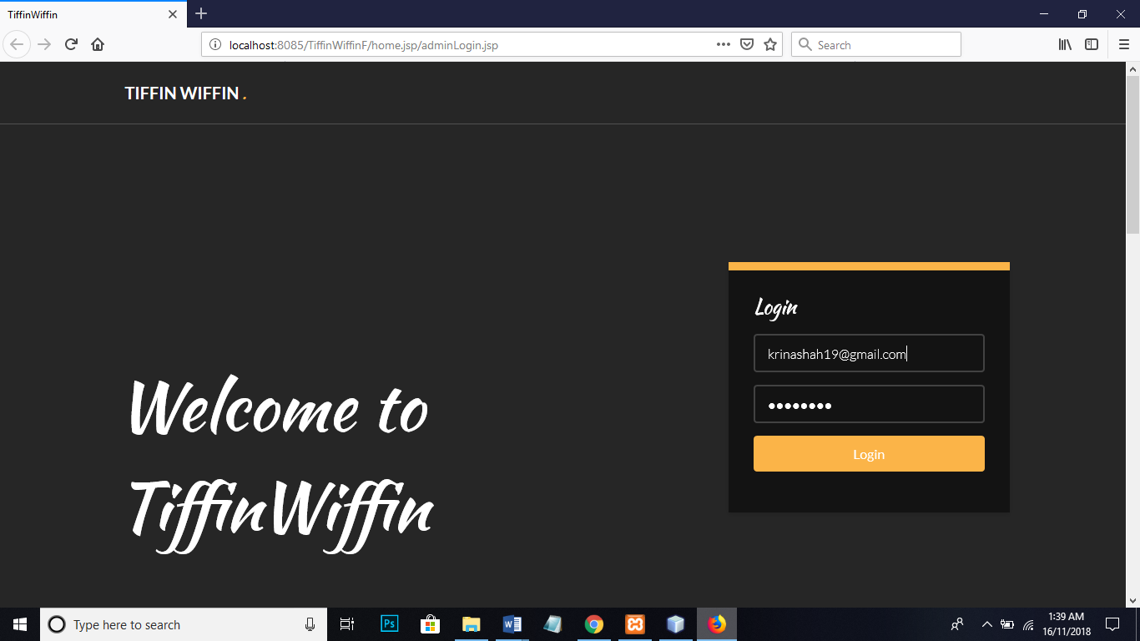

Customers’ orders list (Admin):

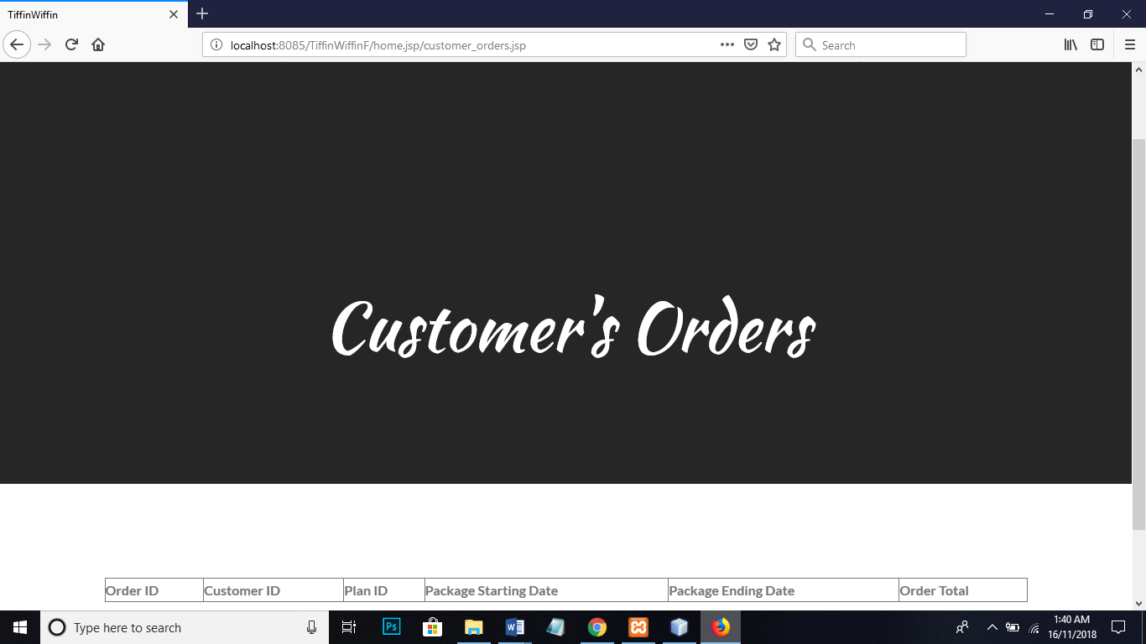

Customer’s feedback:

