Computing Lab-2 Assignment 8 Task 1

Model hyperparameters

Batch Size=64

Learning rate=0.0002

Patience=8

Optimizer=Adam

Epochs=Maximum epochs 50

Early stopping

In early stopping method, after each epoch validation loss is calculated on validation dataset. If validation loss doesn’t decrease for k(here k=8) then, training process will be stopped. In my case, early stopping happens at 48 epochs.

Accuracy on validation and test dataset

Training Accuracy=93.16%

Validation Accuracy=88.85%

Test Accuracy=89.44%

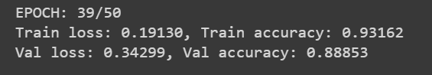

Graph between Training loss, validation loss and epochs

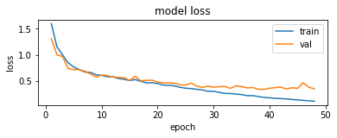

Graph between Training accuracy, validation accuracy and epochs

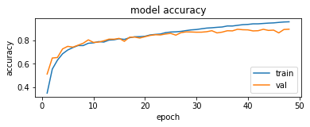

Inference

From the accuracy graph and loss graph, it is clear that our CNN architecture is not overfitting; as validation loss and training loss both are gradually decreasing. Thus, we may achieve higher accuracy with higher patience value.

Classification report

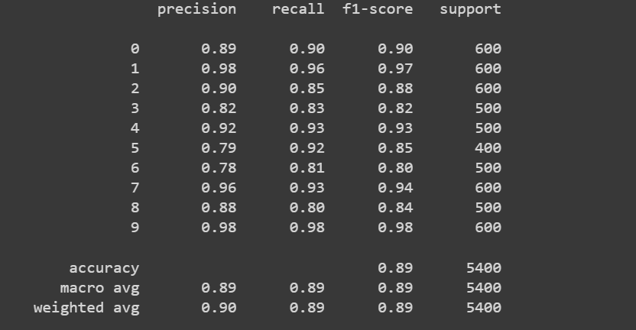

Confusion matrix heatmap

