Computing Lab-2 Assignment 8 Task 2

Model hyperparameters

Batch Size=64

Learning rate = [0.001,0.0002,.0.0004] ------- minimum validation loss achieved for lr=0.0002

Patience=8

Optimizer=Adam

Epochs=Maximum epochs 50

Early stopping

In early stopping method, after each epoch validation loss is calculated on validation dataset. If validation loss doesn’t decrease for k(here k=8) then, training process will be stopped.

Accuracy on validation and test dataset

Resnet18(Pretrained=True), Learning Rate=0.0002

Training Accuracy=96.11%

Validation Accuracy=96.26%

Test Accuracy=95.92%

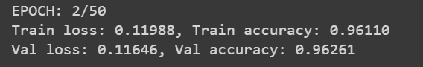

Resnet18(Pretrained=False), Learning Rate=0.0002

Training Accuracy=93.8%

Validation Accuracy=80.87%

Test Accuracy=81.96%

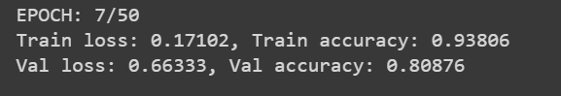

Inference: Resnet18(pretrain=True) model achieves higher accuracy than the Resnet18(pretrain=False). Pretrain model has already been trained on lots of images, thus it has already learnt various features of images. On the other hand, when resnet18(pretrain=False) model has to learn from scratch. Furthermore, it is deeper network than CNN network defined in the task 1. Thus, for better prediction, we have to train resnet18(pretrain=False) for significantly high number of epochs.

Graph between Training loss, validation loss and epochs for Resnet18(pretrained=True)

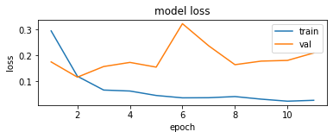

Graph between Training accuracy, validation accuracy and epochs for Resnet18(pretrained=True)

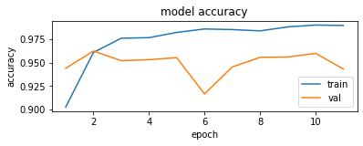

Classification report for resnet18(pretrained=True)

Recall for 10 classes are highlighted in the classification report

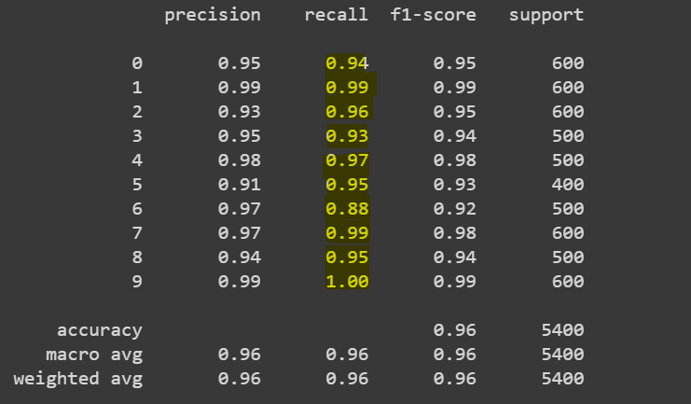

Confusion matrix heatmap for resnet18(pretrain=True)