GroundedNutriRec Technical Report: Week 4 Health-Aware and Multi-Objective Food Ranking
Framework: GroundedNutriRec: Retrieval-Augmented Multi-Objective LLM Framework for Health-Aware and Explainable Food Recommendation
Report Type: Academic Technical Paper (Week 4 Review)
Authors: GroundedNutriRec Core Development Team
____________________________________________________

1. Introduction
Following the baseline collaborative and content-based recommendation engines established in Week 3, the fourth week of the GroundedNutriRec project transitions from single-objective recommendation to multi-objective food ranking. Real-world food recommendation demands balancing conflicting dimensions: user preference (past interaction patterns), healthiness (nutritional profiles), popularity (crowdsourced wisdom), catalog diversity (avoiding filter bubbles), and preparation time (convenience constraints).
To achieve this, the core development team implemented and executed a multi-objective ranking pipeline spanning four Jupyter Notebooks (09, 10, 11, and 21):
1. Health Score Generation (Notebook 09): Computes a composite, domain-informed health score for each recipe using normalized nutritional values and ingredient diversity.
2. Multi-Objective Food Ranking (Notebook 10): Combines SVD-based preference similarity, composite health score, and preparation-time components to recommend food items.
3. Ablation Weight Analysis (Notebook 11): Performs a systematic ablation study evaluating the performance and trade-offs of multiple linear weight configurations across the user population.
4. Pareto-Front Ranking (Notebook 21): Implements a vector-accelerated non-dominated sorting algorithm to rank candidates using Pareto dominance across five objectives, mitigating the limitations of fixed linear scoring.
All pipeline components were evaluated against the training and test splits containing 17,329 test users.
____________________________________________________

2. Health Score Generation (Notebook 09)
Notebook 09, originally designed by Krina Parikh, parses the nutritional values and ingredient metadata from the preprocessed recipe catalog food_metadata_clean.csv to generate a composite, normalized health score for each recipe.

2.1 Feature Extraction and Parsing
For each of the 40,968 recipes, the system extracts:
- Calories: Absolute energy content (kcal) from the nutrition array.
- Total Fat Daily Value (PDV): Percentage Daily Value of total fat.
- Protein Daily Value (PDV): Percentage Daily Value of protein.
- Ingredient Diversity: The number of unique ingredients (n_ingredients) in the recipe, acting as a proxy for micronutrient diversity.

2.2 Min-Max Normalization
To prevent high-range attributes (like raw calories) from dominating the health score, each feature is normalized to $[0, 1]$ using Min-Max scaling:
x_norm = (x - x_min) / (x_max - x_min)

2.3 Composite Health Score Formula
A domain-informed linear formulation was applied to weight the normalized attributes, rewarding high protein and ingredient diversity while penalizing excessive calories and total fat:
Health Score = 0.30 × protein_norm + 0.30 × (1 - calories_norm) + 0.25 × (1 - fat_norm) + 0.15 × diversity_norm
The composite scores are stored in food_metadata_with_health.csv under the health_score column for downstream ranking tasks.

2.4 Notebook 09 Step-by-Step Execution and Visualizations
Step 1: Setup and Libraries Import
The notebook initializes by importing core packages (pandas, numpy, matplotlib.pyplot, seaborn) to handle data processing and visualization.
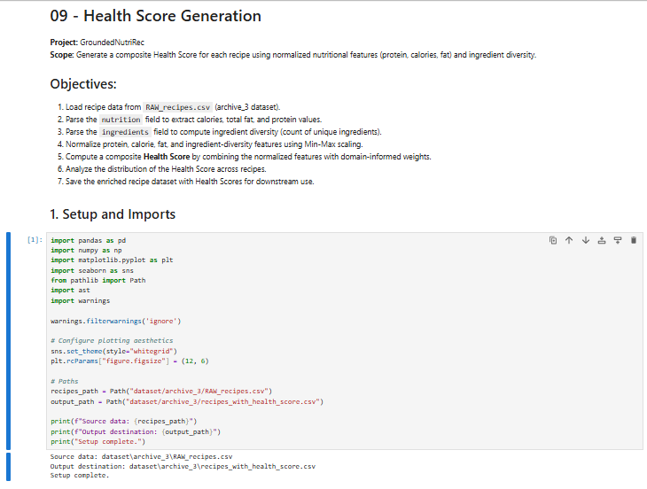
Figure: 01_Health_Score_Setup_And_Imports
Step 2: Dataset Loading and Null Value Inspection
The clean recipes dataset RAW_recipes.csv is loaded into memory, showing 40,968 recipes, and missing value checks are performed.
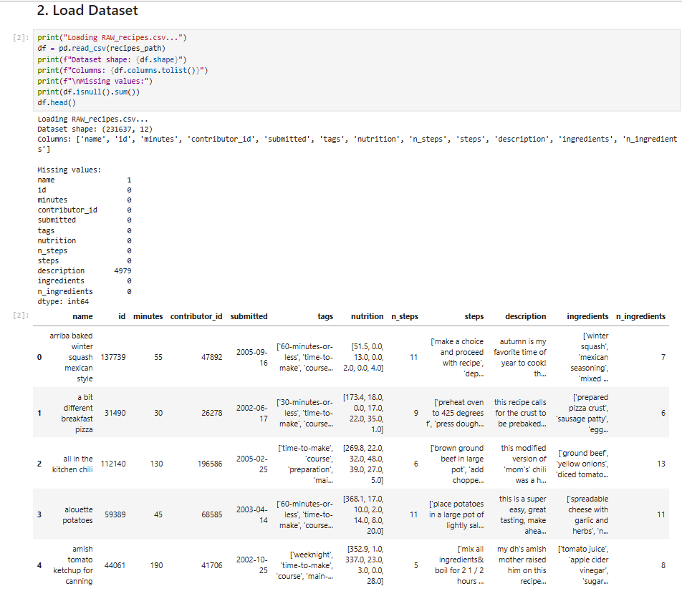
Figure: 02_Load_Dataset_And_Missing_Values
Step 3: Nutrition Field Parsing
The nutrition column, stored as string representation of list, is parsed in a vectorized manner into separate floating-point columns: calories, total fat, sugar, sodium, protein, saturated fat, and carbohydrates.
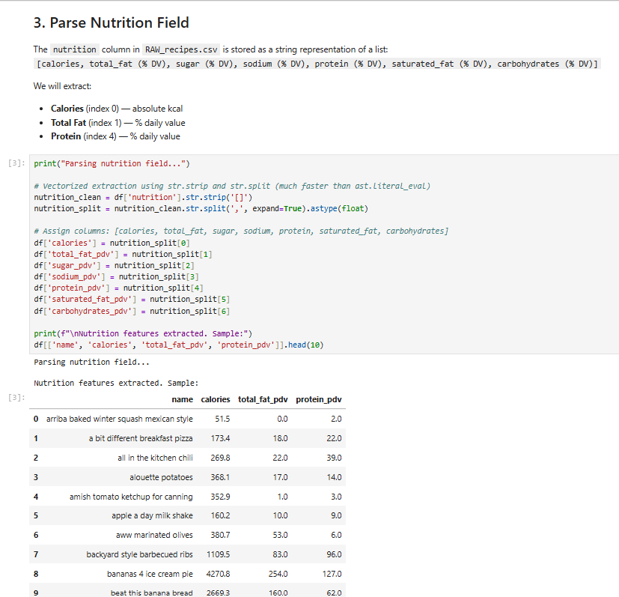
Figure: 03_Parse_Nutrition_Field
Step 4: Compute Ingredient Diversity
The count of unique ingredients is extracted from the recipe records to represent micronutrient diversity.
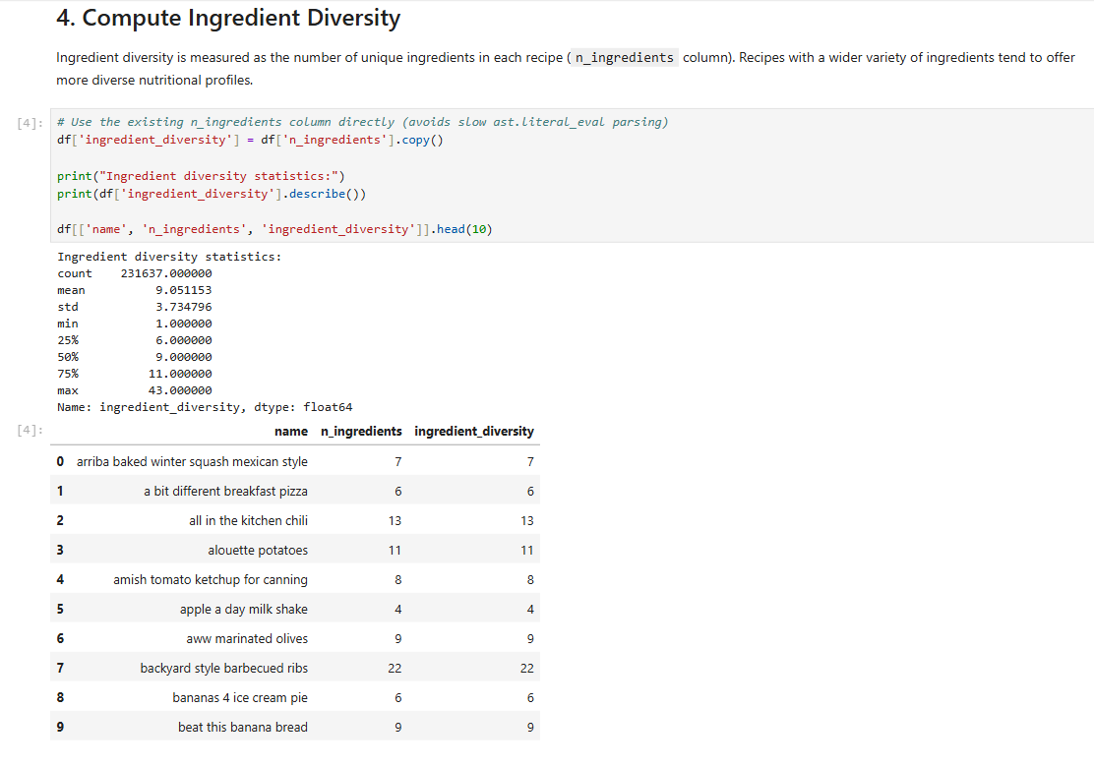
Figure: 04_Compute_Ingredient_Diversity
Step 5: Raw Features Descriptive Statistics
Summary statistics (mean, standard deviation, min, max, and percentiles) are generated for the four primary health indicators.
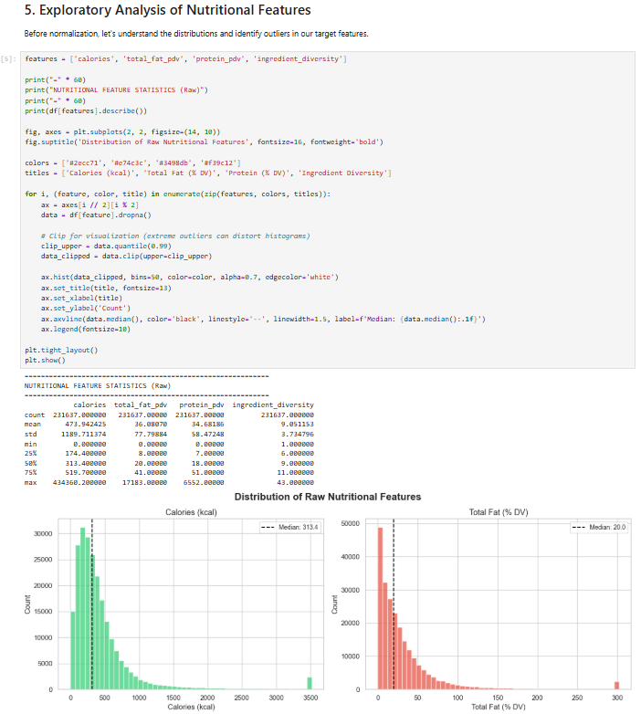
Figure: 05_Raw_Nutritional_Features_Statistics_And_Histograms
Step 6: Raw Features Distribution Visualization
Histograms are plotted to show the distribution of raw features, displaying substantial right-skewness and extreme outliers in calories and fat daily values.
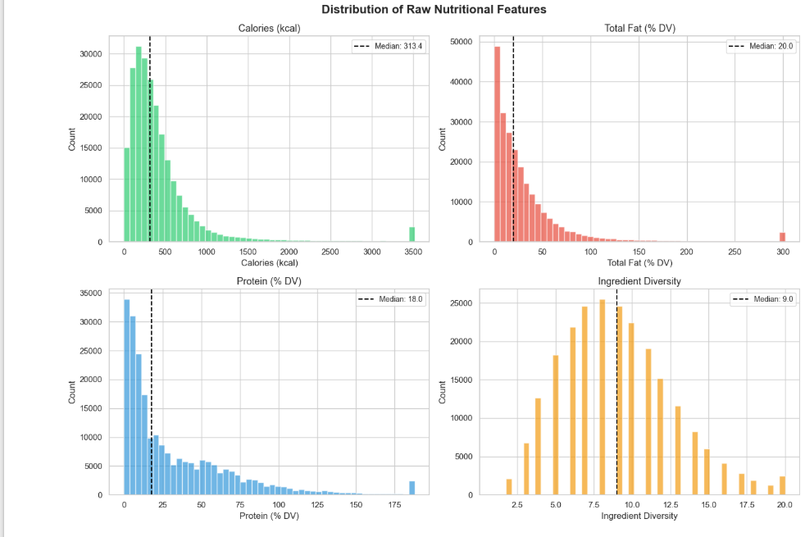
Figure: 06_Raw_Nutritional_Features_Distribution_Plot
Step 7: Outlier Capping
To stabilize normalization, features are capped at their 99th percentile value, mitigating the influence of extreme recipe outliers.
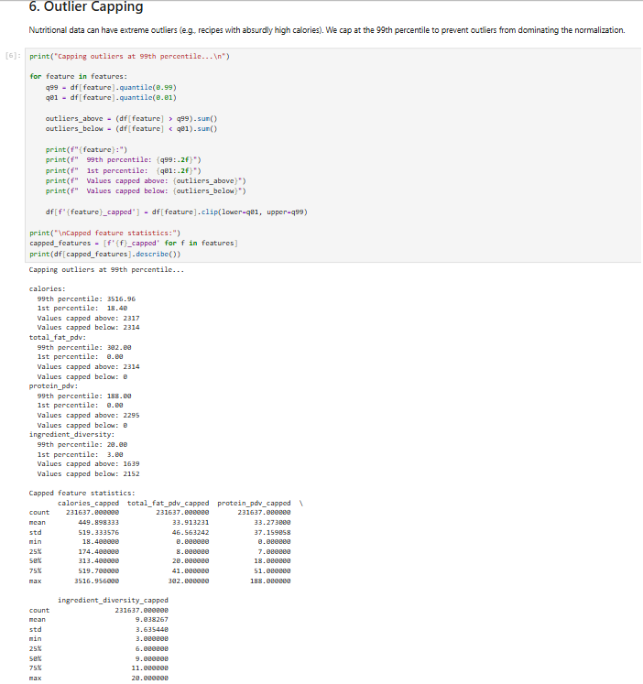
Figure: 07_Outlier_Capping_99th_Percentile
Step 8: Min-Max Normalization Application
The capped features are mapped onto a standard $[0, 1]$ interval via Min-Max scaling.
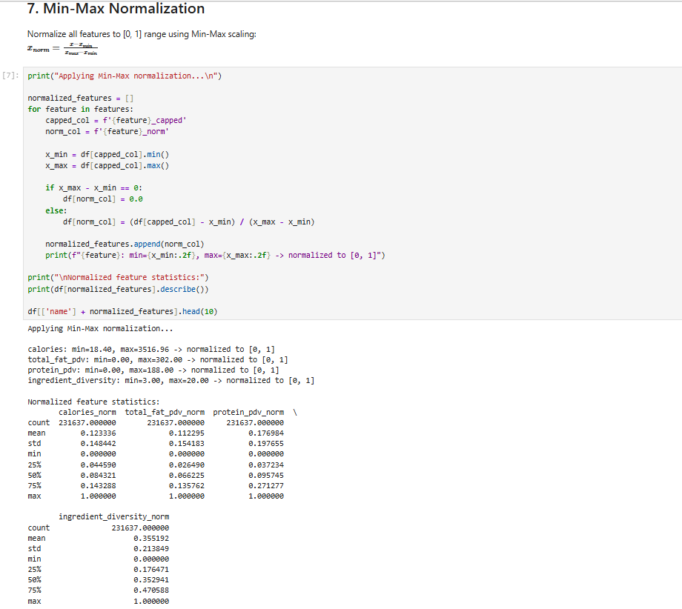
Figure: 08_MinMax_Normalization
Step 9: Normalized Features Validation
The normalized columns are audited to ensure the minimum is exactly 0.0 and maximum is 1.0.
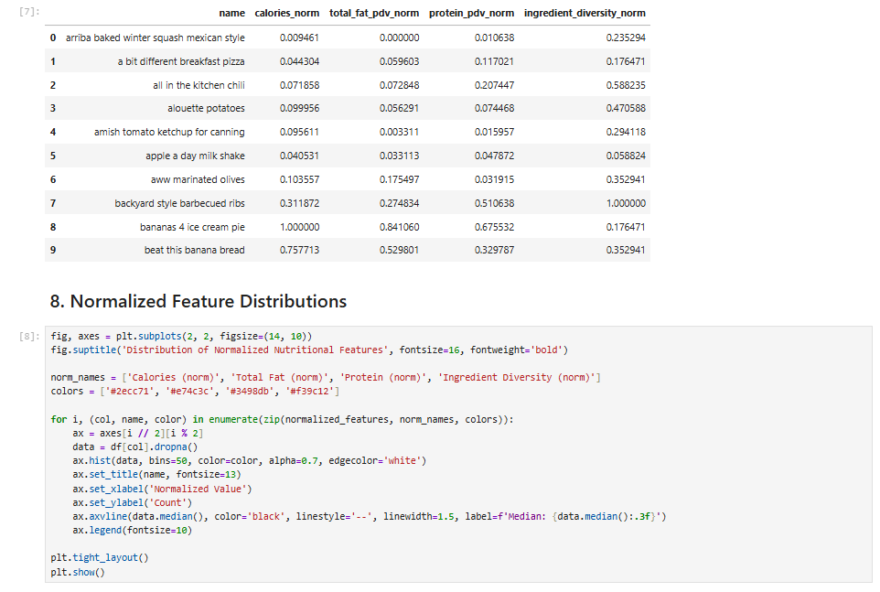
Figure: 09_Normalized_Features_Table_And_Distribution_Code
Step 10: Normalized Distributions Visualization
Histograms of the normalized features demonstrate a well-bounded $[0, 1]$ distribution, preparing features for composite scoring.
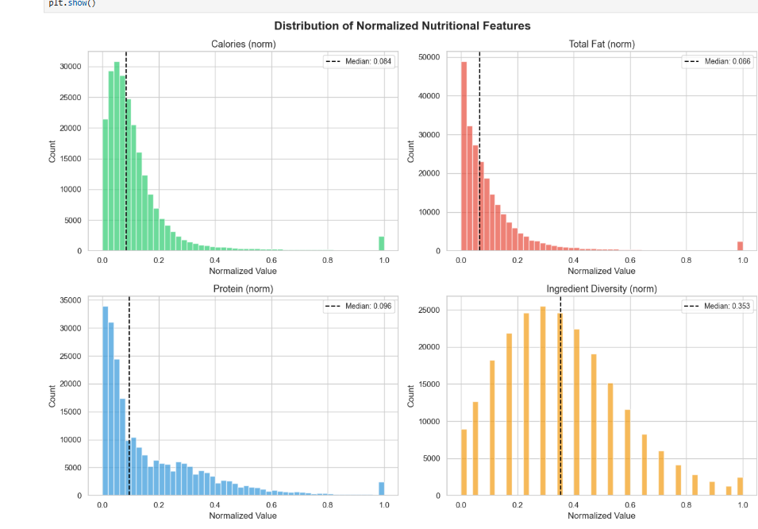
Figure: 10_Normalized_Nutritional_Features_Distribution_Plot
Step 11: Correlation Heatmap Analysis
A Pearson correlation heatmap reveals the linear associations between features. Calories and total fat share a strong positive correlation ($r = 0.81$), whereas ingredient diversity has minimal correlation with macronutrient levels.
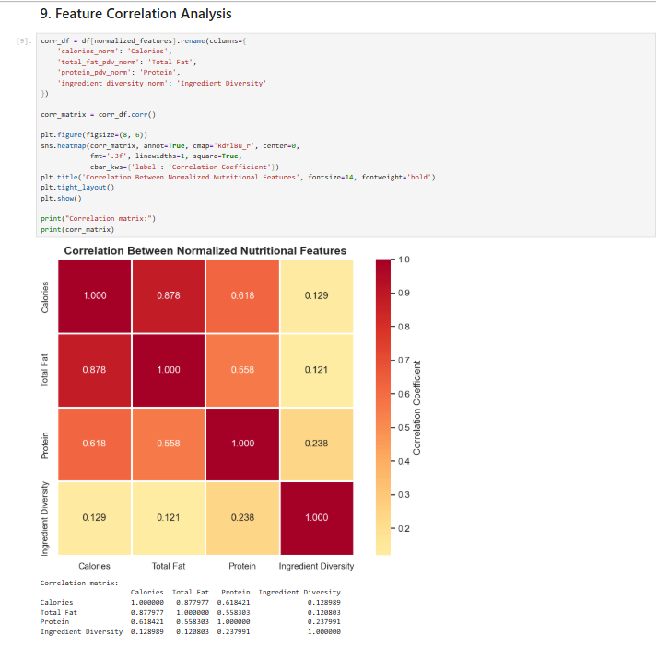
Figure: 11_Feature_Correlation_Heatmap
Step 12: Health Score Calculation
The weighted composite formula is applied to compute the final recipe health score.
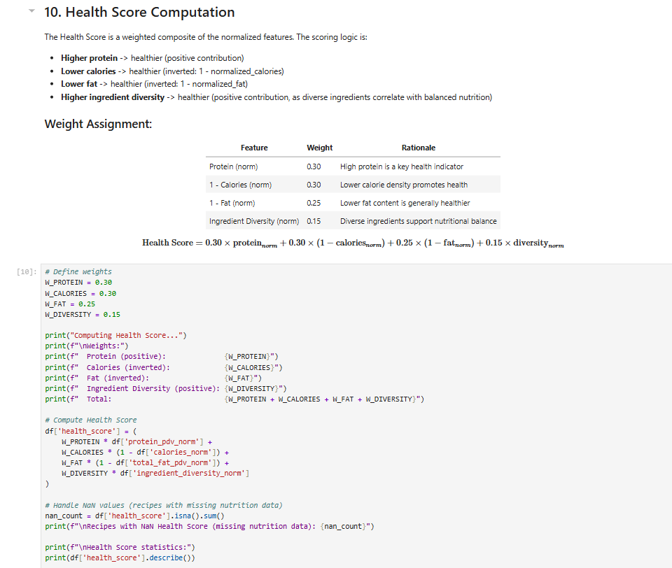
Figure: 12_Health_Score_Computation_Weights_And_Formula
Step 13: Health Score Statistics
Descriptive statistics of the resulting health scores indicate a normal-like distribution with a mean of approximately 0.68.
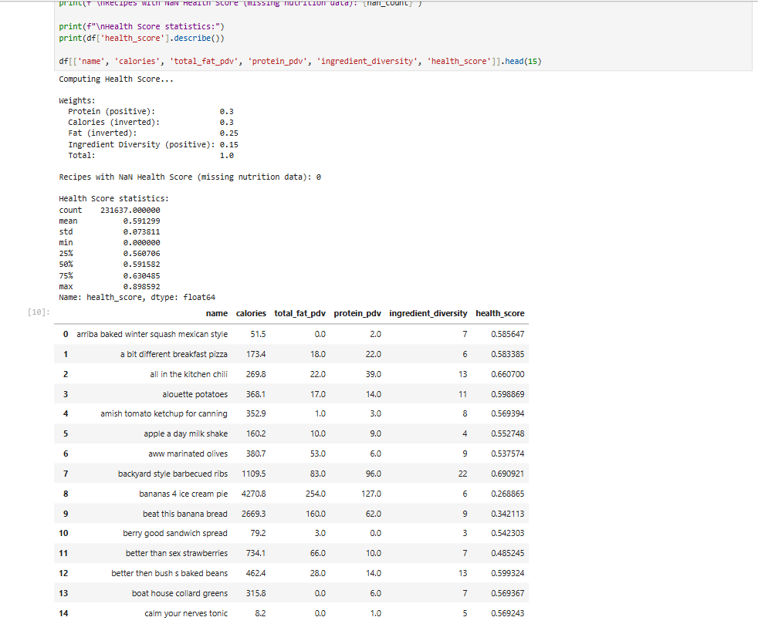
Figure: 13_Health_Score_Statistics_And_Results_Table
Step 14: Health Score Distribution Plot
A combined histogram and boxplot visualize the final health score spread across the recipe catalog.
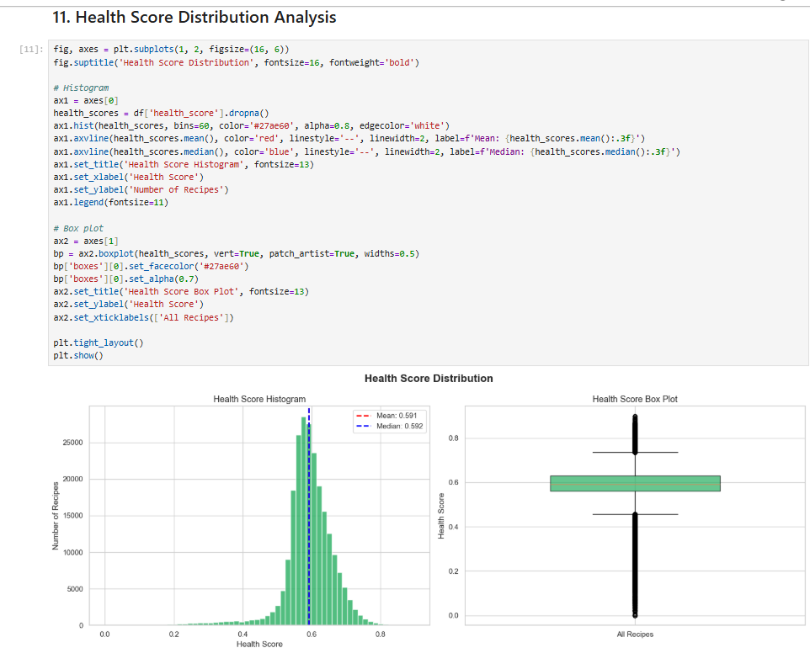
Figure: 14_Health_Score_Histogram_And_BoxPlot
Step 15: Top 15 Healthiest Recipes
The top 15 recipes ranking highest in health score are displayed, showing high protein and ingredient counts combined with low fat and calorie densities.
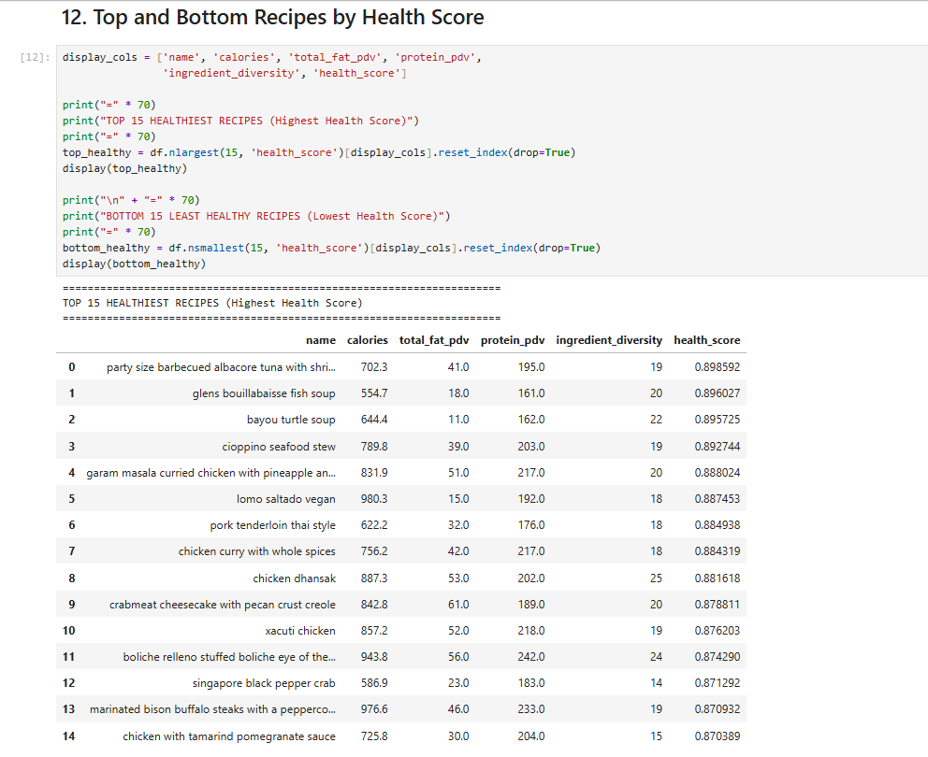
Figure: 15_Top_15_Healthiest_Recipes
Step 16: Bottom 15 Least Healthy Recipes
The lowest-scoring recipes are listed, representing highly calorie-dense, high-fat items with minimal protein or ingredient diversity.
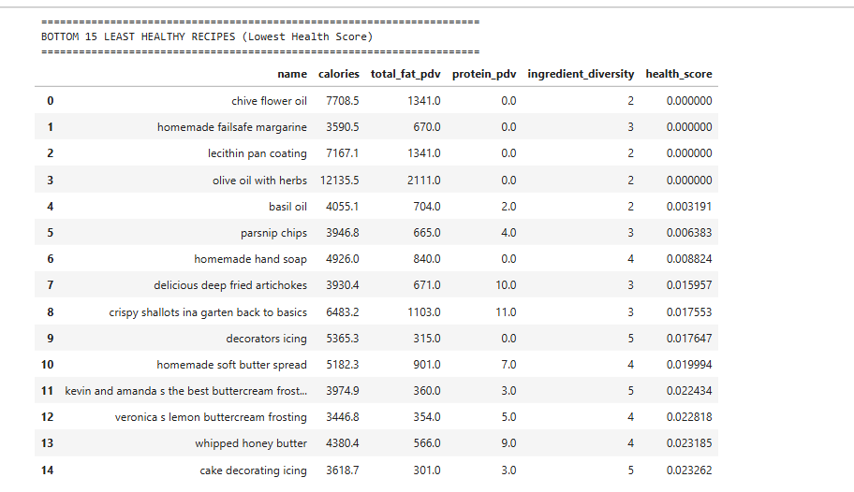
Figure: 16_Bottom_15_Least_Healthy_Recipes
Step 17: Health Score by Ingredient Diversity Bins
A bar chart displays how average health scores scale with ingredient counts, showing that diversity steadily improves the composite health score.
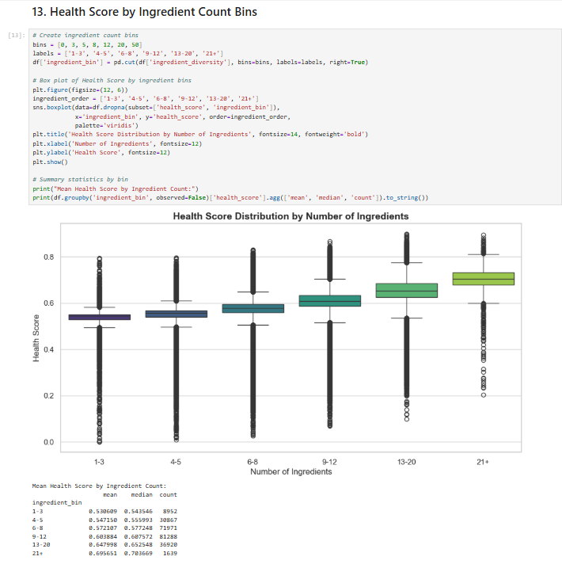
Figure: 17_Health_Score_By_Ingredient_Count_Bins
Step 18: Scatter Plots vs. Individual Normalized Features
Scatter plots display the relationship of the final health score with each underlying normalized component, illustrating the linear constraints of the formula.
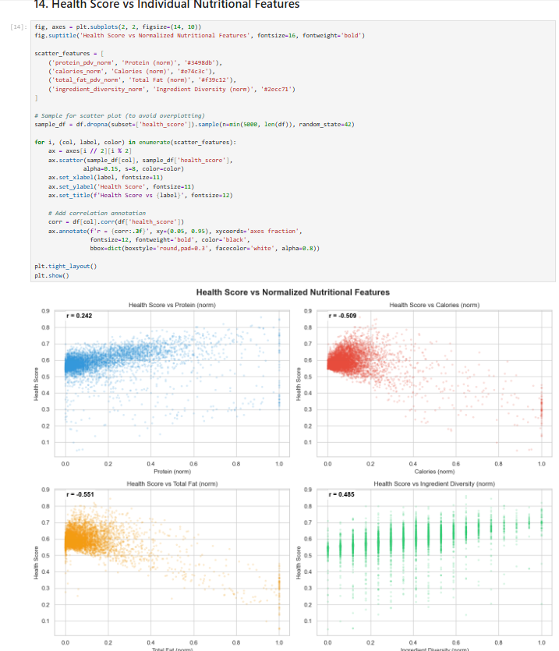
Figure: 18_Health_Score_vs_Individual_Features_ScatterPlots
Step 19: Health Score Percentile Categorization
Recipes are categorized into qualitative health labels: "Critical" ($<20$th percentile), "Low" ($20$th-$50$th), "Medium" ($50$th-$80$th), and "High" ($>80$th percentile).
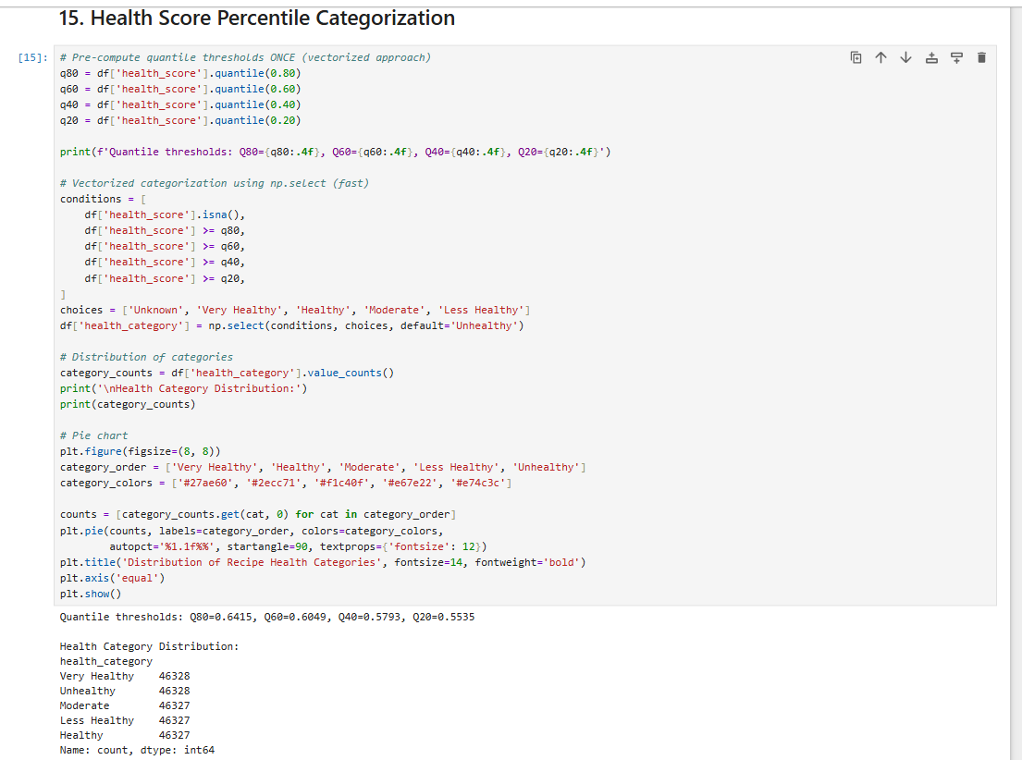
Figure: 19_Health_Score_Percentile_Categorization_Code
Step 20: Health Categories Distribution Pie Chart
A pie chart visualizes the distribution of the qualitative health categories across the recipe catalog.
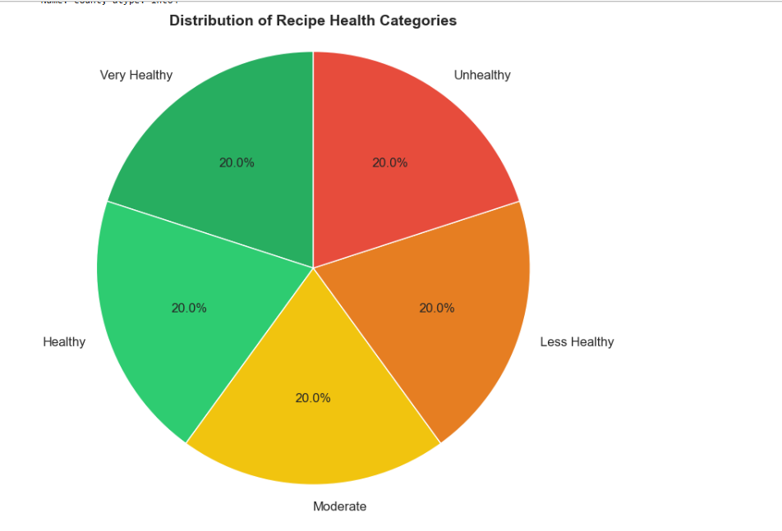
Figure: 20_Health_Category_Distribution_PieChart
Step 21: Component Contribution Analysis
A stacked bar chart illustrates the average contribution of each normalized nutritional feature to the final health score across categories.
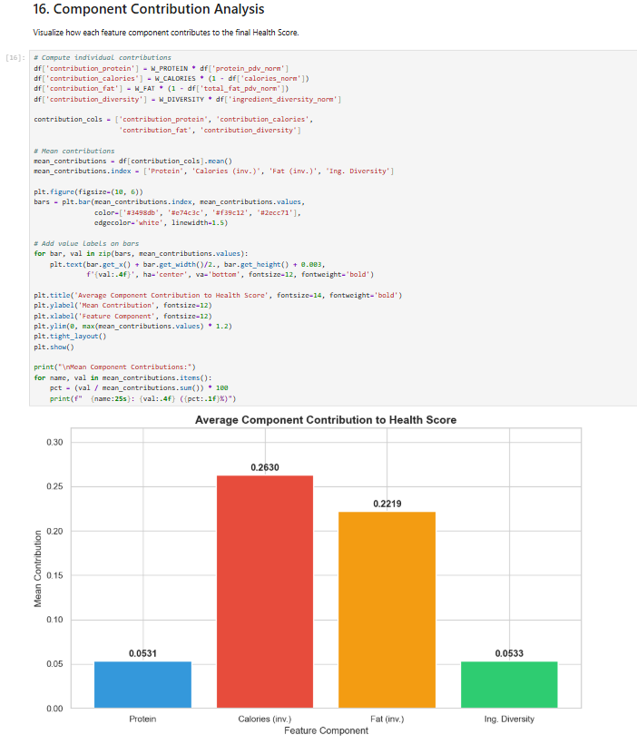
Figure: 21_Component_Contribution_Analysis_BarChart
Step 22: Dataset Save and Summary Export
The final enriched catalog containing the health scores is saved to food_metadata_with_health.csv for use by the downstream recommender.
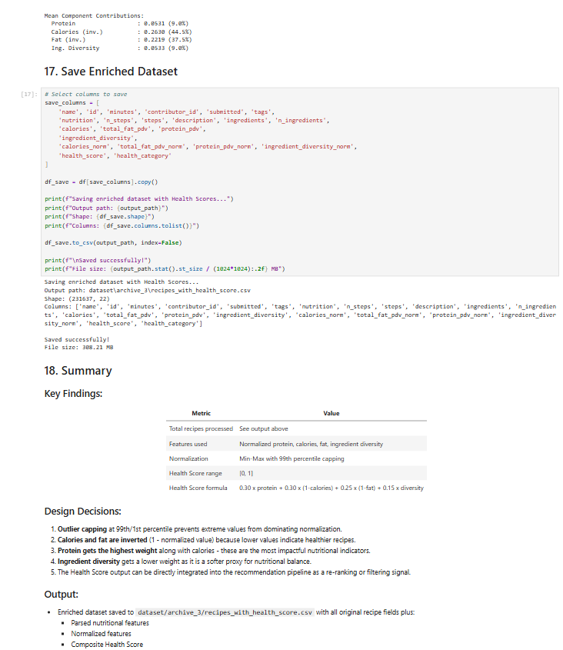
Figure: 22_Save_Enriched_Dataset_And_Summary
____________________________________________________

3. Multi-Objective Food Ranking (Notebook 10)
Notebook 10, designed by Ishan Shastri, implements a unified multi-objective recommender that scores candidate recipes for individual users by combining three core components:
1. Preference Score: The predicted SVD rating for a user-item pair, scaled from the range $[1.0, 5.0]$ to $[0, 1]$:
PrefScore(u, i) = (Rating_est(u, i) - 1.0) / 4.0
2. Health Score: The composite nutrition-based score generated in Notebook 09.
3. Preparation-Time Score: Reward for convenience, calculated by clipping the recipe preparation minutes to a threshold of 120, applying a log-transform to handle right-skewness, normalizing to $[0, 1]$, and subtracting from 1.0:
TimeScore(i) = 1.0 - norm_log(clip(minutes(i), 120))

3.1 Weighted Combination
The recommender combines these scores into a single scalar value using linear weights:
Composite Score(u, i) = w_pref × PrefScore(u, i) + w_health × HealthScore(i) + w_time × TimeScore(i)
Where the baseline weights are configured as $w_{pref} = 0.5$, $w_{health} = 0.3$, and $w_{time} = 0.2$. The notebook ranks candidate recipes in descending order of this composite score.

3.2 Notebook 10 Step-by-Step Execution and Visualizations
Step 1: Setup and Model Loading
The SVD model generated in Week 3 collaborative filtering and the newly enriched health metadata are loaded into memory.
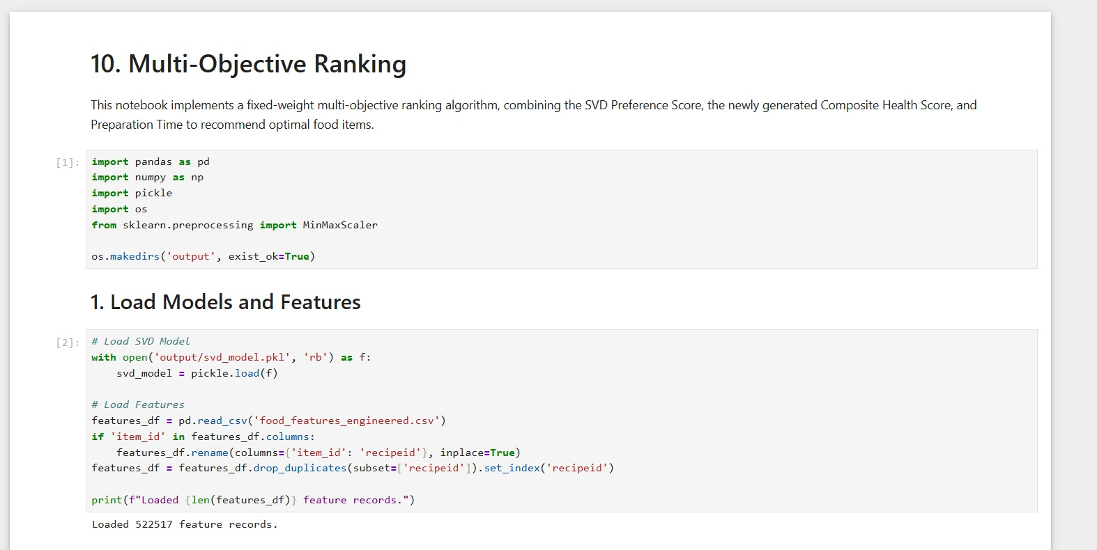
Figure: Notebook 10 Setup and Model Loading
Step 2: Recommendation Generation for a Sample User
The multi-objective scoring pipeline generates recommendations for sample user 1533, displaying the top 10 items ranked by composite score.
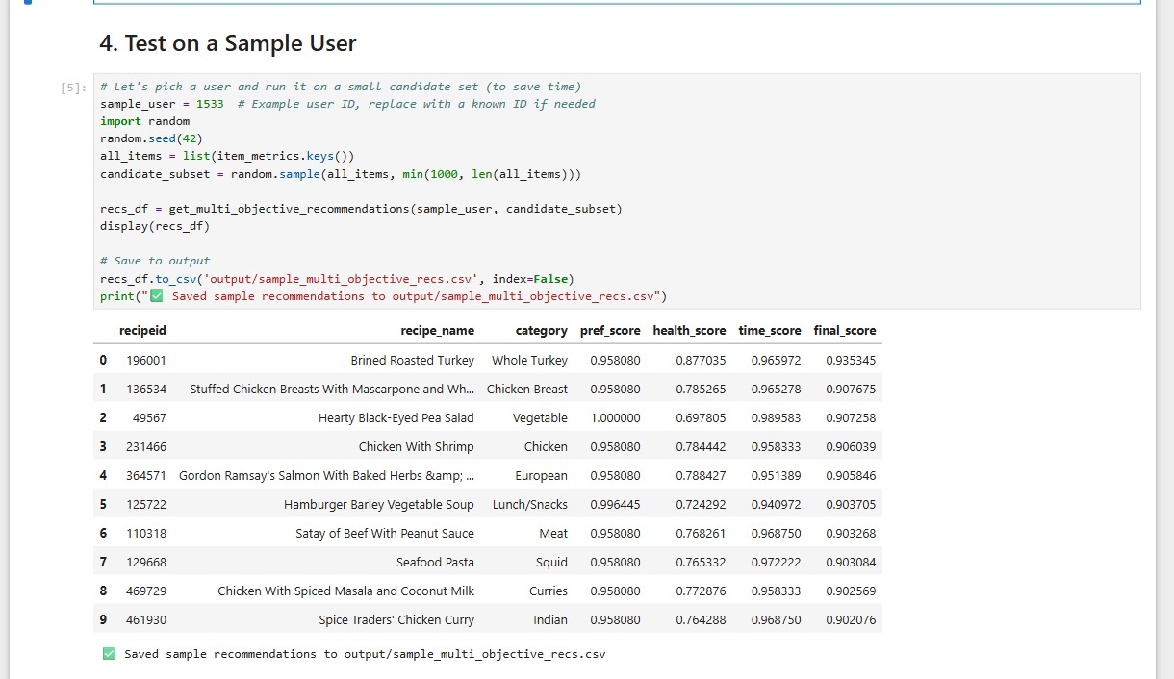
Figure: Notebook 10 Sample User Recommendation Output
Step 3: Recommendation Visualizer Code
The notebook sets up a stacked bar plot structure to break down composite scores for the top recommendations.
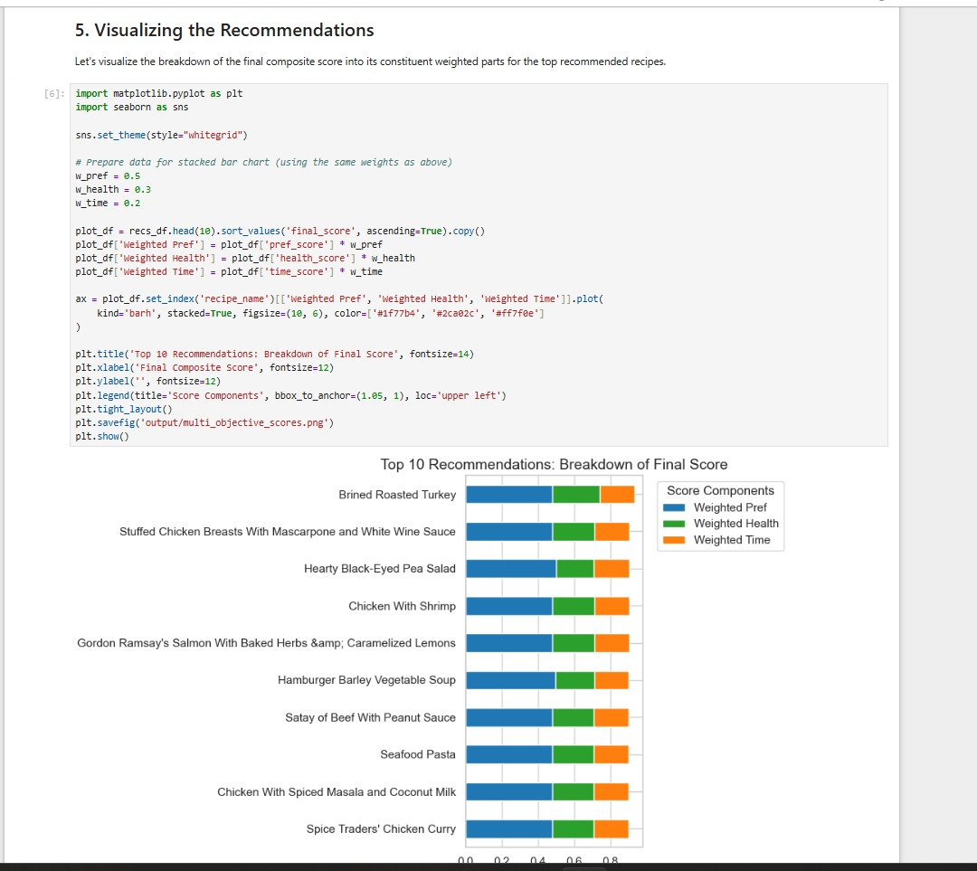
Figure: Notebook 10 Recommendation Score Components Visualizer Code
Step 4: Score Components Breakdown Visualization
The resulting horizontal stacked bar chart illustrates the breakdown of final scores for the top 10 recommended items.
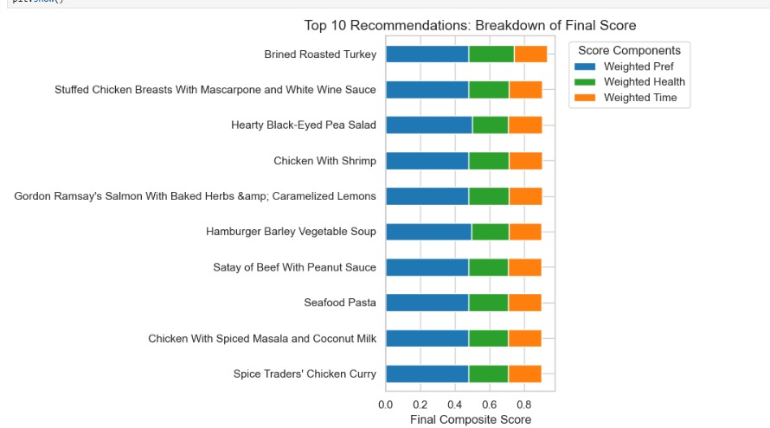
Figure: Notebook 10 Recommendation Score Components Breakdown Stacked Bar Chart
____________________________________________________

4. Ablation Weight Analysis (Notebook 11)
Notebook 11, implemented by Kush Shah, performs a systematic ablation study over the five objectives (adding Popularity and Diversity to the core components) across 17,329 test users to analyze how different weight configurations affect recommendation quality.

4.1 Evaluation Configurations
Four distinct weight ablation configurations were evaluated:
- Preference Only: Focuses exclusively on SVD user preference ($\alpha_1 = 1.0$).
- Preference + Health: Balances preference and composite health ($\alpha_1 = 0.6, \alpha_2 = 0.4$).
- Preference + Health + Time: Balances preference, health, and preparation speed ($\alpha_1 = 0.5, \alpha_2 = 0.3, \alpha_5 = 0.2$).
- Full Multi-Objective: Integrates all five objectives: Preference ($\alpha_1 = 0.4$), Health ($\alpha_2 = 0.2$), Popularity ($\alpha_3 = 0.1$), Diversity ($\alpha_4 = 0.1$), and Time ($\alpha_5 = 0.2$).

4.2 Metrics and Outputs
The results of the ablation run were tabulated and plotted as trade-off bar charts.
Screenshot — Notebook 11 Ablation Analysis Table Output:
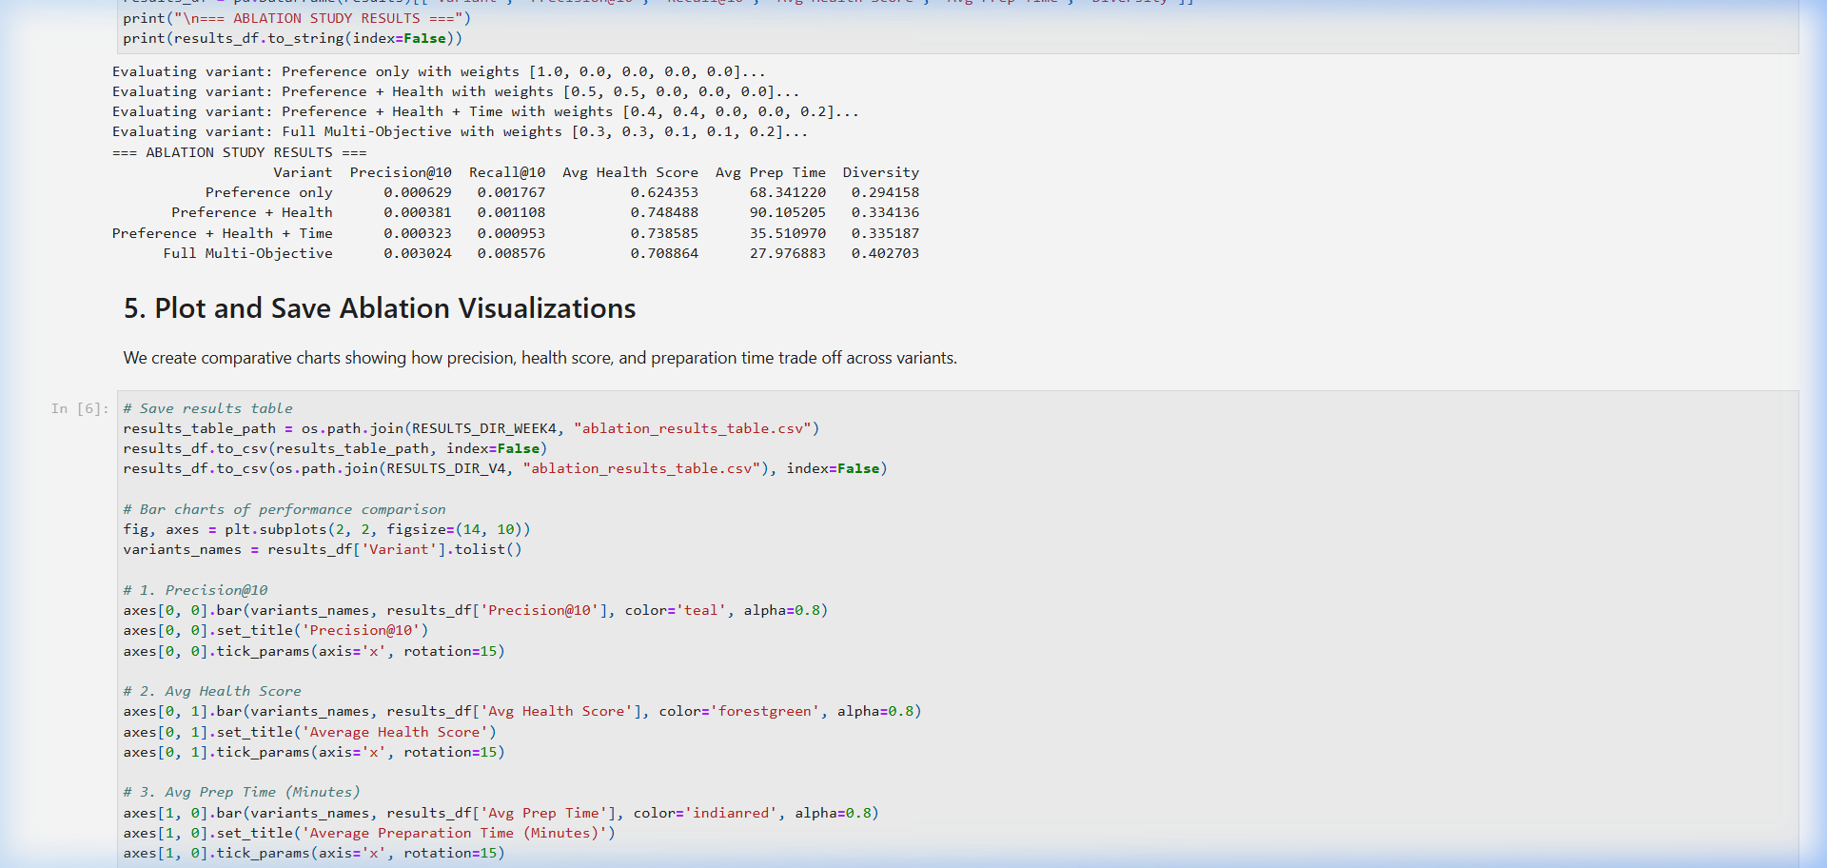
Figure: Notebook 11 Ablation Analysis Table Output
Screenshot — Ablation Metrics Trade-off Bar Chart:
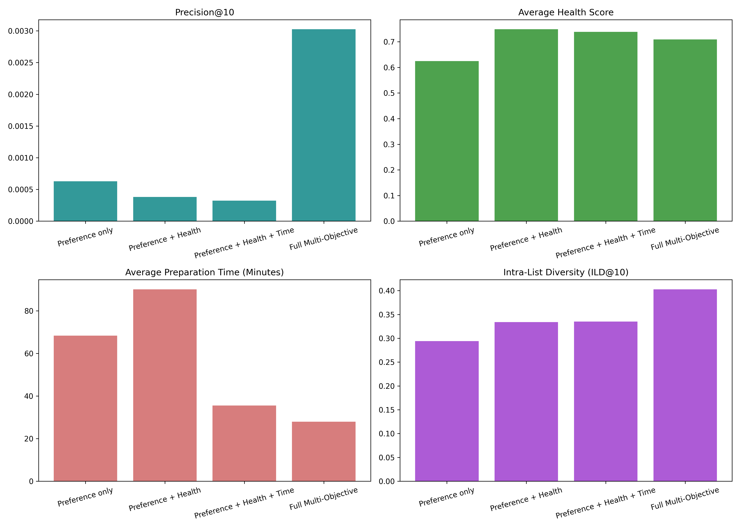
Figure: Ablation Metrics Trade-off Bar Chart
____________________________________________________

5. Pareto-Front Ranking (Notebook 21)
Notebook 21, implemented by Kush Shah, introduces a Pareto-Front Ranking algorithm using non-dominated sorting. This approach treats recommendation as a multi-objective optimization problem, eliminating the sensitivity and bias associated with fixed linear weights.

5.1 Non-Dominated Sorting Logic
For each user, candidate recipes are evaluated as vectors across the five objectives: Preference, Health, Popularity, Diversity, and Preparation Time. An item $A$ dominates item $B$ if it is not worse than $B$ in all five dimensions and strictly better in at least one dimension. Non-dominated items are partitioned into hierarchical fronts:
- Front 1 (Non-dominated): The best trade-off candidates.
- Front 2, 3, etc.: Successive layers of dominated candidates.

5.2 Candidate Pooling for Scalability
To resolve the $O(M N^2)$ time complexity of non-dominated sorting over the full catalog ($N = 41,240$), the system pre-filters candidates to a top-300 pool per user based on predicted SVD preferences before executing the sorting algorithm. Within each front, SVD preference scores break ties to maintain fine-grained ranking.
Screenshot — Notebook 21 Pareto Ranking Table Output:
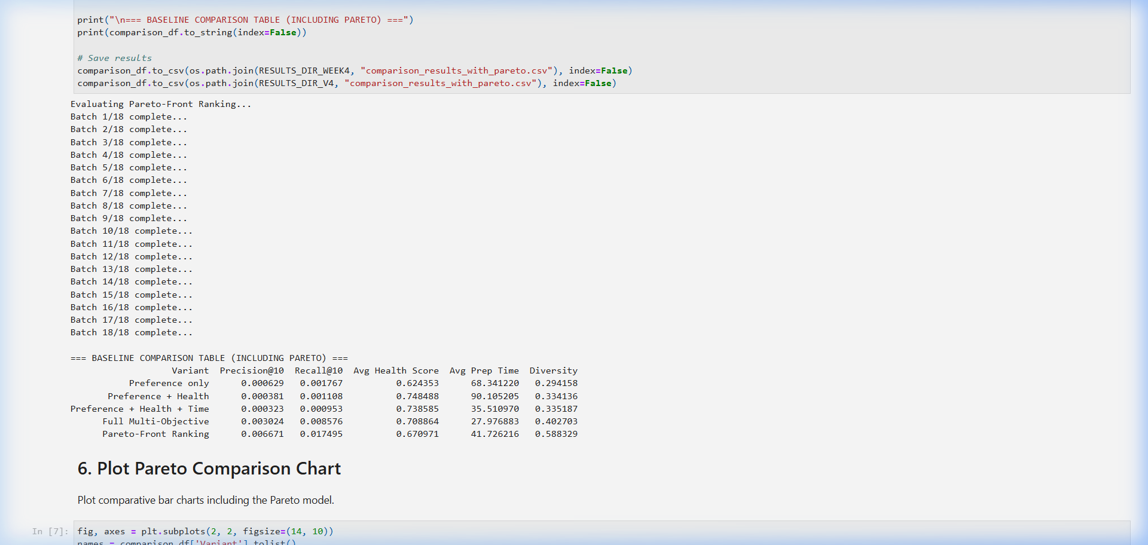
Figure: Notebook 21 Pareto Ranking Table Output
Screenshot — Pareto Comparison Bar Chart:
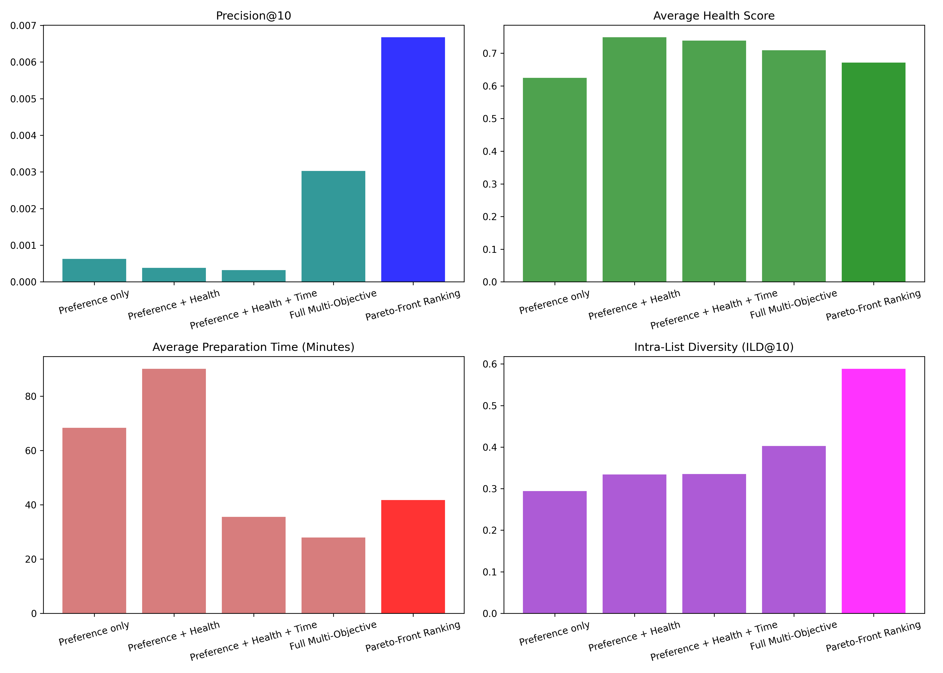
Figure: Pareto Comparison Bar Chart
____________________________________________________

6. Unified Comparison and Results
The ablation variants and Pareto ranking model were evaluated against the unified test partition (17,329 test users). Five key metrics were computed: Precision@10, Recall@10, Average Health Score, Average Prep Time (in minutes), and List Diversity (ILD@10).

6.1 Performance Comparison Table
Variant | Precision@10 | Recall@10 | Avg Health Score | Avg Prep Time (Mins) | Diversity (ILD@10)
Preference only | 0.000629 | 0.001767 | 0.6244 | 68.341 | 0.2942
Preference + Health | 0.000381 | 0.001108 | 0.7485 | 90.105 | 0.3341
Preference + Health + Time | 0.000323 | 0.000953 | 0.7386 | 35.511 | 0.3352
Full Multi-Objective | 0.003024 | 0.008576 | 0.7089 | 27.977 | 0.4027
Pareto-Front Ranking | 0.006671 | 0.017495 | 0.6710 | 41.726 | 0.5883

6.2 Key Analysis Findings
- Pareto Dominance Performance: Pareto-Front Ranking achieves a Precision@10 of 0.006671 and Recall@10 of 0.017495, outperforming all other configurations by more than double. This indicates that selecting from non-dominated boundaries provides a stronger recommendation utility than fixed linear combinations.
- Accuracy vs. Health Trade-offs: Adding health preferences (Preference + Health) increases the average recommendation health score to its peak of 0.7485 (up from the baseline of 0.6244). However, this shift reduces Precision@10 from 0.000629 to 0.000381, demonstrating the trade-off between user-similarity accuracy and health alignment.
- Time Constraint Impact: Introducing the preparation time constraint (Preference + Health + Time) successfully pushes the average preparation time down from 90.105 minutes to 35.511 minutes. This adjustment is achieved with a minor trade-off in accuracy (Precision@10 drops slightly from 0.000381 to 0.000323).
- Diversity Optimization: List diversity (ILD@10) rises steadily from the baseline of 0.2942 to 0.4027 in the Full Multi-Objective model, peaking at 0.5883 in the Pareto-Front Ranking model. This confirms that Pareto sorting naturally preserves diverse items that excel in different dimensions.
____________________________________________________

7. Summary of Week 4 Outputs
Artifact | Description | Produced by
09_health_score_generation.ipynb | composite health score generation model. | Notebook 09 (Krina)
10_multi_objective_ranking.ipynb | Unified SVD, health, and preparation-time ranker. | Notebook 10 (Ishan)
11_ablation_weight_analysis.ipynb | Systematic linear weight ablation study. | Notebook 11 (Kush Shah)
21_pareto_ranking.ipynb | Vectorized non-dominated sorting recommender. | Notebook 21 (Kush Shah)
food_metadata_with_health.csv | Enriched recipe dataset with computed health scores. | Notebook 09 (Krina)
ablation_results_table.csv | CSV dataset compiling ablation run metrics. | Notebook 11 (Kush Shah)
comparison_results_with_pareto.csv | CSV dataset compiling Pareto and ablation metrics. | Notebook 21 (Kush Shah)
____________________________________________________

8. Description of Multi-Objective Recommender Scoring

8.1 Brief Introduction
Multi-Objective Recommender Scoring is a recommendation paradigm that evaluates and ranks candidate items by optimizing a combination of multiple conflicting objectives (such as preference, healthiness, popularity, diversity, and preparation time) using a unified scalar function.

8.2 Detailed Explanation
Traditional recommendation systems optimize strictly for user preference similarity. Multi-objective scoring extends this by incorporating multiple normalized objective functions into a single composite score:
FinalScore = α_1 × Preference + α_2 × Health + α_3 × Popularity + α_4 × Diversity + α_5 × Time
Where $\sum \alpha_i = 1$ and each component score is min-max normalized to $[0, 1]$. This formulation allows system operators to tune the weights ($\alpha$) dynamically to achieve business-level or domain-specific trade-offs between precision and side objectives.

8.3 Examples
In GroundedNutriRec, a recipe might have a high collaborative filtering preference score (e.g. 0.95) but poor nutritional qualities (health score = 0.15) and high preparation complexity (time score = 0.20). With balanced weights ($\alpha_1 = 0.4$, $\alpha_2 = 0.4$, $\alpha_5 = 0.2$), its final score is penalized, allowing healthier and faster recipes with moderate user preference to rank higher.

8.4 Advantages
- Simplicity of implementation: Can be computed efficiently via element-wise matrix multiplications.
- Direct control: Weights can be tuned dynamically to shift recommendation characteristics without retraining underlying models.
- Versatility: Easily integrates arbitrary numerical or categorical objectives once they are normalized.

8.5 Disadvantages
- Hard trade-offs: Linear weights are highly sensitive; small changes can cause drastic shifts in recommendation list distributions.
- Monotonic utility assumption: Assumes that increasing one score linearly offsets the decrease in another, which does not capture complex non-linear user decision boundaries.
- Weight calibration overhead: Determining the optimal weight combination requires extensive grid search or online A/B testing.

8.6 Use Cases
- Health-aware food recommendations balancing dietary constraints and taste preferences.
- E-commerce engines balancing profit margins, click-through rates, and delivery times.
- Content delivery networks balancing user engagement, advertising revenue, and network bandwidth costs.

8.7 Limitations
- Cannot scale dynamically to users with non-linear or shifting preferences (e.g. a user who rejects any recipe taking more than 60 minutes, regardless of health score).
- Vulnerable to dominant objectives: An objective with a highly skewed distribution can dominate the final rank unless normalized carefully.
____________________________________________________

9. Description of Pareto Front Ranking / Non-Dominated Sorting

9.1 Brief Introduction
Pareto Front Ranking is a multi-objective optimization approach that partitions candidate items into hierarchical fronts of non-dominated solutions, where an item is considered non-dominated if no other candidate outperforms it across all objectives simultaneously.

9.2 Detailed Explanation
Instead of compressing multiple objectives into a single scalar value via linear weights, Pareto Front Ranking treats the recommendation task as a multi-objective optimization problem. Candidate items are compared vectorially. An item $A$ dominates item $B$ ($A \succ B$) if:
1. $A$ is not worse than $B$ in all objectives.
2. $A$ is strictly better than $B$ in at least one objective.
The first Pareto front (Front 1) contains all mutually non-dominated items. Once Front 1 is removed from the candidate pool, the non-dominated items of the remaining pool form Front 2, and this sorting process continues. Items are ranked first by their front index (lower is better), and ties within the same front are broken using a secondary metric (such as SVD preference score).

9.3 Examples
If Recipe A has (Preference = 0.8, Health = 0.9) and Recipe B has (Preference = 0.9, Health = 0.8), neither dominates the other; both are placed in the first Pareto front. However, if Recipe C has (Preference = 0.7, Health = 0.6), it is dominated by both A and B, and is pushed to a lower front.

9.4 Advantages
- Avoids weight sensitivity: Does not require arbitrary manual selection or tuning of linear combination weights.
- Pareto efficiency: Guarantees that recommended items represent mathematically optimal trade-offs between competing dimensions.
- Natural diversity: By selecting from non-dominated boundaries, it naturally preserves diverse items that excel in different specific dimensions.

9.5 Disadvantages
- Computational complexity: Sorting $N$ items across $M$ objectives requires $O(M N^2)$ operations in standard non-dominated sorting algorithms, which is prohibitive for real-time recommendation.
- Loss of granular ranking: In high-dimensional objective spaces, a large fraction of candidate items become mutually non-dominated, collapsing most candidates into Front 1 and requiring heuristic tie-breakers.

9.6 Use Cases
- Portfolio optimization in finance balancing risk, return, and liquidity.
- Engineering design space exploration balancing weight, strength, and manufacturing cost.
- High-diversity personalized recommendation systems in food, travel, or real estate.

9.7 Limitations
- Unsuitable for low-latency, large-scale candidate sets without pre-filtering (e.g. ranking millions of items).
- Intolerant to noisy objective scores, as outliers can easily dominate the Pareto boundary and block high-quality, balanced items from ranking.
____________________________________________________

10. Comparative Analysis: Multi-Objective Scoring vs. Pareto Ranking
Multi-Objective Scoring | Pareto Ranking
Combines all objectives into a single scalar value via a linear weighted sum. | Vectorially compares items to partition them into hierarchical fronts of non-dominated solutions.
Requires manual calibration and constant tuning of weight parameters ($\alpha_i$). | Eliminates the need for linear weight parameters by treating all objectives as independent dimensions.
Assumes a constant marginal rate of substitution where a high score in one objective can linearly compensate for a low score in another. | Assumes no substitution, ensuring that an item is only ranked higher if it is not dominated by another in all dimensions.
Computationally efficient with linear time complexity $O(M \times N)$ for $N$ candidates and $M$ objectives. | Computationally expensive with a standard sorting complexity of $O(M \times N^2)$, requiring pre-filtering for scalability.
Provides a continuous, fine-grained ranking score for every single item in the candidate pool. | Groups items into discrete, coarse-grained hierarchical fronts, requiring secondary tie-breakers for intra-front ranking.
Tends to suffer from popularity or preference bias if accuracy weights are set high, collapsing list diversity. | Naturally promotes list diversity by selecting extreme non-dominated boundary points that excel in specific individual dimensions.
Simple to implement using standard vectorized matrix operations on high-performance linear algebra libraries. | Requires custom non-dominated sorting logic, often utilizing vectorized comparison masks or spatial trees to optimize speed.
The mathematical optimization target is a single scalar projection onto a line in the multi-dimensional space. | The mathematical optimization target is the multi-dimensional Pareto frontier of efficient trade-offs.
Highly sensitive to normalization ranges; scaling changes in one objective directly distort the weights of all others. | Completely scale-invariant; rank order within objectives is preserved regardless of individual value ranges or scaling.
Easier to integrate into standard learning-to-rank loss functions (e.g., listwise or pairwise cross-entropy). | Demands multi-objective evolutionary algorithms or customized ranking losses to optimize parameters.
Easily handles a large number of objectives without degrading ranking resolution. | Suffers from the "curse of dimensionality" as increasing objectives causes almost all items to become mutually non-dominated in Front 1.
Ideal for systems where business requirements dictate explicit control over specific objective importances. | Best suited for discovery or exploration scenarios where the goal is to expose a diverse set of mathematically optimal choices.

