Practical – 3
RESPONSIVE UI DESIGN USING CSS GRID, FLEXBOX AND MEDIA QUERIES
Student Name | Krina Sorathiya
Enrollment No | 25AIML071
Program | B.Tech – Artificial Intelligence and Machine Learning
Subject | Web Technology
Faculty Name | Deep Mendha

AIM
To design and implement responsive web pages using HTML5 and CSS3 with CSS Grid, Flexbox, and Media Queries, ensuring proper layout and usability across mobile, tablet, and desktop devices.

PROBLEM DEFINITION
Design responsive layouts for the following web pages:
- Home
- About
- Registration
- Dashboard
- Events
The website should follow a mobile-first responsive design approach and maintain consistent typography, spacing, colors, alignment, and visual structure across different screen sizes.

SCREENSHOTS
Home Page – Mobile View

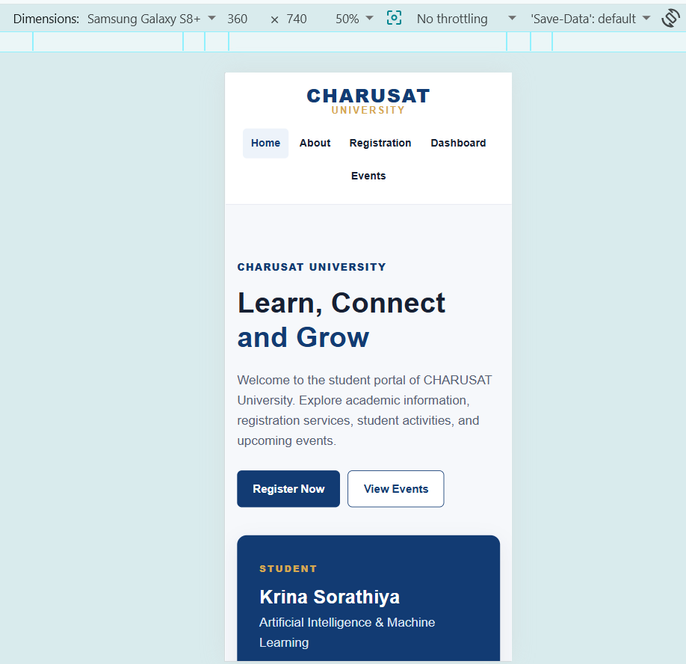
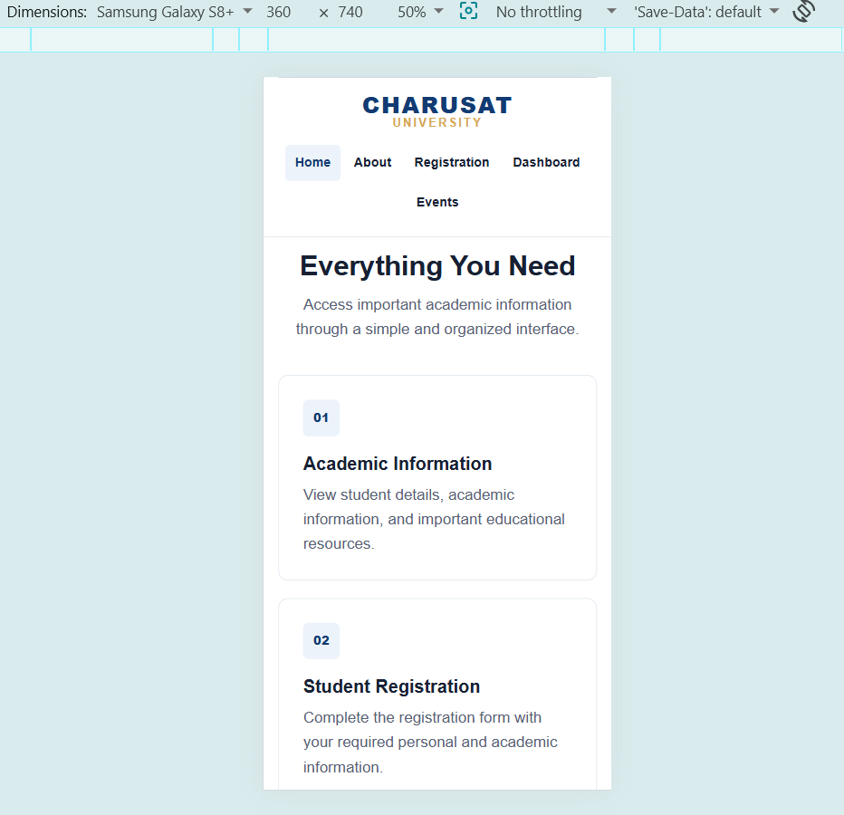
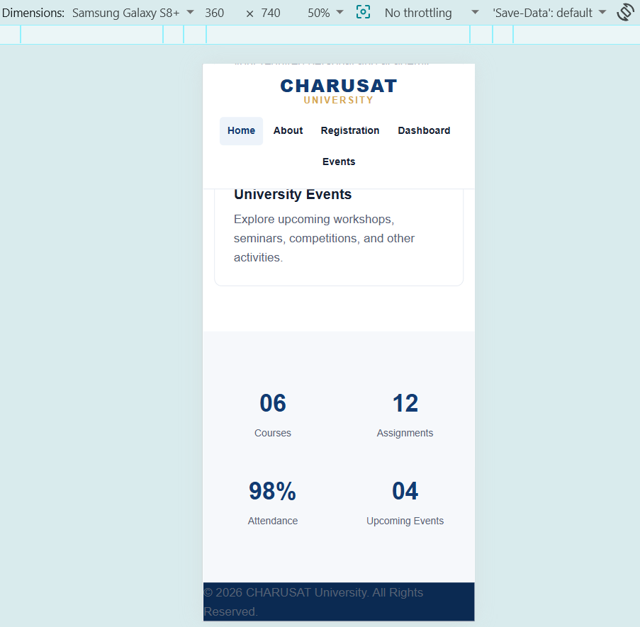

Home Page – Tablet View
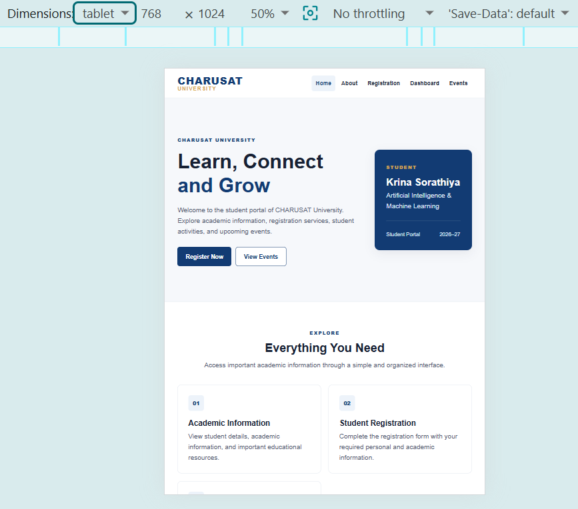
Home Page – Desktop View
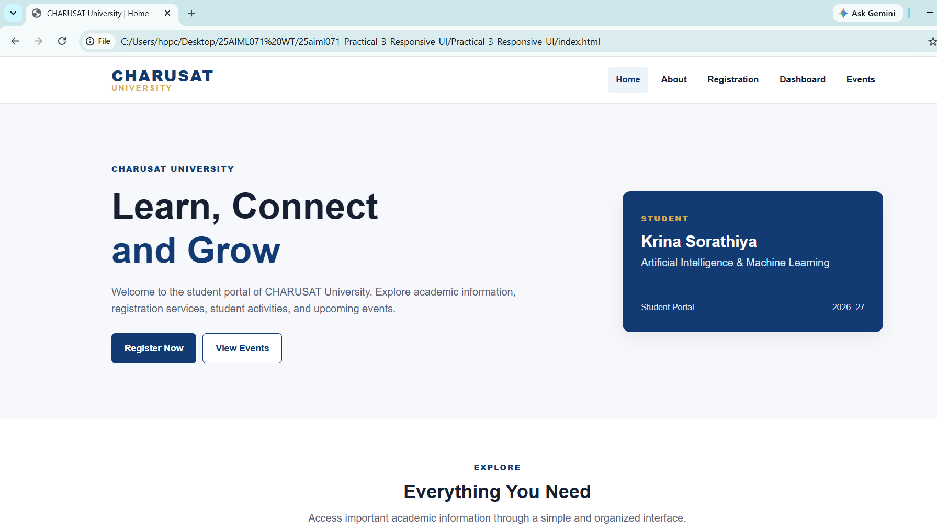
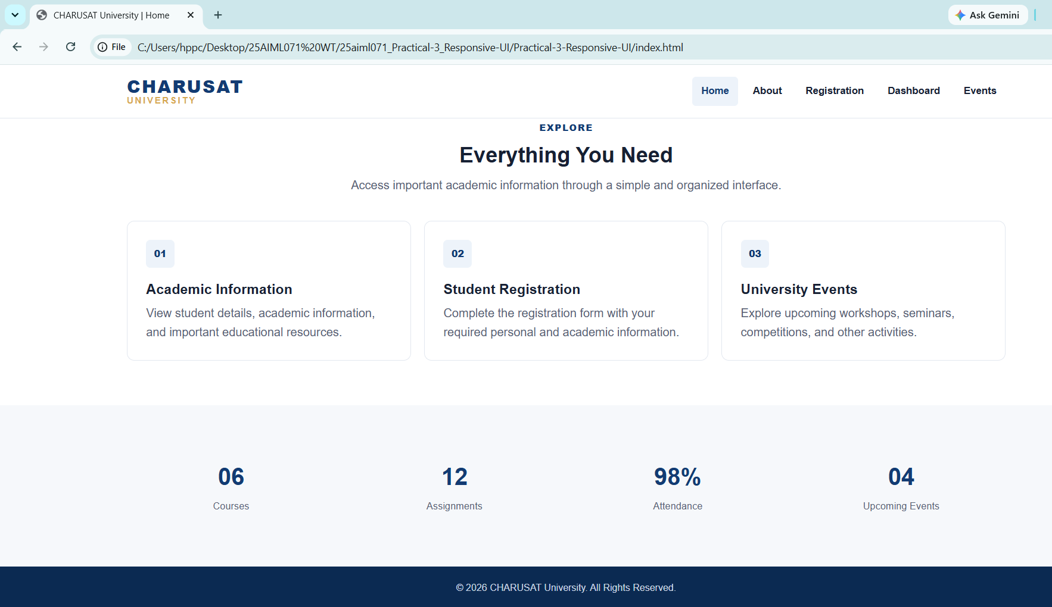
About Page – Responsive View
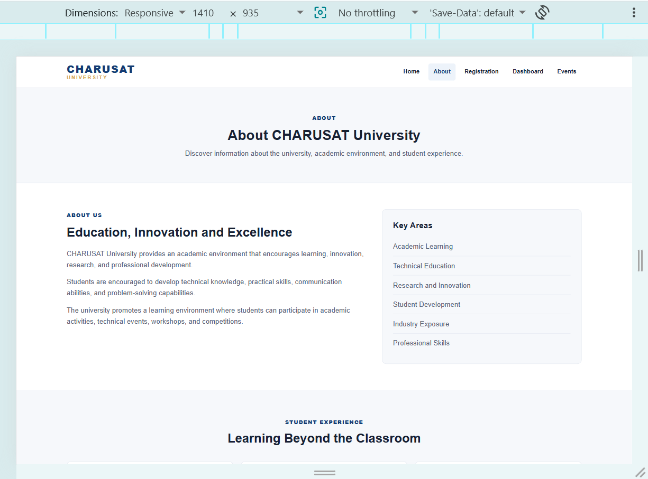
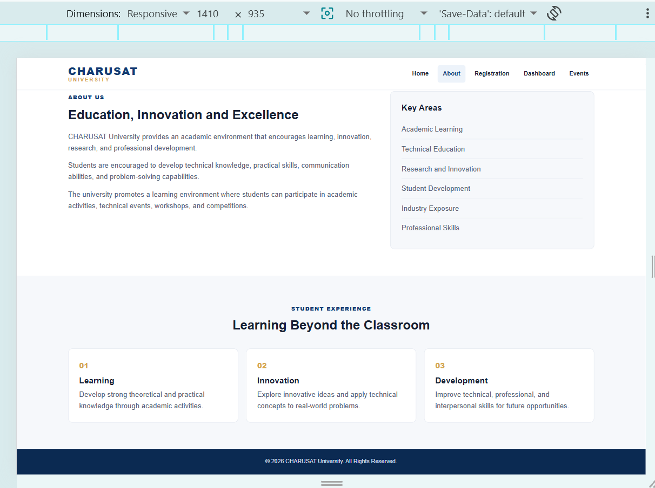
Registration Page – Responsive View
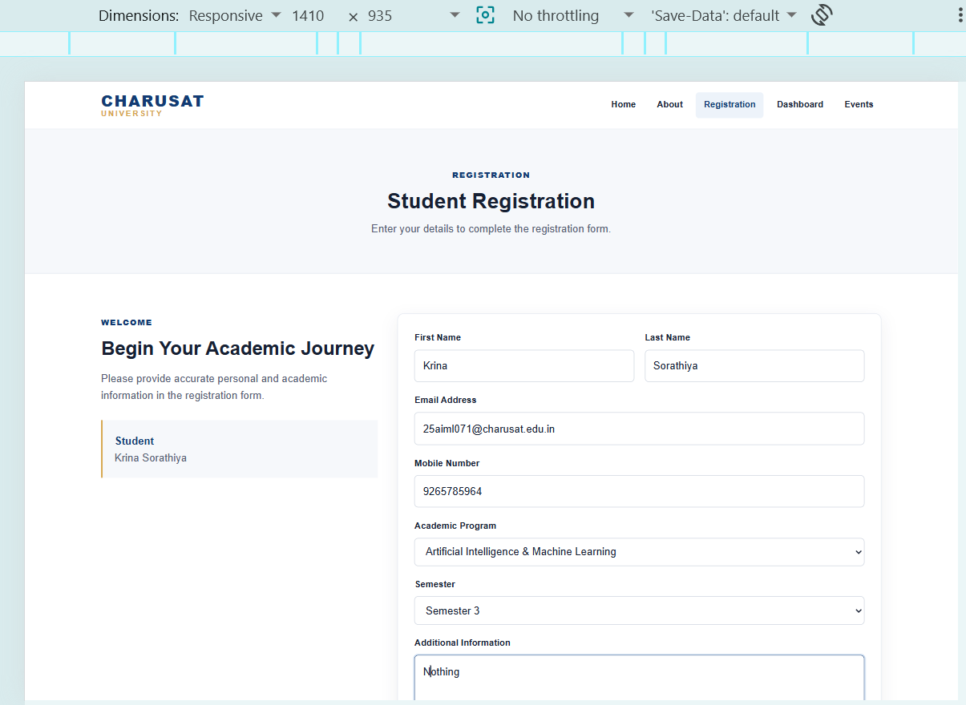


Dashboard Page – Responsive View
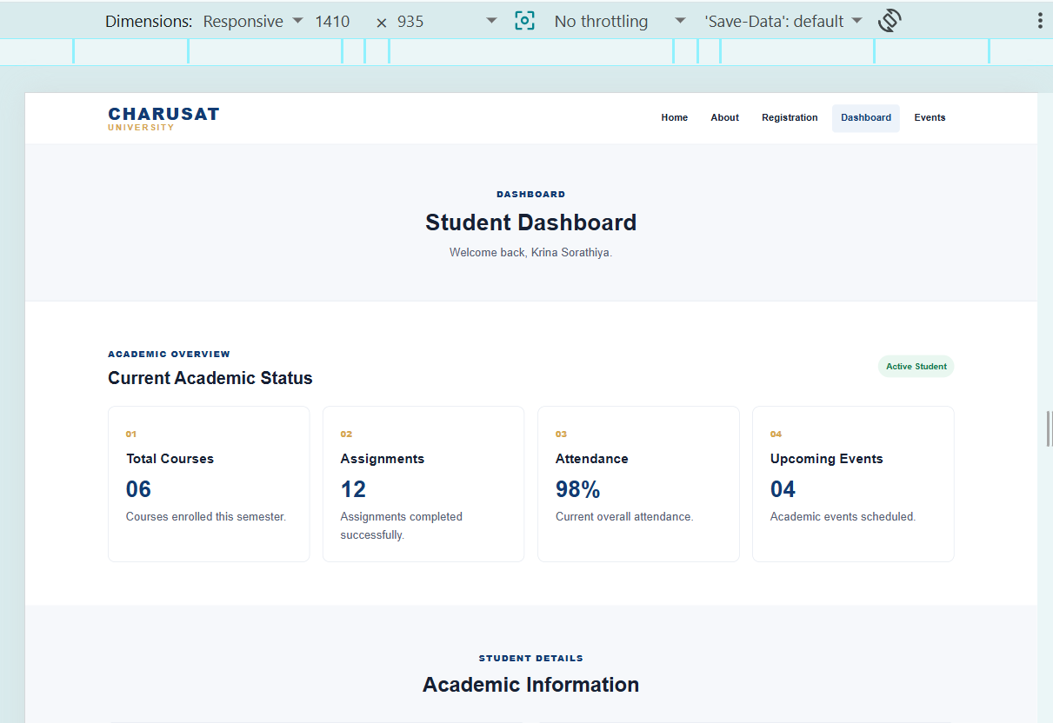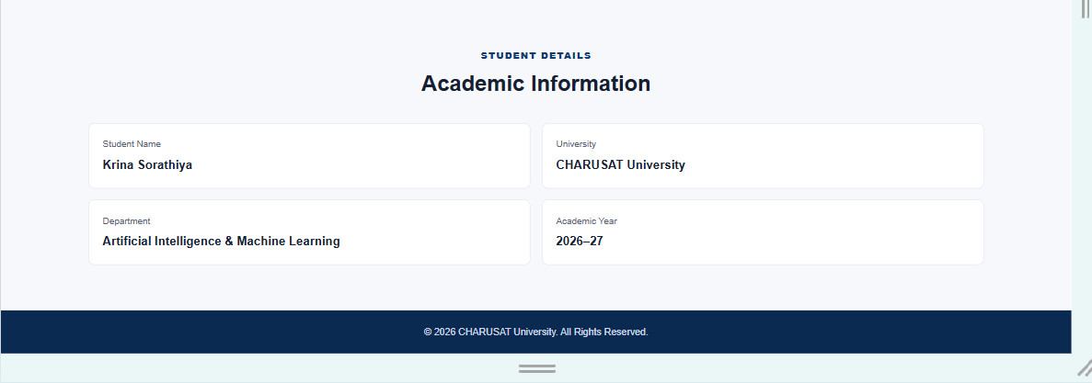

Events Page – Responsive View
