Practical – 1
Project Initiation, Requirement Analysis, Sitemap, Wireframe, and GitHub Setup
Student Name | Krina Sorathiya
Enrollment No | 25AIML071
Program | B.Tech – Artificial Intelligence and Machine Learning
Subject | Web Technology
Faculty Name | Deep Mendha

Problem Definition :
Initiate the semester-long StudentHub portal by identifying the problem scope,
user roles, key modules, navigation flow, and minimum 10 pages. Create a
sitemap, low-fidelity wireframe, project folder structure, README file, and
GitHub repository.
Sitemap:
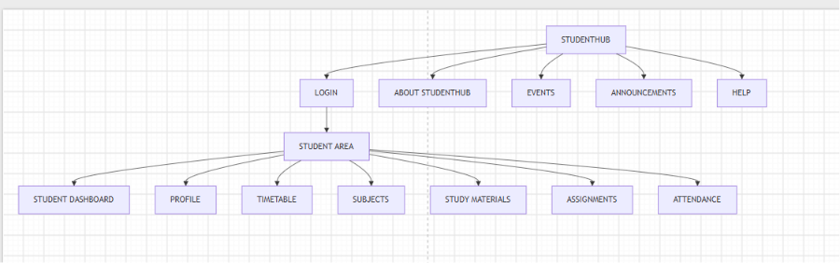
FRAME WORK:
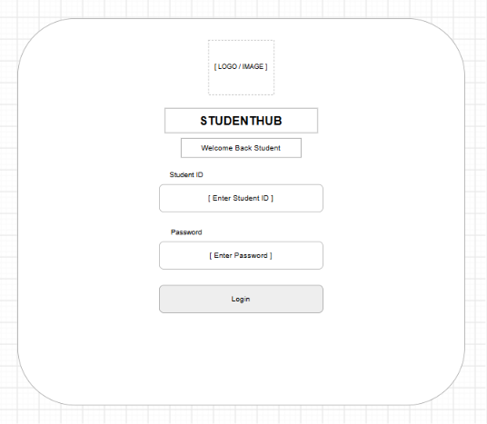

Github Link:
https://github.com/krinasorathiya-com/Web_Technology/tree/main/Practical%201/Student_Hub

