Practical – 3
Semantic HTML5 Pages with Accessibility-Ready Structure
Student Name | Krina Sorathiya
Enrollment No | 25AIML071
Program | B.Tech – Artificial Intelligence and Machine Learning
Subject | Web Technology
Faculty Name | Deep Mendha

Aim
To develop static StudentHub web pages using semantic HTML5 elements and accessibility-friendly structures, with proper navigation and consistent page layout.

Problem Definition
Develop static HTML5 pages for a StudentHub student portal, including Home, About, Register, Login, Dashboard, Profile, Contact, Admin, FAQ, and Feedback.
The website should use semantic HTML elements, accessible forms, meaningful navigation, proper headings, image alternative text, and consistent page structure.

Output Screenshots
  - Home Page
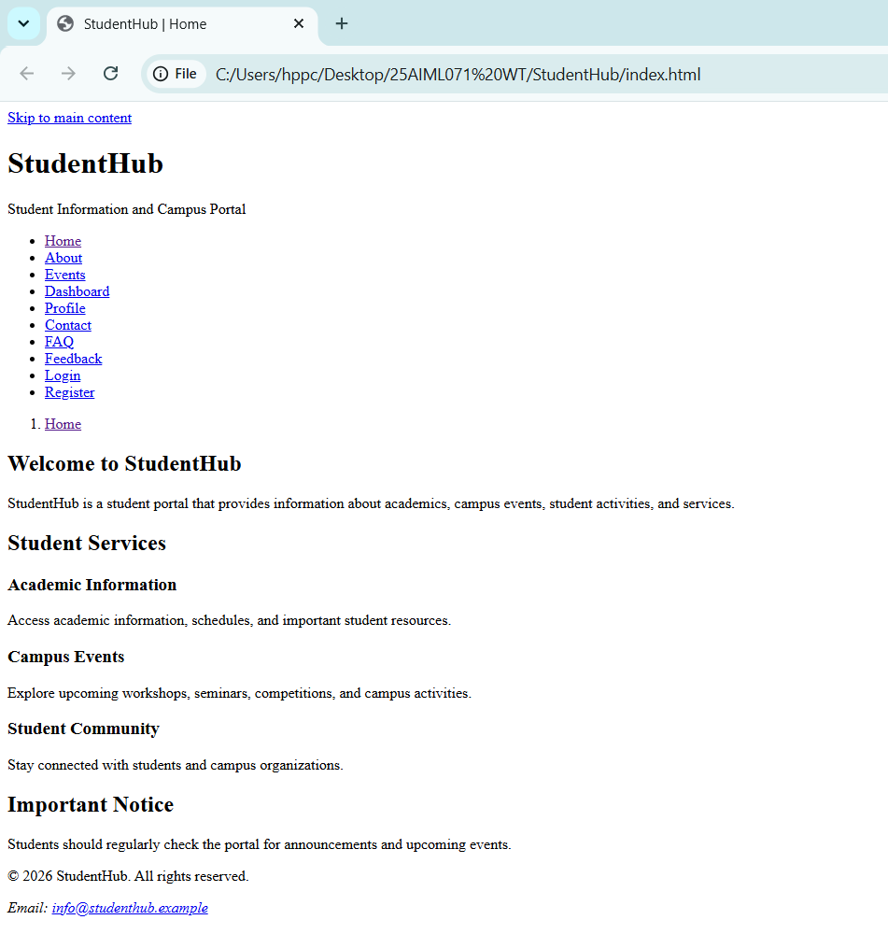

1.2 About Page
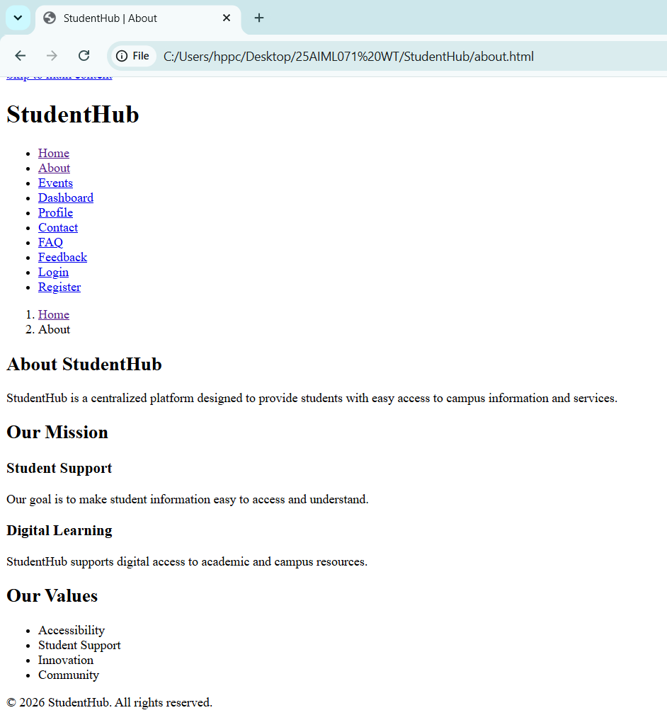

1.3 Events
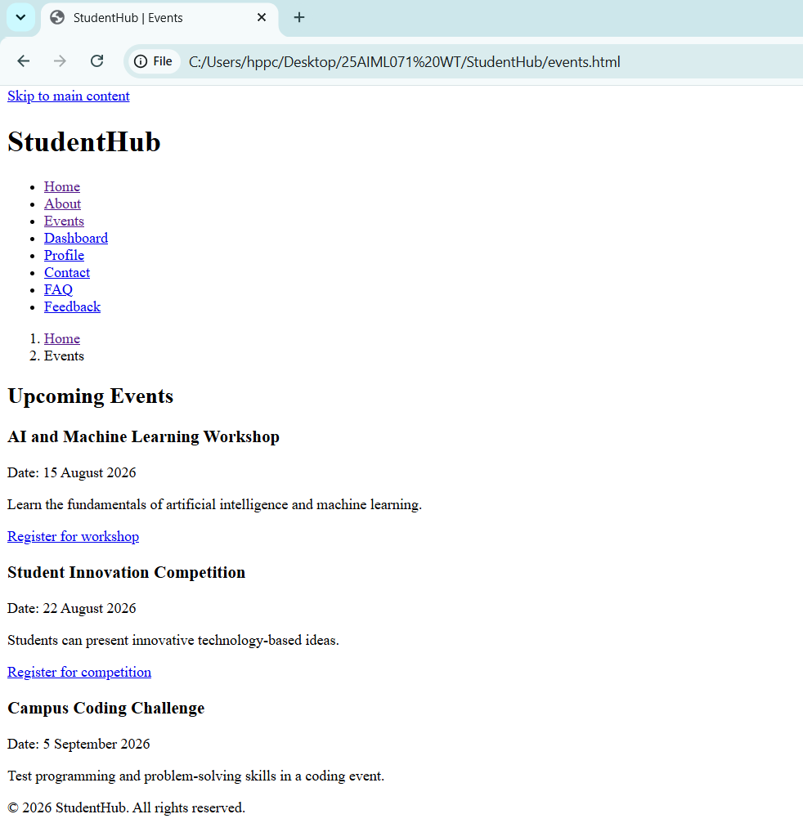

1.4 Login
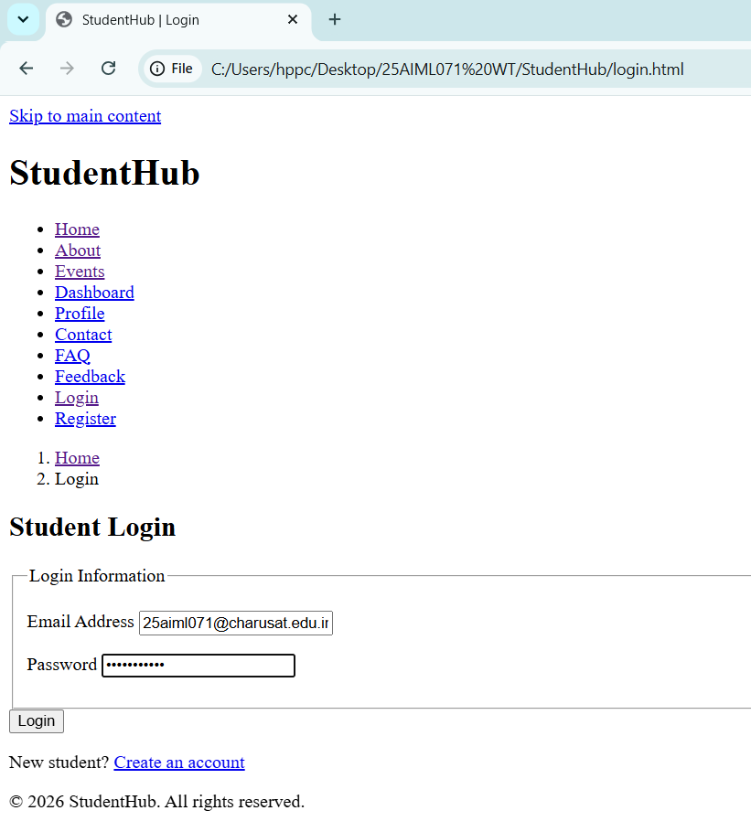

1.5 Register
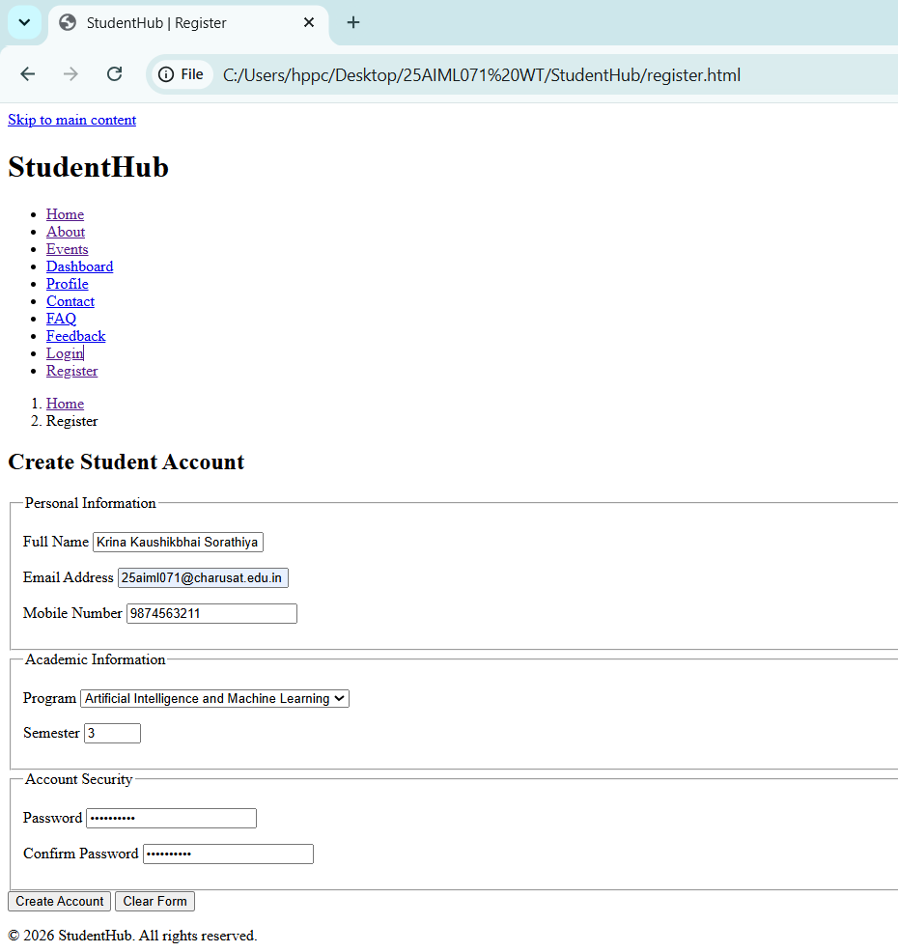

1.6 Dashboard with quick link
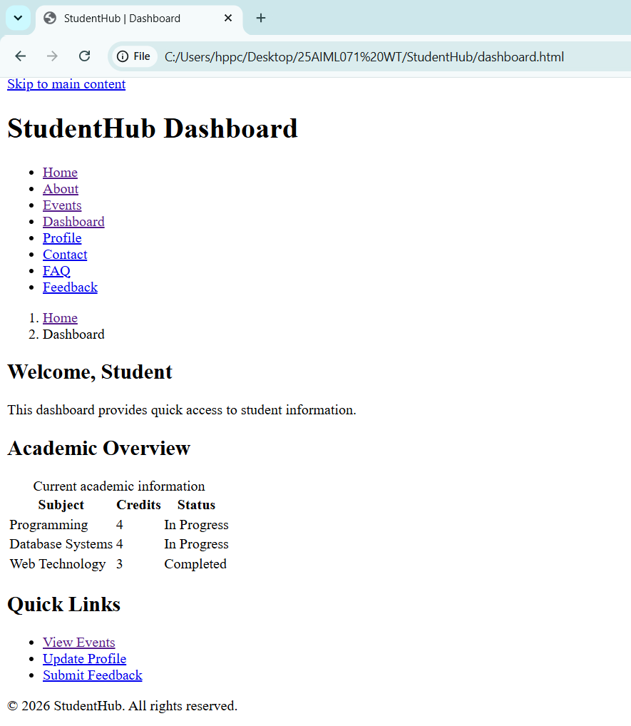

1.7 Profile
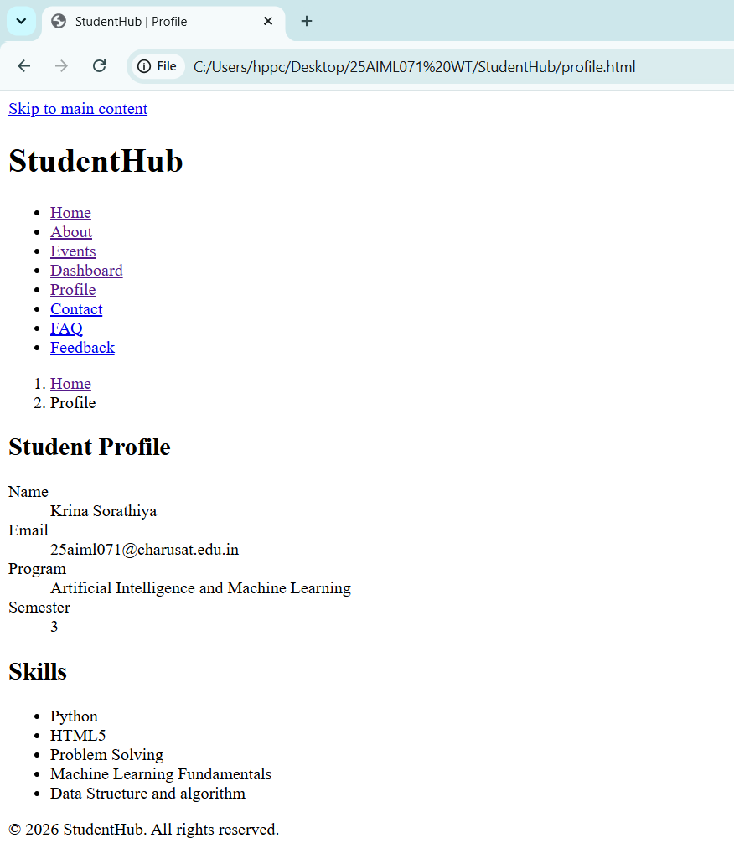

1.8 Contact
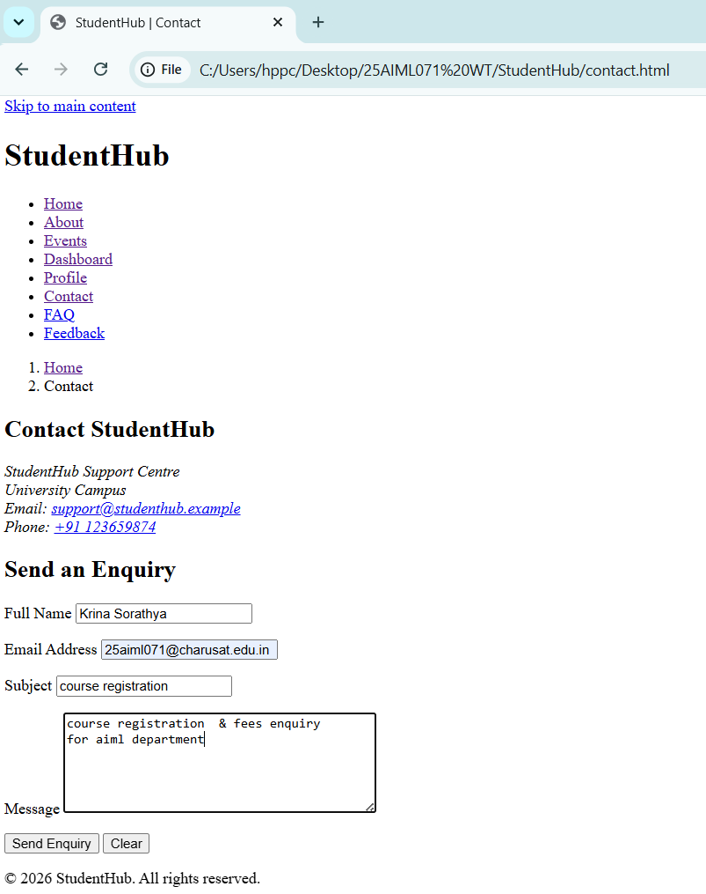

1.9 Admin & FAQ
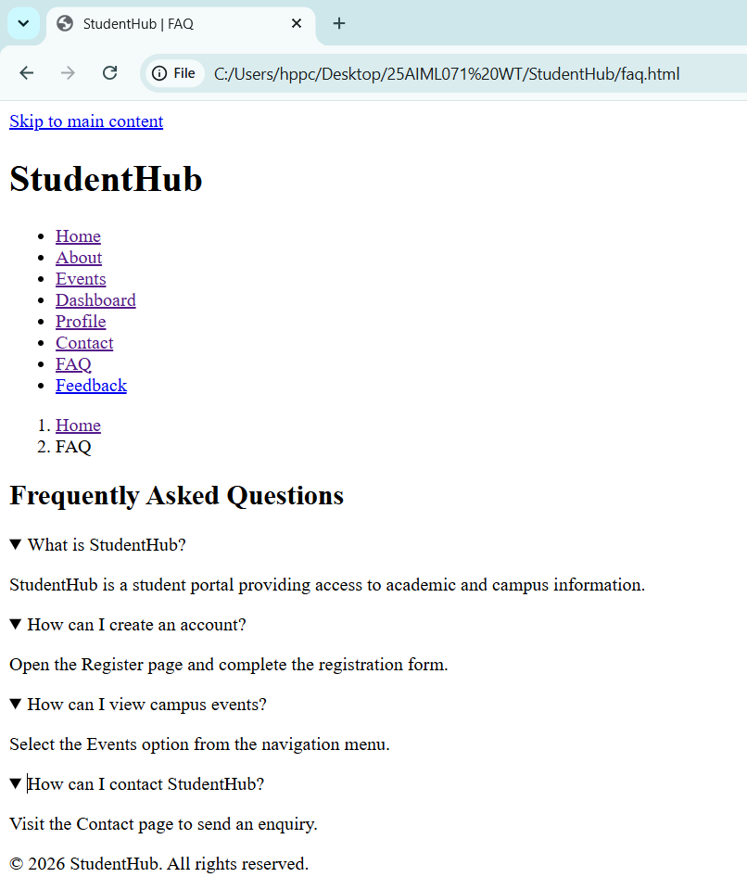

1.10 Feedback
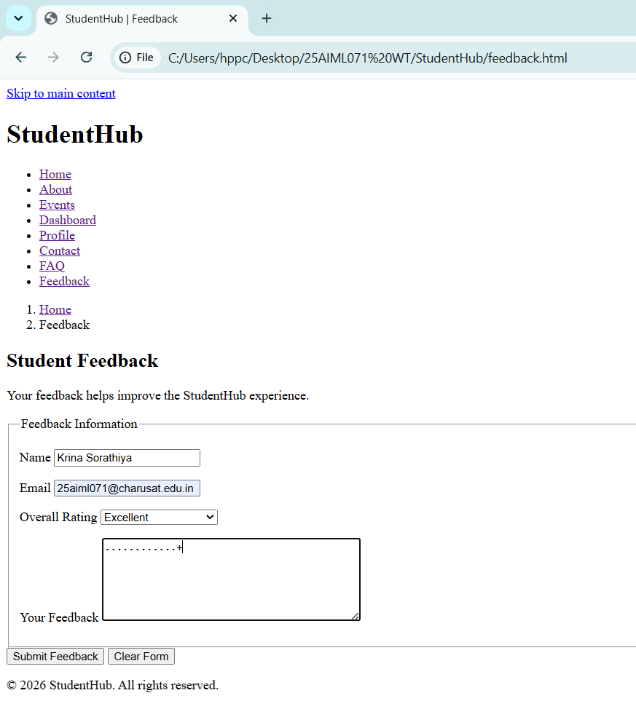

Accessibility checklist :-
Sr. No. | Accessibility Feature | Status
1 | HTML5 Semantic Elements (header, nav, main, section, article, aside, footer) are used correctly | Yes
2 | Proper Heading Hierarchy (h1, h2, h3) is maintained | Yes
3 | Skip to Main Content link is provided | Yes
4 | Navigation menu is available on all pages | Yes
5 | Breadcrumb navigation is included | Yes
6 | Form controls have associated <label> elements | Yes
7 | Images include meaningful alt attributes | Yes
8 | HTML document language is specified (lang="en") | Yes
9 | UTF-8 character encoding is defined | Yes
10 | Viewport meta tag is included for proper responsiveness | Yes
11 | Navigation links are keyboard accessible | Yes
12 | Consistent page layout is maintained across all webpages | Yes
13 | Pages are interconnected using hyperlinks | Yes
14 | HTML code is properly indented and readable | Yes

