PRACTICAL 5 – STUDENT REGISTRATION FORM

Submission Details
Name | Krina Sorathiya
Roll Number | 25AIML071
Date | 21 August 2026
Sir Name | Deep Mendha
Batch | D
Practical No. | 5
Project Name | Student Registration Form

Problem Definition
Create a student registration form using HTML5, CSS and JavaScript with real-time frontend validation. The form validates student information such as name, email, mobile number, password, confirm password, course, year, gender and terms acceptance. Regular expressions are used to check valid input formats. User-friendly red error messages are displayed immediately near the relevant field when incorrect information is entered, while valid information displays a green success message.

Learning Outcome
- Understand HTML5 form elements and appropriate input types.
- Implement client-side validation using JavaScript.
- Use Regular Expressions for name, email, mobile and password validation.
- Display real-time error and success messages near the relevant fields.
- Implement password and confirm-password validation.
- Create an accessible and user-friendly registration form.
- Understand event handling using input and change events.

Features Implemented
- Full Name validation
- Email format validation
- 10-digit Indian mobile number validation
- Password strength and format validation
- Confirm password matching
- Course selection validation
- Year selection validation
- Gender selection validation
- Terms and Conditions validation
- Instant validation while typing/selecting
- Red error messages for invalid input

Screenshots:
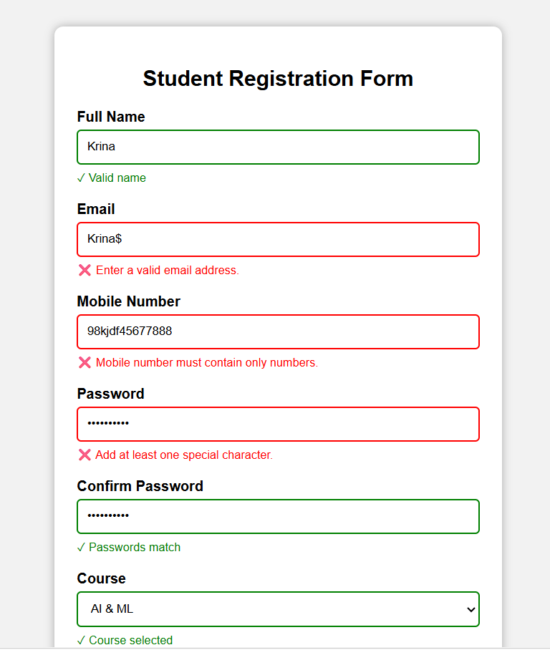

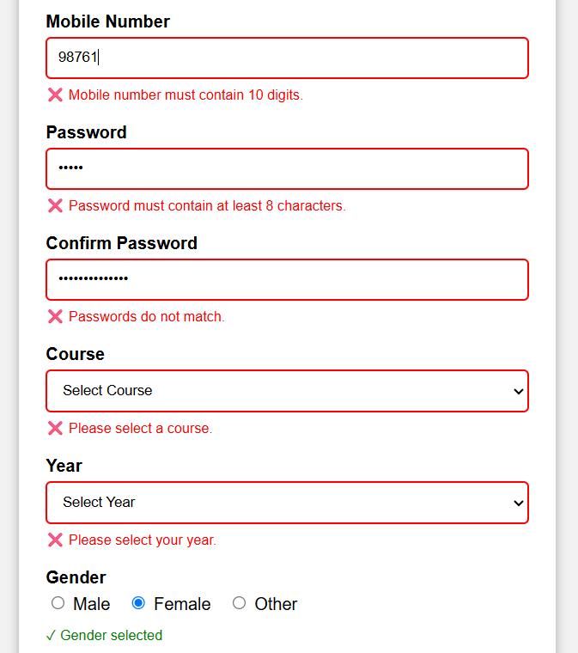

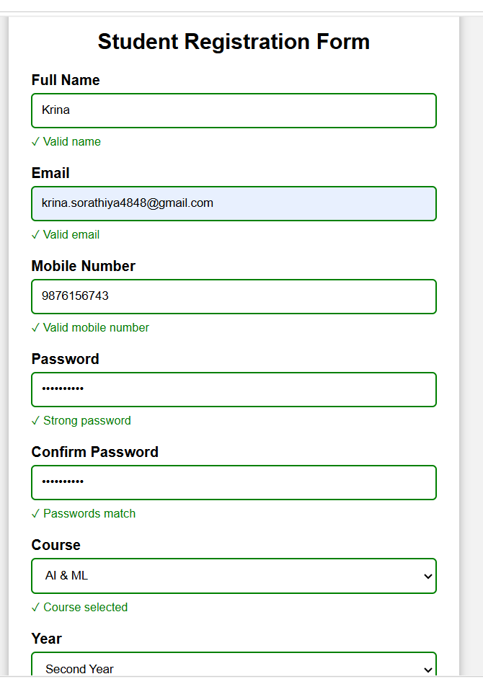

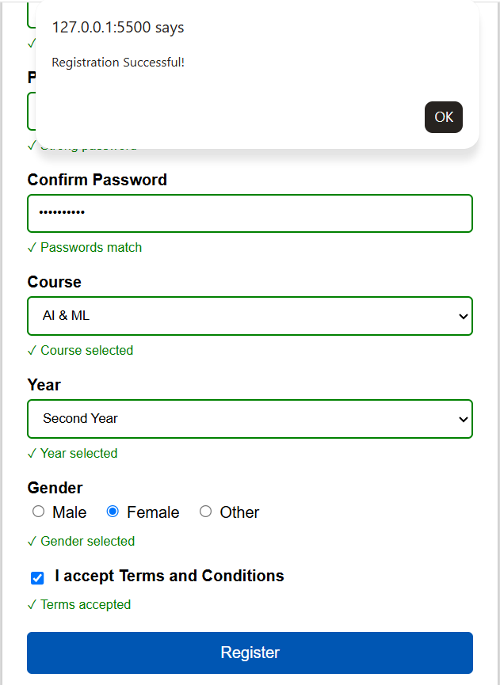

Conclusion
The Student Registration Form was successfully developed with separate HTML, CSS and JavaScript files. Real-time client-side validation provides immediate and user-friendly feedback. Regular Expressions ensure that important fields follow the required format, making the form more accurate, accessible and easy to use.

