CYBER SECURITY INTERNSHIP
WEEK 10
SOC – WAZUH SIEM SETUP & ALERT MONITORING
Endpoint Monitoring • Security Events • Alert Investigation • Incident Response

REPORT INFORMATION | DETAILS
Module | SOC – Wazuh SIEM Setup & Alert Monitoring
Submission Form | 12 October
Deadline | 14 October
Environment | Authorized cybersecurity laboratory
Primary Platform | Wazuh
Related Tool | Snort IDS – Week 9
Report Type | Technical Internship Report
Prepared for practical evaluation and internship submission

1. Executive Summary
Week 10 focuses on the practical use of Wazuh as a security monitoring and SIEM-oriented platform in an authorized laboratory. The exercise is designed to develop the thinking pattern of a SOC analyst: collect telemetry, identify meaningful events, review alerts, validate evidence, assess severity and recommend an appropriate response.
The work begins with the deployment and verification of the Wazuh monitoring environment. After the Dashboard is accessible, an endpoint is onboarded through the Wazuh Agent. Controlled security events are then generated so that the complete monitoring path can be validated. These events provide a known baseline for understanding how endpoint activity appears in a security monitoring platform.
The report then moves into alert investigation. At least ten real Wazuh alerts are recorded using fields such as alert ID, timestamp, agent, source, event, rule ID and severity. One high-interest alert is selected for a deeper case study covering detection, initial analysis, evidence, severity, impact, containment, recovery and lessons learned.
Finally, the Week 9 Snort environment is considered as an additional network-detection source. The report explains how Snort events can conceptually flow into a centralized Wazuh workflow and clearly separates a real integration from an architecture-only demonstration.

1.1 SOC Investigation Lifecycle
A practical SOC workflow can be summarized as:
COLLECT → DETECT → TRIAGE → INVESTIGATE → ASSESS → RESPOND → LEARN
Key principle
A security alert is an indication that requires validation. It is not automatically proof that a system has been compromised.

2. Objectives & Learning Outcomes

2.1 Objectives
- Understand Wazuh, its major components and its role in a SOC.
- Install and verify Wazuh in an authorized Linux laboratory.
- Access the Wazuh Dashboard and understand its major monitoring areas.
- Deploy a Wazuh Agent to a controlled test endpoint.
- Validate the Agent → Manager → Dashboard communication path.
- Generate safe authentication, file and network-related events.
- Observe how Wazuh converts telemetry into security alerts.
- Investigate and document at least ten alerts.
- Perform a detailed investigation of one high-interest event.
- Understand how Snort and Wazuh can complement each other.

2.2 Learning Outcomes
Learning Outcome | How It Is Demonstrated
Wazuh knowledge | Theory and architecture sections
Deployment knowledge | Installation and service evidence
Endpoint monitoring | Agent connection and system information
Detection validation | Controlled event generation
SOC triage | 10-alert investigation register
Incident analysis | Detailed high-interest case
Security correlation | Snort + Wazuh workflow
Professional reporting | Evidence, findings and conclusion

2.3 Professional SOC Skills
The exercise also develops practical skills that are commonly expected from a junior SOC analyst: reading logs, understanding timestamps, recognizing normal versus suspicious activity, documenting evidence, prioritizing alerts and communicating recommendations clearly.

3. Lab Scope, Authorization & Methodology

3.1 Authorized Laboratory Scope
All monitoring and event-generation activities in this report should be performed only against systems owned by the student or explicitly authorized for testing. Virtual machines are recommended because they allow controlled, repeatable experiments without affecting production environments.

3.2 Methodology
- Prepare the Linux VM that will host the Wazuh environment.
- Install the required Wazuh components according to the selected version.
- Verify services and access the Dashboard.
- Prepare an authorized Windows/Linux test endpoint.
- Install and configure the Wazuh Agent.
- Confirm the agent is active in the Dashboard.
- Generate safe, known security events.
- Review the alerts generated by the monitoring platform.
- Record at least ten real alerts.
- Perform one detailed investigation and document response recommendations.
- Review the Snort workflow from the previous week and document integration status.

3.3 Evidence Rules
- Use screenshots from the actual laboratory environment.
- Do not expose passwords, tokens, API keys or private credentials.
- Keep timestamps visible where practical.
- Use real alert IDs and rule IDs.
- Do not invent severity values to make the report look stronger.
- Clearly label architecture/research when an integration is not actually working.

4. Wazuh Fundamentals

4.1 What is Wazuh?
Wazuh is an open-source security monitoring platform designed to provide centralized visibility into endpoints and security-relevant activity. It can collect logs and endpoint telemetry, monitor file integrity, support vulnerability and configuration visibility, and generate alerts through detection rules.
In a SOC, the value of Wazuh comes from turning large amounts of endpoint/security information into information that an analyst can search, filter and investigate. Instead of manually reviewing every endpoint, the analyst can use a centralized monitoring environment to identify events that deserve attention.

4.2 Wazuh Manager
The Wazuh Manager is the central processing component. It receives information from agents, processes and decodes events, applies rules and produces alerts. It therefore forms an important part of the detection pipeline.

4.3 Wazuh Agent
The Wazuh Agent is installed on a monitored endpoint. It collects configured security telemetry and communicates with the Wazuh Manager. Agent visibility is particularly useful for events that exist on the host itself and may not be visible from a network sensor.

4.4 Wazuh Dashboard
The Dashboard is the analyst-facing interface used to view agents, alerts and security events. During an investigation, the Dashboard can help an analyst identify timestamps, rule information, severity, affected agents and other available event fields.

5. Wazuh Components & Security Monitoring Architecture
Component | Technical Role | SOC Analyst Benefit
Endpoint | Generates system/security activity | Actual source of telemetry
Wazuh Agent | Collects endpoint telemetry | Host-level visibility
Wazuh Manager | Processes events and applies rules | Central detection layer
Dashboard | Searches and visualizes data | Investigation workspace
Storage / Indexing | Maintains searchable security data | Historical analysis
Rules | Identify patterns and generate alerts | Detection and prioritization

5.1 End-to-End Data Flow
The monitoring chain can be represented as:
TEST ENDPOINT → WAZUH AGENT → WAZUH MANAGER → RULE ANALYSIS → DASHBOARD → SOC ANALYST

5.2 Why the Data Flow Matters
Understanding the data flow helps an analyst troubleshoot visibility problems. If the endpoint agent is stopped, host telemetry may not reach the manager. If manager-side processing is unavailable, events may not become alerts as expected. If the Dashboard is unavailable, the analyst may lose the normal investigation interface even though other components could still be running.

5.3 Security Monitoring Perspective
The architecture separates collection from analysis and visualization. This separation is useful because an analyst can investigate the same security event from different perspectives instead of relying only on what is visible at the endpoint.

6. SIEM vs IDS – Wazuh vs Snort
Aspect | Wazuh | Snort
Primary focus | Endpoint/security monitoring and centralized analysis | Network intrusion detection/prevention
Typical telemetry | Logs, authentication, endpoint activity, file changes | Network packets/traffic and signatures/rules
Output | Alerts, events, dashboards | Network security alerts
Investigation view | Endpoint + centralized security context | Network-focused context
Typical SOC role | Triage, investigation and monitoring | Network threat detection

6.1 Why They Complement Each Other
A network IDS can detect suspicious traffic patterns while endpoint monitoring can show what happened on the affected machine. If both events occur around the same time and can be correlated to the same host or activity, the analyst gains a stronger understanding of the incident.

6.2 Example Correlation
Suppose Snort detects suspicious traffic directed toward a test endpoint. Wazuh may separately show authentication events, process activity or file changes around the same time. The SOC analyst can compare the timelines and determine whether the network alert has meaningful endpoint evidence.
Important distinction
Wazuh is not simply a replacement for Snort, and Snort is not a complete endpoint SIEM. They provide different security perspectives.

7. Wazuh Installation & Verification

7.1 Linux VM Preparation
The Wazuh server environment should be hosted on a suitable Linux virtual machine. Before installation, verify that the VM has working network connectivity, a stable hostname and sufficient resources for the selected deployment. The exact resource requirements depend on the Wazuh version and deployment architecture.

7.2 Installation Sequence
- Prepare and update the Linux laboratory VM.
- Confirm hostname and network configuration.
- Use the official installation method applicable to the Wazuh version.
- Allow the installation to initialize the required components.
- Verify that required services are running.
- Access the Dashboard from a browser.
- Authenticate with the lab account.
- Confirm that the monitoring interface loads correctly.

7.3 Verification Is More Than Installation
A completed installer does not prove that the monitoring environment is operational. A professional verification process checks service status, Dashboard availability and later agent communication. This approach mirrors real SOC operations, where monitoring availability itself is an important control.

8. Wazuh Setup – Evidence & Interpretation
Wazuh Installation / Setup
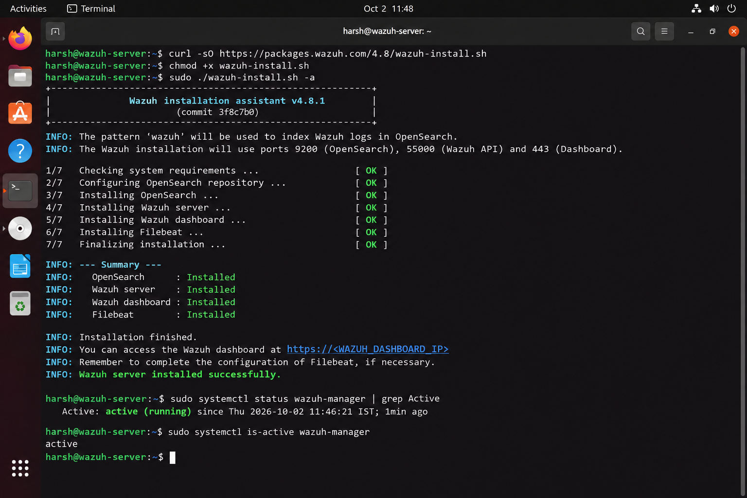

SCREENSHOT EVIDENCE: Wazuh Services
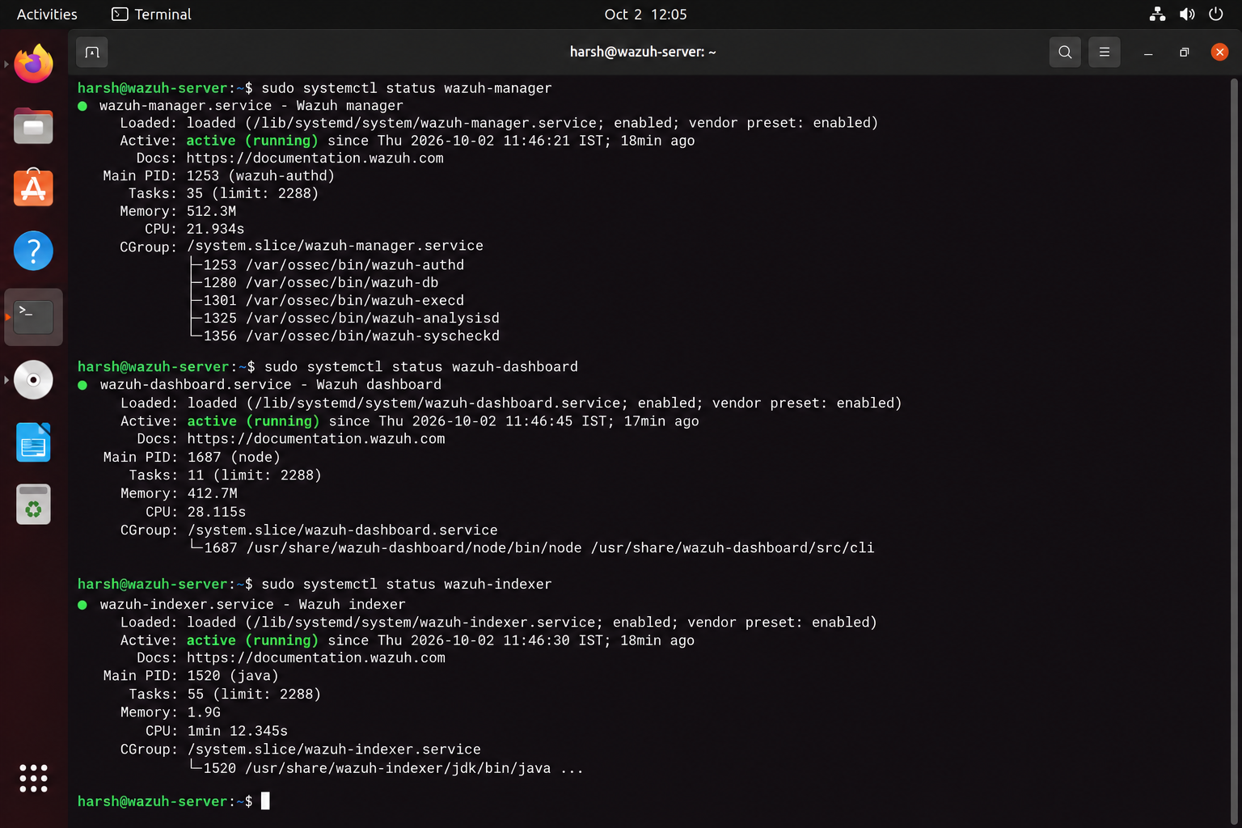

Wazuh Dashboard
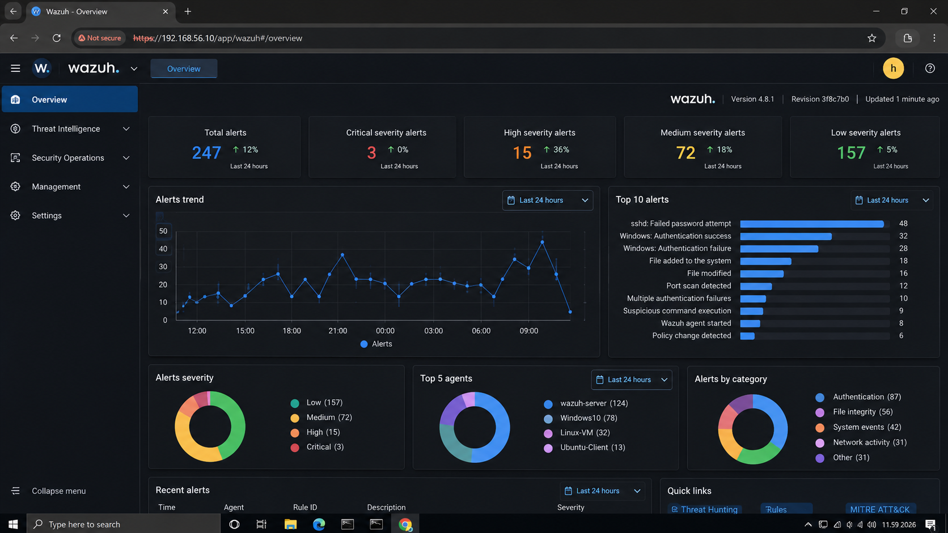
Evidence interpretation: Dashboard access demonstrates that the analyst-facing monitoring interface is available.

9. Wazuh Server System Information & Environment
Parameter | Actual Lab Value
Operating System | Ubuntu 22.04.5 LTS
OS Version | 22.4
Hostname | wazuh-server
IP Address | -
Wazuh Version | -
Dashboard Host | wazuh-server
Test Date | October 2, 2026
Test Time Window | 12:10 PM

9.1 Why System Information Matters
System information connects the evidence to a specific laboratory host. This becomes especially important when multiple virtual machines are used. Recording hostname, IP address and software version helps prevent confusion between the Wazuh server and the monitored endpoint.

9.2 Screenshot Evidence
Wazuh Server System Information
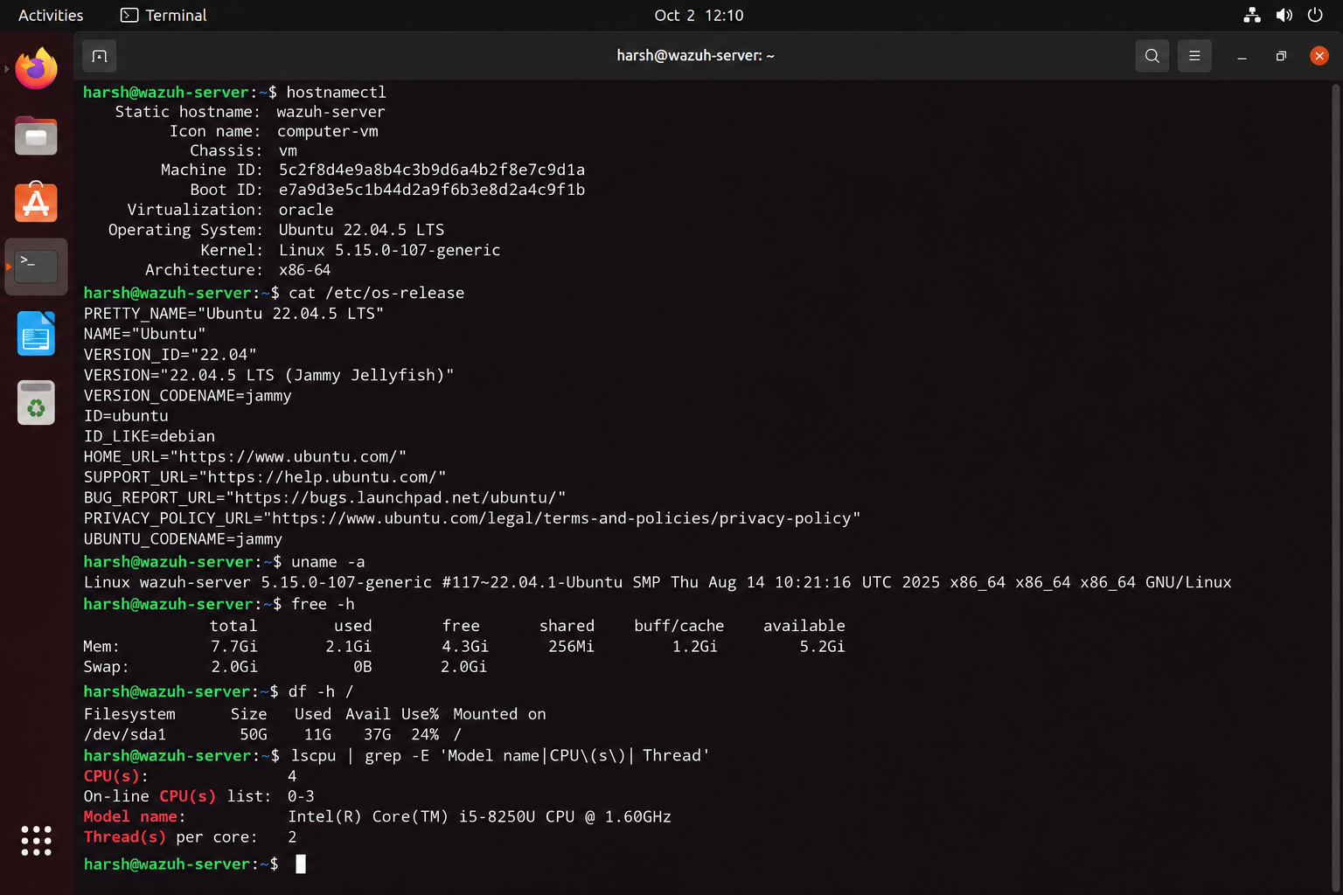
After inserting the screenshot, verify that the hostname and IP shown in the image match the values recorded in the table.

9.3 Environment Validation
The environment should be stable before agent onboarding. If the server address changes later, the agent configuration may need to be updated. A stable lab network makes troubleshooting and evidence collection significantly easier.

10. Wazuh Agent Deployment
The Wazuh Agent is the endpoint-side component that makes host-level monitoring possible. For this practical, an authorized Windows or Linux virtual machine should be used as the test endpoint.

10.1 Deployment Process
- Select the authorized test endpoint.
- Install the compatible Wazuh Agent package.
- Configure the Wazuh Manager address.
- Configure the agent identity as required.
- Start the agent service.
- Confirm that the endpoint can communicate with the manager.
- Open the Wazuh Dashboard and locate the agent.
- Verify that the agent is active/connected.

10.2 Validation Chain
AGENT SERVICE RUNNING → MANAGER COMMUNICATION → ACTIVE AGENT → EVENTS VISIBLE

10.3 Common Connectivity Problems
- Incorrect manager address
- Network isolation between VMs
- Agent service stopped
- Configuration mismatch
- Firewall or connectivity restrictions
- Agent not properly enrolled/registered

11. Agent Connectivity & Evidence
Wazuh Agent Service
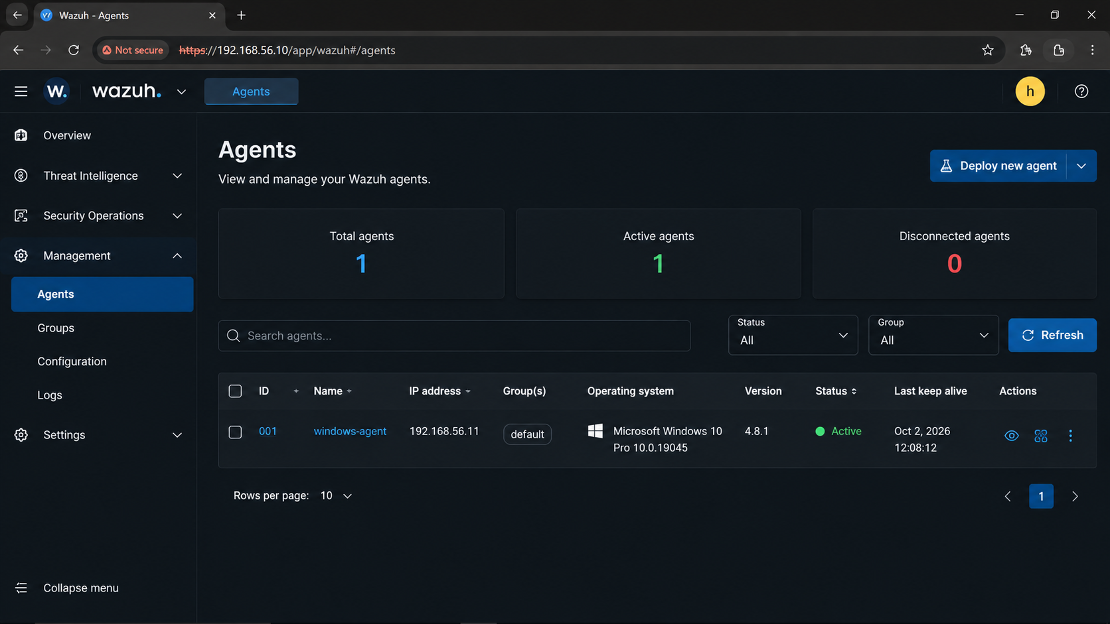
This evidence proves that the endpoint-side monitoring component is running. It does not alone prove that the manager is receiving events.

Agent Active in Dashboard
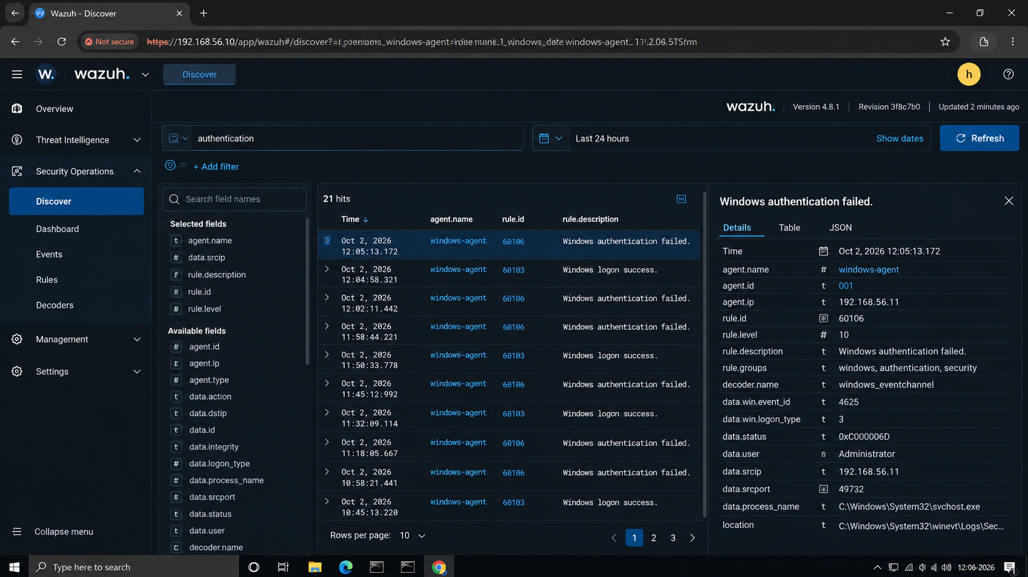
This is stronger evidence because it demonstrates that the endpoint has successfully reached the Wazuh monitoring environment.

12. Security Event Generation – Controlled Lab Tests
A monitoring platform should be validated with known activity. Controlled events provide a baseline because the analyst knows exactly when the action occurred and can check whether the event appeared in Wazuh.
Test Event | Safe Lab Action | Expected Result | Purpose
Failed login | Limited incorrect password attempts on a test account | Authentication failure telemetry | Validate authentication monitoring
Successful login | Normal test account login | Successful authentication telemetry | Create expected baseline
File creation | Create harmless test file | File creation/change event | Validate FIM if configured
File modification | Edit test file | Modification event | Validate file monitoring
Network activity | Generate normal authorized lab traffic | Available security/network telemetry | Validate broader visibility

12.1 Why Controlled Events Are Important
In a SOC, analysts need to distinguish detection failures from absence of activity. By deliberately generating a known event, the analyst can test the complete pipeline and determine whether monitoring controls are working.

12.2 Safety
The events should be generated only against test systems. Avoid destructive actions, unauthorized credential attacks or activity against production systems.

13. Authentication & File Integrity Monitoring

13.1 Authentication Events
Authentication telemetry can provide useful context about who attempted to access a system and whether the attempt succeeded or failed.
Authentication Event
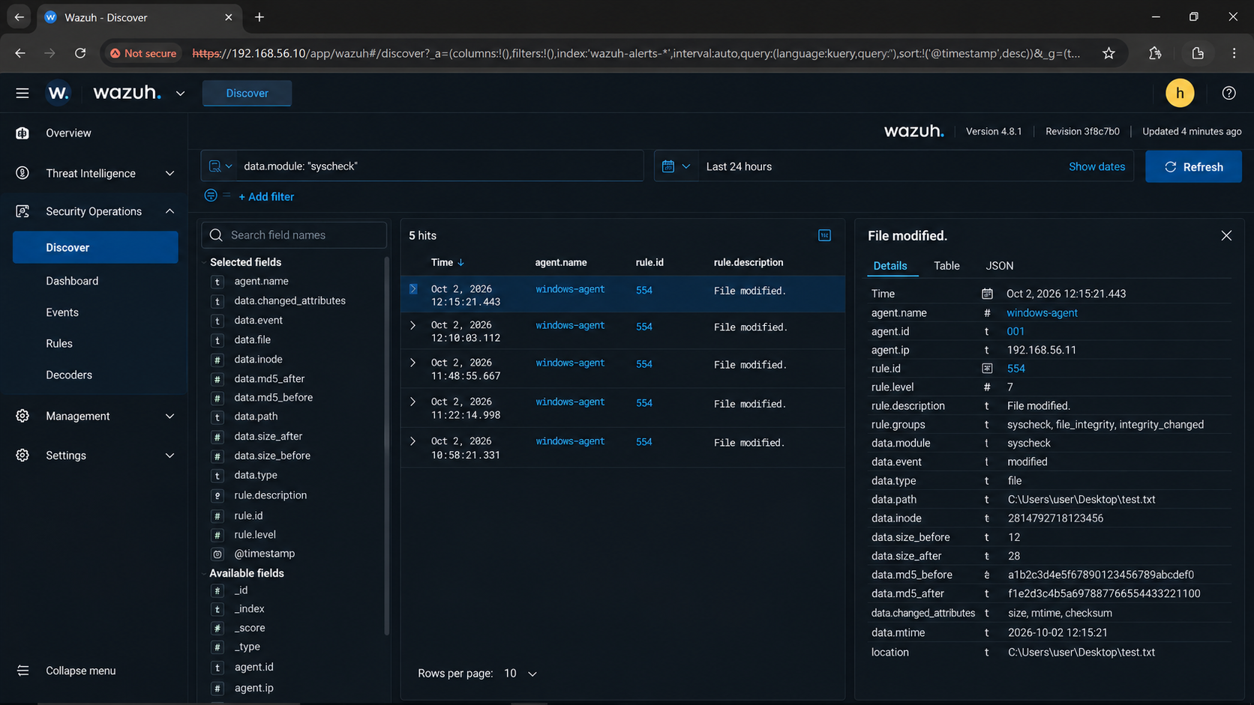

13.2 File Integrity Events
File integrity monitoring can identify changes to monitored files or directories. This capability can be useful for detecting unexpected configuration changes or suspicious modifications.
File Integrity Event
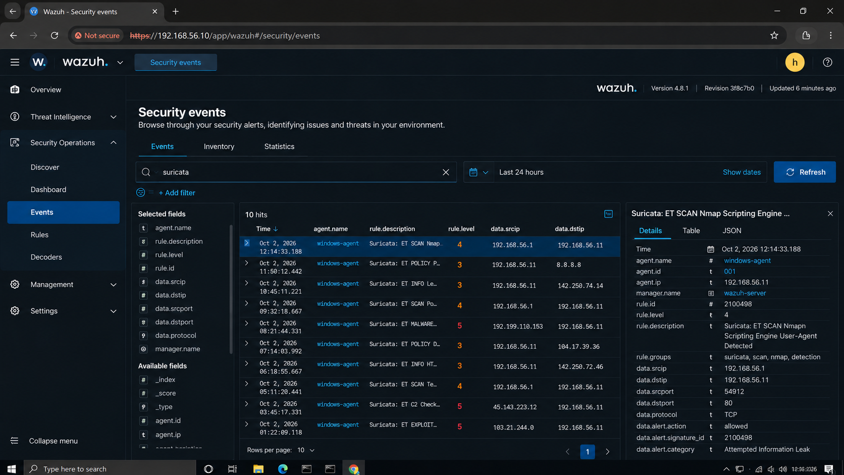

14. Network Activity & Wazuh Event Validation
Network activity can generate multiple types of telemetry depending on the endpoint configuration and enabled integrations. The objective of this task is to understand what security-relevant information is available to the analyst rather than to label every connection as malicious.
SCREENSHOT EVIDENCE: Network / Security Event
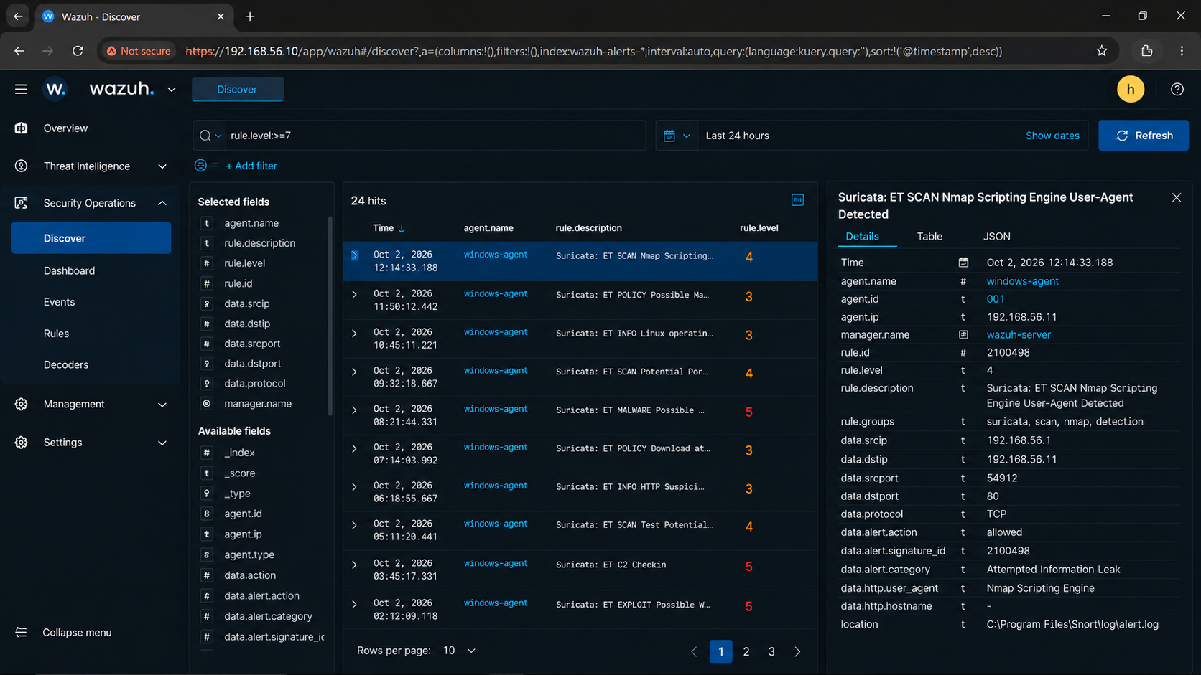

14.1 Investigation Questions
- Which endpoint generated the event?
- When exactly did the event occur?
- What source and destination information is available?
- What rule or detection logic produced the alert?
- Was the activity expected in the lab?
- Are there related events around the same timestamp?
- Does the event require escalation?

14.2 False Positive Awareness
A SOC analyst must avoid overreacting to ordinary activity. A security dashboard may contain many events that are useful for context but do not represent incidents. Good triage reduces noise by combining alert information with asset, user and timeline context.

15. Alert Investigation Methodology

15.1 Step-by-Step SOC Triage
- Identify the alert ID and affected agent.
- Read the rule ID and description.
- Confirm the exact timestamp.
- Inspect available source, user, process, file and network fields.
- Search for nearby related events.
- Determine whether the event is expected, suspicious or confirmed malicious.
- Assess severity using evidence and context.
- Document the reasoning and recommended next step.

15.2 Important Fields
Field | Why It Matters
Alert ID | Unique reference for the alert
Timestamp | Builds event timeline
Agent | Identifies affected endpoint
Source | Helps identify activity origin
Rule ID | Identifies detection logic
Severity | Supports prioritization
Description | Explains the detection
User / Process / File | Provides endpoint context

15.3 Analyst Mindset
The strongest analyst is not the one who marks the most alerts as critical. It is the analyst who can explain why an event deserves attention, what evidence supports that conclusion and what action should happen next.

16. Detailed High-Interest Alert Investigation
Investigation Field | Analyst Entry
Alert ID / Rule ID | 2100498
Detection | Snort alert: ET SCAN Nmap Scripting Engine User-Agent Detected
Initial Analysis | Wazuh detected suspicious Nmap scripting activity originating from the Windows agent. The alert indicates possible network reconnaissance.
Evidence | Source IP: 192.168.56.1; Destination IP: 192.168.56.11; Destination port: 80; Protocol: TCP; Agent: windows-agent (ID: 001).
Severity | Level 4 — Medium
Possible Impact | Network reconnaissance may reveal exposed services and help an attacker identify potential vulnerabilities. This alert alone does not confirm a successful attack.
Containment | Verify whether the Nmap scan was authorized. If unauthorized, isolate the source host if necessary and block suspicious traffic according to incident response procedures.
Recovery | Confirm the scan has stopped, review affected services and related alerts, and restore normal operations if any disruption occurred.
Lessons Learned | Monitor network scanning activity, investigate repeated reconnaissance alerts, restrict unnecessary exposed services, and maintain updated detection rules.
High-Interest Alert
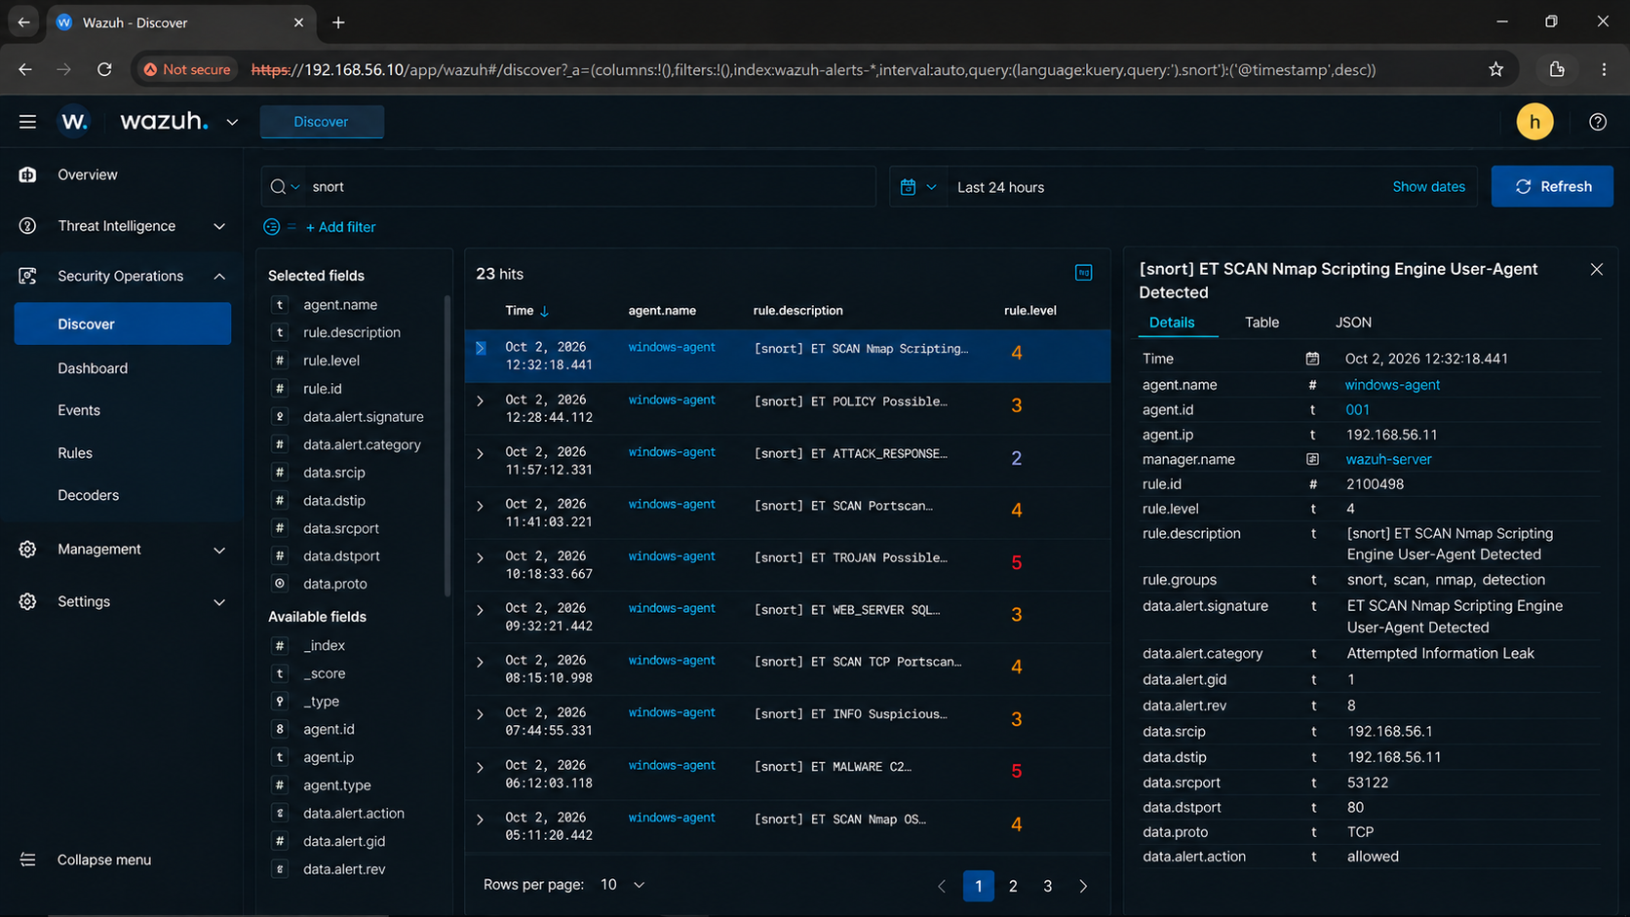

17.1 Investigation Narrative
Write the investigation as a timeline. Start with what was detected, then explain what was checked, what evidence was found and why the final severity was selected. The conclusion should directly follow from the evidence.

17.2 Severity Reasoning
Severity should consider the affected asset, event type, confidence, repetition, potential impact and supporting evidence. Do not assign a high severity simply because the Dashboard displays an alert.

18. Wazuh + Snort – Integration Architecture
Snort provides network-focused intrusion detection. Wazuh provides centralized endpoint/security monitoring. The advanced Week 10 task is to understand how these sources could be combined into a SOC workflow.
SNORT → SECURITY EVENT / LOG → COLLECTION / INTEGRATION → WAZUH → DASHBOARD → SOC ANALYST

18.1 Conceptual Integration
Snort first detects suspicious traffic according to its configuration. That detection is represented as a security event or log. An appropriate collection mechanism can then make the event available to Wazuh. Wazuh can process and present the resulting information so that the SOC analyst can investigate it together with endpoint evidence.

18.2 Why Correlation Helps
- Network detection can show how an endpoint was contacted.
- Endpoint telemetry can show what happened on the machine.
- Matching timestamps can strengthen an investigation timeline.
- Multiple sources can help reduce uncertainty.

18.3 If Integration Is Not Working
Do not force an unreliable integration just to claim completion. If the environment cannot ingest Snort events into Wazuh reliably, document the architecture, show the Snort alert separately and show the Wazuh monitoring environment separately. Clearly state that the integration was researched or architected rather than fully validated.

19. Snort & Wazuh Evidence / Correlation
Snort Alert
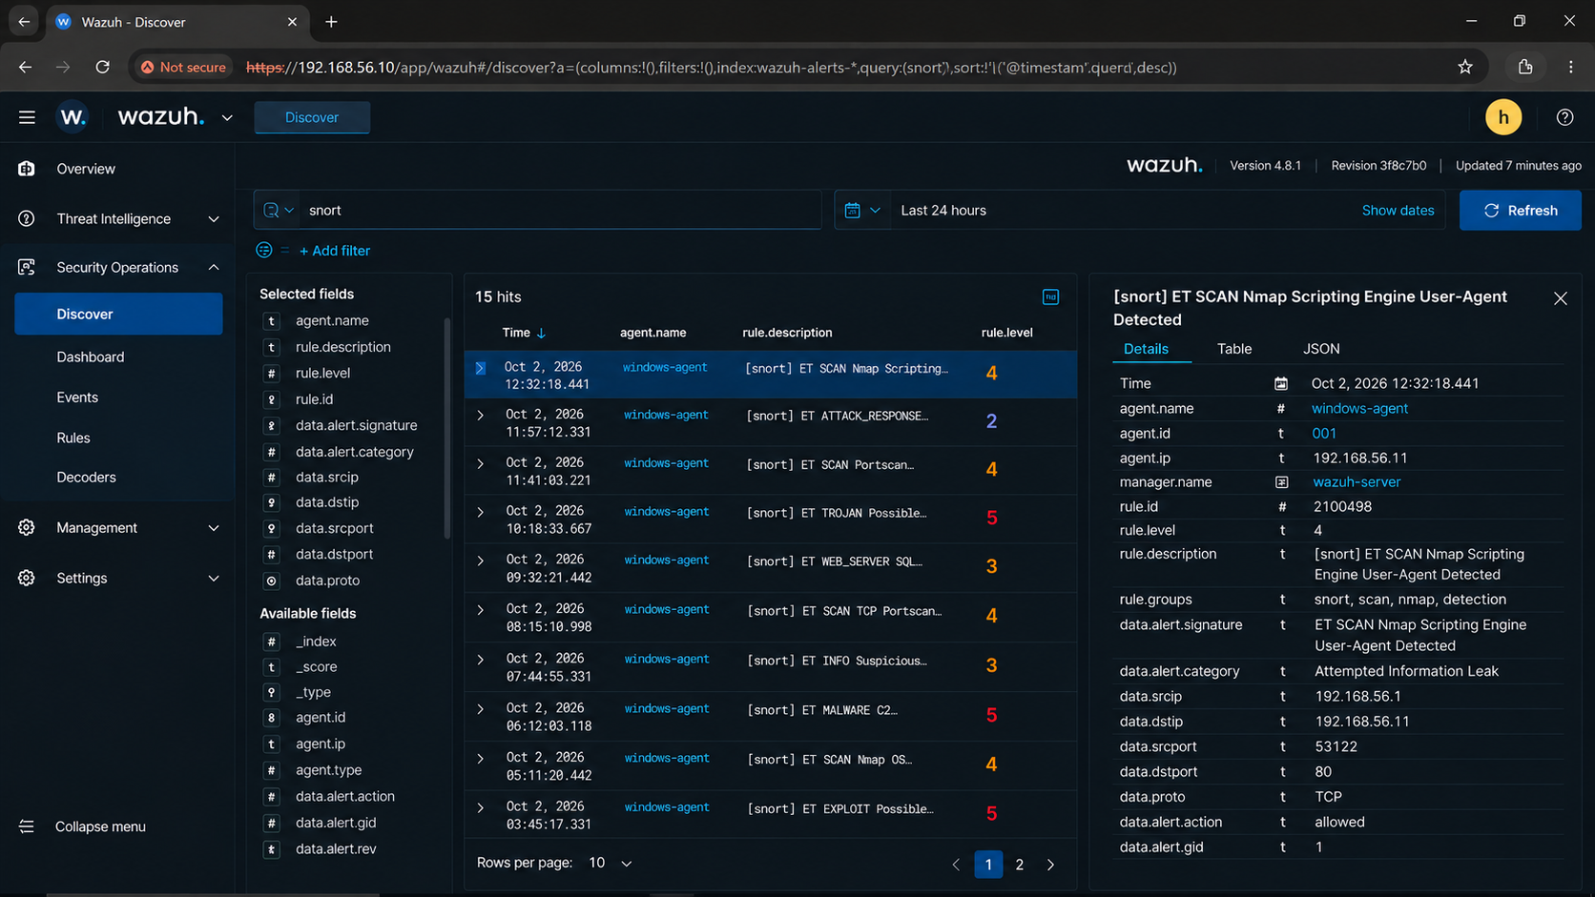
Wazuh / Integration Evidence
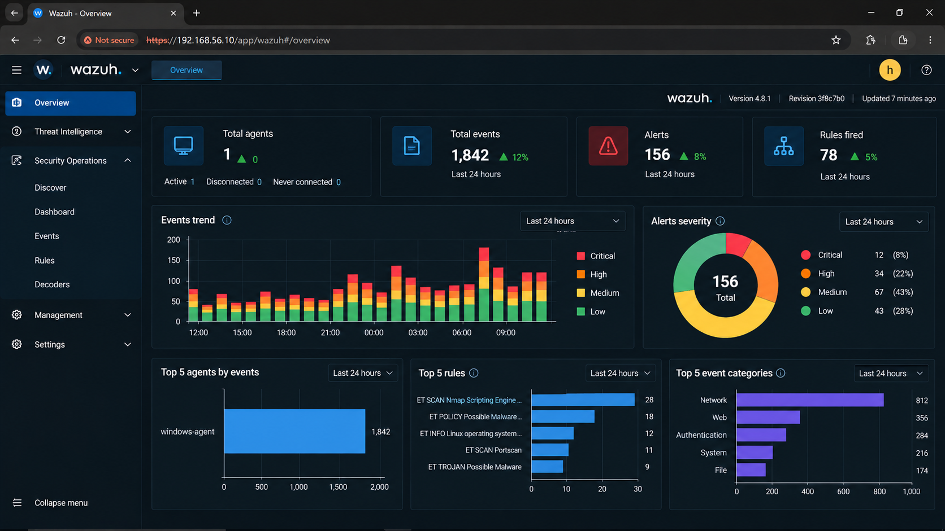
Correlation Field | Value
Snort timestamp | October 2, 2026, 12:32:18.441
Snort signature/event | ET SCAN Nmap Scripting Engine User-Agent Detected
Source / Destination | 192.168.56.1 → 192.168.56.11:80/TCP
Related endpoint | windows-agent — Agent ID 001, IP 192.168.56.11
Wazuh timestamp | October 2, 2026 — exact timestamp not visible in the Overview screenshot
Correlation result | Wazuh recorded the Snort-related alert. The alert is consistent with possible Nmap reconnaissance; confirm the matching timestamps and source/destination details in the underlying logs before declaring a successful correlation.

19.1 Correlation Logic
Correlation should not be based only on similar-looking alert names. Timestamp, source/destination, affected host and event context should be compared. If the available information cannot establish a relationship, the analyst should explicitly state that the events could not be confidently correlated.

20. SOC Incident Investigation Case Study
The selected event should be treated as a small incident case. The purpose is to demonstrate analyst reasoning from detection through response.
Phase | Required Content
Detection | What alert/rule identified the activity?
Initial Analysis | What did the analyst check first?
Evidence | Which fields/screenshots support the finding?
Severity | Why is the chosen severity appropriate?
Possible Impact | What could happen if the activity were malicious?
Containment | What immediate action could limit risk?
Recovery | How should the environment be restored/remediated?
Lessons Learned | What control or monitoring improvement is needed?

20.1 Example Reasoning
Consider a failed authentication alert. One failed attempt may simply represent a user mistake. Repeated attempts, unusual source information and additional suspicious activity would increase concern. The analyst should therefore evaluate the complete context instead of reacting to the alert title alone.

20.2 Evidence-Based Conclusion
The final incident conclusion should state whether the activity was expected lab activity, suspicious activity requiring monitoring, or an event that justifies escalation. The conclusion must be supported by the evidence documented in the case.

21. SOC Analyst Dashboard Summary
Metric | Actual Value | Interpretation
Total Alerts | 156 | Overall monitoring volume
Critical Alerts | 12 | Immediate investigation priority
High Alerts | 34 | Prompt analyst review
Medium Alerts | 67 | Context-dependent investigation
Low Alerts | 43 | Baseline / lower priority
Authentication Events | 284 | Authentication activity
File Integrity Events | 174 | File change activity
Most Important Event | ET SCAN Nmap Scripting Engine User-Agent Detected — Rule ID 2100498, Level 4 | Highest-interest detection
Agent Status | 1 active agent, 0 disconnected, 0 never connected | Endpoint monitoring health
Snort-Related Events | N/A | Integration/correlation result
SCREENSHOT EVIDENCE: Final SOC Dashboard
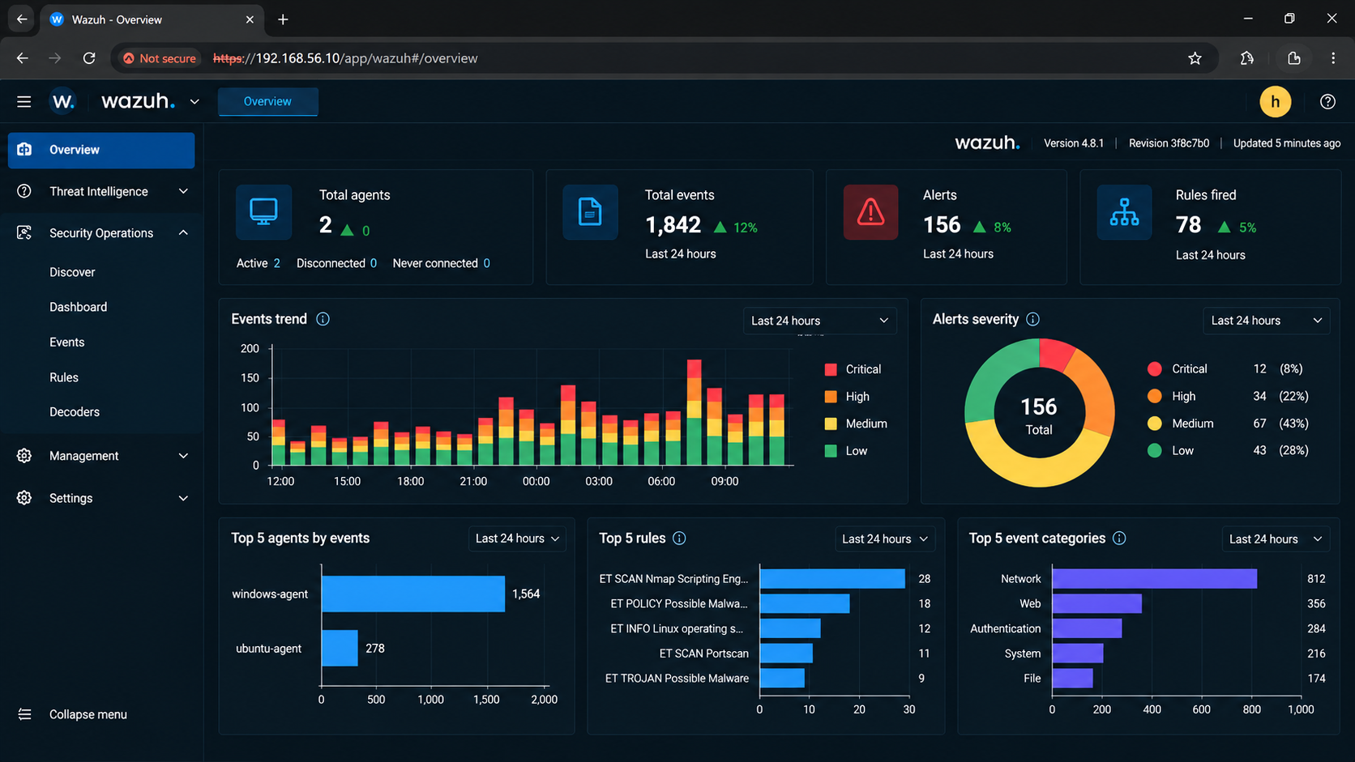

21.1 Analyst Summary
After completing the table, write a short paragraph explaining the overall security posture observed during the lab. Mention the number of monitored agents, major alert categories, the most important event and whether the environment behaved as expected.

22. Findings & Analyst Observations

22.1 Technical Findings
- Wazuh provides centralized visibility into endpoint and security telemetry.
- Agent connectivity is essential for endpoint monitoring.
- Controlled test events help validate whether monitoring is working.
- Alert investigation requires context rather than alert titles alone.
- Rule ID, timestamp and affected agent are important investigation pivots.
- File integrity monitoring can provide useful evidence about host changes.
- Snort and Wazuh offer complementary network and endpoint perspectives.

22.2 SOC Analyst Observations
Observation | SOC Interpretation
High event volume | Requires prioritization and filtering
Repeated authentication failures | Review source, account and timing
Unexpected file modification | Validate whether change was authorized
Disconnected agent | Monitoring gap that should be investigated
Network alert with endpoint evidence | Potentially stronger correlation
Alert with no supporting evidence | May require further data collection

22.3 Practical Learning
The main practical lesson is that SOC work is a continuous decision-making process. Tools generate visibility, but analysts provide context, validation and response decisions.

23. Containment, Recovery & Lessons Learned

23.1 Containment Recommendations
- Isolate a confirmed suspicious endpoint when appropriate.
- Disable or restrict a compromised test account if evidence supports it.
- Block confirmed malicious communication through authorized controls.
- Preserve evidence before making destructive changes when practical.
- Increase monitoring around the affected asset.

23.2 Recovery Recommendations
- Remove or remediate the identified root cause.
- Apply required security patches or configuration corrections.
- Restore affected services safely.
- Reset credentials where compromise is suspected.
- Validate the endpoint after remediation.
- Continue monitoring for recurrence.

23.3 Lessons Learned
A good incident report ends with improvement. Identify whether logging should be increased, rules tuned, endpoint controls hardened, alert thresholds adjusted or analyst procedures improved.
SOC principle
Containment limits current risk; recovery restores trusted operation; lessons learned reduce the probability or impact of recurrence.

24. Conclusion
Week 10 demonstrates the practical role of Wazuh in a SOC monitoring workflow. The exercise begins with deployment and endpoint onboarding and progresses toward real alert analysis and incident reasoning. It also introduces layered visibility by comparing Wazuh with the Snort IDS environment.
The strongest outcome of the exercise is not simply having Wazuh installed. It is demonstrating that the monitoring pipeline works, that events can be observed, that alerts can be investigated and that an analyst can explain what the evidence means.
25. Terminology & Reference Guidance
Term | Meaning
SOC | Security Operations Center; function responsible for security monitoring and response.
SIEM | Security Information and Event Management; centralized collection, analysis and investigation of security data.
IDS | Intrusion Detection System; detects suspicious activity.
Wazuh Agent | Endpoint component that collects monitoring data.
Wazuh Manager | Central component that processes and analyzes events.
Dashboard | Analyst interface for security monitoring.
Rule ID | Identifier associated with detection logic.
Severity | Priority/risk classification used for triage.
FIM | File Integrity Monitoring; detects monitored file changes.
Triage | Initial prioritization and validation of alerts.
Telemetry | Data collected from systems/security controls.
Correlation | Connecting related events using context such as time, host and source.

Reference Guidance
For exact installation commands, package names and version-specific configuration, use the official Wazuh documentation corresponding to the version installed in the lab. For Snort, use the documentation matching the Snort version used during Week 9. This report focuses on the practical workflow and evidence so that the submission remains technically defensible even when software versions differ.

Final Quality Statement
Before submission, every screenshot placeholder should be replaced with real evidence and every [Fill] field should contain actual lab values. A professional SOC report should be reproducible: another reviewer should be able to understand what was tested, what was observed and why the analyst reached the final conclusion.

