**Supplementary material**

**FIG S1**

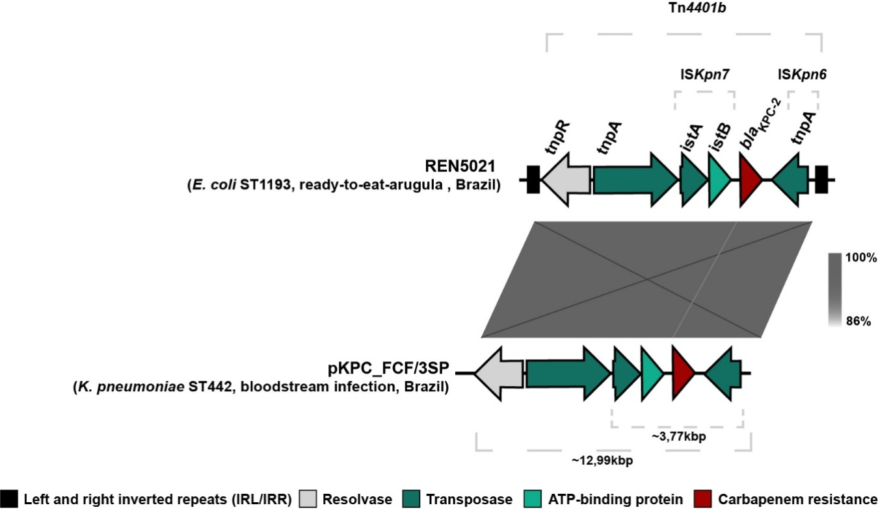

**FIG S1** Overall comparison of Tn*4401b* containing the *bla*KPC-2 gene carried by *E. coli* REN5021 strain belonging to ST1193, isolated from ready-to-eat vegetable, and clinical *K. pneumoniae* FCF3SP strain belonging to ST442. The Tn*4401b* was composed of genes encoding to resolvase (*tnpR,* grey triangles), transposase (*tnpA* and *istA*, dark-green triangles), ATP-binding protein (*istB*, light-green triangles) and carbapenem resistance (*bla*KPC-2, red triangles). The *bla*KPC-2 was flanked by a ~3.77 kb region composed of IS*Kpn7*-*bla*KPC-2 -IS*Kpn6*. Black rectangles represent left and right inverted repeats (IRL and IRR, respectively) delimiting Tn*4401b*. Comparative environments of *bla*KPC-2 gene were performed using Easyfig (<https://bio.tools/easyfig>).

**FIG S2**

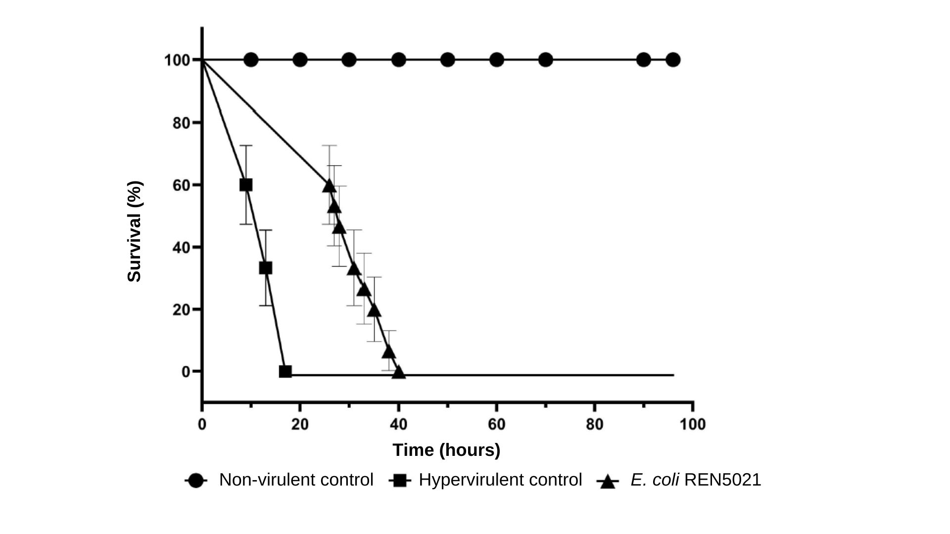

**FIG S2**  Kaplan-Meier survival curves of *Galleria mellonella* larvae after infection with 105 CFU/larva of KPC-2-producing *Escherichia coli* REN5021, isolated from ready-to-eat vegetable, *E. coli* ATCC 25922 (non-virulent control) and *E. coli* MNEC (hypervirulent control). Data were analyzed by log-rank test, with *p* < 0.05 indicating statistical significance (Graph Pad Software, San Diego, CA, USA).