Dataset Selection & Operational Context
I selected the corporate client dataset from PowerCo's SME customer churn analysis project because understanding electricity consumption dynamics is critical for commercial energy suppliers. In retail utilities, anticipating forward energy demand directly informs contract capacity bookings, fixed tariff structures, and client renewal risk . To quantify this core relationship, I performed a simple linear regression using spreadsheet tools, modeling 12-month forecasted electricity consumption (y, forecast_cons_12m in kWh) as a dependent variable of historical annual electricity consumption (x, cons_12m in kWh).
Regression Model Output
- Regression Equation: y = 0.1377x - 312.11
- Correlation Coefficient (r): 0.8661
- Coefficient of Determination (r²): 0.7501 (75.01%)
Metric / Parameter | Notation | Value | Interpretation
Independent Variable | x | cons_12m (kWh) | Past 12-month electricity consumption
Dependent Variable | y | forecast_cons_12m (kWh) | Projected 12-month electricity consumption
Slope | m | 0.1377 | +137.7 kWh forecasted per +1,000 kWh past usage
Y-Intercept | b | -312.11 kWh | Baseline adjustment for dormant or suspended accounts
Pearson Correlation | r² | 0.8661 | Strong direct linear relationship
R-Squared | r2 | 0.7501 | 75.01\% of forecast variance explained
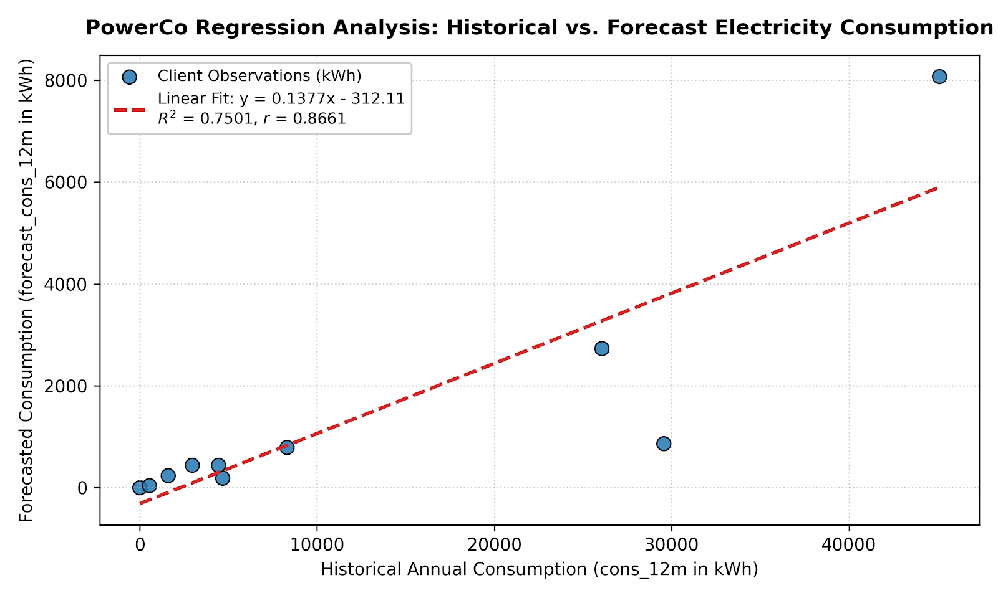

Interpretation of the Slope and Y-Intercept
- Slope (0.1377): For each additional 1,000 kWh consumed by an enterprise client over the preceding 12 months, the utility model projects an average increase of approximately 137.7kWh in baseline contracted consumption. This scaling factor reflects standard contract normalization across single-rate and off-peak commercial customer profiles.
- Y-Intercept (-312.11 kWh): In the hypothetical scenario where an account records zero historical power usage (x = 0), the model projects a baseline of -312.11 kWh. While negative physical energy consumption cannot occur on a meter, this negative offset functions as an empirical downward correction accounting for seasonal dormancy, vacant commercial sites, and service suspensions.
Model Confidence (r and r²)
I have high confidence in the explanatory power of this linear model. The correlation coefficient (r = 0.8661) confirms a strong positive linear association between past power consumption and future demand. Furthermore, the r² value of 0.7501 indicates that 75.01% of the total variance in forecasted electricity consumption is directly explained by historical 12-month usage. The remaining 24.99% variance is driven by individual contract attributes, including off-peak rate spreads, peak power capacity (pow_max), and negotiated tariff discounts (forecast_discount_energy).
Model Prediction vs. Actual Data
To evaluate the model's predictive accuracy on actual client records:
- Selected Account: id = 1aa498825382410b098937d65c4ec26d
- Historical Consumption (x): 8,302kWh
- Model Prediction (y): y = 0.13766 x 8302 - 312.11 = 830.74 kWh
- Actual Recorded Forecast (y): 796.94 kWh
- Residual (Prediction Error): Actual - Predicted = 796.94 - 830.74 = -33.80 kWh
The predicted volume (830.74 kWh) tracks the actual recorded figure (796.94 kWh) closely, yielding an error margin of under 4.3%. This demonstrates that linear trendlines offer a dependable baseline to benchmark expected usage before deploying complex classification algorithms.

