

Dharmsinh Desai University, Nadiad

Faculty of Technology, Department of Computer Engineering B.Tech. CE Semester – VI

**FARMER PORTAL**

Submitted By:

### Jay Patel (roll no: CE089 id: 17CEUOF008)

Parth Patel (roll no: CE092 id: 17CEUOS060) Krinish Radadiya (roll no: CE105 id: 17CEUOG025)

Submitted To: Prof. Pandav K. Patel

|  |
| --- |
| Assistant Professor of Department of Computer |
| Engineering, Dharmsinh Desai University, Nadiad. |



Dharmsinh Desai University, Nadiad

Faculty of Technology, Department of Computer Engineering

## CERTIFICATE

This is to certify that **System Design Practice** project entitled “**Farmer Portal**” is the bonafied report of work carried out by

#### Jay Patel (17CEUOF008)

1. **Parth Patel (17CEUOS060)**
2. **Krinish Radadiya (17CEUOG025)**

Of Department of Computer Engineering, Semester V, academic year 2019-20,

under our supervision and guidance.

|  |  |
| --- | --- |
| Guide | HOD |
| **Prof. Pandav K. Patel** | **Dr. C. K. Bhensdadia** |
| Assistant Professor of | Head of the Department of |
| Department of Computer | Department of Computer |
| Engineering, Dharmsinh Desai University, Nadiad. | Engineering, Dharmsinh Desai University, Nadiad. |

Table of Contents

|  |  |
| --- | --- |
| 1. Abstract | 4 |
| 2. Introduction | 5 |
| 2.1. Project Details: Brief Introduction | 5 |
| 2.2. Technology and Tools Used | 5 |
| 3. Software Requirement Specifications | 6 |
| 3.1 Types of user | 6 |
| 3.2 System Functional Requirements | 6 |
| 3.3 Other Non Functional Requirements | 9 |
| 4. Design | 10 |
| 1.Use case | 10 |
| 2. Class | 11 |
| 3. Activity | 11 |
| 4. Sequence | 13 |
| 5. E-R Diagram | 14 |
| 6. data Dictionary | 15 |
| 5. Implementation Details | 19 |
| 6. Testing | 20 |
| 7. Screen shots of the System | 23 |
| 8. Conclusion | 28 |
| 9. Limitations and Future Extensions of System | 28 |
| 10. Bibliography | 29 |

1. Abstract

“Agriculture is the backbone of the Indian Economy”- said Mahatma Gandhi six decades ago. Even today, the situation is still the same, with almost the entire economy being sustained by agriculture, which is the mainstay of the villages. It contributes 16% of the overall GDP and accounts for employment of approximately 52% of the Indian population. Rapid growth in agriculture is essential not only for self-reliance but also to earn valuable foreign exchange.

It is envisaged to make available relevant information and services to the farming community and private sector through the use of information and communication technologies, to supplement the existing delivery channels provided for by the department. Farmers’ Portal is an endeavor in this direction to create one stop shop for meeting all informational needs relating to Agriculture.

# Introduction

#### Brief Introduction

The farmer portal provides its users to get online information about the crop, statistical details and new tendencies. Now a days farmers facing problems like they have not any portal available to share or retrieve innovative ideas and also don’t have any portal to ask any expert for specific queries related to crop or see market price. If any farmer has success story then they can share with other farmer, we provide platform for that. We provide a single portal where a farmer can get everything on one site.

* 1. **Tools/Technologies Used**

#### Technologies:

Python (Django) HTML 5

CSS 3

Bootstrap 4

#### Tools

Visual Studio Code GitHub Desktop

#### Platform

http://127.0.0.1:8000

# Software Requirement Specifications

#### Types of User

* + 1. Farmer
    2. Expert
    3. Admin

#### System Functional Requirements

* 1. **Manage Account**
     1. Sign-up

Description: User, Expert can sign-up in system by entering details Input: User details

Output: Success/Error message

* + 1. Login

Description: Admin/User/Expert can login in system by entering details

Input: User credentials

Output: Success/Error message

* + 1. Logout

Description: Admin/User/Expert can logout in system by click the button

Input: User request

Output: Render to home page

#### Manage Success Stories

Description: User can add, update, remove & view success stories.

* + 1. Add success story

Description: User can add success story Input: Story details

Output: Success/Error message

* + 1. Update success story

Description: User can update success story Input: Story details

Output: Success/Error message

* + 1. Remove success story

Description: User can remove success story Input: User request

Output: Success/Error message

* + 1. Display Success story

Input: User request Output: Story details

* + 1. Filter success story

Input: User request

Output: Display stories according to filter

* + 1. Like success story

Input: Press like button Output: Like added to story

* + 1. Unlike success story

Input: press Unlike button Output: like removed from story

#### Manage Query

Description: User can raise & get answer of query.

* + 1. Raise query

Input: User request

Output: Success/Error message

* + 1. Answer a query

Input: User request

Output: Success/Error message

#### Manage Experts

* + 1. Add expert

Description: User can add expert. Input: User request

Output: Success/Error message

R.4.3 Remove expert

Description: User can remove expert. Input: User request

Output: Success/Error message

#### view price

Description: User can view current market price Input: User request

Output: Price list

#### 3.3 Other Nonfunctional Requirements

1. **Performance**

The system must be interactive and the delays involved must be less. So in every action-response of the system, there are no immediate delays. In case of opening App components, of popping error messages and saving the settings or sessions there is delay much below 3 seconds.

#### Safety

User details should be securely stored to the server. The main security concern is for user account hence proper login mechanism should be used to avoid hacking.

#### Reliability

As the system provides the right tools for discussion, problem solving it must be made sure that the system is reliable in its operations and for securing the sensitive details.

#### Database

System requires to access users data fast to maintain the performance.

# Design

#### USECASE

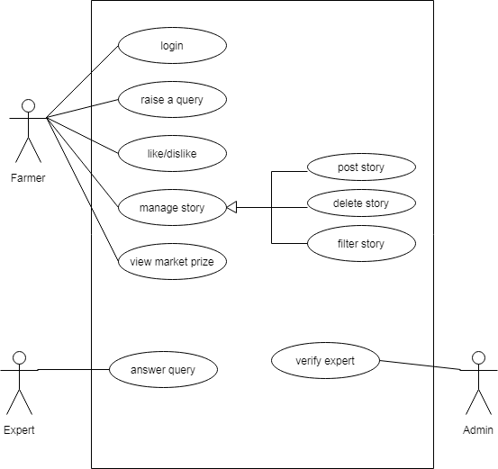

* 1. **CLASS**

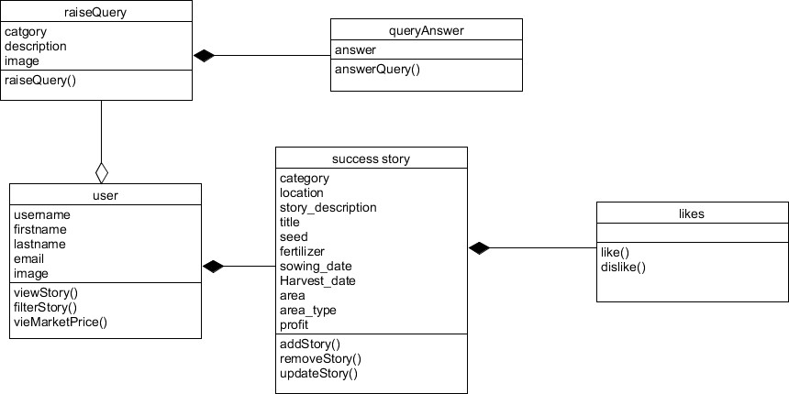

* 1. **ACTIVITY**

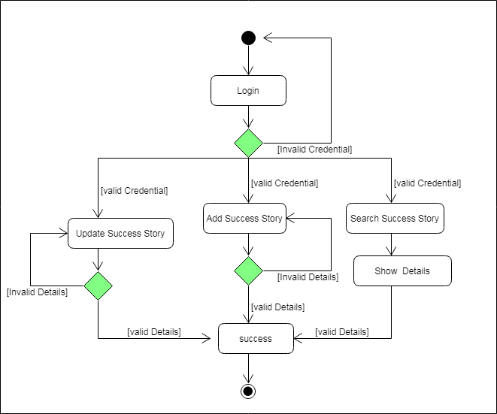

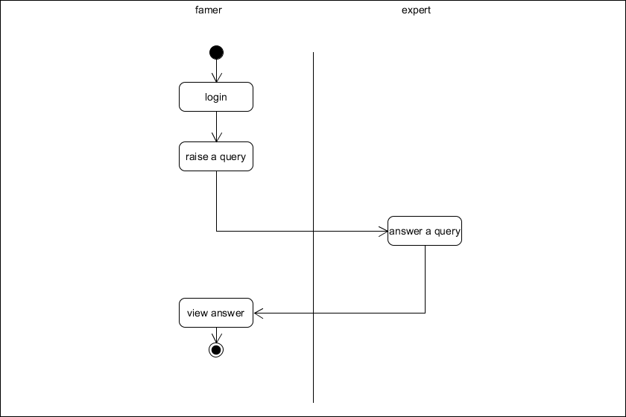

* 1. **SEQUENCE**

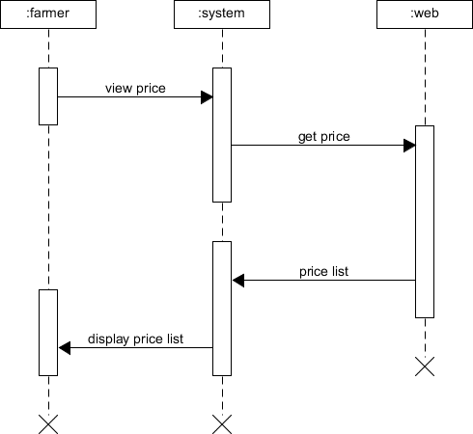

* 1. **E-R Diagram**

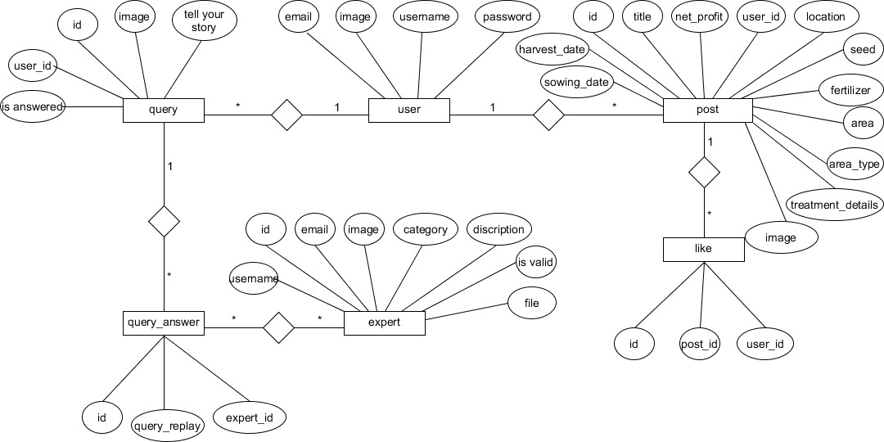

* 1. **Data Dictionary**

|  |  |  |  |  |  |  |  |  |
| --- | --- | --- | --- | --- | --- | --- | --- | --- |
| **1.User** | | | | | | | | |
| **Sr. No.** | **Field Name** | **Data Type** | **Width** | **Required** | **Unique** | **PK/FK** | **Referenc ed table** | **Descripti on** |
| 1. | _id | Varchar | 10 | Yes | Yes | PK |  | Auto increment key generated by database itself |
| 2. | username | Varchar | 10 | Yes | Yes |  |  | Unique id defined by user to login |
| 3. | password | Varchar | 8 | yes | no |  |  |  |
| 4. | Fname | Varchar | 50 | Yes | No |  |  |  |
| 5. | Lname | Varchar | 50 | Yes | No |  |  |  |
| 5. | email | Varchar | 30 | Yes | Yes |  |  |  |

|  |  |  |  |  |  |  |  |  |
| --- | --- | --- | --- | --- | --- | --- | --- | --- |
| **2.Query** | | | | | | | | |
| **Sr. No.** | **Field Name** | **Data Type** | **Width** | **Required** | **Unique** | **PK/FK** | **Referenc ed table** | **Descripti on** |
| 1. | Q_id | Varchar | 10 | Yes | Yes | PK |  |  |
| 2. | U-id | Varchar | 10 | Yes | No | FK | User |  |
| 3. | Category | Varchar | 10 | Yes | No |  |  |  |
| 4. | Image | Varchar | 50 | Yes | No |  |  |  |
| 5. | query | Varchar | 500 | Yes | No |  |  |  |

|  |  |  |  |  |  |  |  |  |
| --- | --- | --- | --- | --- | --- | --- | --- | --- |
| **3.Post** | | | | | | | | |
| **Sr. No.** | **Field Name** | **Data Type** | **Width** | **Required** | **Unique** | **PK/FK** | **Referenc ed table** | **Descripti on** |
| 1. | Post_id | Varchar | 10 | Yes | Yes | PK |  |  |
| 2. | Title | Varchar | 20 | Yes | No |  |  |  |
| 3. | Post_desc | Varchar | 500 | Yes | No |  |  |  |
| 4. | username | Varchar | 10 | Yes | Yes | FK | User |  |
| 5. | Location | Varchar | 20 | Yes | No |  |  |  |
| 6. | Seed | Varchar | 20 | Yes | No |  |  |  |
| 7. | Fertilizer | Varchar | 20 | Yes | No |  |  |  |
| 8. | Treatment | Varchar | 500 | Yes | No |  |  |  |
| 9. | Category | Varchar | 10 | Yes | No |  |  |  |
| 10. | Sow_date | Date | 20 | Yes | No |  |  |  |
| 11. | Harvest | Date | 20 | Yes | No |  |  |  |
| 12. | Area | Number | 10 | Yes | No |  |  |  |
| 13. | Areatype | Number | 10 | Yes | No |  |  |  |
| 14. | Profit | Number | 10 | Yes | No |  |  |  |
| 15. | Image | Varchar | 50 | Yes | No |  |  |  |

|  |  |  |  |  |  |  |  |  |
| --- | --- | --- | --- | --- | --- | --- | --- | --- |
| **4.Query** | | | | | | | | |
| **Sr. No.** | **Field Name** | **Data Type** | **Width** | **Required** | **Unique** | **PK/FK** | **Referenc ed table** | **Descripti on** |
| 1. | Q_id | Varchar | 10 | Yes | Yes | PK |  |  |
| 2. | U-id | Varchar | 10 | Yes | No | FK | User |  |
| 3. | Category | Varchar | 10 | Yes | No |  |  |  |
| 4. | Image | Varchar | 50 | Yes | No |  |  |  |
| 5. | query | Varchar | 500 | Yes | No |  |  |  |

|  |  |  |  |  |  |  |  |  |
| --- | --- | --- | --- | --- | --- | --- | --- | --- |
| **5.Query_answer** | | | | | | | | |
| **Sr. No.** | **Field Name** | **Data Type** | **Width** | **Required** | **Unique** | **PK/FK** | **Referenc ed table** | **Descripti on** |
| 1. | A_id | Varchar | 10 | Yes | Yes | PK |  |  |
| 2. | Q_id | Varchar | 20 | Yes | Yes | FK | Query |  |
| 3. | E_id | Varchar | 20 | Yes | Yes | FK | Expert |  |
| 4. | Reply | Varchar | 500 | Yes | No |  |  |  |

|  |  |  |  |  |  |  |  |  |
| --- | --- | --- | --- | --- | --- | --- | --- | --- |
| **6.Expert** | | | | | | | | |
| **Sr. No.** | **Field Name** | **Data Type** | **Width** | **Required** | **Unique** | **PK/FK** | **Referenc ed table** | **Descripti on** |
| 1. | E_id | Varchar | 10 | Yes | Yes | PK |  |  |
| 2. | Username | Varchar | 10 | Yes | Yes |  |  |  |
| 3. | Password | Varchar | 10 | No | No |  |  |  |
| 4. | Image | Varchar | 10 | No | No |  |  |  |
| 4. | Category | Varchar | 10 | Yes | No |  |  |  |
| 5. | Email | Date | 30 | Yes | No |  |  |  |
| 6. | File | Varchar | 50 | Yes | No |  |  |  |

|  |  |  |  |  |  |  |  |  |
| --- | --- | --- | --- | --- | --- | --- | --- | --- |
| **7.Like** | | | | | | | | |
| **Sr.**  **No.** | **Field Name** | **Data Type** | **Width** | **Required** | **Unique** | **PK/FK** | **Referenced table** | **Description** |
| 1. | _id | Varchar | 10 | Yes | Yes | PK |  |  |
| 2. | Q_id | Varchar | 10 | Yes | No | FK | Query |  |
| 3. | E_id | Varchar | 10 | Yes | No | FK | Expert |  |

1. Implementation Details

Registration module:

This module is used to store user’s data to the database and enables the user to login to the system. All the fields in this module contains required validations. User can also navigate to login page if he/she already registered.

Login module:

This module takes users credentials and then verifies it with registered users, if user is not registered the invalid credentials is shown else if they match with database then login user.

### Success story module:

In this module farmer can add their success story by posting their complete details about crop, fertilizer, timings and profit. farmer can also view other’s stories by filtering them by location wise. user can also like the story.

### Query module:

In this module farmer can raise a query about particular crop and also upload images and get the answer by expert of that category.

# Testing

### We have performed black box testing for this system.

**Test cases:**

|  |  |  |  |
| --- | --- | --- | --- |
| **Module name** | **Field Input** | **Expected output** | **Actual output** |
| Login | Username & Password (true input) | Redirect to Home page | Redirect to Home page |
| Login | Username & Password  (wrong password) | Error message and  Stay to login page | Error message and  Stay to login page |
| Farmer Signup | Username(name which Is already taken) | Warning message and stay to signup page | Warning message and stay to signup page |
| Expert Login | Username & Password  (true input but expert is not verified) | Warning message and stay to login page | Warning message and stay to login page |
| Success story | Sowing and harvest dates(harvest date is not afterwards than sowing ) | Alert message | Alert message |
| Admin | admin try to login but not verified | Alert message | Alert message |

When user enter wrong details

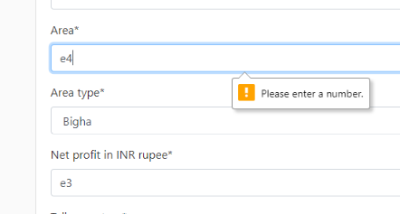

When user name already taken or password is not in given format

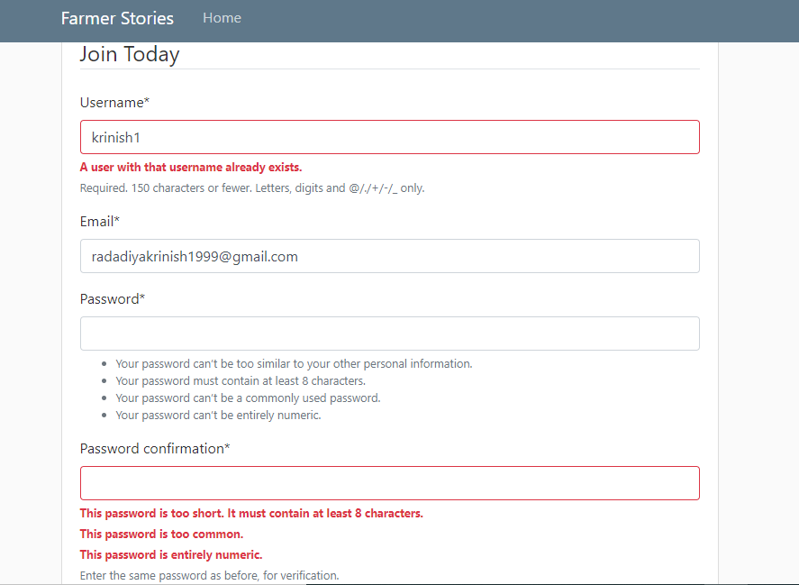

When harvest date is afterwards than sowing

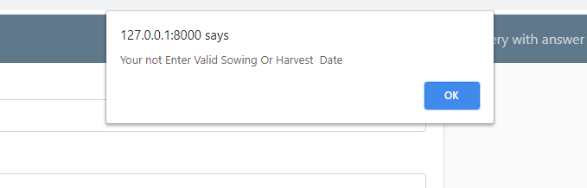

When admin try to login but not verified

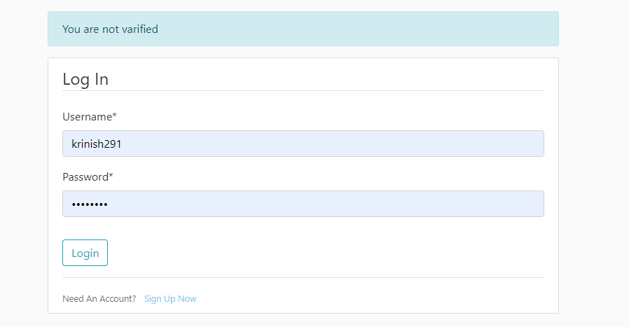

1. screen shots
2. Home page without login

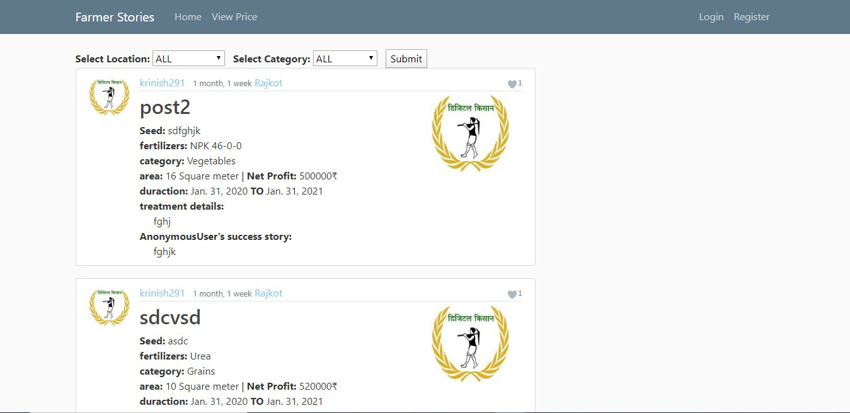

1. Farmer Login page

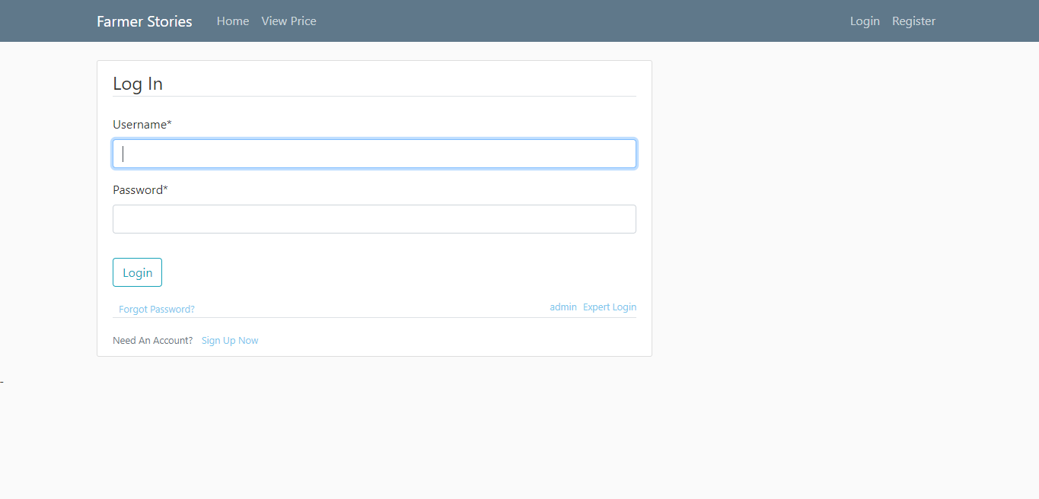

1. Farmer registration page

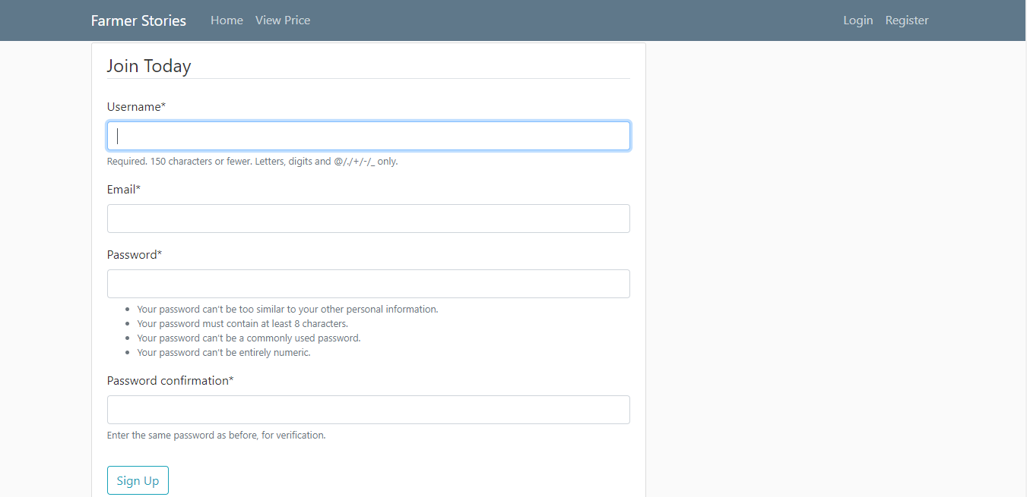

1. Price page

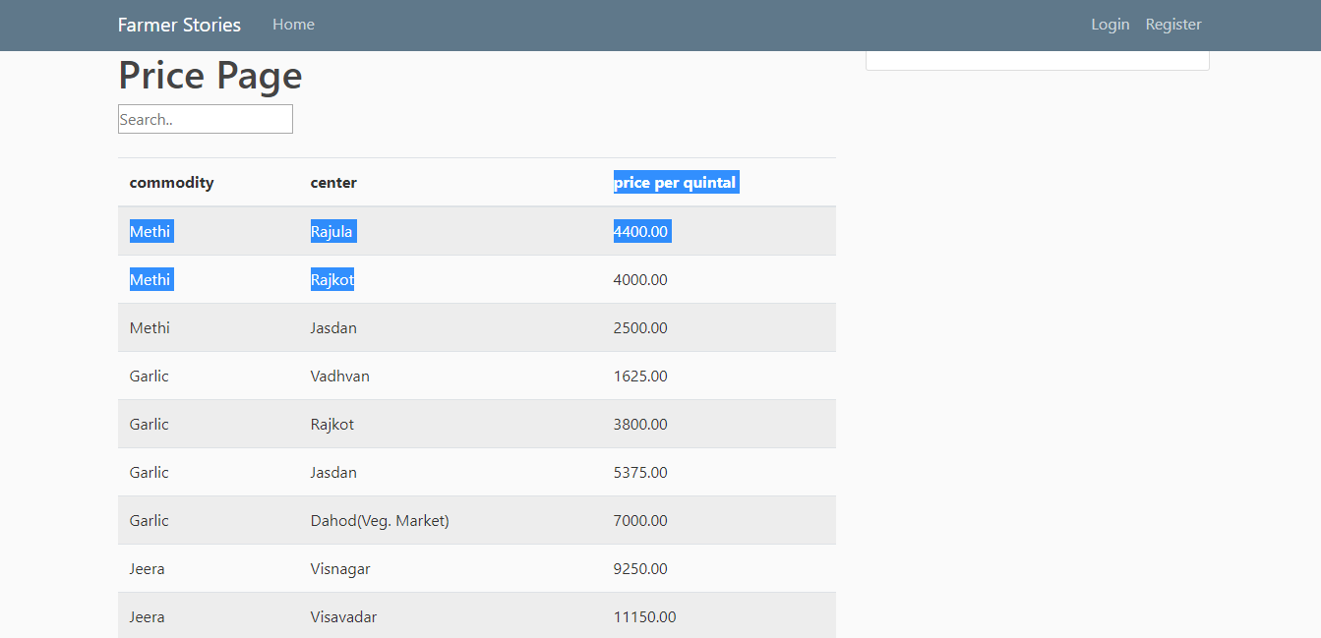

1. add success story page

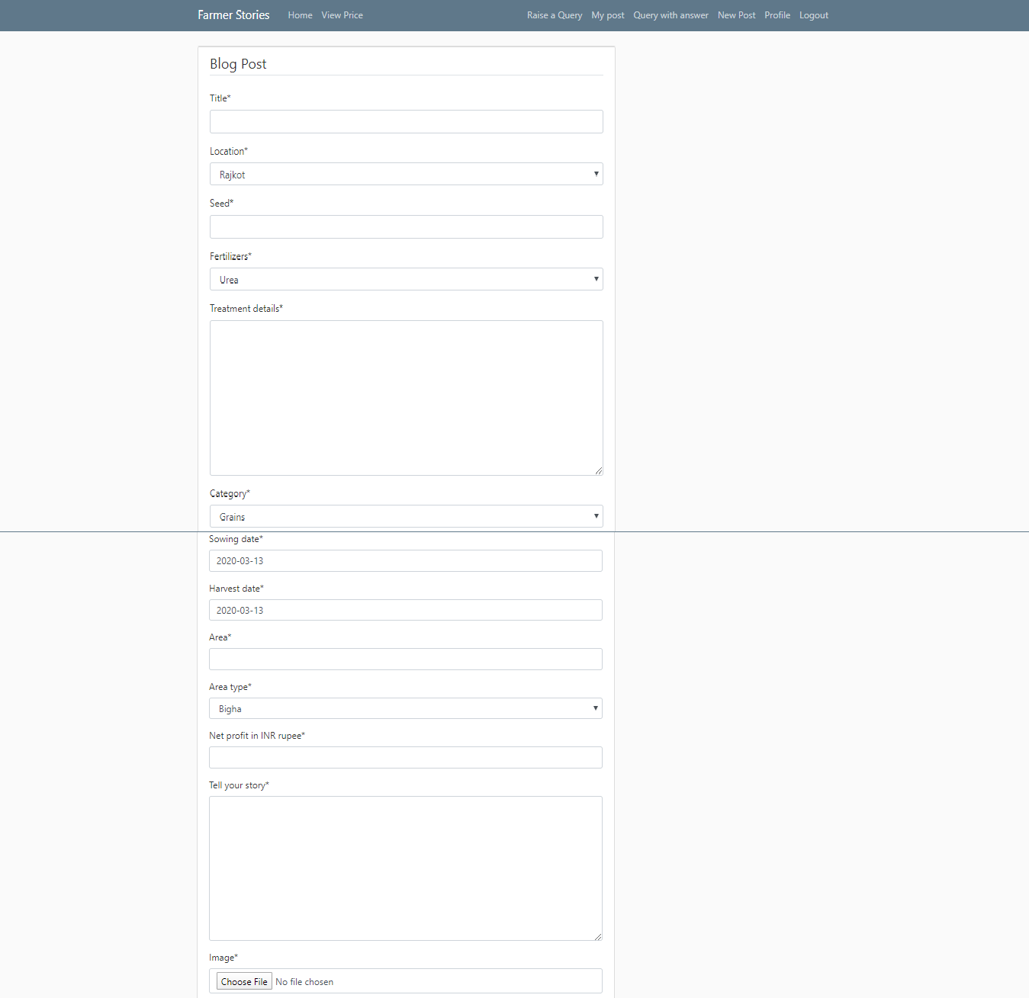

1. pending queries with no answer page

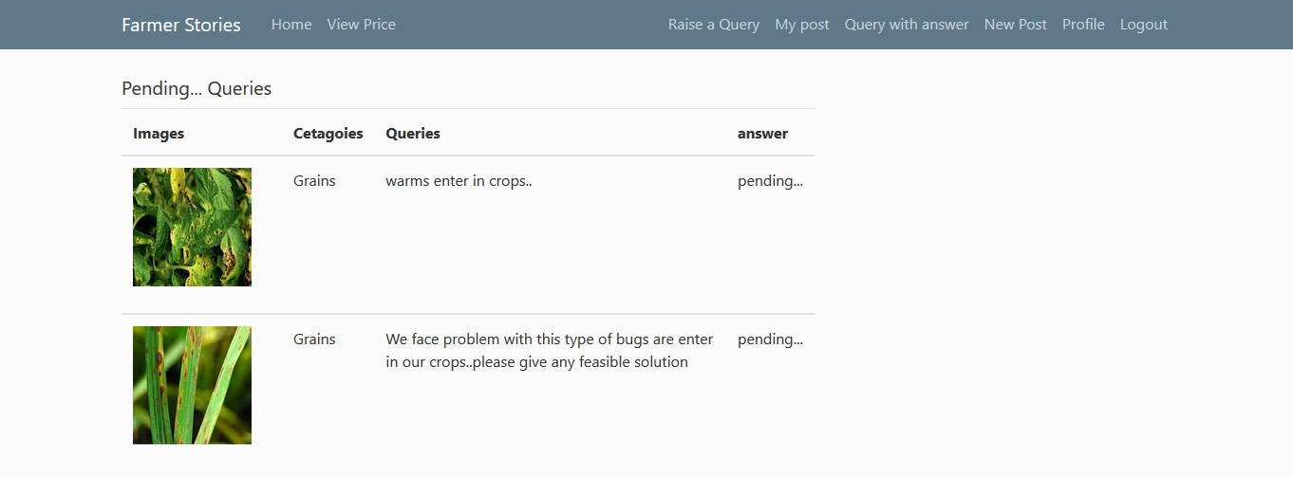

1. queries answered by an expert

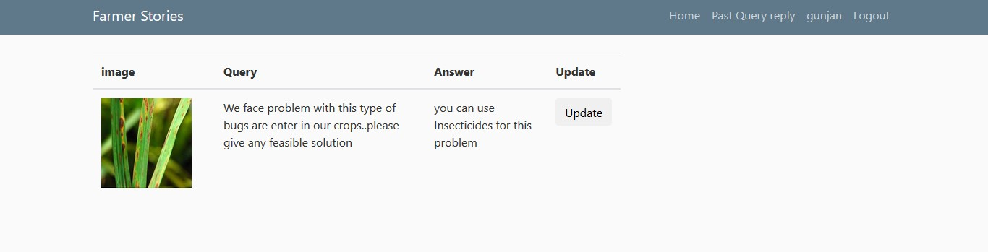

1. Raise Query page

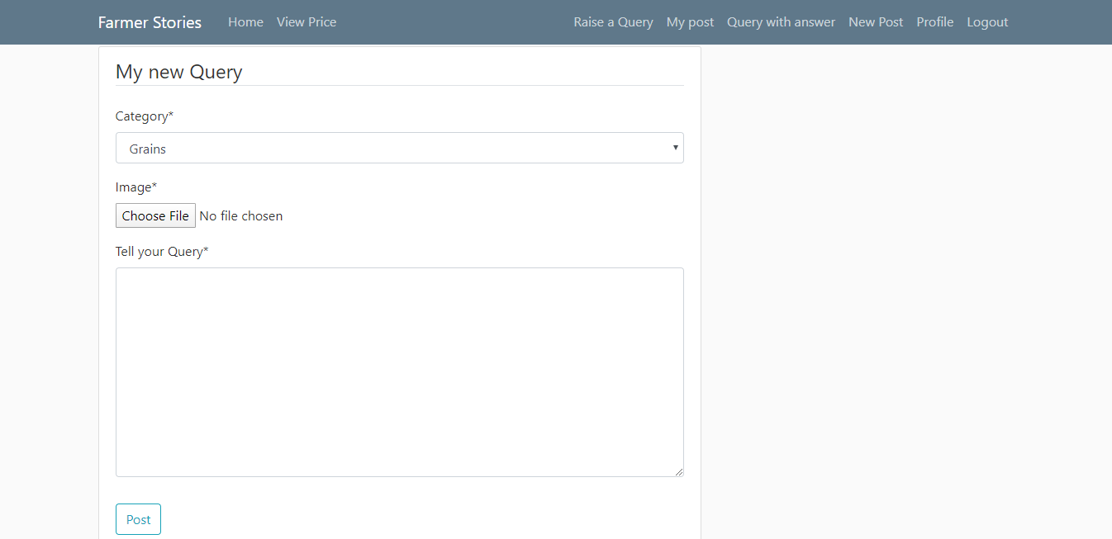

1. admin login page

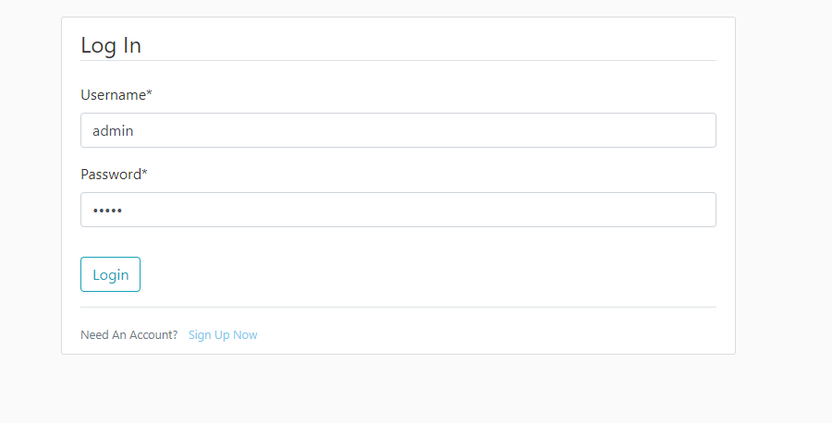

1. expert verification page

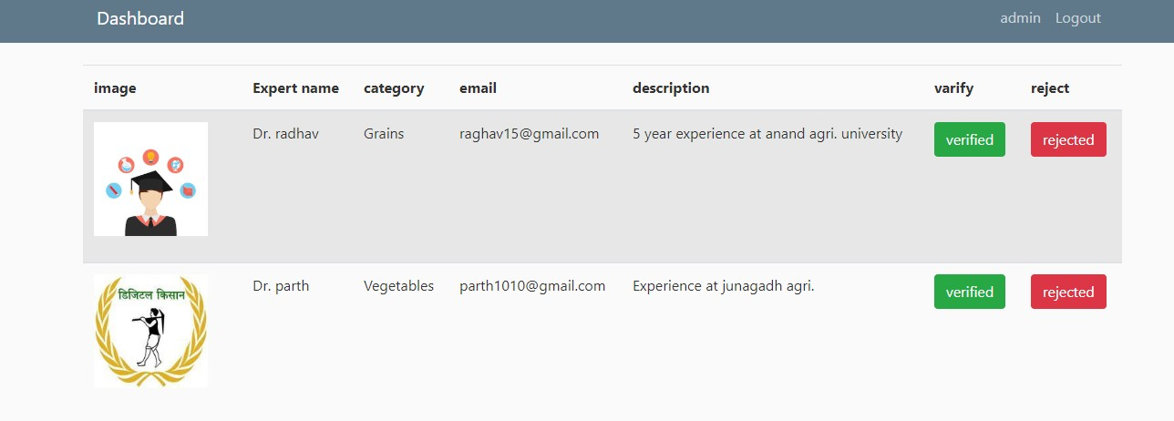

# conclusion

The functionalities implemented in system after understanding all the system modules according to the requirements. Functionalities That are successfully implemented in the system are :

* + User registration containing all the necessary validation on field
  + login
  + user authentication
  + logout
  + post success story
  + view stories according to your search
  + raise queries
  + liking the story
  + view market price
  + Admin side management

After the implementation and coding of system comprehensive testing was performed on the system to determine the errors and possible flaws in the system.

# Limitations and Future Enhancement

The System has adequate scope for modification in future if it is necessary.

Refining existing services and adding more service, System security, data security and reliability are the main feature.

In the future there are no need of any experts , Farmers can directly take picture of crop and our portal will give the best solution for that with use of Machine learning and previous data.

# Reference / Bibliography

Following links and websites were referred during the development of this project. [https://www.google.co.in](https://www.google.co.in/)

[http://www.wikipedia.org](http://www.wikipedia.org/) <https://docs.djangoproject.com/en/3.0/> <https://docs.python.org/3/> <https://selenium-python.readthedocs.io/> [http://www.w3schools.com](http://www.w3schools.com/) [http://www.tutorialspoint.com](http://www.tutorialspoint.com/) [http://www.stackoverflow.com](http://www.stackoverflow.com/)