1. What is the _mask value for LED1?

What is the address of FIOSET?

LED1 mask  
FIO1MASK = 0xFFFFFBFF

FIO0SET - 0x2009 C018

FIO1SET - 0x2009 C038 ---> FIOSET for LED1

FIO2SET - 0x2009 C058

FIO3SET - 0x2009 C078

FIO4SET - 0x2009 C098

LED1's FIOSET byte address:

FIO1SET1 = 0x2009C039

--------------------------------------------------------------------

2. What is the RS232 Frame?

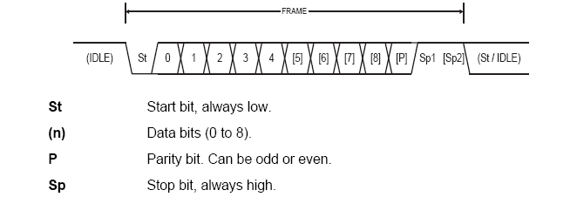

Odd parity: 0/1 if odd/even number of 1’s in the data bits - making total number of 1’s off

Even parity: 0/1 if even/odd number of 1’s in the data bits – making total number of 1’s even

--------------------------------------------------------------------

3. Explain the start and stop conditions of i2c?

The Start condition is defined by a high to low transition of SDA when SCL is high.

A low to high transition of SDA while SCL is high defines a Stop condition.

--------------------------------------------------------------------

4. Is the i2c acknowledge SDA LOW or SDA HIGH?

I2C ack is SDA low

--------------------------------------------------------------------

5. Tell me about the DDR3 write leveling Concept in one sentence.

(ref: slides)

END