**PROJECT-NAME: Lenskart**

**Lenskart is an indian optical eyewear retail chain.**

Every eyewear is available under the same roof.

Navigation bar (on top):



Menu bar (carousel) :

A horizontal division below navigation bar where different categories of items are available to see.



Advertisements and offers and banners section :



Sign up and sign in page :

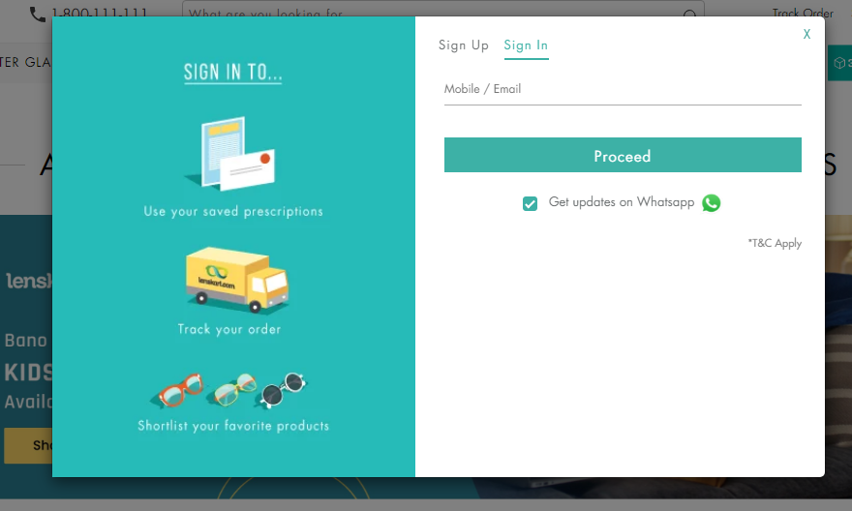

Payment page:

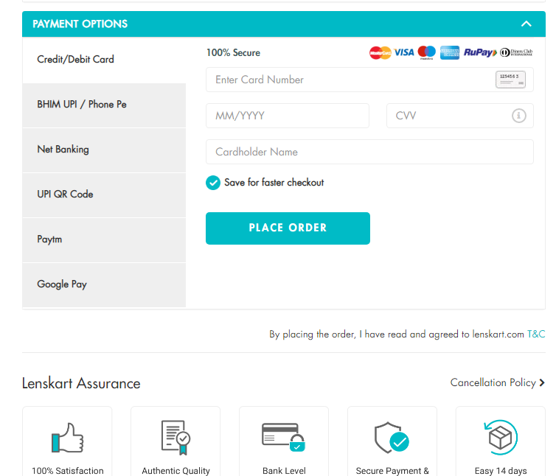

Reference link:

www.lenskart.com