AEC FINAL PROJECT REPORT

Kripi Singla, 2022102063

IIIT Hyderabad

Abstract/ Main Aim of the Project: -

Designing a Quadrature Down Converter (QDC) that is commonly used in modern day wireless receivers such as Bluetooth, Wi-Fi and WLAN.

Quadrature down conversion helps in interference mitigation and improves the quality of communication. In this project, we will implement a prototype of QDC for given specifications.

Keywords: - Quadrature, frequency, phase-shift

Introduction

The basic circuit implementation for the Quadrature Downconverter is clearly shown in the above figure. Basically, we will be sending a sinusoidal input signal which in turn will give two sinusoidal signals as output, one in-phase and the other Quadrature-Phase.

In-phase means that input and output waves should have a phase difference of 0 degrees and quadrature-Phase refers to the Phase difference of 90 degrees.

**Basic working of the Circuit**

It is clear from the above equations that multiplying two sinusoidal signal with different frequencies, we get the resultant signal which is the sum of two sinusoidal signals , frequency of one signal being the sum of the input and the oscillator frequency while the other signal having a frequency which is the difference of input and oscillator frequency. Our desired output is the sinusoidal signal with the difference of both the frequencies, this is achieved using a Low Pass filter.

The Quadrature Downconverter designed consists of the following three components:-

* Quadrature Oscillator
* Switch (Mixer)
* Low pass filter

**Quadrature Oscillator Design**

The Quadrature Oscillator is an extremely significant part of the Quadrature Down Converter. The Quadrature oscillator converts the DC supply to an op-amp into an AC signal without requiring any input signal.

We require a simple feedback circuit which has a phase shift of 360 degrees so that our output is the same after the completion of an entire loop which will happen only when the phase shift is either 0 degrees or 360 degrees.

**Circuit Diagram of the Oscillator: -**

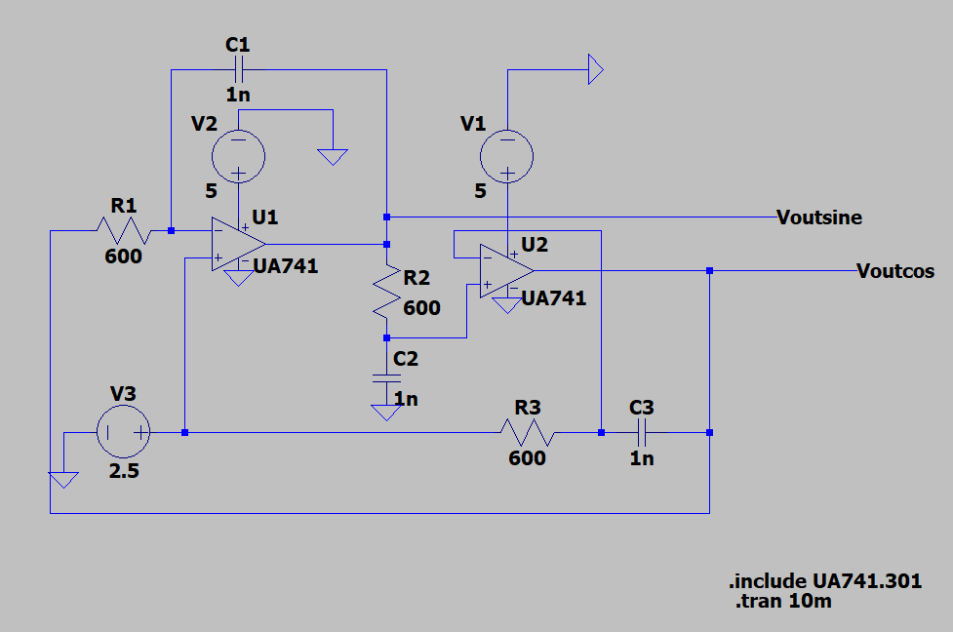

As is evident from the above circuit diagram, our circuit uses 2 op-amp circuits as integrators to amplify the DC energy and then a RC circuit is used as feedback to give the required phase shift and filter all the unwanted signals, basically Noise.

Now, let’s see how the Total Phase shift across the entire circuit is equal to 0 degrees.

Observing all the three components of the Quadrature Oscillator one by one:-

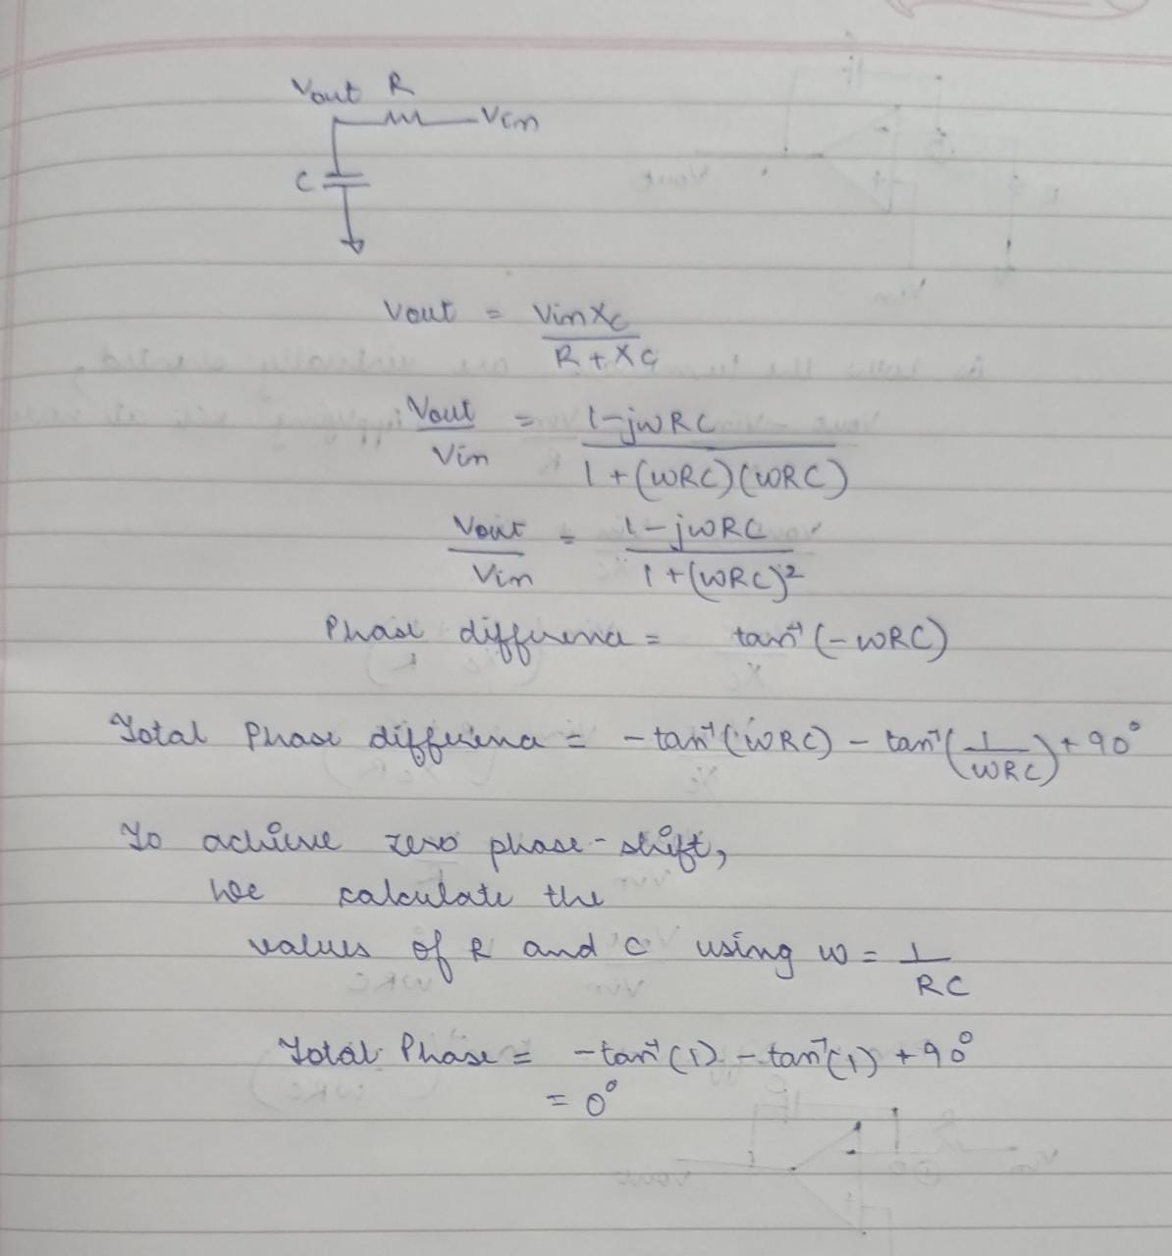

**Calculations**:-

Using w = 1/ RC which means frequency = 1/ 2piRC, the values of R and C are calculated.

Given that frequency should be 100KHz, the values of R and C were calculated as 1.59nF and 10 k ohms.

After simulating in LTSpice, the peak of the FFT plot was observed around 68KHz, which didn’t match our expectations.

The following simulation results were obtained:-

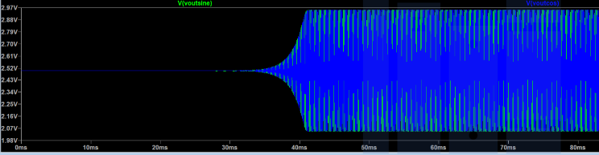

By playing around the values of R and C a little bit, to get the correct frequency as output in the simulation results, Finally R = 600 ohms and C = 1 nF were decided as the final values for the accurate working of the Oscillator.

The final Simulation results are as follows:-

FFT of both the signals:-

Sine:-

Cosine:-

The frequency obtained now was closer to 100KHz.

**Realising The Quadrature Oscillator Circuit in Lab**

**SWITCH(MIXER) CIRCUIT**

The basic function of the mixer circuit is to multiply two signals which are given to the two terminals of the MOSFET.

**Circuit Diagram:-**

The purpose of connecting Cc and RBias is to ensure that the same voltage appears at the gate terminal of the MOSFET.

To ensure this, the values for Rbias and Cc were decided keeping in mind that the value of Rbias needs to be high enough so that the potential at the Gate terminal is approximately equal to VBias when we are observing the DC picture of the above circuit.

Similarly, a capacitor is introduced for the sinusoidal signal so that only AC signal reaches the gate terminal.(AC Coupling).

Multiplication of Vosc and Vin is the desired output of the mixer.

**LTSpice Simulations**

When fosc = 95k

Fosc = 98k

Fosc = 99k

Fosc = 101k

Fosc = 102k

Fosc = 105k

The basic shape of the graph is defined by the switching action of the mixer.

**Realisation of the circuit in lab**

Observing the FFT at 5Hz, the magnitude is around -48.227dB which is similar to what is obtained in the LTSpice Simulation.

**LOW PASS FILTER**

A low pass filter allows only signals with frequencies less than a particular frequency which is known as cut-off frequency to pass through.

Circuit

We know that the formula for the Cutoff-frequency is ½*pi*RC, as per the circuit we want the cutoff-frequency to be around 2KHz.

Equating 2KHz with ½*pi*R*C, we can calculate corresponding values of R and C.

Assuming C to be 0.1uF, R as per calculation comes around 800 ohms, since 820 ohms resistor was present in the lab, we have used 820 ohm for simulation.

**LTSpice Simulation:-**

From the above LTSpice simulation, the cutoff frequency obtained measured using cursors is 2KHz.

The low pass filter allows to pass the frequency of 1KHz with reduced amplitude. This justifies the proper working of the Low Pass Filter Circuit.

**COMPLETE PROTOTYPE DESIGN**

Now that we are done with individual working and testing of all three major components required for the design of Quadrature Downconverter, we integrate all three circuits to look for the final desired output.

**Final Circuit Diagram**

**LTSpice Simulations**

**Final Output**

**Input Voltage:-**

**Oscillator Outputs:-**

**Mixer outputs:-**

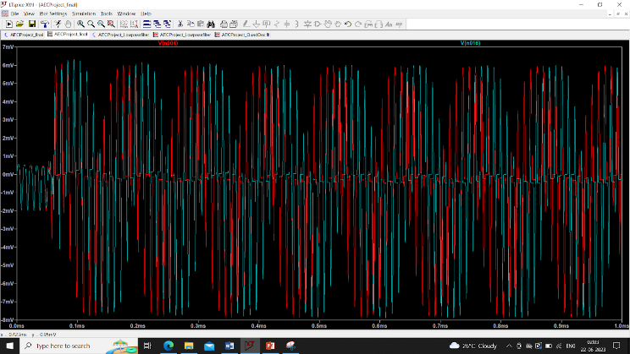

**FFT Plots: -**

**Realizing the complete circuit in Lab**

**This is the output waveform observed. Measured frequency is the difference of the oscillator frequency and the frequency applied at the input.**

**Both the waveforms are at 90 degrees phase difference with each other.**

**Hence, we have the desired output of the quadrature downConverter.**

**CONCLUSION**

A quadrature downconverter is a device used in communication systems and signal processing applications to convert high-frequency signals down to lower intermediate frequencies (IF) or baseband frequencies. By mixing the input signal with these two quadrature signals, the downconverter is able to shift the frequency of the input signal down to a lower frequency.

The process of downconversion involves multiplying the input signal by the quadrature signals using mixers. The mixers perform a multiplication operation that results in both sum and difference frequencies. By utilizing the difference frequency, which is the desired output, the input signal is downconverted.

Quadrature downconverters find applications in various fields, including wireless communication systems, radar systems, software-defined radios (SDR), and other signal processing applications where frequency downconversion is required.

We designed a prototype of the Quadrature DownConvertor which consists of three components - Quadrature Oscillator, Switch and Low Pass Filter, the working of all these individual circuits have been discussed in the report.