**Customer Relationship Management**

Screenshots

1. Customers List

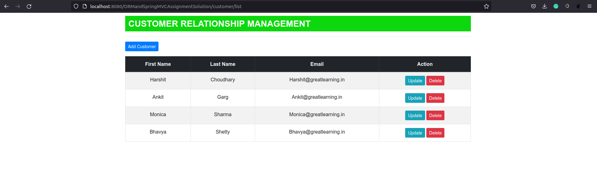

1. Update Customer

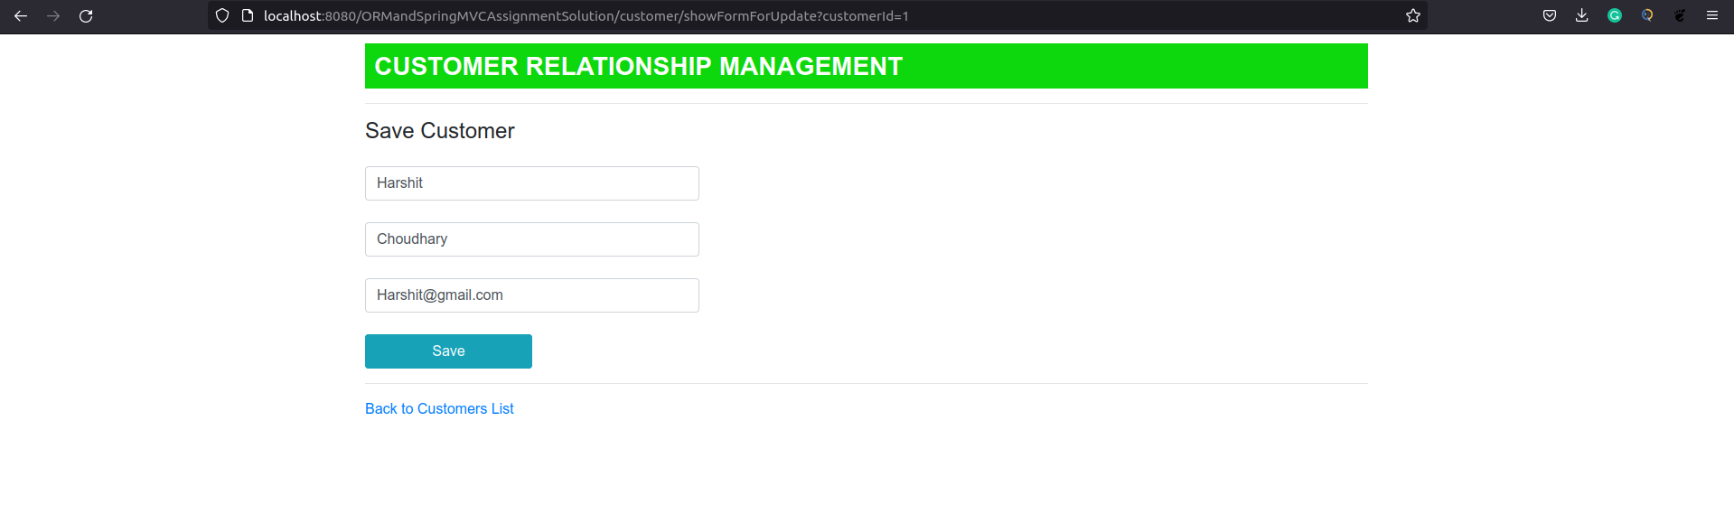

1. Add Customer

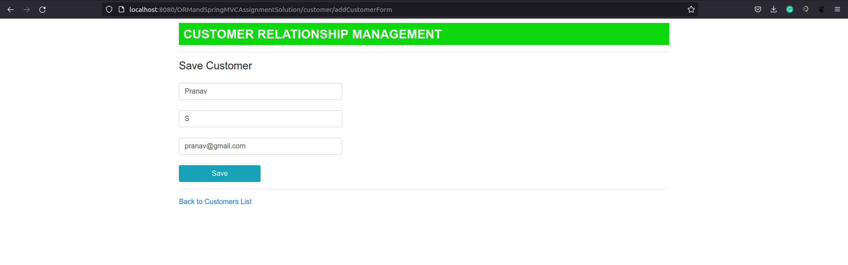

4) Customer List After Add

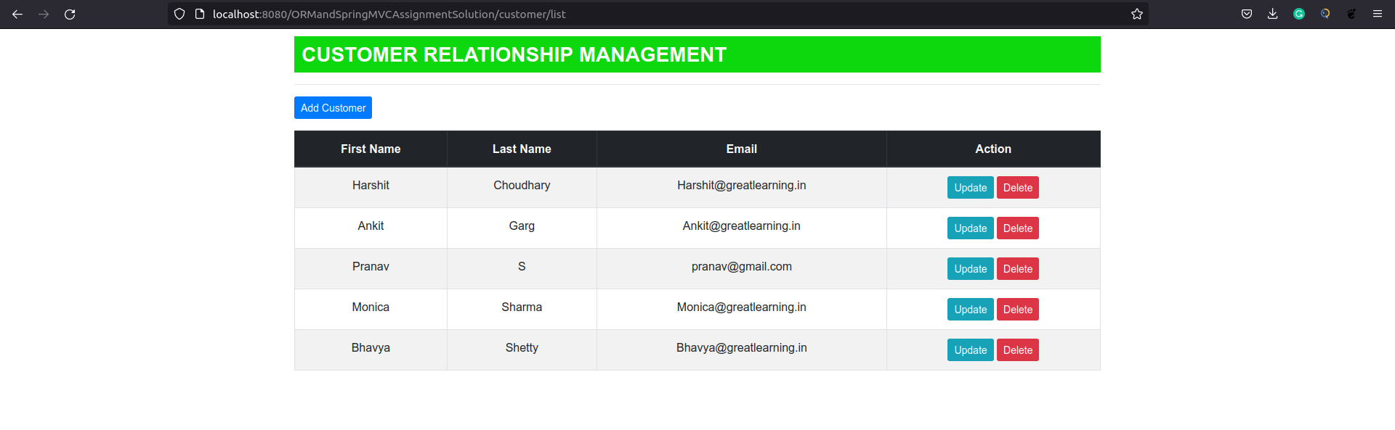

5) Customer Delete Message

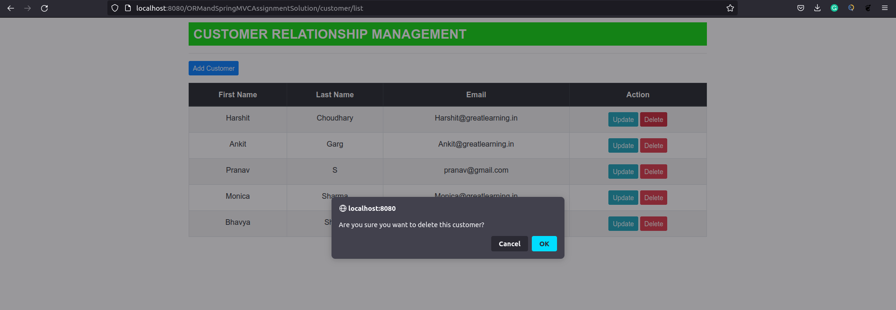

6) Customer List After Delete

