**Kontrolni zadatak 4/7**

**Grupa A**

Ime i Prezime ________________________________________________________

**- Tabela proizvoda: Products(prod_id, prod_name, category_id, price, stock)  
- Tabela kategorija: Categories(category_id, category_name)  
- Tabela narudžbina: Orders(order_id, order_date, customer_id)  
- Tabela stavke narudžbine: OrderItems(order_id, prod_id, quantity, item_price)  
- Tabela kupaca: Customers(customer_id, city, country))**

**1) Kreiranje tabela (Oracle SQL DDL)**  
  
**-- Kategorije**  
CREATE TABLE Categories (

category_id int PRIMARY KEY,

category_name VARCHAR(100) NOT NULL

);  
**-- Proizvodi**  
CREATE TABLE Products (

prod_id int PRIMARY KEY,

prod_name VARCHAR(100) NOT NULL,

category_id int REFERENCES Categories(category_id),

price NUMERIC(10, 2) NOT NULL,

stock NUMERIC DEFAULT 0 NOT NULL

);  
**-- Kupci**  
CREATE TABLE Customers (

customer_id INTEGER PRIMARY KEY,

city VARCHAR(100),

country VARCHAR(100)

);  
**-- Narudžbine**  
CREATE TABLE Orders (

order_id INTEGER PRIMARY KEY,

order_date DATE NOT NULL,

customer_id INTEGER REFERENCES Customers(customer_id)

);  
**-- Stavke narudžbine**  
CREATE TABLE OrderItems (

order_id INTEGER REFERENCES Orders(order_id),

prod_id INTEGER REFERENCES Products(prod_id),

quantity INTEGER NOT NULL,

item_price NUMERIC(10, 2) NOT NULL,

PRIMARY KEY (order_id, prod_id)

);

**2) Skripta za unos podataka (Oracle, koristeći 10 proizvoda u 4 kategorije, 50 narudžbina)**  
**- Unos kategorija**

INSERT INTO Categories (category_id,category_name) VALUES (1,'Elektronika');

INSERT INTO Categories (category_id,category_name) VALUES (2,'Kuvanje');

INSERT INTO Categories (category_id,category_name) VALUES (3,'Igračke');

INSERT INTO Categories (category_id,category_name) VALUES (4,'Kancelarijski');

**- Unos proizvoda (10 proizvoda raspoređenih po 4 kategorije)**.

INSERT INTO Products (prod_id, prod_name, category_id, price, stock) VALUES (1, 'Laptop Pro 14"', 1, 1200.00, 20);

INSERT INTO Products (prod_id, prod_name, category_id, price, stock) VALUES (2, 'Smartphone X', 1, 799.99, 50);

INSERT INTO Products (prod_id, prod_name, category_id, price, stock) VALUES (3, 'Televizor 55"', 1, 699.99, 15);

INSERT INTO Products (prod_id, prod_name, category_id, price, stock) VALUES (4, 'Električni blender', 2, 89.99, 40);

INSERT INTO Products (prod_id, prod_name, category_id, price, stock) VALUES (5, 'Espresso aparat', 2, 129.99, 30);

INSERT INTO Products (prod_id, prod_name, category_id, price, stock) VALUES (6, 'Pisaći blokčić', 4, 3.50, 500);

INSERT INTO Products (prod_id, prod_name, category_id, price, stock) VALUES (7, 'Fen za kosu', 4, 24.99, 60);

INSERT INTO Products (prod_id, prod_name, category_id, price, stock) VALUES (8, 'Igračka lutka', 3, 14.99, 200);

INSERT INTO Products (prod_id, prod_name, category_id, price, stock) VALUES (9, 'Disk mobilni 1TB', 1, 59.99, 25);

INSERT INTO Products (prod_id, prod_name, category_id, price, stock) VALUES (10, 'Set Olovaka', 4, 5.99, 300);

**- Unos kupaca**

INSERT INTO Customers (customer_id, city, country) VALUES (1, 'Beograd', 'Srbija');

INSERT INTO Customers (customer_id, city, country) VALUES (2, 'Novi Sad', 'Srbija');

INSERT INTO Customers (customer_id, city, country) VALUES (3, 'Niš', 'Srbija');

INSERT INTO Customers (customer_id, city, country) VALUES (4, 'Zagreb', 'Hrvatska');

INSERT INTO Customers (customer_id, city, country) VALUES (5, 'Sarajevo', 'Bosna i Hercegovina');

**-- Narudžbine**

- Narudžbine:

INSERT INTO Orders (order_id, order_date, customer_id) VALUES

(1, '2025-01-02', 1)

(2, '2025-01-03', 2)

(3, '2025-01-02', 3)

(4, '2025-01-03', 4)

(5, '2025-01-03', 5)

(6, '2025-03-02', 1)

(7, '2025-03-03', 2)

(8, '2025-03-02', 3)

(9, '2025-03-03', 4)

(10, '2025-03-03', 5)

- Stavke narudžbine:

- Narudžbine:

INSERT INTO Orders (order_id, order_date, customer_id) VALUES

- Stavke narudžbine:

INSERT INTO OrderItems (order_id, prod_id, quantity, item_price) VALUES

(1, 1, 1, 1200.00)

(1, 3, 4, 699.99)

(1, 5, 1, 129.99)

(1, 6, 2, 3.50)

(1, 9, 1, 59.99)

(2, 2, 1, 799.99)

INSERT INTO OrderItems (order_id, prod_id, quantity, item_price) VALUES

(2, 3, 10, 699.99)

(2, 7, 10, 24.99)

(3, 1, 1, 1200.00)

(3, 3, 4, 699.99)

(3, 6, 2, 3.50)

(3, 8, 1, 14.99)

(3, 9, 1, 59.99)

INSERT INTO OrderItems (order_id, prod_id, quantity, item_price) VALUES

(4, 8, 1, 14.99)

(4, 9, 10, 59.99)

(4, 10, 10, 5.99)

(5, 1, 1, 1200.00)

(5, 3, 4, 699.99)

(6, 5, 1, 129.99)

(6, 6, 2, 3.50)

INSERT INTO OrderItems (order_id, prod_id, quantity, item_price) VALUES

(6, 9, 1, 59.99)

(7, 2, 1, 799.99)

(7, 3, 10, 699.99)

(7, 7, 10, 24.99)

(8, 1, 1, 1200.00)

(8, 3, 4, 699.99)

(8, 6, 2, 3.50)

INSERT INTO OrderItems (order_id, prod_id, quantity, item_price) VALUES

(9, 8, 1, 14.99)

(9, 9, 1, 59.99)

(9, 10, 10, 5.99)

(10, 1, 1, 1200.00)

(10, 2, 1, 799.99)

(10, 3, 4, 699.99)

INSERT INTO OrderItems (order_id, prod_id, quantity, item_price) VALUES

(10, 6, 2, 3.50)

(10, 8, 1, 14.99)

(10, 9, 1, 59.99)

(10, 10, 10, 5.99)

select * from products

select * from customers

select * from categories

select * from orders

select * from orderitems

**Zadatak A1:** Broj proizvoda po kategoriji  
- Opis: Prikažite broj proizvoda u svakoj kategoriji.

select count(Products.prod_id),Categories.category_id

from Products join Categories on (Products.category_id=Categories.category_id)

group by Categories.category_id

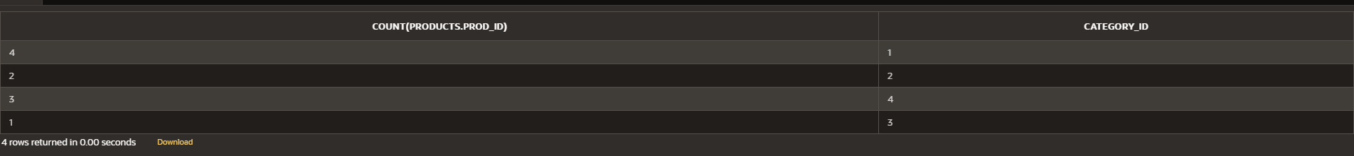  
  
**Zadatak A2**: Minimalna, prosecna i maksimalna cena po kategoriji

select min(price),avg(price),max(price),Categories.category_id

from Products join Categories on (Products.category_id=Categories.category_id)

group by Categories.category_id

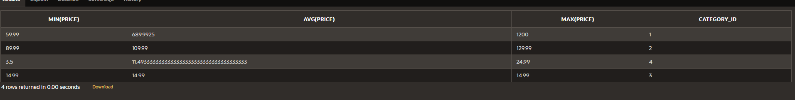

**Zadatak A3:** Prosečna prodajna vrednost po kategoriji samo za kategorije sa više od 3 proizvoda (HAVING)

select Categories.category_id,avg(item_price*quantity),count(distinct Products.prod_id)

from Products join Categories on (Products.category_id=Categories.category_id) join OrderItems on(OrderItems.prod_id=Products.prod_id)

group by Categories.category_id

having count(distinct Products.prod_id)>3



**Zadatak A4:** Spajanje sa podupitom – prosečna količina i cena po proizvodu sa filtriranjem “prodavnica” (store)

Opis: Ispišite proizvod zajedno sa prosečnom količinom po narudžbini i prosečnom

iznosu po jedinici, ali samo za proizvode iz kategorije koja ima više od 3 proizvoda.

**select Products.prod_id,avg(OrderItems.quantity),avg(OrderItems.item_price)**

**from Products join OrderItems on (OrderItems.prod_id=Products.prod_id)**

**where category_id in**

**(select category_id**

**from Products**

**group by category_id**

**having count(Products.prod_id)>3 )**

**group by Products.prod_id**

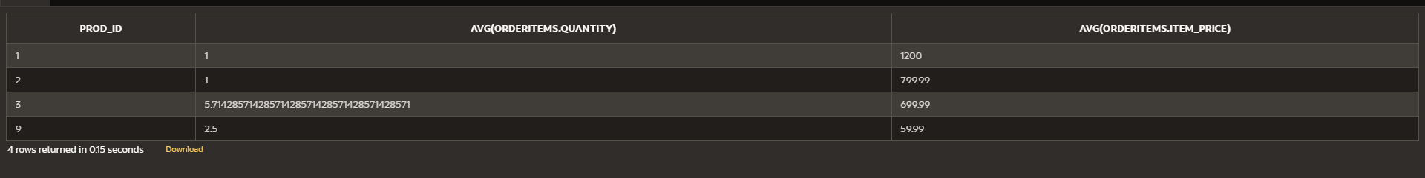

**Zadatak A5:** Vremenski trend ukupne prodaje po mesecu sa HAVING

Opis: Prikažite mesec i ukupnu prodaju (revenue) za svaki mesec, samo meseci gde ukupna prodaja

prelazi određeni iznos (npr. 1000).

select to_char(order_date,'MM'),sum(quantity*item_price)

from Orders join OrderItems on (OrderItems.order_id=Orders.order_id)

group by to_char(order_date,'MM')

having sum(quantity*item_price)>1000

