**TITLE:** Too hot to handle? Exploring environmental and stomatal drivers of leaf temperature in a native plant

**BACKGROUND:**

In plants, leaf temperature plays a critical role in regulating physiological processes, including photosynthesis, water use, and heat tolerance. Unlike animals, plants cannot move to escape heat; instead, they rely on physical and physiological traits to dissipate excess thermal energy. One key strategy is the regulation of water loss through stomata, microscopic pores on the leaf surface that open and close to balance gas exchange and evaporative cooling (Fig. 1A). However, this cooling comes at a cost: water loss can lead to desiccation stress, especially under high temperature or low humidity conditions (Fig 1B).

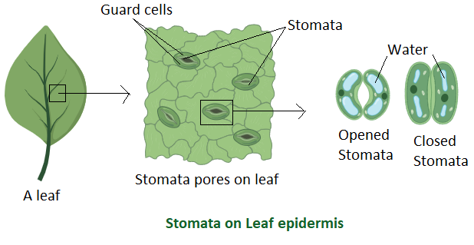

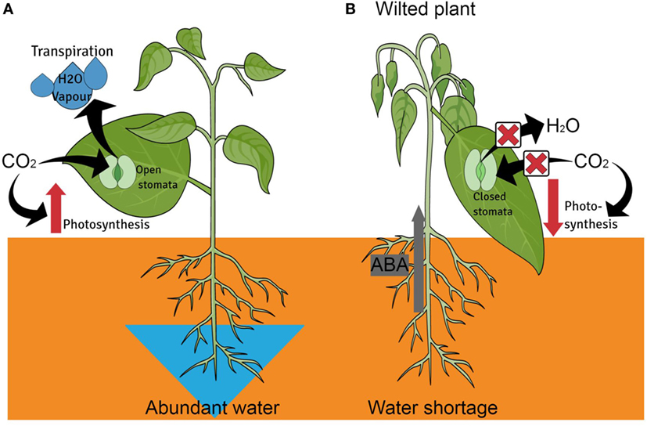

**Figure 1.** Location of stomata under leaves and how they regulate water (A). How desiccation stress can impact the physiological processes of leaves (B).

**B**

**A**

Although leaf temperature is often assumed to closely follow ambient air temperature, recent research shows that this is not always the case. Due to species-specific traits like leaf shape, size, and stomatal conductance, leaves can become significantly hotter than the surrounding air. When leaves exceed critical thermal thresholds, cellular damage can occur—reducing photosynthetic efficiency and potentially leading to fitness consequences. Understanding what environmental factors drive leaf temperature, and how plant traits like stomatal conductance mediate this response, is essential for predicting how plants will fare under future climate extremes.

In this study, you will use field measurements of environmental conditions (air temperature, humidity, irradiance, wind speed) and physiological data (leaf temperature and stomatal conductance) to investigate how plants thermoregulate. The dataset represents a subset of measurements from a single species monitored in the field. Stomatal conductance is expected to play a key role in maintaining cooler leaf temperatures through evaporative water loss, especially when solar irradiance and air temperature are high.

**METHODS:**

Data were collected from field-monitored leaves of a single plant species. Measurements were taken repeatedly on individual leaves exposed to varying microclimatic conditions. Environmental data recorded at each time point included air temperature (°C), relative humidity (%), solar irradiance (W/m²), and wind speed (m/s). Leaf-level traits measured include stomatal conductance (gs, in mmol/m²/s) and corresponding leaf temperature (°C). These values reflect how the plant responds physiologically to dynamic environmental conditions throughout the day.

Stomatal conductance was measured using a porometer, and leaf temperature was recorded concurrently with a leaf thermocouple. These data allow us to evaluate how stomatal behaviour interacts with environmental conditions to influence leaf temperature, and by extension, potential risk of overheating.

**DATASET DESCRIPTION:**

The dataset, Temperature_waterloss.csv, includes measurements and observations from field-monitored leaves of one plant species. Variables are:

* Latin_name: Latin name of the species
* Family: Plant family
* Leaf: Replicate ID (individual leaf monitored)
* Tair_(°C): Air temperature
* RH_(%): Relative humidity
* S_(W/m2): Solar irradiance
* u_(m/s): Wind speed
* gs_mmol/ms: Stomatal conductance
* Tl_(°C): Leaf temperature

**YOUR OBJECTIVE:**

Using the provided dataset (*Leaf_temperature_waterloss.csv*) and its accompanying metadata file (*Meta_Data_ColumnNames.csv*), students will address the following three specific questions. Each question corresponds to creating one or more plots. Students may need to transform or subset the original data to address these questions clearly. Students should aim to clearly visualise relationships through appropriate graphs and conduct statistical analyses to answer these questions.

Question 1: How does leaf temperature vary with environmental conditions?

Question 2: Does stomatal conductance help regulate leaf temperature?

Question 3: What combination of factors best explains variation in leaf temperature?

Students should aim to clearly visualise relationships through appropriate graphs to answer these questions.