kristoffer wild example

Libraries
[1] 4

Example: Filtering out extreme distance outliers (histogram)
We’ll compare flight distances before/after removing unrealistic values (> 5000 miles).
library(dplyr)
library(nycflights13)
# Put two plots side-by-side
par(mfrow = c(1, 2))
## ---- Before cleaning ----
hist(
flights$distance,
breaks = seq(0, 10000, by = 100), # consistent binning
main = "Before Cleaning",
xlab = "Distance (miles)",
xlim = c(0, 10000) # shows long right tail
)
## ---- After cleaning ----
filtered <- flights %>%
filter(distance < 5000) %>%
pull(distance)
hist(
filtered,
breaks = seq(0, 10000, by = 100), # same bins for fair comparison
main = "After Cleaning",
xlab = "Distance (miles)",
xlim = c(0, 10000)
)
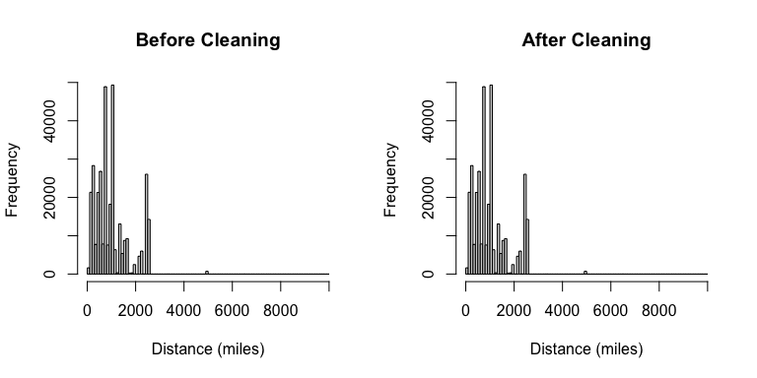
# Reset plotting layout
par(mfrow = c(1, 1))

