1| Introduction



Figure 1: Theoretical expectations on the relationship of ROS, ATP, and respiration relate across temperature. Panel A shows two expectations on how repair can occur as temperatures get warmer. The null hypothesis is that there is no relationship between repair and temperature and the alternative hypothesis suggest that repair increases linearly with ross until a temperature point where it rapidly declines. Here individual damage costs from ROSS would outstrip repairs. Panel B shows the relationship of respiration (O2) and ATP and how these traits vary across temperature.

2| Methods

*2.1 Empirical data and parameter estimation*

*2.2. Egg simulations within a DEB framework*

Dynamic energy budget (DEB) theory (Koojiman, 1993) was used to help predict how maintenance costs drive embryonic and adult life history traits. In brief, the Dynamic Energy Budget theory offers a unified quantitative framework for dynamically explaining how metabolism (both energy and mass budgets) operates across all living organisms at the individual level. This theory is grounded in specific assumptions regarding how biomass is partitioned into three types, reserve, structure and reproduction buffer. During embryonic stages embryos do not feed or allocate energy to reproduction buffer, but rather use high initial reserves for growth and maintenance until they are hatched. Here we tested

3| Results

*3.1 Empirical data*

Between 2019-2021 adult gravid *Lampropholis delicata* were housed until eggs were laid. Eggs were then pseudo-randomly (to ensure equal sample sizes) assigned to both incubation treatments ‘cold’ (23°C; n = 205) or ‘hot’ (28°C s.d. ± 3.0; *See Table 1*).  Egg incubation temperatures were chosen to mimic conditions experienced at extremes of natural nest temperatures in nature while also showing natural thermal fluctuations throughout the day. To capture variation in egg mass yolk was removed on a subset of eggs (yolk removal: n = 218; control: n = 186). Yolk removal treatments followed Sinervo et al., with 15–20% of the total egg mass being removed via a sterilized syringe. Control treatments were punctured with the syringe without any yolk removal.

Table 1. Mass and developmental times by incubation temperature treatment for each species.



3.2 *Null model: Can DEB model predications accurately predict developmental time and offspring body mass under different environmental scenarios?*

23: incubation time 46days; wet mass 0.104g

28: incubation time 32days; wet mass 0.140g

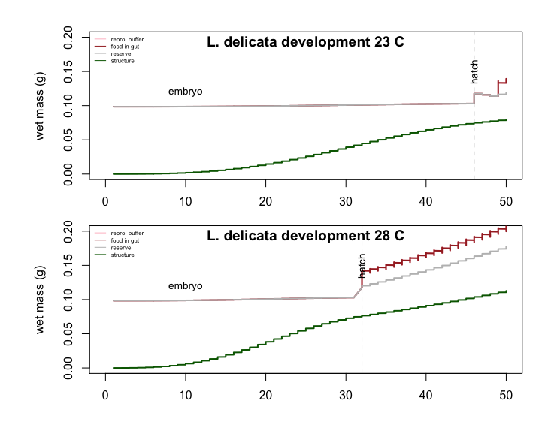

3.3 *Structure costs model under varying temperature conditions: Does decreasing structural costs (EG) for cool incubated individuals and increasing structural costs for warm incubated individuals accurately predict developmental time and offspring body mass?*

Simulations were run where structural costs (EG) from our null model were changed (10%, 20%, 30%*)* depending on the incubation temperature treatment to test theoretical expectations (Figure 1). In this simulation cold incubation treatments decreased whereas warm incubation treatments increased.Decreasing the cost of structure (EG) by 10% for ‘cold’ incubation treatment caused incubation time to become 48d and wet mass of hatching to become 0.118g, whereas increasing EG by 10% in the warm incubation treatment caused incubation time to become 31d and wet mass of hatching to become 0.124g (Figure 2A). When decreasing the cost of structure (EG) by 20% for ‘cold’ incubation treatment caused incubation time to become 49d and wet mass of hatching to become 0.116g, whereas increasing EG by 20% in the warm incubation treatment caused incubation time to become 30d and wet mass of hatching to become 0.108g (Figure 2B). These values were remarkably close to empirical data (Table 1). Finally decreasing the cost of structure (EG) by 30% for ‘cold’ incubation treatment caused incubation time to become 51d and wet mass of hatching to become 0.105g, whereas increasing EG by 30% in the warm incubation treatment caused incubation time to become 29d and wet mass of hatching to become 0.131g (Figure 3B).

