Kris Kleiner
April 17, 2026
Module 4 – MySQL Install
Initial MySQL Connection
I successfully installed MySQL and connected to the database using the root account through the terminal.
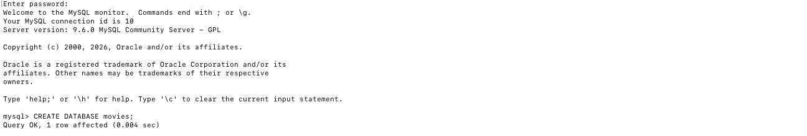
Create Database
I created a database named movies using the CREATE DATABASE command. I verified that the database was created successfully by using the SHOW DATABASES command.
CREATE DATABASE movies;
SHOW DATABASES;
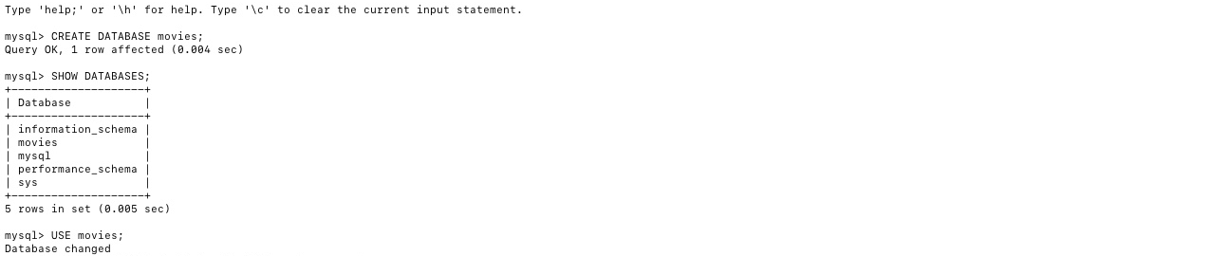
MySQL Function Experiments
Function 1: UPPER()
The UPPER() function is used to convert text to uppercase. This is useful when formatting and standardizing text values.
SELECT UPPER('kris kleiner') AS Name_Uppercase;
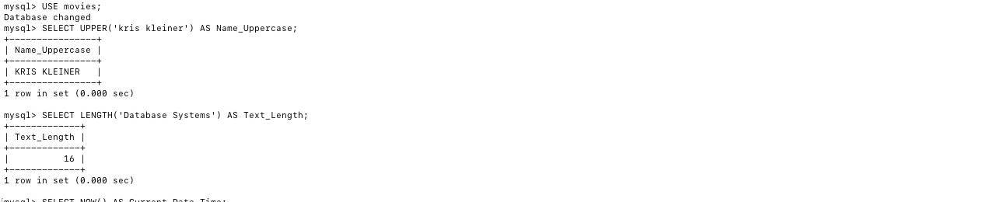
Function 2: LENGTH()
The LENGTH() function is used to determine the number of characters in a string. This can be useful for validating and analyzing text data.
SELECT LENGTH('Database Systems') AS Text_Length;
Function 3: NOW()
The NOW() function returns the current date and time. This is useful for timestamps and tracking when data is created.
SELECT NOW() AS Current_Date_Time;
