Kris Kleiner
CSD-310 Module 2 Assignment: Data Models
Entity Relationship Diagram
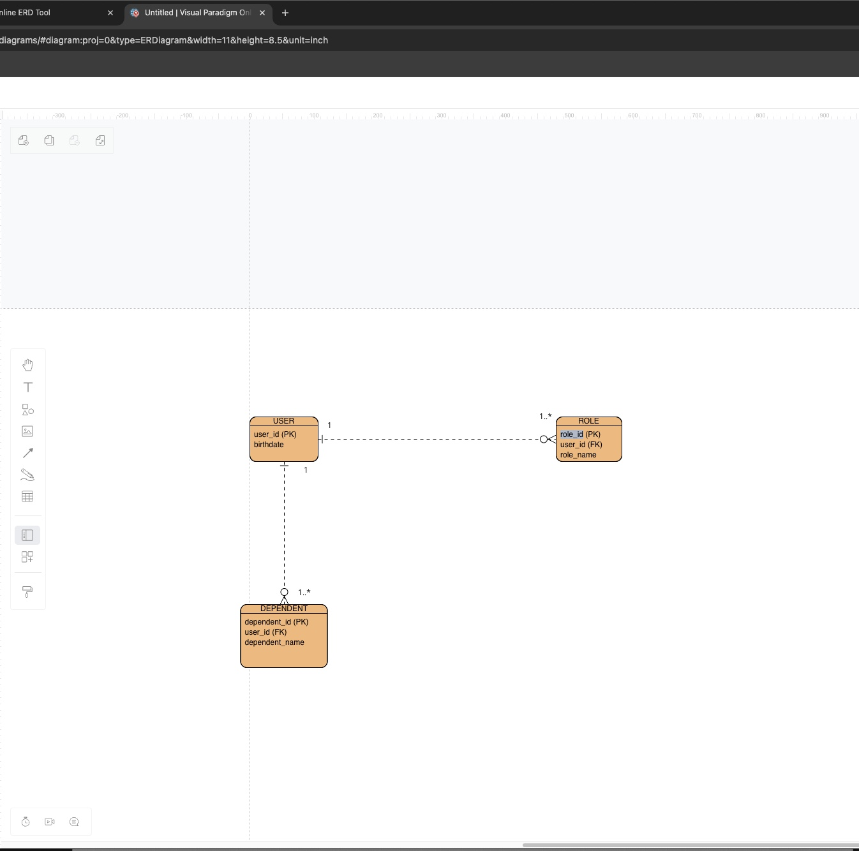
NoSQL Data Structure
