Name: Kris Kleiner
Date: April 26, 2026
Assignment: Module 6.2

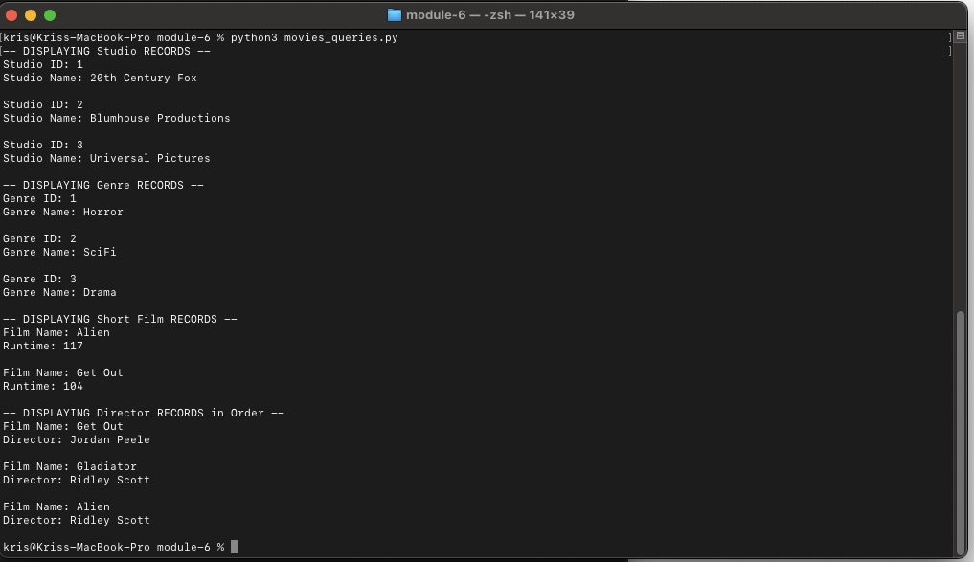

https://github.com/kris0541/csd-310

