Name: Kris Kleiner
Date: May 17, 2026
Assignment: 10.2

Purpose
The purpose of this assignment is to create a graphical To-Do List application using Python and Tkinter. The program demonstrates how to build a GUI window, add tasks, display tasks in a scrolling list, delete tasks with the right mouse button, and close the application using a File -> Exit menu option.

Tutorial Program Screenshot
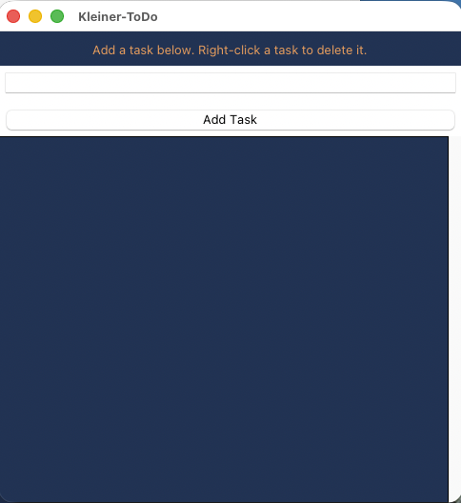

Modified Program Description
The modified program changes the window title to Kleiner-ToDo, uses complementary colors for the interface, provides instructions for deleting tasks, changes task deletion to a right-click action, and adds a File -> Exit menu item so the user can close the program correctly.

Modified Program Screenshot With Tasks Added
This screenshot shows the completed Kleiner-ToDo program after adding several tasks.
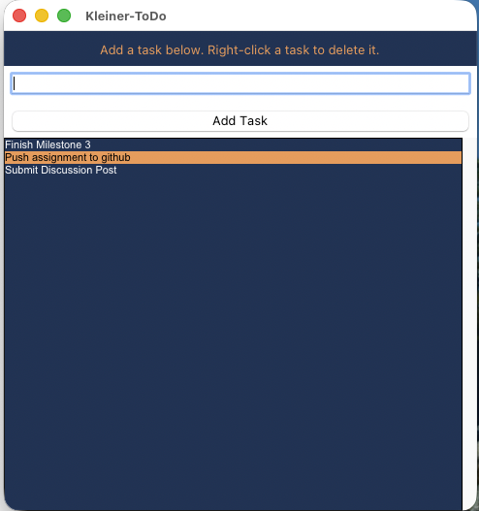

Modified Program Screenshot After Deleting a Task
This screenshot shows the modified program after right-clicking one task to delete it from the list.
