Name: Kris Kleiner
Date: May 3, 2026
Assignment: Module 8.2

Flowchart
The flowchart below models the program logic for loading, printing, updating, and saving the student JSON file.
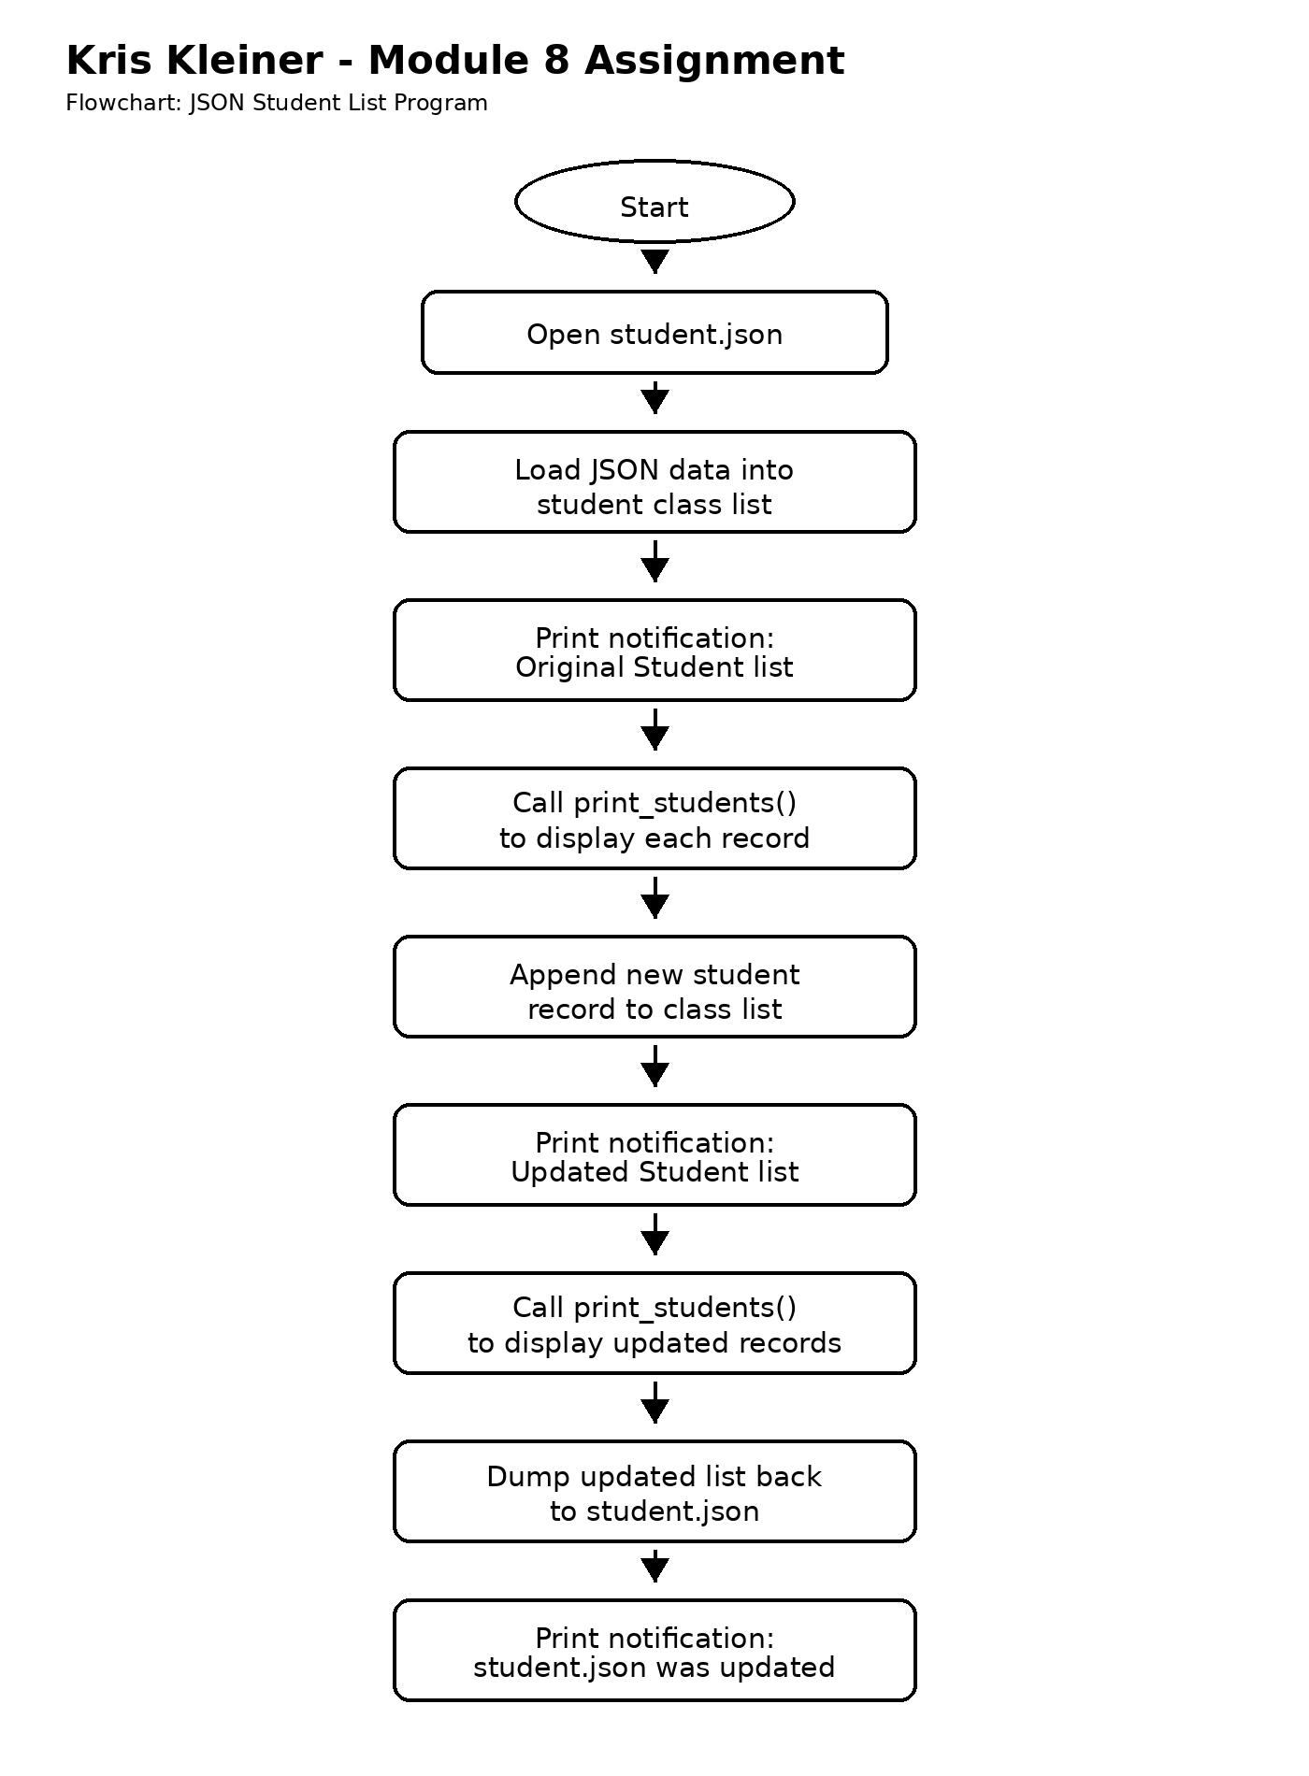

Program Output Screenshot
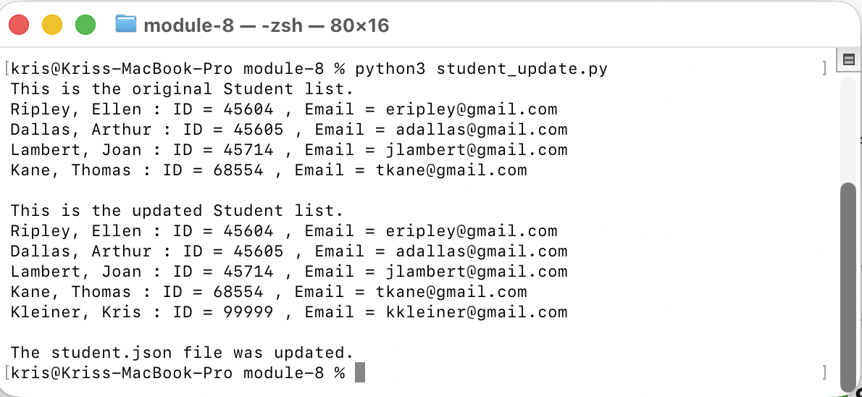

JSON File Changed Notification Screenshot
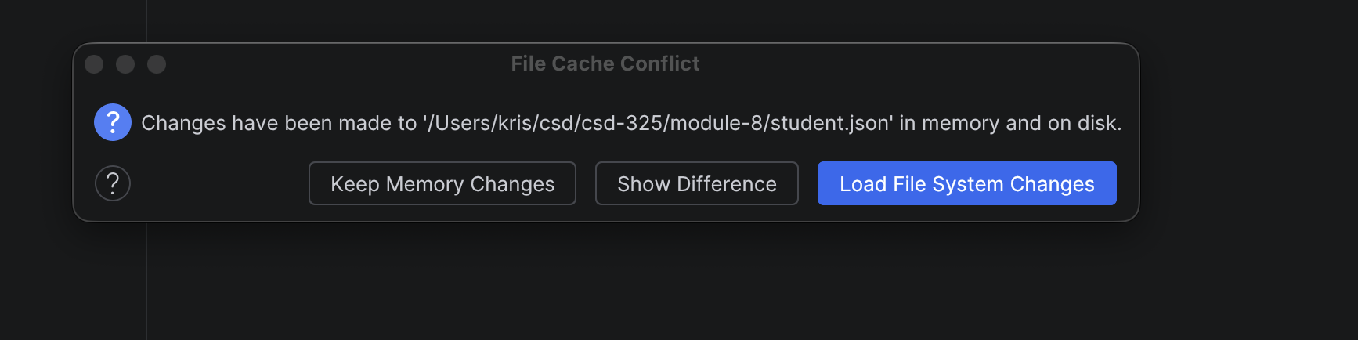

Updated student.json Contents
After running the program, open student.json, copy the updated contents, and paste them below.

[

{

"F_Name": "Ellen",

"L_Name": "Ripley",

"Student_ID": 45604,

"Email": "eripley@gmail.com"

},

{

"F_Name": "Arthur",

"L_Name": "Dallas",

"Student_ID": 45605,

"Email": "adallas@gmail.com"

},

{

"F_Name": "Joan",

"L_Name": "Lambert",

"Student_ID": 45714,

"Email": "jlambert@gmail.com"

},

{

"F_Name": "Thomas",

"L_Name": "Kane",

"Student_ID": 68554,

"Email": "tkane@gmail.com"

},

{

"F_Name": "Kris",

"L_Name": "Kleiner",

"Student_ID": 99999,

"Email": "kkleiner@gmail.com"

}

]

Conclusion
This assignment demonstrated how to use Python to load data from a JSON file, display the original records, append a new student record, write the updated data back to the JSON file, and confirm the updated results.

