Name: Kris Kleiner
Date: May 10, 2026
Assignment: Module 9.2

Introduction
This assignment demonstrates how to connect to APIs using Python. The program tests API connections, retrieves JSON data, prints raw responses, and formats JSON output for readability.

Google Connection Test
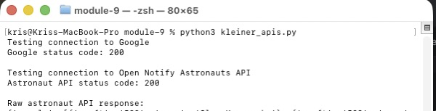

Raw Astronaut API Response
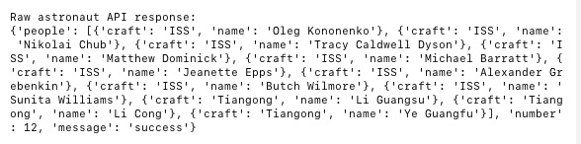

Formatted Astronaut API Response
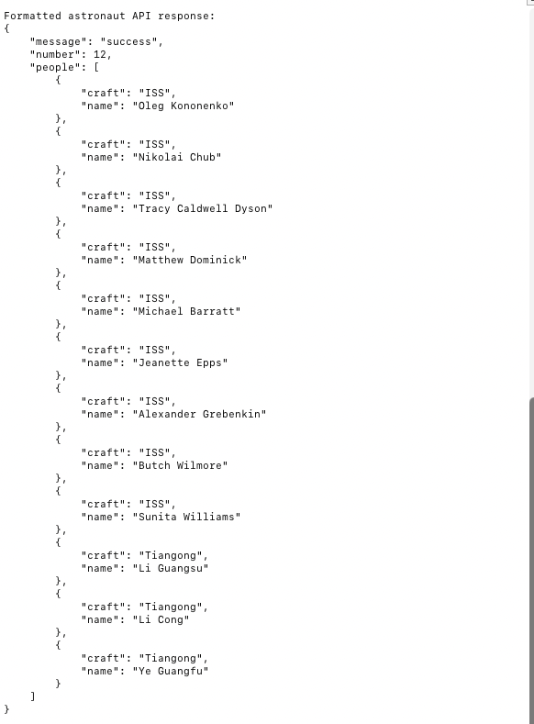

Dog API Connection and Raw Response
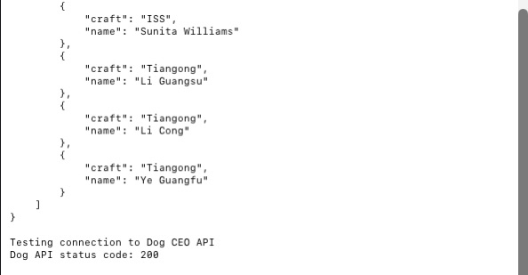

Dog API Formatted Response
