Kris Kleiner
Assignment: GitHub Repository Setup
March 29, 2026

Repository Link:
https://github.com/kris0541/csd-325
Screenshot of Local Directory:
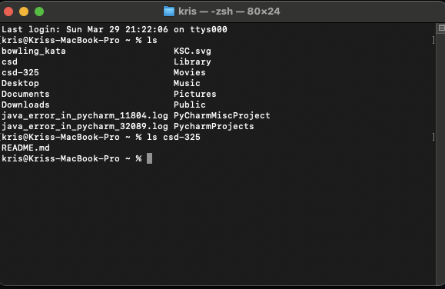
Screenshot of GitHub Repository:
