Name: Kris Kleiner
Date: May 3, 2026
Assignment: Module 7.2

Introduction
This assignment demonstrates how to create a Python function and validate it using unit tests. The process includes modifying the function to introduce required and optional parameters and observing how those changes impact test results.

Screenshot 1: Initial Function Output
This screenshot shows the initial version of the city_country function that uses only the city and country parameters.
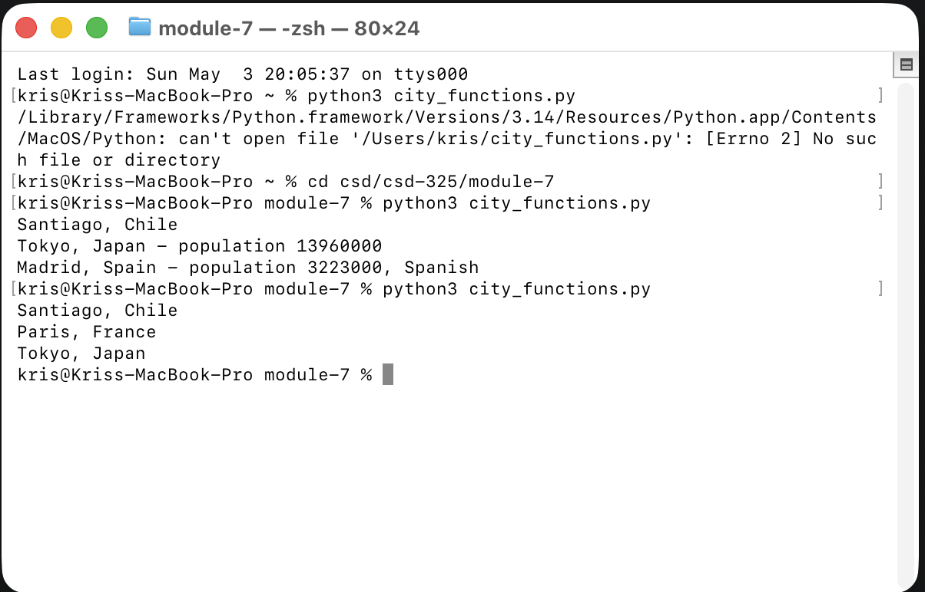

Screenshot 2: Initial Unit Test Passing
This screenshot shows the unit test successfully passing with the original function
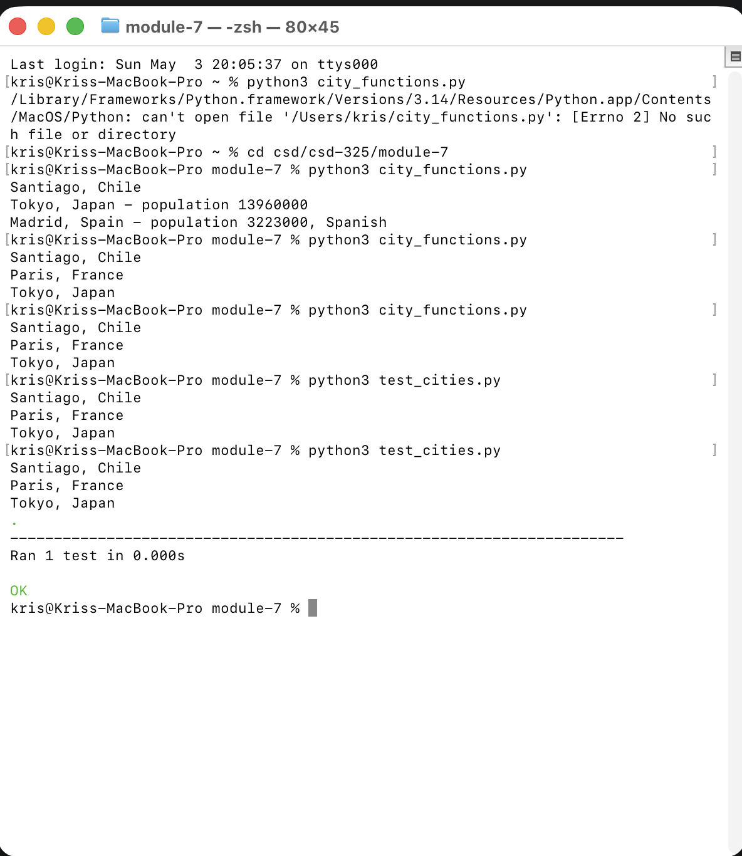

Screenshot 3: Test Failure (Population Required)
This screenshot shows the unit test failing after modifying the function to require a population parameter.
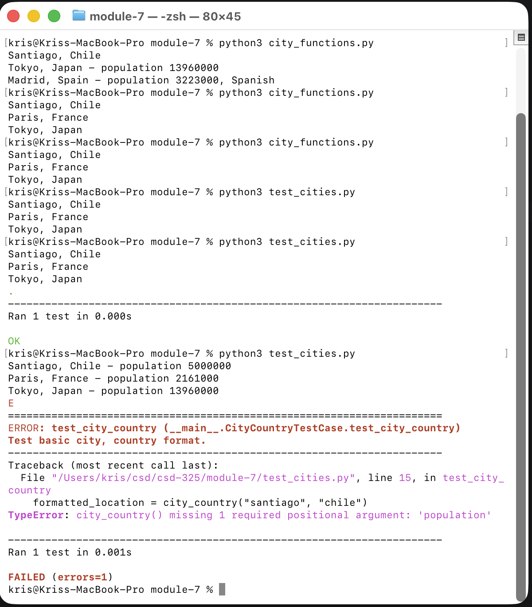

Screenshot 4: Test Passing (Population Optional)
This screenshot shows the unit test passing again after making the population parameter optional.
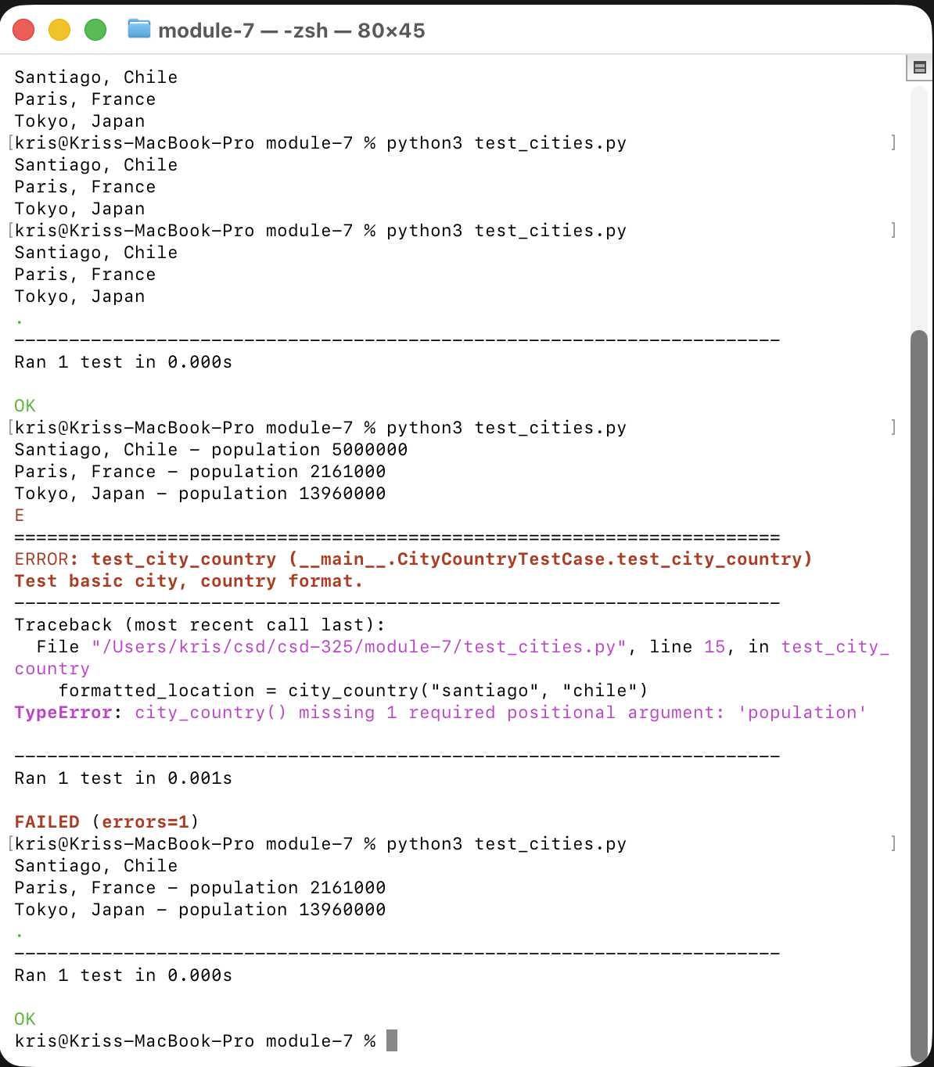

Screenshot 5: Test Failure (Language Required)
This screenshot shows the unit test failing after modifying the function to require a language parameter.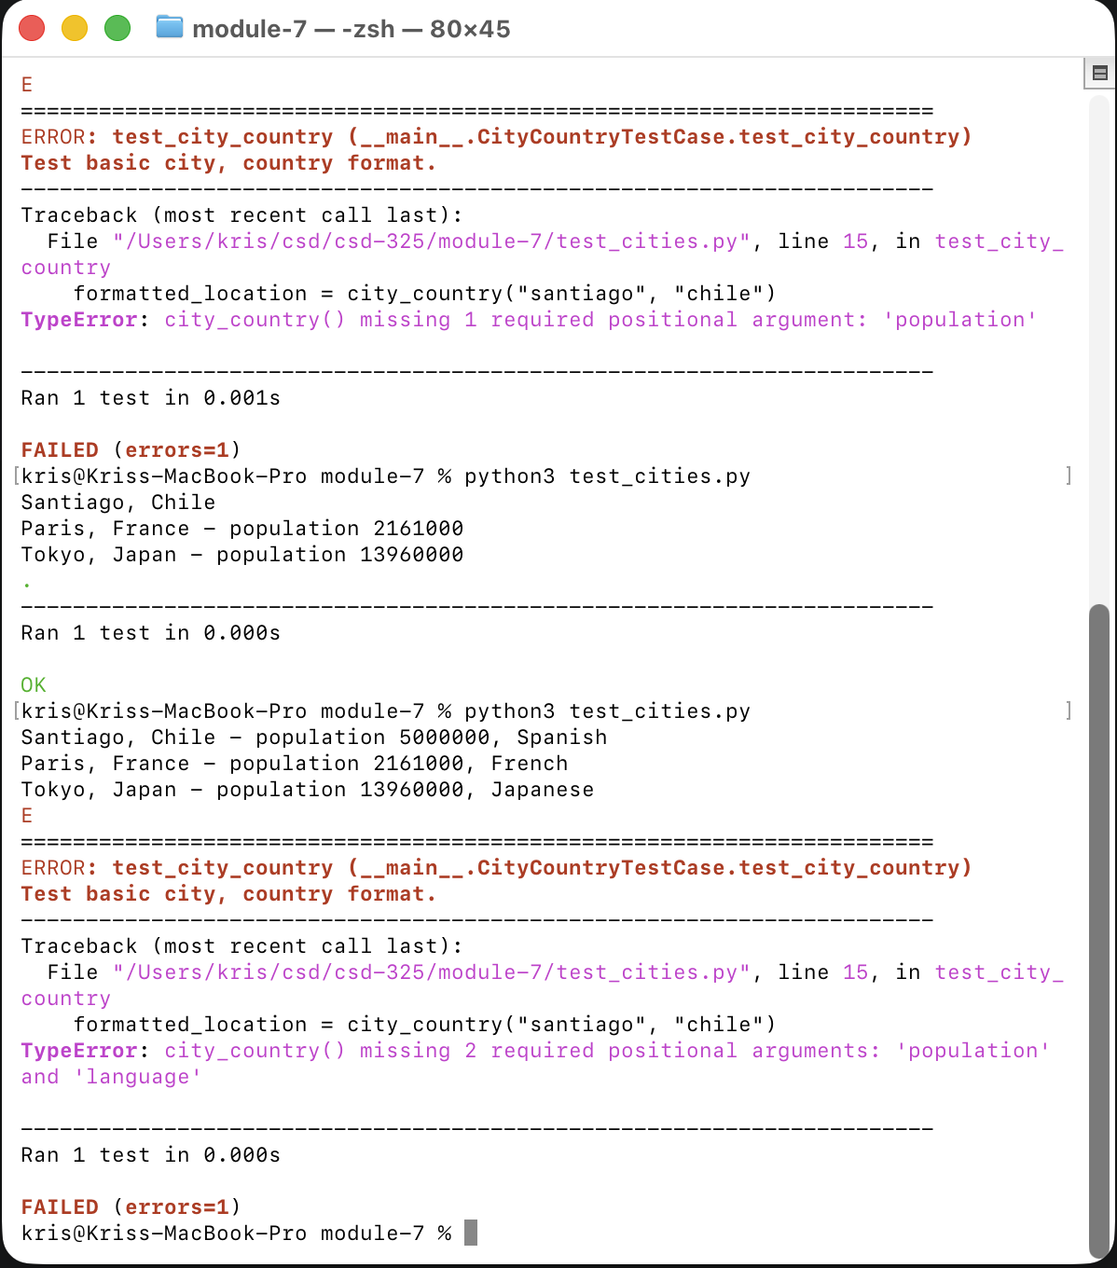

Screenshot 6: Test Passing (Language Optional)
This screenshot shows the unit test passing again after making the language parameter optional.
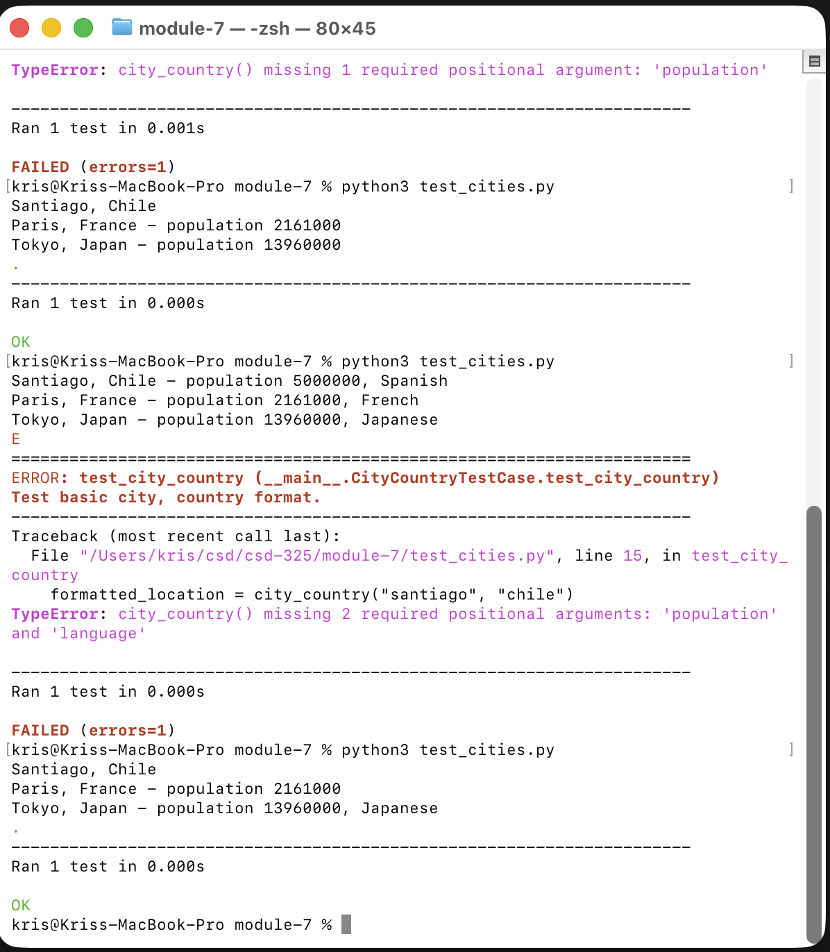

Screenshot 7: Final Function Output
This screenshot shows the final version of the function demonstrating all variations.
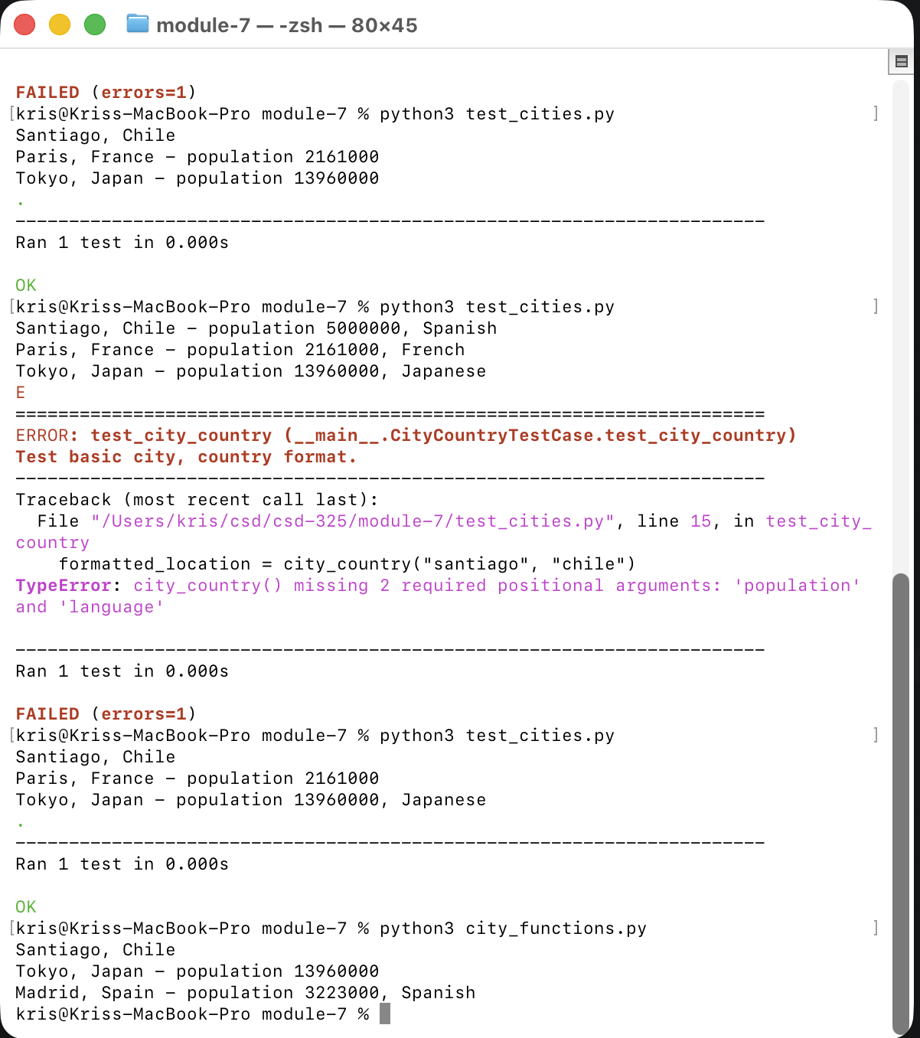

Conclusion
This assignment demonstrated how unit testing helps validate functionality and catch errors when changes are made to a program. By making parameters required and optional, it became clear how small changes can impact program behavior and test results. Unit tests provide a reliable way to ensure code continues to work as expected during development.

