Program Modifications
The program was modified to include a user menu that allows selection between viewing high temperatures, low temperatures, or exiting the program. A loop was added so the program continues running until the user chooses to exit. A new function was created to display low temperatures with a blue line, while the original high-temperature graph remains red. The sys module was used to exit the program cleanly when the user selects the exit option.
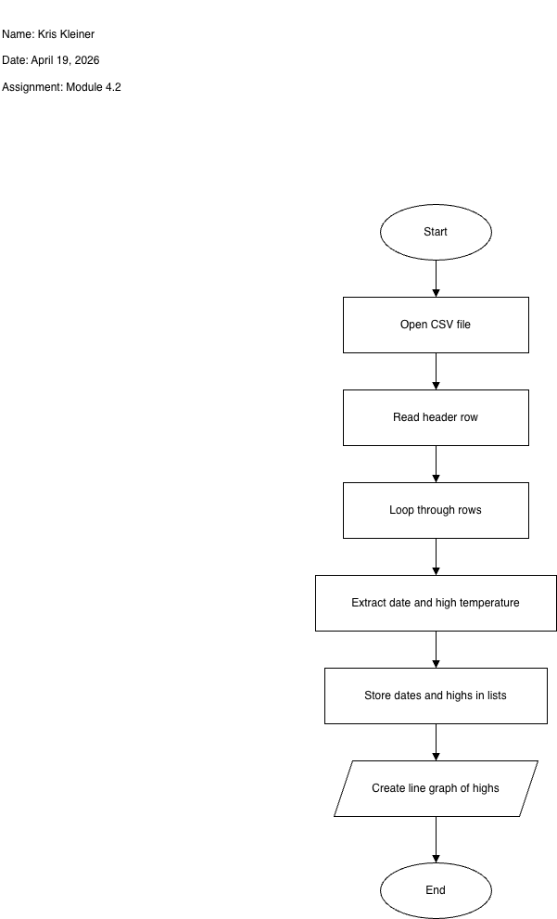anly when the user selects the exit option.

