5ENT1140 ARTIFICIAL INTELLIGENCE PRINCIPLES · MINI PROJECT REPORT
Backgammon AI
An Expectiminimax opponent for a game of chance
Name | Krishna Mahajan
Student ID | 106wucww
Module | 5ENT1140 Artificial Intelligence Principles
Institution | University of Hertfordshire (delivered at PSB Academy, Singapore)
Submission | Mini Project: published game, presentation, report and code
Playable game | https://kris072008.itch.io/backgammon-ai
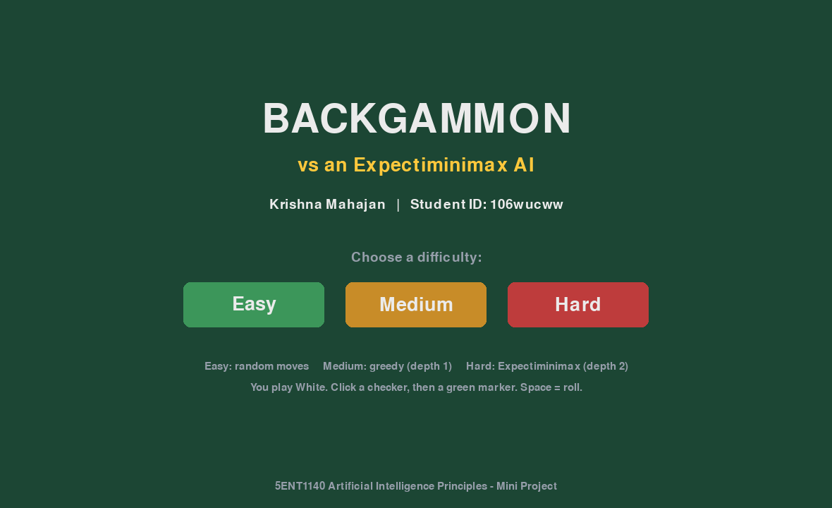
Title screen of the published game

1. Introduction
The aim of this project was to implement a two-player game that involves chance, in which the computer evaluates every possible consequence of each move and chooses the one that is closest to victory. I chose backgammon. It is a genuinely stochastic game: before every turn the dice decide which moves are even possible, so a player cannot plan against a single fixed future. This makes ordinary Minimax unsuitable and calls for Expectiminimax, which extends Minimax with chance nodes that average outcomes by their probability (Russell and Norvig, 2021). Backgammon is also the classic benchmark for this family of methods, most famously in Tesauro's TD-Gammon (1995).
The finished program implements the full rules: 15 checkers each on 24 points, doubles played four times, hitting single checkers (blots) onto the bar, compulsory re-entry from the bar, bearing off, and the rules that a player must use as many dice as possible and must use the larger die when only one can be played. Three computer opponents are provided: Easy (random legal moves), Medium (greedy, one move of look-ahead) and Hard (depth-2 Expectiminimax). The game has a graphical interface written with Pygame and is published online, playable in any browser, at kris072008.itch.io/backgammon-ai. The report also traces one real decision by the Hard AI step by step, and compares the three methods over more than 550 AI-versus-AI games.

2. Design

2.1 System architecture
The code is split into small modules so that the game rules, the AI and the interface can be developed and tested independently. The board is stored as a list of 24 integers: a positive number is that many White checkers, a negative number is Black checkers. Two small dictionaries hold the checkers on the bar and those borne off.
File | Responsibility
backgammon.py | Rules engine: board state, dice, legal-move generation, applying moves, win detection, terminal test mode.
ai.py | Evaluation function, Expectiminimax search, the three difficulty levels and a benchmark mode.
gui.py | Pygame interface: menu, board drawing, click-to-move, dice animation, AI move animation, game-over screen.
main.py | Entry point; runs the asynchronous game loop required for the browser version (pygbag).
experiments.py | AI-vs-AI tournaments; produces the results table and charts used in Section 3.5.

2.2 Interface design (wireframes)
Figure 1 shows the two screens. The title screen displays the student details required by the brief and lets the player choose a difficulty. On the game screen the board is drawn from White's point of view; legal sources are ringed in gold and, once a checker is selected, its legal destinations are shown as green markers, so the player can never make an illegal move. The side panel holds the dice, the Roll, Undo and Hint buttons, pip counts, an AI analysis box and a message log.
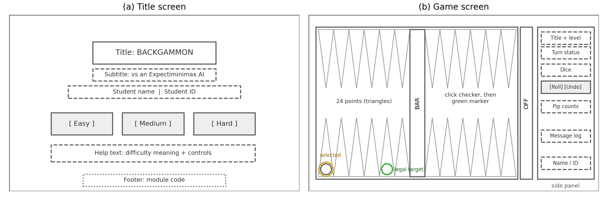
Figure 1. Wireframes of (a) the title screen and (b) the game screen.

2.3 AI design: Expectiminimax
The search tree has three kinds of node (Figure 2). At a MAX node the AI chooses the turn with the highest value; at a MIN node the opponent is assumed to choose the turn that is worst for the AI; and at a CHANCE node the value is the probability-weighted average over the 21 distinct dice rolls (doubles have probability 1/36, other rolls 2/36):
value(chance node) = Σ_{r} P(r) × value(best decision after roll r)
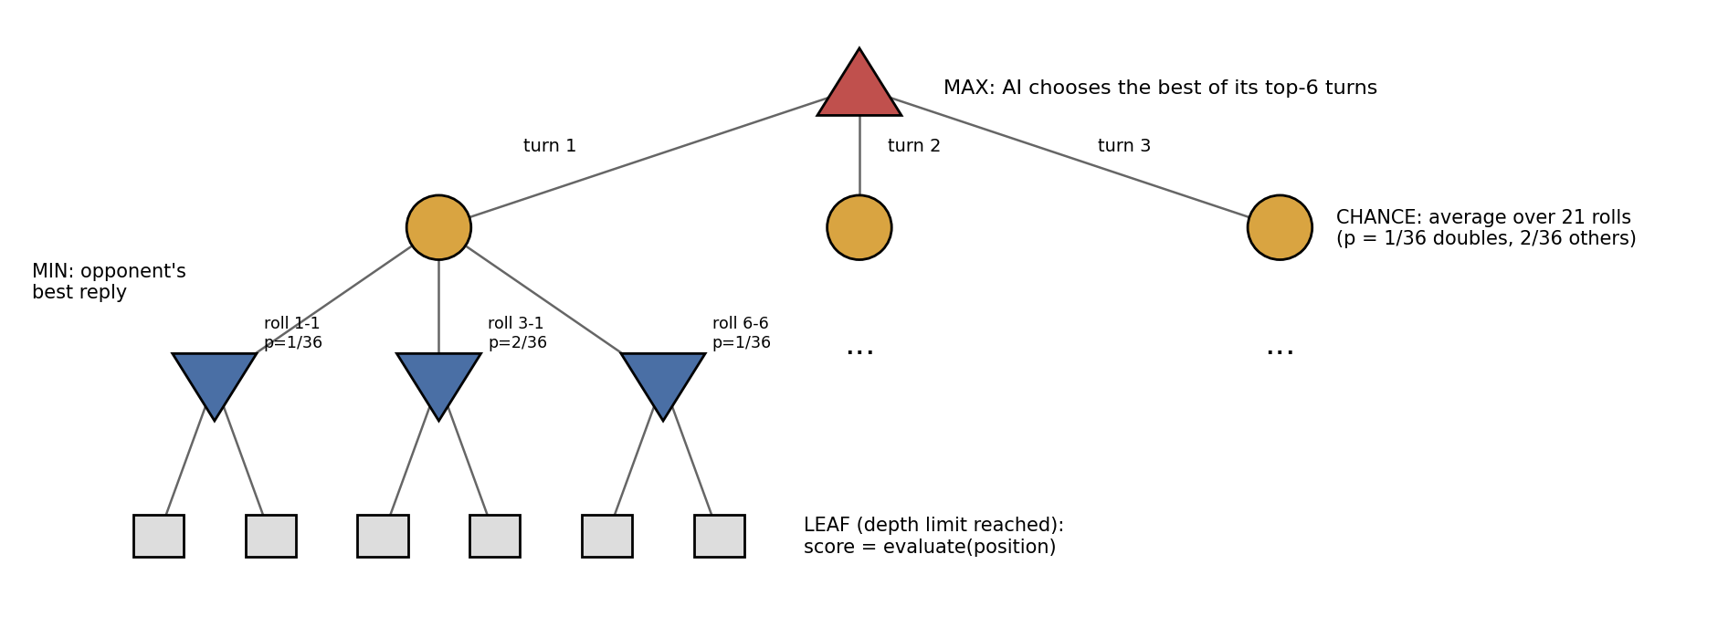
Figure 2. Depth-2 Expectiminimax tree used by the Hard AI.
Because a single roll can allow dozens of legal turns, the full tree grows very quickly. Two design decisions keep it fast: search stops at a depth limit, where positions are scored by a hand-written evaluation function, and a beam keeps only the six most promising turns (ranked by the evaluation function) at each decision. The evaluation function combines the features below; all weights are constants at the top of ai.py so they can be tuned.
Feature | Weight | Reason
Pip-count lead (race) | +1.0 per pip | Being ahead in the race is the basic measure of winning chances.
Opponent checkers on the bar | +8.0 each | Hitting costs the opponent time and tempo.
Checkers borne off | +3.0 each | Directly progresses toward victory.
Made point (2+ checkers) | +2.0 (+3.0 in home) | Safe points block the opponent; home points trap hit checkers.
Blot within reach of opponent | −4.0 each | Exposed checkers risk being hit.
Blot out of reach | −1.0 each | Small penalty for loose structure.
Win / loss | ±10000 | A finished game outweighs every other feature.

3. Implementation

3.1 Rules engine and move generation
get_single_moves() lists every move a single die allows, handling bar entry and the bearing-off rules. get_legal_turns() then explores every order in which the dice can be used recursively, keeps only turns that use the maximum number of dice, applies the larger-die rule, and removes turns that lead to identical positions. The rules engine was tested by running hundreds of complete random games, none of which crashed or stalled.

3.2 Interface and web publishing
The desktop version runs the AI in a background thread so the window never freezes. Browsers cannot run threads, so in the web build the search runs directly after an 'AI is thinking' frame has been drawn, and the main loop is asynchronous (await asyncio.sleep(0) each frame). The game was packaged with pygbag, which compiles Python to WebAssembly, and uploaded to itch.io.
Several features make the AI's reasoning visible to the player (Figure 3). After each Medium or Hard turn, the side panel lists the AI's top three moves with their scores, how many turns it searched and how long it took; while the Hard AI is searching, the panel names the MAX, CHANCE and MIN steps it is working through. A bar above the board shows the estimated chance of each side winning. It passes the evaluation function through a logistic curve whose three constants were fitted on 18,764 positions from 300 simulated games; positions rated 70-80% were actually won 76% of the time. After each of the player's turns, the Hard AI's search grades the move from Best to Blunder by how many evaluation points it gave up, and the game-over screen summarises the grades. A Hint button (or H) runs the Hard AI's search on the player's own roll and draws the suggested move as numbered arrows. The panel re-runs the same search as ai.py, and it was checked to pick exactly the same move in 149 test positions. Checkers slide between points, hit checkers fly to the bar, and dice, move, hit, bear-off, win and lose sounds are generated in code, so no audio files are needed.
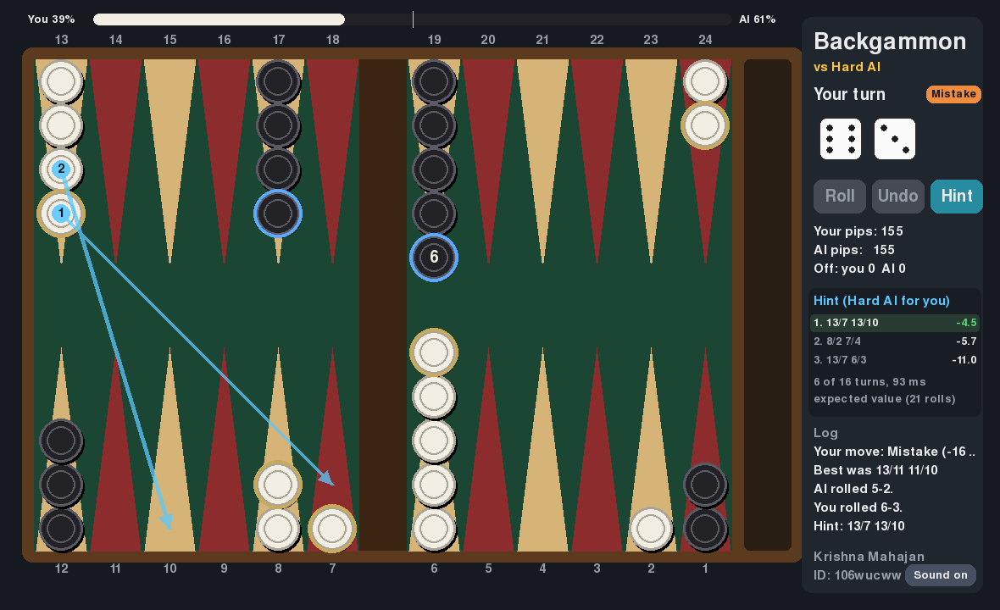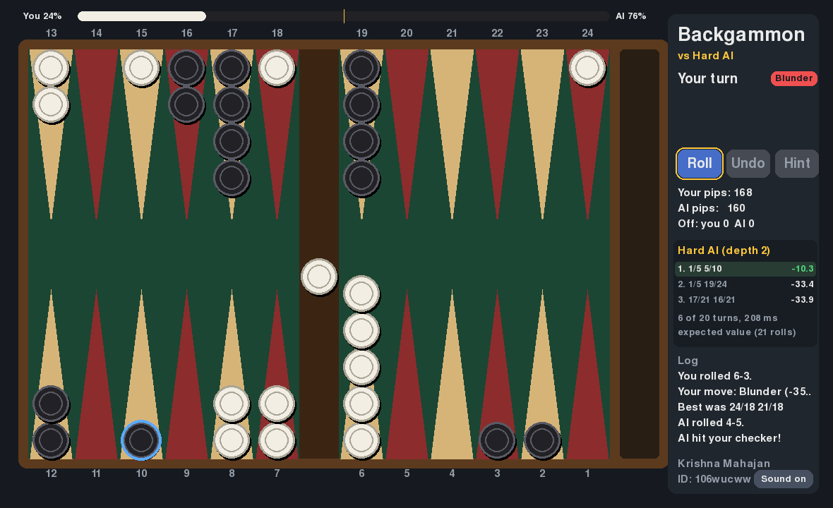
Figure 3. The GUI during play. Left: a Hint, with the Hard AI's suggested move drawn as numbered arrows and its top three moves in the side panel; the bar at the top shows the estimated win chance and the badge rates the previous move. Right: after an AI turn, its last move ringed in blue and its analysis in the panel.

3.3 Sample input and output: terminal mode
The terminal test mode shows the engine's input and output most clearly. Below, White (the human) rolls 3-1 at the start; the program lists all 16 legal turns, the player enters turn 5 (the standard opening 8/5 6/5), and the Hard AI replies to a 6-4 by making a new point in its home board rather than leaving blots.
13 14 15 16 17 18 19 20 21 22 23 24
W5 . . . B3 . B5 . . . . W2
B5 . . . W3 . W5 . . . . B2
12 11 10 9 8 7 6 5 4 3 2 1

White rolled [3, 1]
0: 6/3 3/2 1: 6/3 6/5 2: 6/3 8/7
3: 6/3 24/23 4: 8/5 5/4 5: 8/5 6/5
... (16 legal turns in total)
Choose a turn number: 5
Black rolled [6, 4]
Computer plays: 17/23 19/23

13 14 15 16 17 18 19 20 21 22 23 24
W5 . . . B2 . B4 . . . B2 W2
B5 . . . W2 . W4 W2 . . . B2
12 11 10 9 8 7 6 5 4 3 2 1

3.4 Inside one decision: the opening 5-3
Input: the standard starting position; the Hard AI plays White and rolls 5-3. Processing: the AI generates its legal turns, keeps the six best by immediate score, and for each one searches all 21 opponent rolls and the opponent's best reply. Table 1 shows the real values returned by hard_ai().
Candidate turn | Immediate score | Expected value (21 rolls)
8/3 6/3 (chosen) | 24 | 15.83
13/8 13/10 | 15 | 4.19
13/8 6/3 | 15 | −1.83
13/8 8/5 | 15 | −3.17
13/8 24/21 | 9 | −7.72
8/3 13/10 | 11 | −8.47
Table 1. The six candidate turns searched for an opening 5-3.
Opponent roll (P) | 8/3 6/3 | 13/8 13/10 | 13/8 24/21
1-2 (2/36) | 21 | 12 | −2
3-3 (1/36) | 12 | −16 | −16
6-6 (1/36) | 0 | −9 | −20
Table 2. Value after the opponent's best reply (MIN node) for three of the 21 rolls.
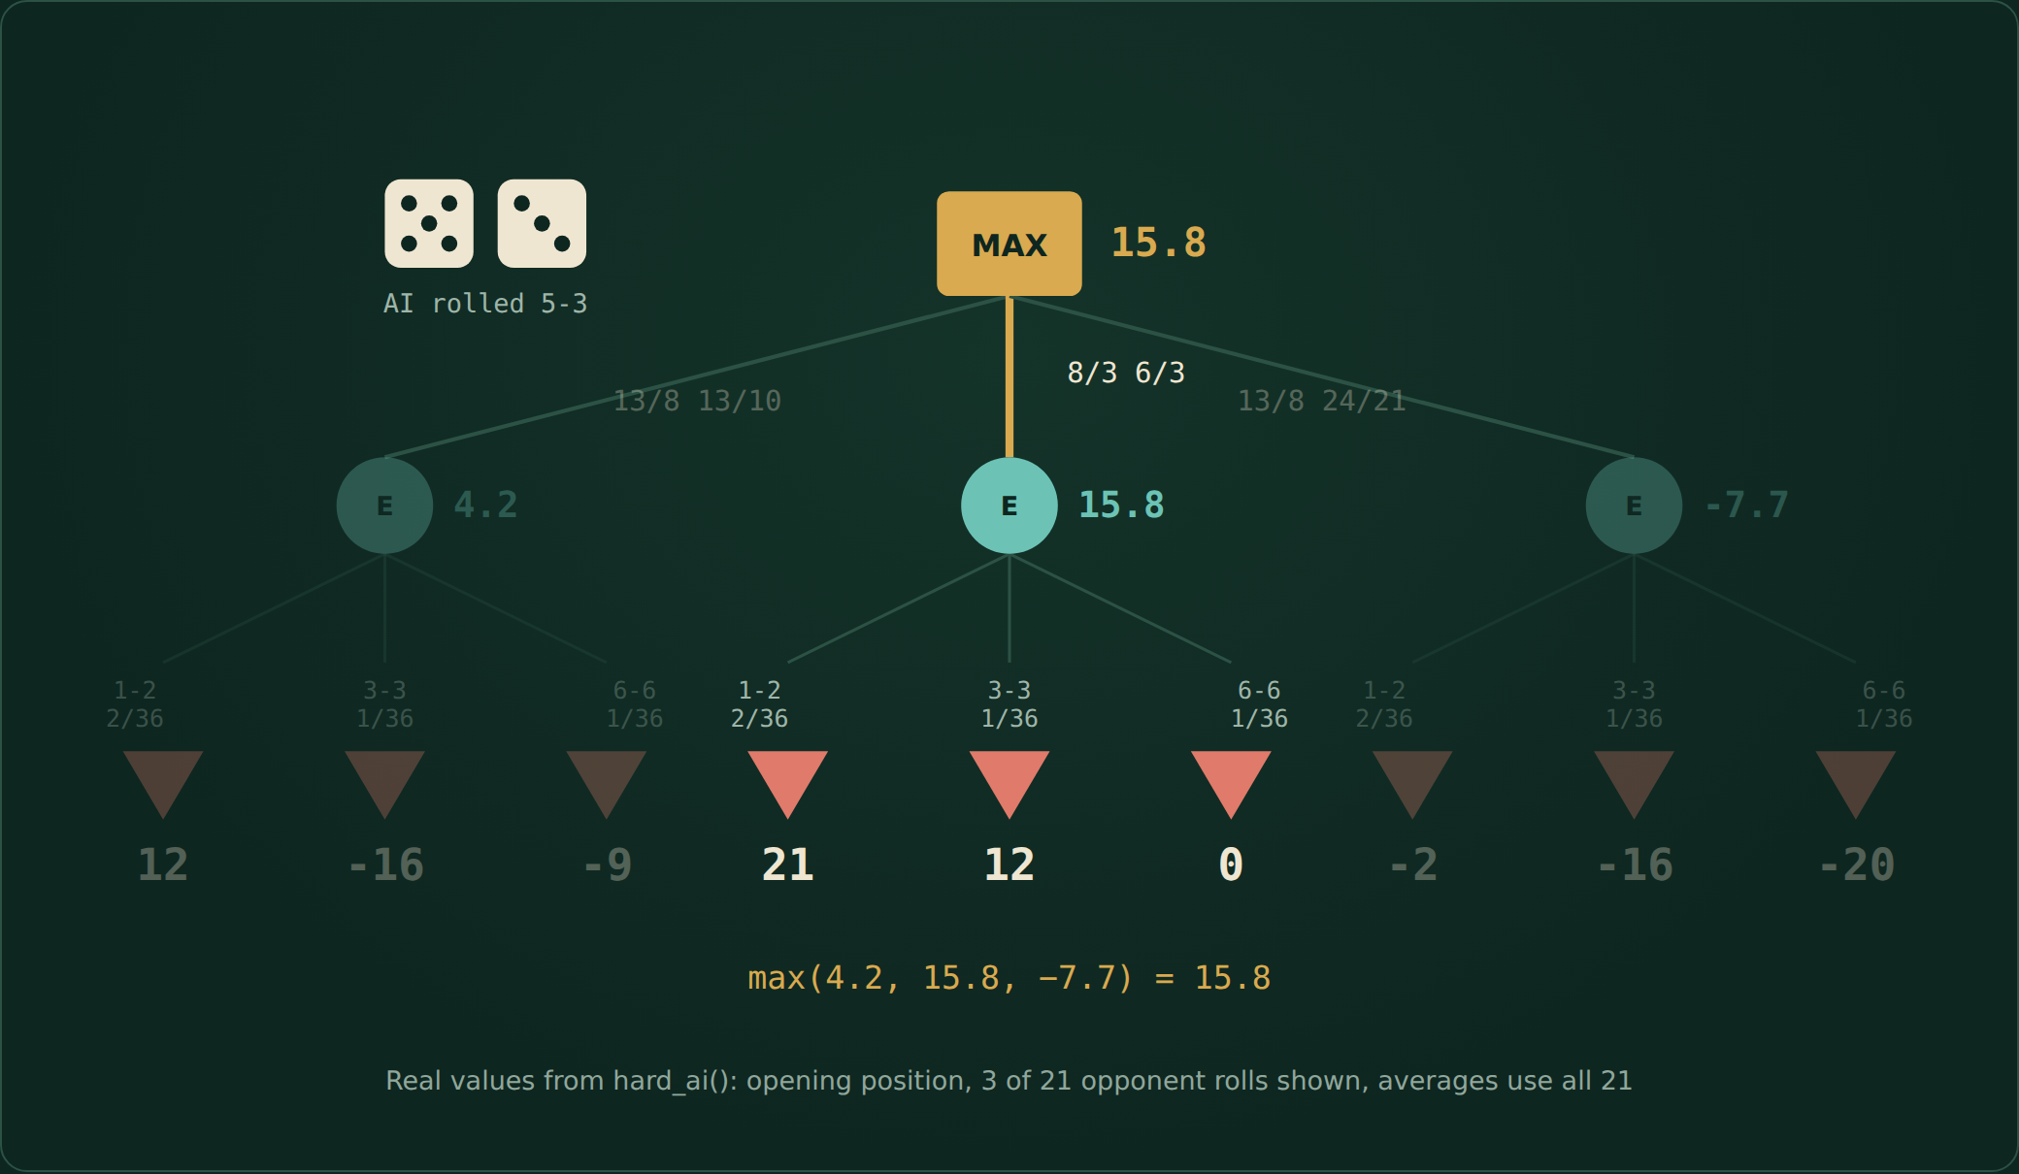
Figure 4. Frame from the explainer animation: MIN values feed the chance averages, and MAX takes the best.
Output: the AI plays 8/3 6/3, making its 3-point. It leaves no blots, so even the opponent's best roll (6-6) only lowers the value to 0, while 13/8 13/10 scores well on most rolls but is punished by 3-3 down to −16. The chance node judges each move by its average over every roll, not by one lucky or unlucky outcome. 8/3 6/3 is also the standard expert opening for 5-3, a good sign that the evaluation weights are sensible.

3.5 Experimental evaluation
To compare the methods, experiments.py plays silent AI-versus-AI games, swapping colours halfway through each match so neither side benefits from moving first. Hard vs Medium was run twice with different random seeds to check how much the result varies.
Experiment | Games | Win rate of first player | Gammons won | Thinking time
Medium vs Easy | 100 | 100% | 97 | 0.2 ms/move
Hard vs Easy | 50 | 100% | 47 | 60 ms/move
Hard vs Medium (run 1) | 100 | 52% | 21 | 54 ms/move
Hard vs Medium (run 2) | 100 | 59% | – | 50 ms/move
Hard vs Medium (combined) | 200 | 55.5% | – | ≈ 52 ms/move
Hard (beam 1 / 3 / 6 / 10) vs Medium | 40 each | 47.5 / 55 / 57.5 / 65% | – | rises with beam

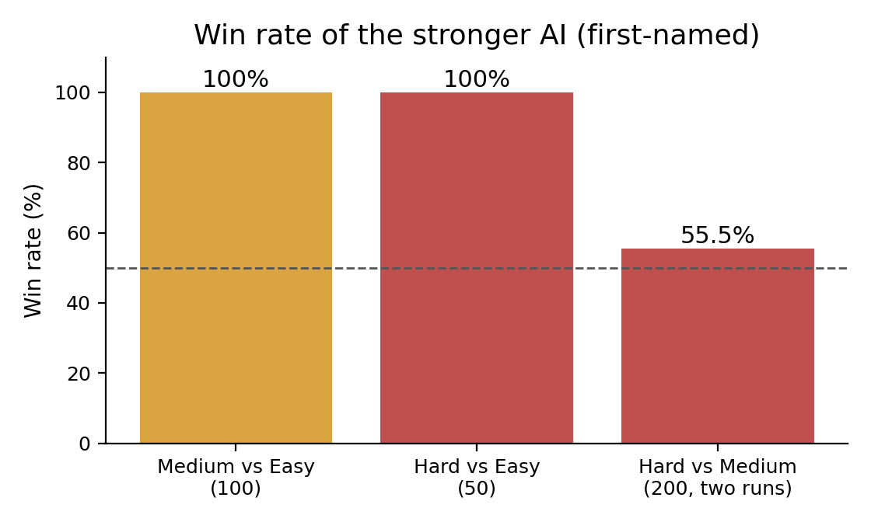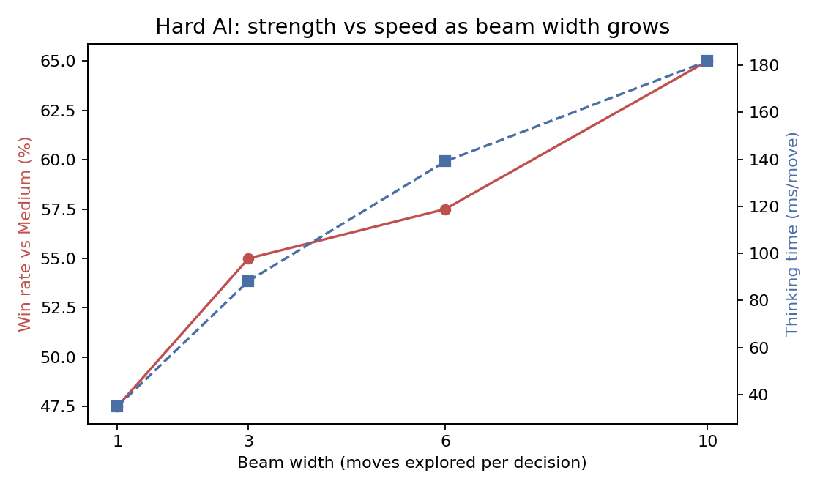
Figure 5. Left: tournament win rates. Right: effect of beam width on the Hard AI's strength and thinking time.
Any evaluation function is overwhelmingly better than random play: Medium won every game against Easy, almost all by gammon. Adding a full look-ahead over the opponent's dice gives a smaller but real gain. The two Hard vs Medium runs (52% and 59%) show how much luck there is in 100 games of backgammon; combined, Hard won 111 of 200 (55.5%). The gain grows as the search explores more candidate moves, from 47.5% with a beam of one to 65% with ten. This is a clear strength-versus-speed trade-off: every extra candidate costs another 21 dice rolls of opponent replies. The default beam of six keeps each move well under a second in the browser.

4. Conclusion
The project delivers a complete, playable backgammon game with three AI opponents, a clear graphical interface that shows the AI's reasoning, a calibrated win chance, hints and move grades, and an online version that runs in any browser. The Hard AI evaluates every legal turn, averages over every possible dice roll and assumes the best reply from the opponent, meeting the brief's requirement to choose the move that is closest to victory. Traced through a real decision, it finds the expert opening for 5-3. The experiments confirmed that search and evaluation matter, and showed honestly that in a game dominated by dice the benefit of deeper search is smaller than in deterministic games.
Challenges. Enforcing the must-use-both-dice and larger-die rules required generating complete turns rather than single moves. Pygame 2.6 was incompatible with Python 3.14, which was solved by switching to pygame-ce. The web build first showed a blank screen because pygbag only detects libraries imported in main.py, and browsers do not support threads; both were fixed by importing Pygame in the entry file and running the search in the main loop. Later, the web build stalled on its loading screen because pygbag also tried to load matplotlib, which is only used by experiments.py; that file is now left out of the web build. Sound was silent in the browser because the browser chooses its own audio format; the sounds are now built from raw samples converted to whatever format the mixer uses.
Limitations and future work. The evaluation weights were set by hand; learning them through self-play, as TD-Gammon did, would likely strengthen the AI considerably. The beam of six can prune a good move whose immediate score is low. Alpha-beta style pruning for chance nodes (*-minimax), a deeper search, the doubling cube and a mobile-friendly layout are further improvements.
Use of AI tools. AI assistance (Claude) was used to support code development, debugging and the explainer animation; the design decisions, testing, experiments and analysis in this report are my own.

References
Russell, S. and Norvig, P. (2021) Artificial Intelligence: A Modern Approach. 4th edn. Pearson (Ch. 5, Stochastic games).
Tesauro, G. (1995) 'Temporal difference learning and TD-Gammon', Communications of the ACM, 38(3), pp. 58-68.
Michie, D. (1966) 'Game-playing and game-learning automata', in Fox, L. (ed.) Advances in Programming and Non-numerical Computation. Pergamon.
pygame-ce and pygbag documentation (2026). Available at: pyga.me and pygame-web.github.io.

